HMC Boarding and Day
839 Boys; 277 Sixth Form

Careers Adviser



Bedford School

Situated just 35 minutes on the train from London St Pancras, and half way between Oxford and Cambridge, Bedford School is one of the region’s leading boarding and day schools, educating boys from the ages of 7 to 18. Part of The Harpur Trust, Bedford’s leading educational and social welfare charity, we’re a vibrant school with a very strong sense of community, set in a beautiful 50-acre estate in the heart of the town.

There are some 694 pupils in the Upper School aged 13 to 18, with approximately 260 in the Sixth Form. 35% of the boys are boarders in our six boarding houses, each of which is “twinned” with a day house. Our Prep School with 400 boys caters for the 7-13 age range on the same campus, and has its own junior Boarding House.

Academic excellence is central to life at Bedford School, and we encourage boys to aspire to the highest possible standards and to exceed their expectations. Our success is demonstrated by a long history of impressive exam results at GCSE, A level, and in the International Baccalaureate Diploma. The vast majority of our leavers go on to Higher Education, and over two thirds of our Upper Sixth boys accepted places at Russell Group universities in 2018; 75% of boys went to universities in the Top 30, to specialise in particular areas of expertise. We are seeing our boys diversify their applications, with more expressing an interest in degree-level apprenticeships and universities in the USA and Europe. Typically, between five and ten boys take up places at Oxbridge each year.

The School was inspected in November 2016, and we are particularly proud of the fact that ISI (Independent Schools Inspectorate) gave us the top ratings possible. Full details, including a copy of the inspection report can be found here:
http://www.bedfordschool.org.uk/Inspection-Report

The school adopts a selective entry policy without being ruthless and seeks to provide an environment where all boys will thrive academically. It emphasises continuity of education at 13+ and 16+ so that, although there are academic entry requirements at each point, they are geared to whether boys are suitable to move to the next stage rather than over-formulaic targets. We believe in an all-round education that exposes all boys to a wide range of experiences and opportunities.

We place great emphasis on the value of Sport, Music and the Arts for the camaraderie, teamwork and self-motivation they instil, and encourage boys to explore their individual talents. Our extensive programme of extracurricular activities is wide-ranging and offers boys the opportunity to learn new skills and discover new interests outside the classroom. Boarding is at the heart of the school and all full-time members of staff are expected to contribute to the wider life of the school through involvement in the tutoring system and in activities outside the classroom.

The school’s ongoing development programme has included the construction of a new Library (2003), Observatory & Planetarium (2003), a new Music School (2006) and a wonderful new theatre in St Luke’s Church, on the edge of the estate (2015). Other developments have included renovation of the school dining halls and kitchens (2009), fitness suite (2010), staff common room (2011), sports pavilion (2012) and science department (2015).

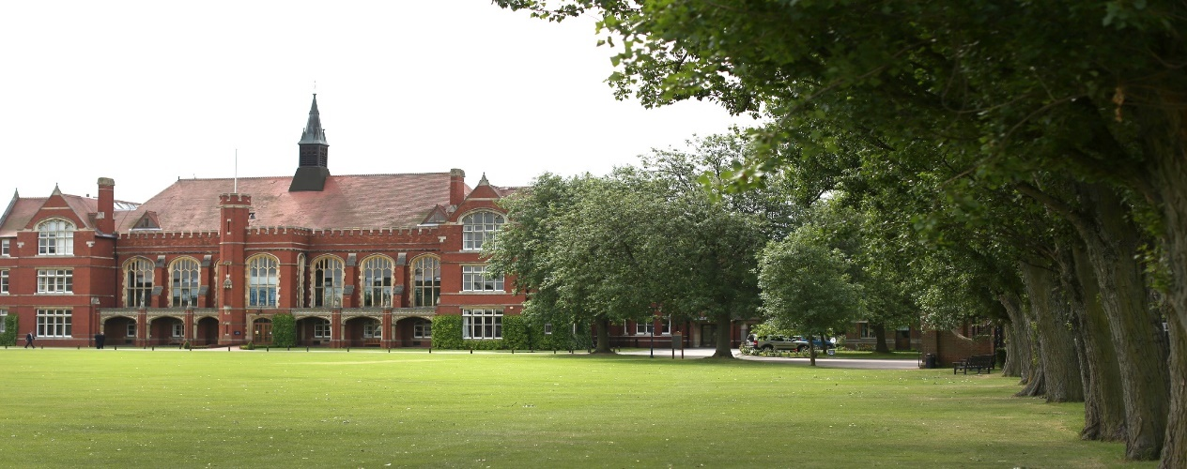

Role Information

We wish to appoint a Careers Adviser to work closely with our Head of Careers and UCAS to help construct, monitor, plan and co-ordinate the delivery of the school’s programme of careers education, information, advice and guidance.

Careers Education and Guidance
There is a full careers guidance programme for pupils from Year 7 to Upper Sixth. Much more detailed and specific information is given to pupils and parents at the time of GCSE and A Level/IB choices concerning the requirements of university courses and various careers and individual interviews are held with each pupil in Year 11 to establish areas of interest and give suggestions. At this time, pupils are exposed to Morrisby profiling activities to assist with these individual interviews with an external qualified Careers Adviser. Pupils are encouraged to undertake work experience at the end of 5th Form and beyond. The Careers Department offers an extensive range of careers resources in the Careers Library and online, which include numerous books, up-to-date magazines, computer programmes and brochures. Reference books as well as books about job-seeking skills, Curriculum Vitae and interviews all help boys in their preparation for entry into Higher Education and the world of work. These can all be created and tracked by staff and parents on the Unifrog platform which hold a wealth of resources for boys.
There is a dedicated member of staff for Careers and UCAS, and a team of specialised advisers, available at careers@bedfordschool.org.uk. The School also has close links with the National Citizen Service, Cambridge Occupational Analysts and the CDI (Careers Development Institute). The School is also the holder of the Onslow Trust’s Gold Award for Education to Employment and holds the nationally accredited Career Mark.
In the Fourth Form all boys take part in a team and leadership building experience entitled 'The Chocolate Challenge', following an extensive programme of employer and specialist activities in years 7 and 8, including Careers Investigator, an online test, and Finance workshops. In the Remove Form and Fifth Form, boys are introduced to the online career profiling service Morrisby (previously mentioned) which boys can then access online for life. The resultant report is discussed with an independent specialist and their Fifth Form Tutor and an action plan is formulated. The emphasis is placed not on specific job titles but on assessing personal strengths and interests in relation to the wide range of careers open to the boys. Boys take a COA ‘Centigrade’ assessment in the Lower Sixth to assist with university and career choices. Pastoral staff are specifically trained to help the boys interpret and use these reports to their best advantage. There is also a Careers Fair open to all boys held in conjunction with the OB Club in the Spring Term. Speakers representing a broad range of different careers give presentations to pupils and their parents throughout the evening. Pupils are encouraged to attend as many sessions as possible and to ask questions freely.
Throughout the year Careers events are held with a focus on enthusing and informing boys regarding certain career pathways. Recent events include a law event, a journalism event, The Times 100 Top Employers event, and other subject-specific events. Interactive webinars with Channel Talent are regular features of a lunchtime and well-attended, ranging from Q&A with Jaguar Land-Rover apprentices and graduate entrants, to university professors giving valuable advice from their lecture theatres.
Higher Education
Most Sixth Formers from Bedford proceed to Higher Education in the October of the year that they leave the School. Some defer entry for a year and some prefer immediately to enter the world of business, apply for degree-level apprenticeships, join the armed forces or take up other professional training.
Bedford School has a distinguished record in preparing students for Higher Education. The majority of our Upper Sixth Formers achieve the necessary grades for entry to their first choice universities. Pupils choose to study a wide diversity of subjects from Aerospace Engineering to Zoology but a distinctive feature of the School is the high proportion of engineering and science entries, and the proportion of boys entering Russell Group universities exceeds 75% year on year.
The School has a good record in preparing students for entrance to Oxford and Cambridge Universities, as well as overseas universities, including Ivy League in the USA, European universities and even as far as Australia.
In the Fifth Form boys are given individual independent Careers interviews and each boy sees a senior member of staff to discuss their Sixth Form options. During the Lower Sixth Year A Level and IB students begin to explore their Higher Education options and are guided through the application process via a series of presentations, the use of online resources such as Unifrog, and lesson time.
Towards the end of the Lower Sixth Year parents are invited to attend a presentation that outlines the UCAS process and offers advice on how they can assist their son in the choices ahead of him. Guidance on the writing of Personal Statements is available to all boys through Tutors and Heads of Departments. Additionally the Head of Careers and UCAS is available for one-to-one meetings. Application to Higher Education takes place in the Autumn Term of the Upper Sixth Year and UCAS forms are completed electronically via the School computer network. The Head of Careers and UCAS checks forms and guides pupils through this process. Rigorous procedures and dedicated staff produce high quality applications. University interviews take place in the Autumn and Spring Terms, preceded by practice and mock interviews in School and offers are confirmed at the start of the Summer Term; with these offers the candidate approaches A Levels or their IB diploma in the Summer.
Oxford and Cambridge applications form part of this procedure, but are separately handled by a dedicated member of staff. Additional application forms and Admissions Tests may be needed, as is a particular knowledge of courses and Colleges. For both Universities there are interviews in November and December; and at both the outcome is known in the subsequent January. Boys are advised on the process and are given a number of mock practice interviews by Heads of Departments and senior members of staff prior to the real interviews.
Benefits of Service

Bedford School has high expectations of its staff and therefore looks to reward them with a competitive salary and beneficial conditions of service. The school offers a pension scheme with generous contributions, private healthcare, a competitive holiday allowance and free lunch during school term time.

The school also believes we have a responsibility to pro-actively support all staff in their development and to make this an outstanding place to work. A range of opportunities for professional development exist and staff are encouraged to further their skills and consider career options at all levels.

The school is set in beautiful grounds within a 50-acre site on the edge of a busy town centre that is well connected to London, Milton Keynes and Cambridge in particular.

Staff are welcome to make use of the extensive leisure and sporting facilities on the site (which includes gym, swimming pool, tennis courts, squash courts etc.) for themselves and their immediate family. Weekly football, yoga and mindfulness sessions are complemented by additions such as staff sports fixtures, a staff book club and free or discounted tickets to music and theatre productions.

Bedford is a dynamic and incredibly rewarding place to work with a strong sense of community. We very much hope that you will want to come and find out more about us.

General Information

Bedford School is committed to safeguarding and promoting the welfare of children and young people and expects all staff to share this commitment. Offers of appointment are subject to satisfactory references, DBS clearance and other pre-employment checks as required.

Application Process

Applicants are asked to complete the School Application Form and email this to vacancies@bedfordschool.org.uk; CVs in place of an Application Form cannot be accepted.

Short-listed candidates will be invited to the school for interview on the advertised date. The selection process will involve an interview, tour of the school and a practical exercise.

The School’s Deputy Head (Academic), Sam Baldock, would be happy to talk to prospective applicants; he can be contacted through the School Reception on 01234 362200 or by email sbaldock@bedfordschool.org.uk

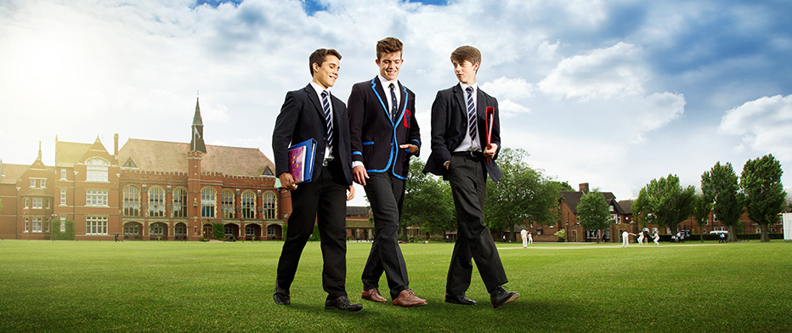
Bedford School is part of The Harpur Trust

