Turton School Art & Design Department: Philosophy & Vision
“We all know that Art is not truth. Art is a lie that makes us realize truth.” (Pablo Picasso, 1972) Art is a moment of calm in a chaotic world. It is a release of expression, emotion and thought that can be aesthetically beautiful and harmonious whilst simultaneously challenging, confrontational, unnerving, disturbing or confusing. Art moves us, influences us, changes us and speaks to us on a level that language, text and numbers do not. Art is autobiographical, self-reflective and is born from our basic human need to communicate, to record, to create. Art is an attempt at immortality for “Life is short, art is long” (Hippocrates, c.460–357 BC). Art is evolutionary, revolutionary and in a constant state of flux. From the earliest prehistoric cave paintings to the most contemporary objet d’art, the human race desires art.

Key Stage 3
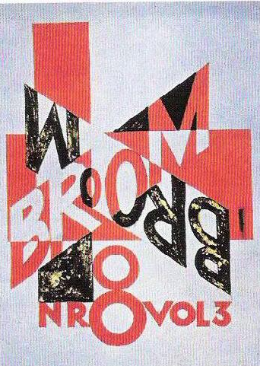
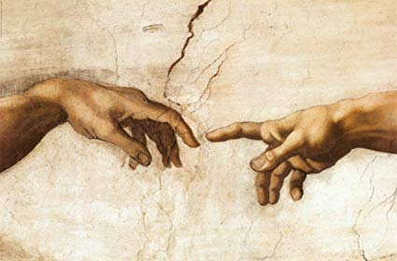
Throughout Key Stage 3 our Art & Design students are taken on a chronological, historical journey through the key periods that have shaped, and continue to influence, artists nowadays. We delve into the artwork of the Middle Ages, in Year 7, and the ornamental illustrations in The Book of Kells (c. 800AD), exploring traditional iconography, typography and calligraphy appreciating the geometry and symmetry of archetypal Celtic knots. Students will experience the birth of The Renaissance in Florence, Italy: a period of significant cultural change, underpinned by the belief that people should be better educated and that art, music and science could make life better for everyone. Our KS3 artists will explore Impressionism and Post-Impressionism with specific reference to landscapes and still life (1865 – 1910), looking at how artists recreated landscapes during this period, considering movement, line and mark making. Pupils will be introduced to the work of Monet, Renoir, Cezanne, Van Gogh, Gaugin and Seurat with the specific reference to the way light can be depicted within a painting and how each artist used colour. Next, our journey will take us to the start of Cubism with Picasso’s ‘Demoiselles D ’Avignon’. We will discuss the muted tones and the stark way that the girls stare out at the viewer. The application of colour, simple shapes and inclusion of real objects will be introduced together with the meaning of both analytical and synthetic cubism, using a wide range of materials – including collage and an opportunity for relief sculpture – to investigate shape, pattern and texture with painting. To conclude, Year 8 will delve into the unusual world of Surrealism and its diverse meaning. Joan Miro, Paul Nash, Salvador Dali and Rene Magritte will form the basis for our exploration into the way dreams and subconscious thoughts can be conveyed through painting. We will use formal drawing exercises, observational studies and imaginative thinking using a range of materials including watercolour, acrylic, oil pastels and graphite. In Year 9, students will revisit key periods on our artistic timeline investigating controversial artworks of the time. For example, Michelangelo’s cornerstone of High Renaissance Art, the ceiling of the Sistine Chapel in Rome, seen hundreds of times a day by visitors to the Vatican, caused a stir when it was first painted in 1508. Centuries later, Tracey Emin, Marc Quinn and Damien Hirst’s three-dimensional sculptures are still raising eyebrows. In Graphic Design lessons, students will study the iconic British designer, Neville Brody, investigating his interest in art movements: Dadaism, Futurism and Constructivism which heavily shaped his artwork to influence his iconic magazine designs: The Face (1981-86) and Arena (1987-1990) later studying Lazlo Maholy-Nagy’s early 20th Century experiments with photographic image and text to understand the terminology “Typophoto”. Students will explore the visual language of letter forms and how these can be combined with photographic elements. This journey will begin with students looking at early examples of illuminated texts created in the Middle Ages to the influence of Gutenberg’s mechanical printing press.

Key Stage 4
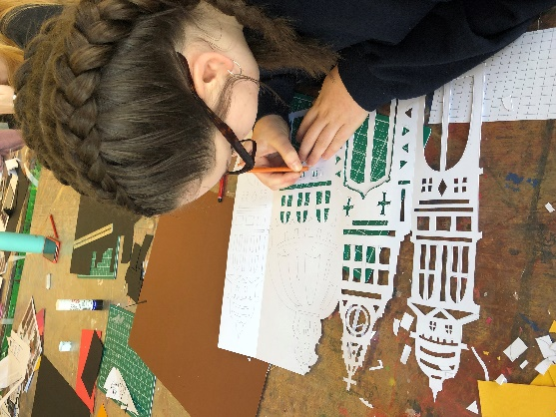
For those students continuing their artistic journey, we aim to build upon practical skills and contextual knowledge by investigations into both traditional and contemporary artists. We study a selection of artists’ work as stimulus, dependent on our external exam brief, all of which draw upon the rich knowledge acquired throughout Key Stage 3: Renaissance (Caravaggio, Rembrandt); Romanticism (Constable, Turner); Impressionism (Monet, Renoir); Post-Impressionism (Van Gogh, Matisse); Modernism (Hepworth); Cubism (Picasso, Cezanne); Surrealism (Ernst, Dali). Students will compliment and compare their historical knowledge with practising artists/designers through gallery visits, workshops and/or art enrichment opportunities and will use these experiences as a basis upon which to build a personal response and substantial artistic portfolio. Art & Design at Key Stage 4 will encompass contextual referencing, design development and refinement, initial research, photography and observational drawing studies. Students will add to and enhance existing artistic skills in addition to learning new techniques including: mono and lino printing, inks and dying, ceramics, collage, textiles, manipulation of photography, three-dimensional studies, relief sculpture and large-scale painting. The Key Stage 4 course allows for more diversity and personalisation, allowing each individual student to experience a wealth of creative opportunities. Graphic Design students develop their visual vocabulary by exploring the use of both traditional and digital media techniques. Students will develop a portfolio of work that includes lino printing, drawing, photography and digital media via the use of Photoshop. Investigations into the work of renowned designers such as Reid Miles, Wolfgang Weingart along with more recent contemporary design practice will encourage students to develop a more acute awareness of the use of type, colour, image and compositional ideas. Students will experience a broad range of graphic styles and genres by responding to series of carefully sequenced design briefs for which they will need to consider specific design requirements and constraints.

Key Stage 5
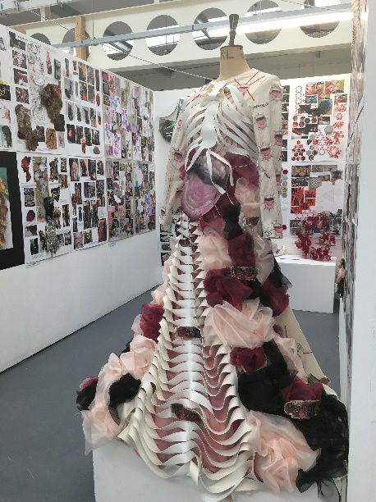
At Advanced Level students may explore a range of art pathways including Fine Art, Art, Craft & Design, Three-Dimensional Design, Graphic Communication, Photography and/or Textiles Design. Advanced Level is a continuous practical investigation supported by written material in which students, again, are given the freedom to explore themes poignant to them. At Advanced Level students are exposed to diverse ways of working: exploratory drawing, photographic manipulation, textiles, sculpture, ceramics, print and paint all of which are supported by contextual references from both traditional and contemporary periods. In Fine Art, Textiles Design and Art, Craft & Design Year 12 forms the basis of a foundation year with natural forms, man-made structures and portraiture being topics of exploration. Photography students study English scientist, inventor and pioneer of photography, William Fox Talbot creating pinhole cameras or camera obscura. Advanced Level Graphic Designers develop a portfolio following design briefs on influential British designers Neville Brody, Ken Garland, Alan Kitching before moving on to Component One when students will be responsible for selecting their own artistic references. They will explore the use of traditional and more contemporary digital media appropriate to their chosen areas of study. This may include collage, print, drawing, paint, photography combined with the use of Adobe Photoshop and Illustrator.

