

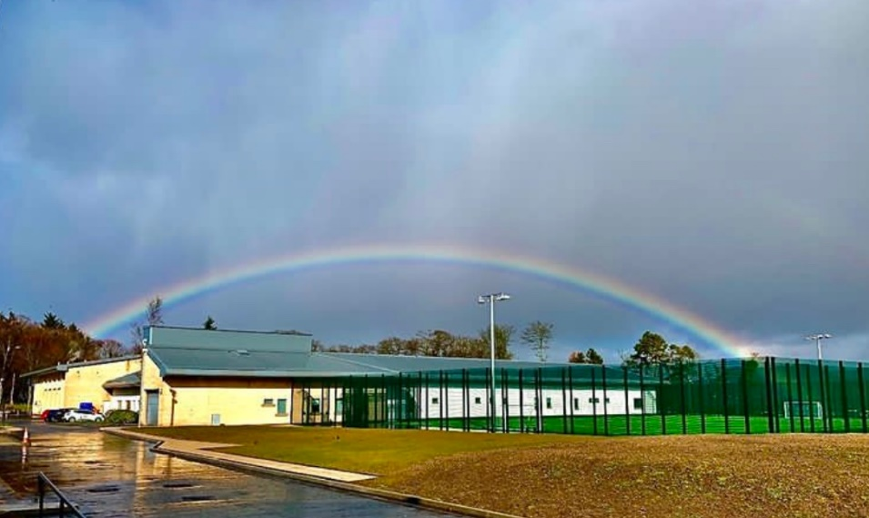

CANDIDATE INFORMATION
for the exciting roles in our Education team:

Outdoor Education Instructor
Permanent, full time

Outdoor Development Worker
Fixed term, full-time

The Good Shepherd Centre, Greenock Road, Bishopton, PA7 5PW
Tel: 01505-864500
Email: applications@goodshepherdcentre.org.uk

Contents
A message from the Director 3
Introduction to the Good Shepherd Centre 4
Working for us 4
Our structure 5
SSQR 5
Care Inspectorate Report (2022) 5
Outdoor Education Instructor 6
Outdoor Development Worker 10
Academic Year Calendar 2023-2024 14
Benefits 15

A message from the Director

Dear Applicant,


Thank you for your interest in the Good Shepherd Centre (GSC). Our work helps and supports young people who have experienced extreme difficulties in their lives to make sense of their experiences and build hope for the future.

We want to give you a flavour of who we are, what we do and why, and how we go about our work. We want to share the vision and values of Team GSC so that you understand what the rewards and challenges of working with us might be for you. We also want to tell you about the lives and experiences of young people who come to stay here with us.

In this pack, you will see that there are links to sections on our website which explain the purpose of GSC, how the different departments work together towards the best care, education and specialist support the young people who come to stay with us need and to the stories of the young people we support.

Everyone at GSC is committed to making a positive difference alongside and for young people. The Good Shepherd Centre’s purpose is to provide a positive, life changing experience for young people through individual care, education and skills development. We do this through trying to make sure everything we do upholds the values and principles of kindness, respect, nurture, and relational and rights-based practice. This means we have a strengths-based approach, and we get to know and to understand each young person as an individual and build trust and positive relationships with them. We work with families and other adults in their life to support each young person to move forward from the often-extreme challenges and harm they have experienced.

There is a well know proverb or saying, which is common across several different African cultures and languages, which is ‘It takes a village to raise a child.’ In the Kijita language the literal translation is that regardless of a child's biological parents, their upbringing belongs to the community. So, for the children and young people at GSC and in our care, we know this means a whole team/whole Centre approach and valuing every colleague in every job role; because whatever our role; we all play our part, working together in the best interests of the children and young people we support.

The GSC has made a commitment to #KeepThePromise and all our staff team will have a part to play as we further strengthen our care, education and health and wellbeing teams.

If you are committed to making a positive difference to the lives of vulnerable young people through being a positive role model for GSC, we’d love to hear from you.

We hope to meet with you to discuss this opportunity.

Alison Gough, Director, GSC

Introduction to the Good Shepherd Centre

“Our purpose is to provide a positive, life-changing experience for young people through individual care, education and skills development focused on promoting young people’s mental and emotional wellbeing and longer-term positive outcomes”

We are a Scottish charity that provides a secure care & intensive care service for vulnerable young people based in Bishopton, Renfrewshire and are privileged to be situated in a 38-hectare campus; within a beautiful countryside setting and stunning views over the Clyde estuary.
We support young people from the age of 12 up to 18 in secure care and 20 in close support care. We work alongside their families and the professionals involved in their lives, to make sense of their experiences and to build hope, coping skills and goals for the future.
Young people live in one of our 4 houses or cottage depending on the level of support required. They continue their education in our school on campus or attend further education out with the campus.
We offer a place of safety and nurture and a positive, holistic and strengths-based ethos.
GSC has gone through an exciting period of growth and we’re on journey for a further period of change with strategic goals aligned with The Promise in place for 2021-2024. These goals are set to move the organisation forward confidently in the best interests of the young people and other stakeholders.

This is an exciting time to join Team GSC as the charity seeks to build on its strong reputation for relational based practice.

Context of Work
Young people are referred to us through the Children’s Hearing System and the Criminal Justice System. They have experienced difficulties in their lives, and many will have faced traumatic and harmful situations and may be experiencing psychological distress; mental health problems; and problems coping with managing feelings and day to day life.
Values
Our values are at the core of every decision we make as a team; we are Kind, Nurturing, Resilient, and Rights Respecting. In addition to our core values, ‘Hope’ has also been part of our ethos for a long time, as we believe without Hope we cannot achieve our goals.

Working for us
We have a caring, experienced and committed staff team. This multi-professional, multi-skilled team includes qualified and registered residential childcare managers and staff teams for each House, and GTC registered teachers within our Education Department. Our senior staff promote and model a positive, compassionate, strengths and relational based approach to all aspects of our work and encourage a culture and climate of ‘whole centre community’, where the dignity, needs and rights of the individual are respected at all times.

In addition to our residential care and Teaching staff, we have a number of other specialist practitioners including learning support staff with specific skills, Clinical and Forensic Psychologists and advisors, therapists, creative arts, sports and vocational coaches and tutors.
Team GSC includes c150 staff and our Director leads a Senior Management Team including:

- Head of Secure Care
- Head of Intensive Support & Throughcare
- Head of Education

Our structure

SSQR
You can read more about our work and outcomes for young people in our SSQR (2020-2021)
Service Standards & Quality Reports - Good Shepherd Centre (gsc.scot)

Care Inspectorate Report (2022)
We are very proud of our scores and the feedback we received from young people, staff, social workers and the care inspectors. You will find the full report for both secure and close support here.
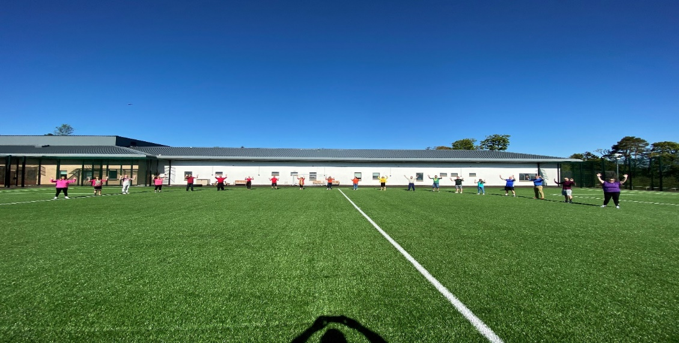

Outdoor Education Instructor

Job Description

Position title: Outdoor Education Instructor
Reports to: Head of Education/Depute Head of Education
Contract Type: Permanent
Position Type: Full time
Hours of work: 37.5 hours week
Salary guideline: £34,570 per annum
Pattern of work: Monday to Friday with a degree of flexibility and some weekend working may
be required.

Purpose
The Outdoor Education Instructor will promote and uphold the vision and values of the Good Shepherd Centre (GSC) as a place of care, safety, and learning. Our purpose is to provide a positive, life changing experience for young people through individual care, education and skills development focused on promoting young people’s mental and emotional wellbeing and longer-term positive outcomes.
Through ensuring that the work is in keeping with legislative, procedural, and good practice requirements and guidance, the overall focus of the role is to deliver outdoor learning activities to young people, both in school curriculum time and during school holidays.

The Outdoor Education Instructor will engage with vulnerable young people to provide exciting and enjoyable ways to learn; providing opportunities and support to achieve their highest potential in outdoor education and future success in training and work.

They will supervise and support young people in a nurturing, stimulating and outdoor environment, ensuring all activities are provided to a high standard and that an appropriate level of safety and security are maintained at all times.

Responsibilities, Activities and Duties
The specific actions and programmes for this role will be defined by the Good Shepherd Centre (GSC).
Young People:
- Provide a safe and engaging environment for young people to thrive.
- Motivating and inspiring children and young people to participate in sport and outdoor education.
- Supervise and support young people whilst carrying out all activities.
- Promote, monitor and maintain health, safety and security in the outdoor environment.
- Use outdoor learning to develop and mentor young people in a positive way.
- Customise programmes for individual young people as appropriate.
- Plan, track and monitor young people’s progress and provide reports for outdoor education.
- Work within a school environment, building a rapport with the young people and create strong relationships with other members of staff.

School Specifics:
- Develop and oversee the delivery of the Duke of Edinburgh Award in line with the Operating Licence through the Good Shepherd Centre’s own programmes.
- Initiate, develop, and deliver outdoor education programmes and activities for young people to include trips and excursions, DoE expeditions and activity sessions.
- Ensuring there are more opportunities to participate in sport and sport in the wider community (where possible) and high quality is delivered.
- Deliver a range of Wider Achievement Qualifications e.g. John Muir, Paddlesports etc.
- Accompany trips and excursions as part of this programme, including overnights.
- Engage GSC staff to support outdoor education and provide training or access to courses.
- Maintain the outdoor education stores and resources to ensure that all equipment is adequately logged, monitored, and maintained so that it is available for issue, use and return as required.
- Maintain records of all work or repairs undertaken in the outdoor education stores and to advise the Education Management Team of any concerns regarding equipment.
- Prepare lesson plans and the equipment needed in advance of the lessons.
- Provide assessments for young people and adapt lesson plans based upon the ability of the group.
- Attend staff briefings and meetings (when required) and to be familiar with all school routines and policies.

Partnership Working and Wider Community:

- Building capacity through the recruitment, retention, and development of a network of volunteers to deliver sport.
- To improve partnership working with our local community and sport clubs to increase outdoor education.
- To promote community engagement in sport, outdoor and recreational activities by strengthening local, regional sports specific pathways and regional partnerships.
Undertake other tasks including:

- Work closely with school senior management team(s) and all relevant departments and partners to ensure the priorities for the Good Shepherd Centre are delivered.
- Recruit and support coaches, leaders and volunteers and ensure ongoing training opportunities.
- Source additional funding opportunities to further enhance the sports opportunities in school sport and sport in the community.
- Coordinate and develop extended curricular opportunities for physical activity and sport in the school and the wider community.
- Develop a network of sustainable clubs and supporting pathways for GSC staff and young people.
- To support the effective monitoring, evaluation, reporting and communication process at operational levels for the Good Shepherd Centre.

Person Specification

 | Essential | Desirable
Qualifications | - Educated to degree level or equivalent.
Experience | - Duke of Edinburgh leader and assessor status  - Pursue and maintain accreditation in a range of outdoor education activities e.g., bikeability, paddlesports, mountain biking.  - Knowledge & understanding of maintenance practices relevant to equipment and facilities.  - Knowledge of health and safety and risk assessing when working within the Outdoor adventurous activities’ environment  - Extensive experience of engaging with children, young people and volunteers in sport and physical activity within the education, sport, health, community, leisure and/or leisure sectors.  - Proven project management experience. | - Experience of the primary and secondary curriculum and working in a school environment.  - Experience of physical activity planning and knowledge of strategic sports development planning.  - Knowledge and experience of financial management.
Professional Registration | - Membership of a professional organisation such as SSSC, GTCS or another relevant Professional Regulatory Body.
Professional Qualities | - Ability to engage effectively and deliver outdoor activities with young people.  - Ability to work with groups of young people in an outdoor education setting.  - Ability to demonstrate an interest in Young People’s welfare, and a sense of enjoyment in being with young people.  - Ability to demonstrate Youth Work skills.  - Ability to risk assess and deal with complex situations involving groups of young people engaged in a diverse range of activities under a variety of weather and other environmental conditions.  - Ability to lead, motivate and organise young people.  - Ability to work under pressure and to meet conflicting demands within timescales.  - ICT literate, in particular in using email and Duke of Edinburgh portal.  - Pro-active with highly developed organisational and time management skills  - Willing to adapt to change and show a flexible approach.  - Ability and willingness to work constructively as part of a team.  - Understanding of young people with additional educational needs  - Commitment to raising levels of young people’s engagement and to the success of the Education department and wider GSC.  - Ability to be innovative and creative.  - Clearly demonstrate the ability to engage with key partners and maintain good working relationships.  - Clearly demonstrate excellent written and verbal communication skills.  - Ability to prioritise tasks, meet deadlines and work on own initiative.  - Competent in using Word, Excel, and PowerPoint.  - Full and valid UK driving licence.
Personal Qualities | - Ability to work as a team member.  - Enthusiastic and highly motivated with the ability to motivate others.  - Excellent interpersonal skills.  - Strong influencing and negotiating skills.  - Ability to build trust and devolve responsibility and resources to partners/colleagues.  - Clear understanding of the benefits that physical activity and sport can bring to all.  - Resilient and able to deal confidently with difficult challenges.

Outdoor Development Worker

Job Description

Position title: Outdoor Development Worker
Reports to: Head of Education/Depute Head of Education
Contract Type: Fixed term for two years
Position Type: Full time (part-time/job share will be considered)
Hours of work: 37.5 hours per week
Salary guideline: £33,543 per annum
Pattern of work: Out-with school hours, 5 days over 7 including weekend working.

Purpose

The Outdoor Development Worker will promote and uphold the vision and values of the Good Shepherd Centre (GSC) as a place of care, safety, and learning. Our purpose is to provide a positive, life changing experience for young people through individual care, education and skills development focused on promoting young people’s mental and emotional wellbeing and longer-term positive outcomes.

The Outdoor Development Worker will transform existing accessible courtyard spaces creating extra-curricular, multi-functional, curated spaces supporting wider achievement and providing young people and families with increased opportunities and choice for physical, social, recreational, and learning opportunities aligned to the UNCRC Rights of the Childhood. The Outdoor Development Worker will help to create a nurturing, stimulating outdoor environment, ensuring all activities are provided to a high standard and that an appropriate level of safety and security are maintained at all times.

The Outdoor Development Worker will engage with vulnerable young people to provide exciting and enjoyable ways to learn; providing opportunities and support to achieve their highest potential in outdoor activities leading to improved physical health and lifestyle choices. Through ensuring that the work is in keeping with legislative, procedural, and good practice requirements and guidance, the overall focus of the role is to transform outdoor learning spaces and deliver outdoor learning activities to young people, as extra-curricular activities out-with school hours.

Responsibilities, activities, and duties
The job holder will be required to carry out the following responsibilities, activities, and duties:

With management support:
- Involvement in the re-design, planning, and restructure of outdoor spaces.
- Developing suitable outdoor spaces for play.
- Purchasing inspiring play / outdoor equipment.
- Listening to our young people’s voice:
- Delivering a programme of extra-curricular outdoor recreational activities.
- Support and work with our young people on learning for sustainability.
- Implement GSC’s Sustainability Plan including reducing food waste, acquisition of practical outdoor life skills; cooking, growing fresh produce and spending time connecting with nature.
- Deliver outdoor, fun, educational experiences about wilderness survival skills.
- Design, plan and deliver GSC’s internal ‘vegetable farm to fork’ initiative.
- Inclusion of family and friends in sustainable outdoor learning activities.
- Development of young people’s skills in outdoor pursuits, growing, gardening, budgeting, play, cooking and recreation.
- Customise programmes for individual young people as appropriate.
Other duties:
- Maintain the outdoor education stores and resources to ensure that all equipment is adequately logged, monitored, and maintained so that it is available for issue, use and return as required.
- Maintain records of all work or repairs undertaken in the outdoor education stores and to advise the Education Management Team of any concerns regarding equipment.
- Plan, track and monitor young people’s progress and provide reports for outdoor education and wider achievements.
- Provide a safe and engaging outdoor environment for young people to thrive.
- Use outdoor learning to develop and mentor young people in a positive way.
- Work within a secure outdoor environment, building a rapport with the young people and creating strong relationships with other members of staff.
- Supervise and support young people whilst carrying out all activities.
- Promote, monitor, and maintain health, safety, and security in the outdoor environment.
- Undertake excursions as required,
- Prepare relevant documentation for Education Management Team for quality assurance purposes.
- Attend and contribute to relevant meetings as required.

Person Specification

 | Essential | Desirable
Qualifications | - Outdoor Learning Qualifications. | - Degree and or relevant higher-level qualifications.
Experience | - Learning for Sustainability experience.
Professional Registration | - Hold SSSC registration or other professional regulatory body registration.
Professional Qualities | - Ability to demonstrate Youth Work skills.  - Ability to risk assess and deal with complex situations involving groups of young people engaged in a diverse range of activities under a variety of weather and other environmental conditions.  - Ability to lead, motivate and organise young people.  - Ability to work under pressure and to meet conflicting demands within timescales.  - Ability to plan, design and develop outdoor spaces.  - Knowledge & understanding of outdoor maintenance practices relevant to equipment and facilities.  - Knowledge of health and safety and risk assessing when working within the Outdoor adventurous activities’ environment.  - Outdoor space and gardening skills.  - Pro-active with highly developed organisational and time management skills.  - Commitment to raising the levels of young people’s engagement and to the success of the Education department and wider GSC.  - Ability to be innovative and creative.  - Full and valid UK driving licence
Personal Qualities | - Ability to engage effectively and deliver outdoor activities with young people.  - Ability to work with groups of young people in an outdoor education setting.  - Ability to demonstrate an interest in Young People’s welfare, and a sense of enjoyment in being with young people.  - Learning for sustainability knowledge and experience.  - Approachable, courteous, and able to present a positive image to young people, staff and visitors.  - Willing to adapt to change and show a flexible approach.  - Ability and willingness to work constructively as part of a team.  - Understanding of young people with additional educational needs.  - Genuine interest in all young people and a sensitive attitude to them  - Commitment to raising the levels of young people’s engagement and to the success of the Education department and wider GSC.  - Ability to be innovative and creative.

Academic Year Calendar 2023-2024

Term 1 | Mon 14th Aug – Fri 16th Sept  2 Inservice Days  (Tues 15th & Wed 16th August) | 4 Weeks & 4 Days
Autumn Holiday | Mon 18th Sept – Mon 25th Sept | 1 Week & 1 Day
Term 2 | Tues 26th Sept – Fri 3rd Nov  1 Inservice Day  (Monday, 23rd October) | 5 Weeks & 4 Days
November School Closure | Mon 6th Nov – Fri 10th Nov | 1 Week
Term 3 | Mon 13th Nov – Fri 22nd Dec  St. Andrews Holiday  (Thursday 30th Nov) | 5 Weeks
Winter Holiday | Mon 25th Dec – Fri 5th Jan | 2 Weeks
Term 4 | Mon 8th Jan – Fri 9th Feb  1 Inservice Day  (Monday 8th Jan) | 5 Weeks
February School Closure | Mon 12th Feb – Fri 16th Feb | 1 Week
Term 5 | Mon 19th Feb – Thurs 28th Mar  1 Inservice Day  (Mon 19th Feb) | 5 Weeks & 4 Days
Spring Holiday | Fri 29th Mar – Fri 12th Apr | 2 Weeks & 1 Day
Term 6 | Mon 15th Apr – Fri 17th May  May Day Holiday  (Mon 6th May)  2 Inservice Days  (Mon 15th Apr & Thurs 2nd May) | 5 Weeks
May School Closure | Mon 20th May – Mon 27th May | 1 Week & 1 Day
Term 7 | Tues 28th May – Fri 28th June  1 Inservice Day  (Tues 28th May) | 4 Weeks & 4 Days
Summer School | Mon 1st Jul – Fri 12th Jul | 2 Weeks
Summer School Closure | Mon 15th Jul – Fri 26th Jul | 2 Weeks
Summer School | Mon 29th July – Fri 12th Aug  Post Summer Holiday  (Mon 12th Aug) | 2 Weeks & 1 Day

Benefits
Below is a summary of our typical Statement of Main Terms and Conditions of Employment.
We believe we offer a generous package of benefits to all our employees including:
Hours of work
Hours of work is 37.5 hours per week per the GSC’s working arrangement.
Annual leave
32 days including public holidays. Pro-rata entitlements for part-time staff.
Pension
Enhanced Employer Pension contribution. Employees with permanent contracts, or temporary contracts lasting 3 months or more, become members of the Local Government Pension Fund, unless they apply to opt out. The employee contribution is based on salary level.
Life assurance. 3 x salary subject to being a member of the pension scheme.
Generous Occupational sick pay scheme entitlement
Other Benefits
- Cycle to Work Scheme
- Employee Assistance Programme
- Access to Blue Light Card scheme offering a range of discounts from large national retainers to local businesses in a wide range of categories including holidays, cars, days out, fashion, gifts, insurance phones and much more!
- Investment in workforce development
- On site car parking to name but a few

How to apply
We hope you have found the information in this pack both useful and informative.
If you are looking for a new and exciting role in the third sector and would welcome the opportunity to help young people achieve their potential, then working as part of our dedicated and experienced team may be a good move for you.
Please note, as per our company policy, we are strictly unable to accept CV’s.

To apply, please complete our application form available to download on our website at the link below and submit to applications@gsc.scot by the closing date.

Pre-Employment Medical Questionnaires will be undertaken prior to confirmation of employment. All convictions whether spent or unspent must be declared. These posts are regulated work with children under the Protection of Vulnerable Groups (Scotland) Act 2007. The preferred candidate will be required to join the PVG Scheme or undergo a PVG Scheme update check. Where an individual has spent a continuous period of 3 months or more out with the UK in the last 5 years, an Overseas Criminal Record Check will be required. You will be required to provide this check. A confirmed offer of employment and commencement in the post will be subject to the outcome of both these pre-employment checks being deemed satisfactory.

Applications will be shortlisted for interview by matching the details given in their application against the job description and person requirements. We would therefore ask you to provide clear evidence to show how your experience, skills and knowledge match those requirements.

We are developing an innovative selection process to have a focus on values and engagement with young people.

Thank you for your interest in working with us. If you have any questions at all, please do not hesitate to contact either the contacts given herein for each job role or the HR department on 01505-864500.

Best wishes,

The Good Shepherd Centre



“Staff try to support you as much as possible to help you maintain a positive image for the future” Young Person
www.gsc.scot









