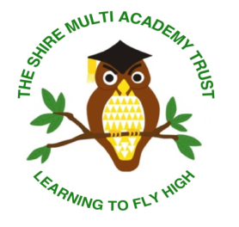
Prospective Candidates Information
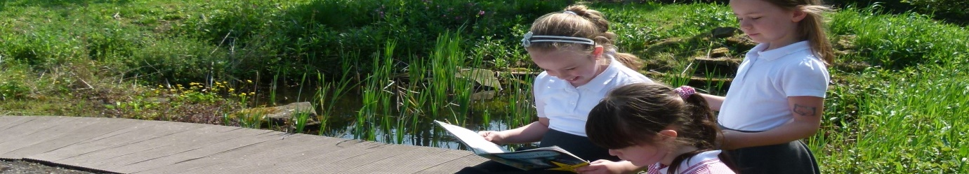
Thank you for showing an interest in our advertised position.

The following information aims to give you a brief insight into the ethos and vision of the Trust and how we work together collaboratively across our schools. We welcome visits to our school for any prospective candidates. We look forward to your application if you feel you would like to join our team and make our vision a reality.
Sandhill Primary School- School Specific Information
Deputy Headteacher Position
Sandhill Primary School is a 10 class school including nursery in the village of Great Houghton in the town of Barnsley.
Our children are enthusiastic, curious and enjoy coming to school. Our curriculum is based upon exploring quality texts as a stimulus for our learning .We place an emphasis on the teaching of reading, maths and we exploit all opportunities to write.
Our staff team vary in their experience and we place a great emphasis on CPD for everyone. All staff as highly motivated to ensure that the children achieve well, are safe and enjoy being at school.

About the Trust
At the Shire Multi Academy Trust our ethos is simple. We put children first; we provide them with opportunities and experiences through which they can excel, creating a Trust-wide learning culture where children thrive.
There are currently 2 schools within the trust. Sandhill Primary and Laithes Primary, both situated in Barnsley, South Yorkshire. The Trust has established shared policy and procedures across the schools. Joint initiatives on school improvement are common place and teachers meet regularly to work together and learn from each other. Trust INSET days are planned annually and the investment in CPD is high. The leadership structure is similar at both schools meaning that our phase, subject and senior leaders support each other with development in our schools. Each school has its own SLT and the Trust has an Executive Leadership Group. The CEO, Finance Director, Director of Strategic Improvement and the Heads of School work together at a strategic level to support the development and underpin the collaborative intentions of the Trust.

Our Vision
We believe in Leaders Leading. We believe in Teachers Teaching. We believe in Children Learning.
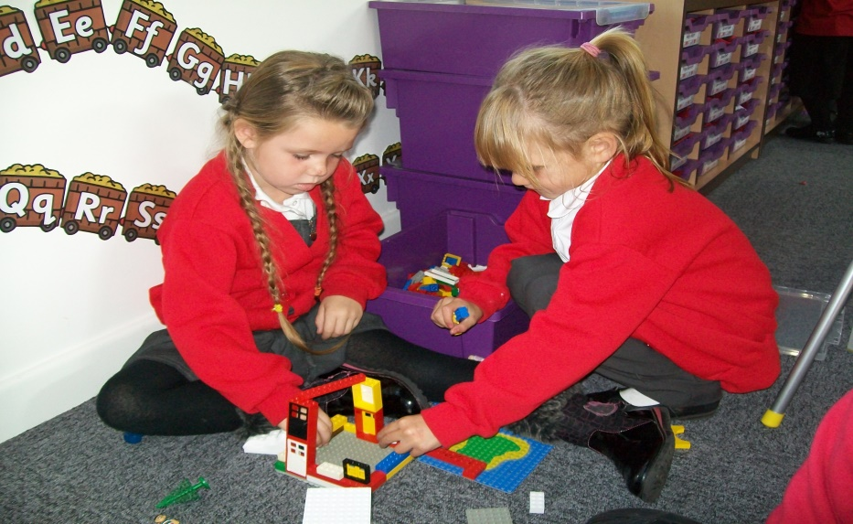
Our Trust aims for all its schools to collaborate, sharing expertise and skills. We listen to, value and strategically utilise the experience and practice of all. We embrace each other’s strengths and openly support each other’s developments. Learning together makes us stronger.
Our Trust aims for inclusivity. We know that success in modern Britain depends upon respecting, understanding and celebrating difference. We welcome all. We endeavour to improve the lives and life chances for our children and their families. As a Trust we nurture, celebrate achievement and recognise success in order that all our children become confident citizens of the future.
As a Trust we innovate. In the fast-paced world of education in the 21st century we welcome challenge and provide an environment that encourages staff reflection and debate about the way they teach. We want our schools to create a climate in which teachers are motivated and trusted to take risks, to be inventive, to ‘think out of the box’ in ways that suit the uniqueness of our schools.
Our Trust has a culture among all stakeholders that makes it unequivocally clear that there are no excuses for children not achieving high standards in their learning and behaviour. Rigorous quality assurance is ensured through strong governance and a framework of accountability and responsibility by all.
‘Learning to fly high’ is our motto. Our children engage with exciting learning journeys that provide a wealth of experiences fostering future aspirations. From jumping in puddles to playing a tuned instrument, we aspire to be the best that we can be.
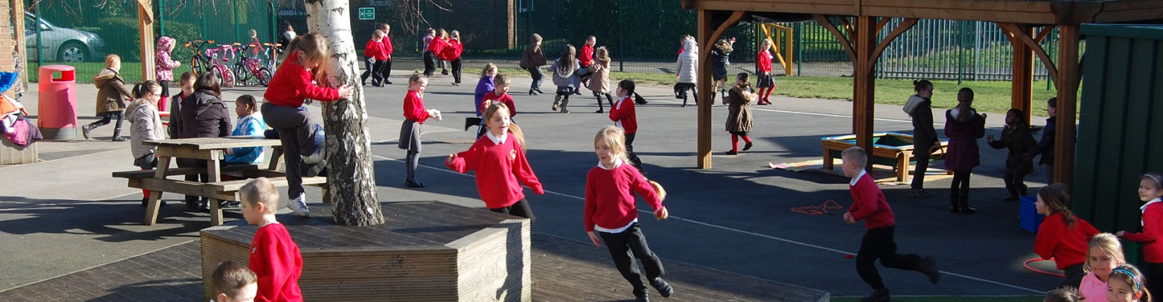

The Role of Local Governing Bodies
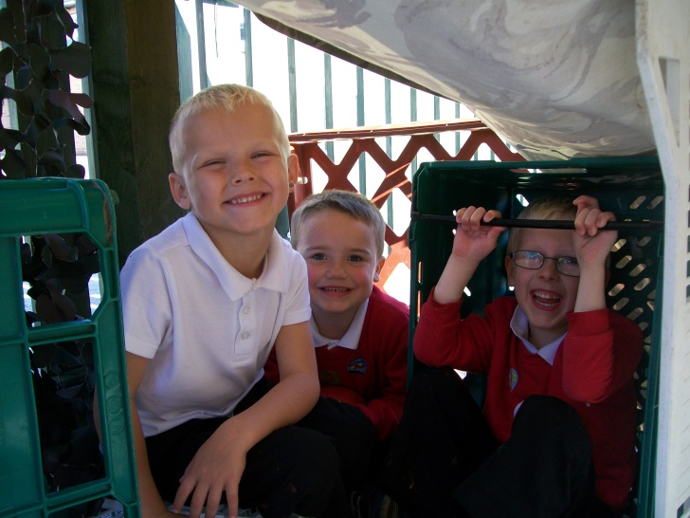
The Local Governing Bodies provide support and challenge to Headteachers in ensuring every child makes good or better progress and that parents and carers are fully involved in their child’s education. The Local Governors are active in supporting our schools: they have a variety of experiences and perspectives and come from a range of backgrounds. We value their expertise and input into making our academies successfully.

The Executive Leadership Group
The Trust operates an Executive Leadership Group (ELG). The ELG is chaired by the CEO and is composed of the Finance Director, Director of Strategic Improvement and the Heads of School. The goal is to support development and to underpin the collaborative intentions of the trust.
The ELG will meet on a regular basis to consider and advise on the business of the Trust and the improvement of all academies and any cross-trust initiatives.

We hope this has given you a flavour of what we are about at the Shire Multi Academy Trust and look forward to hearing from you in the future. If you require any further information please do not hesitate to contact us using the contact details on the Job Advertisement.

