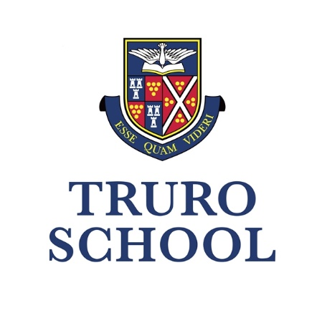

NURSERY | PREP | SENIOR | SIXTH

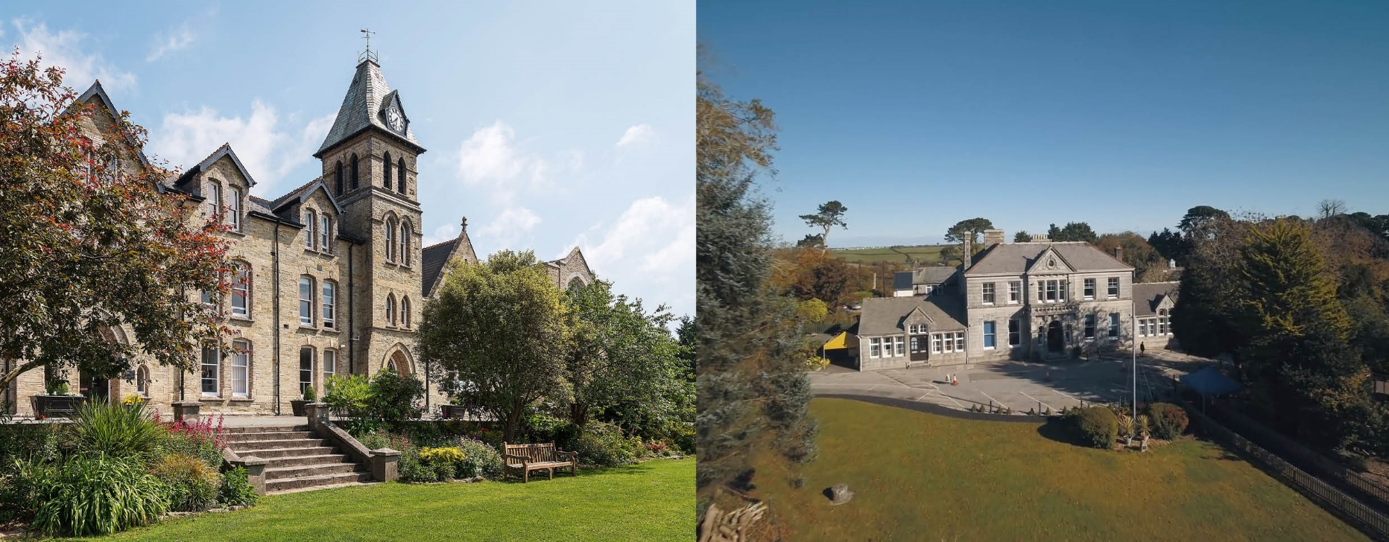

Information for Candidates
Early Years Teacher

Commence around September or January 2024
Full Time

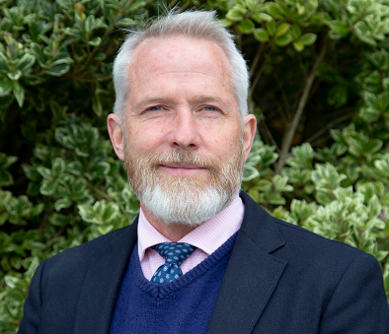

From Andy Johnson
Head &
Rob Morse
Head of Prep

Welcome to Truro School!
Thank you for your interest in the role of Early Years Teacher here at Truro School Prep.
Our School is steeped in 140 years of history and is Cornwall’s leading coeducational independent school for children aged 3-18. We are situated over two campuses. The Senior School educates around 840 pupils and is set within 40 acres of sports fields and open spaces overlooking Truro and its iconic Cathedral. The Prep School educates around 300 pupils and is located next to the Royal Cornwall Hospital. We have superb facilities and resources at both sites that support our forward-looking educational ambitions.
Our Cornish setting allows us the privilege of working in a thriving city surrounded by beautiful rural and coastal opportunities. Our educational philosophy is to promote inclusive excellence, academically, pastorally and via a vibrant co-curriculum, for all who join our school.
Underpinned by a welcoming and liberal Methodist ethos, we champion the values of curiosity, courage, creativity, compassion and confidence in all we do. We want all our pupils to be and to become the very best of themselves, embracing the richness of a broad and forward-thinking education. We want our staff to be excited by what we are able to provide for the children under our care.
We are an “excellent” co-educational school that is large enough to offer many diverse and exciting opportunities, but small enough to know our children and families well. We champion an ambitious, broad and balanced education, and we hope that everybody who joins us will feel an important part of this flourishing community.
For a flavour of life here at Truro School please look at our website www.truroschool.com and view our virtual tour, where you will see and hear from staff and pupils, and find a glimpse of who we are and where we work.


Andy Johnson
Head
The Role
Job Title:
Early Years Teacher in either Reception or Nursery

Responsible to:
Head of Truro School Prep and EYFS Coordinator

We are looking for a teacher who will build excellent relationships with our children and is committed to working closely with our parents to achieve the highest outcomes for all children at the very start of their educational journey.

The specific responsibilities of the Early Years Teacher are to:

- teach and manage the pupils in the class in co-ordination with the other EYFS staff;
- attend and participate in EYFS/Pre-Prep departmental and planning meetings as required by the EYFS Coordinator;
- work effectively and supportively as a member of the whole school team and be prepared to go the extra mile;
- be professional and passionate about the role of early education and continue to develop the exemplary childcare we provide;
- support the families within our school community;
- possess a sound understanding of child development within an educational setting;
- understand the importance of play based learning within a developmentally appropriate EYFS curriculum;
- provide a safe and nurturing environment in which every child has the opportunity to thrive;
- inspire children through the planning, preparing, delivering and assessment of individual children’s progress, maintaining learning journeys and reporting to parents;
- take on the role of a key person;
- understand and provide opportunities for different styles of learning;
- put children at the centre of all decisions;
- reflect on one’s own teaching;
- possess excellent classroom management in order to create a calm working environment.

The general responsibilities for all teachers at Truro School Prep are to:

- plan and prepare for the short, medium and long term;
- teach according to the educational needs of the pupils;
- provide a stimulating environment for learning to take place;
- be involved and inclusive;
- be supportive, creative and imaginative;
- assess, record and report on the development, progress, behaviour and attainment of pupils and maintain effective records;
- participate in all necessary arrangements and procedures for assessment;
- maintain good order and discipline among pupils with particular reference to health and safety;
- undertake supervision duties as required;
- provide pastoral care and guidance to pupils as appropriate;
- participate in staff meetings and discussions as required by the Head;
- undertake INSET as part of the school’s development plan and in agreement with the Head through participation in the school’s staff review process;
- adhere to the school’s policies regarding reporting to parents;
- adhere to the school’s child protection and anti-bullying policies;
- contribute to the training and development of students on placement within the school;
- to maintain an up to date First Aid qualification and to administer basic First Aid as needed;
- act at all times as a professional member of staff.
- Liasing with the SENDCo to ensure that all children are supported in their educational journeys;

KEY SKILLS

- adaptability
- creativity
- patience
- responsibility
- resourcefulness
- a good sense of humour

PERSON SPECIFICATION
Essential Criteria
- a qualified teacher (preferably with an early years’ degree)
- a good standard of written English
- a basic level of computer literacy both for personal administration and teaching
- a clear enhanced DBS disclosure
- the willingness of work cooperatively as part of a team
Desirable Criteria
- recent experience within the EYFS
- a willingness to be involved with the life of the school in terms of clubs and activities
- an empathy and understanding of Independent Schools
- an understanding of the school’s Methodist tradition
- the ability to use ICT to a high standard within the classroom context

ADDITIONAL
- Truro School is committed to safeguarding and promoting the welfare of children and young people and expects all staff and volunteers to share this commitment and behave accordingly. This role will involve daily contact with pupils.
- This Job Description sets out current duties of the post that may vary from time to time without changing the general character of the post or the level of responsibility entailed.

Ethos of Truro School Prep:
The school actively seeks to promote participation by pupils in a wide range of activities to achieve a broad and balanced education. It is expected that staff will support this intention by undertaking activities with the pupils either at lunchtimes or after school according to their skills and interests. Those who take sporting activities may be asked to accompany teams on fixtures and to referee (as per qualifications). Such participation is greatly appreciated and helps to create a happy and positive school environment.
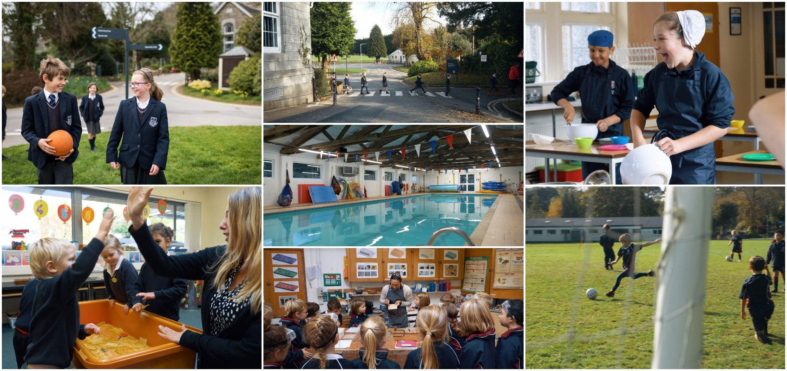

Our Motto
Esse Quam Videri, meaning ‘to be, rather than to seem to be.’
Founded by Methodists in Cornwall in 1880 our School is a welcoming community in which children and adults can flourish, thrive and be happy. They enjoy being and becoming the very best of themselves.
Our Values
From nursery through to Sixth Form, the values our community nurtures are:
- Curiosity to always want to discover and learn more, academically and more widely too.
- Confidence to build resilience by learning from both successes and failures alike.
- Compassion to understand and champion the needs of others, in our community and beyond.
- Creativity to be imaginative in how we express ourselves and approach new challenges.
- Courage to enjoy becoming the very best of who we are, with integrity and ambition.

Our Ambition
To be a community of inclusion and excellence delivering the best educational journey in the South-West.
Our community and its culture reflect our Methodist foundation and our ongoing evolution in an inspiring Cornish setting. In an ever-changing world, we support and challenge young people to thrive – personally, spiritually, academically, socially, and physically. We value our pupils in the diversity of their identities, beliefs, abilities, talents, interests, backgrounds, and needs. The happiness, energy and wellbeing of our community shapes and inspires who we are and who we can become.

Truro School Prep
Truro School Prep educates around 300 pupils between the ages of 3 – 11. From Nursery to Year 6, we offer an outstanding environment for girls and boys to embrace all that life has to offer, nurturing them to discover and cultivate their individual talents. Our aim is not just to prepare pupils for the next stage of their education, but to also lay the foundations for them to grow up and lead happy, purposeful and fulfilling lives.
Learning takes place both inside and outside the classroom and our on-site Forest School encourages children from the very earliest ages to safely enjoy the great outdoors. In addition, there are many exciting educational outings and visits the enhance learning as we take advantage of the beauty and variety that Cornwall provides.
Between Years 3 and 6 pupils become less involved with a singular teacher in order to take advantage of specialist subject teachers, just like at the Senior School.
At Truro School Prep we intentionally keep our class sizes small. The average class size is 16 and we believe this is important in the education of every child. It ensures that pupils are given appropriate attention and support by our dedicated team of teachers.

Cornwall
Truro School is located in the county of Cornwall, in south-west England. It is surrounded almost exclusively by water which makes it ideal for those who love to spend their downtime at the beach, surfing, sailing, windsurfing or just enjoying a coastal walk. With the nearest beach only a 15-20 minute drive either north or south from Truro School, it is most certainly a life style choice of many. Take a look at www.visitcornwall.com for more information about how to get here, where to stay and what’s on.




TERMS OF APPOINTMENT

If you are appointed to the role, a formal offer will first be made verbally and then followed up with an offer letter and contract of employment. The following are for guidance and may or may not be available at the time of offer. Benefits are subject to change from time to time.
- Competitive salary based on the Truro School Salary Scales
- Pension scheme
- Free membership of the Sir Ben Ainslie Sports Centre and pool facilities
- Weekly fitness classes for staff only
- Free parking
- Free lunch, plus fruit, tea and coffee
- Discounted school fees
- Employee Assistance Programme
- Cycle to Work and Electric car scheme
- Employee benefits platform
- Continued Professional Development and training possibilities.

Appointment

The appointment is a full-time role with a probationary period. Start date: September 2024 or January 2025.
The starting salary is dependent on skills and experience. Truro School has its own pay scales.
Truro School complies with its legal obligations to provide access to a pension scheme and teaching staff currently have the Teachers’ Pension Scheme. There is also the option to join a DC Pension Scheme run by L&G instead of the TPS and this Pension Scheme has higher pay scales attached to it.
The School is currently consulting with teaching staff on a proposal to potentially withdraw the School from the TPS as of January 2025. In the event that the consultation results in a decision to withdraw the School from the TPS, the School would exercise its contractual discretion in clause 10 of the employment contract to change the scheme available to you, and you would no longer be entitled to membership of the TPS from January 2025. If you have any questions, please let us know.
Other Employment Checks

The offer of employment will be conditional upon satisfactory receipt of the following;
- Proof of right to work in the UK | - Evidence of qualifications held
- Acceptable self-disclosure form | - Barred List check
- Overseas criminal record check (if you have resided or worked out of the UK in the past 3 years) | - TRA and section 128 check (if applicable)  - Two satisfactory references  - Fitness to Work Questionnaire

APPLICATION PROCESS

To apply for this position, you will need to complete and submit a formal application using our Truro School application form. We are unable to accept any CVs. This should be emailed to recruitment@truroschool.com or mailed to the School address.
Through the submission of your application form you should demonstrate your qualifications, skill, and experience in relation to the role you are applying for. This information will be assessed against the requirements detailed in the job description.
Once the closing date for applications has been reached we will shortlist applicants and you will be contacted in order to either be invited to interview or to be notified that you have not been successful this time. Our shortlisting process utilises anonymised application form in order to avoid any bias. If you are called for interview you will be asked to provide your right to work in the UK evidence, complete a self-disclosure form and a provide a copy of your qualifications. Additional selection methods such as preparation and delivery of a lesson, a presentation or activities/tasks may be used and you will be notified in advance if that is the case.
References may be taken up prior to interview.
All applicants must be prepared to have a Disclosure and Barring Service (DBS) check and undergo any other appropriate child protection screening including checks with past employers.
The post for which you have applied is exempt from Section 4 (2) of the Rehabilitation of Offenders Act 1974 by virtue of the Rehabilitation of Offenders Act 1974 (Exemptions) Order 1975, amended 2013. If you are shortlisted and invited to interview, you must declare any relevant warnings, reprimands, cautions and/or convictions by completing a self disclosure form prior to interview. Any positive disclosure will be discussed at interview.
Any information given will be treated in strict confidence and will be considered only in relation to your application for this post. Truro School does not discriminate against candidates with irrelevant criminal convictions. For further information on which offences should be disclosed please visit:
http://hub.unlock.org.uk/wp-content/uploads/What-will-be-filtered-by-the-DBS.pdf and/or view the flowchart on our employment webpage.
Candidates who have a disability or any other special requirement should let the school know so that reasonable adjustments can be made during the recruitment process.
You should be aware that provision of false information is an offence and could result in the application being rejected or summary dismissal if the applicant has been selected and possible referral to the police and/or Department for Education.


We look forward to receiving your application.

As judged by ISI in 2017 at both our Senior and Prep Schools

