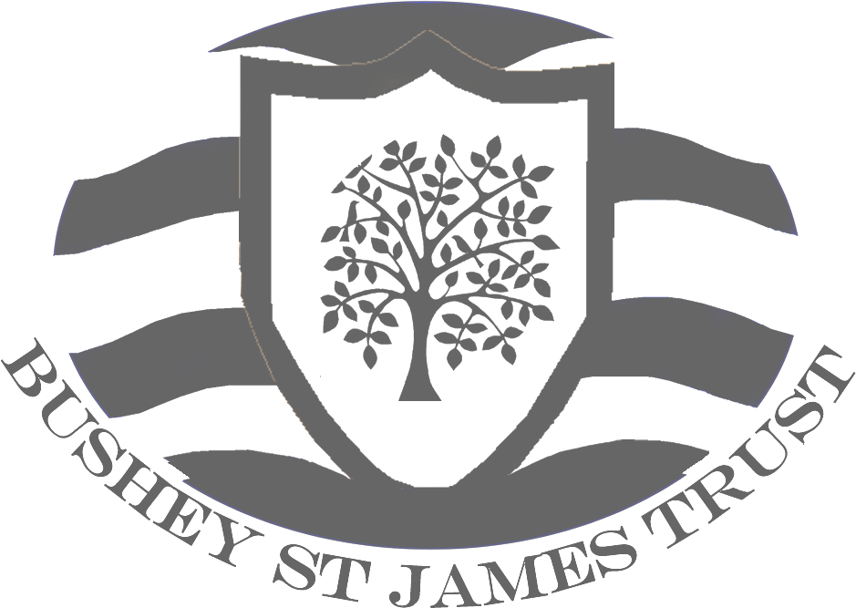


Bushey Meads School

Bushey Meads School (BMS) is an 11-18, oversubscribed, successful mixed comprehensive specialist technology school at a very exciting time in its development. It is part of the Bushey St James Trust, an innovative and exciting Multi-School Academy Trust established in February 2012 with Little Reddings Primary School and now comprising three schools including Hartsbourne Primary School who joined the MAT in December 2017. It is committed to continuous improvement and creativity across The Trust.

We celebrate the comprehensive nature of the school by realising the potential of our students through science & technology and subjects across our varied curriculum offer. Our commitment to this lies at the heart of our school. Within our inclusive, strong, family ethos staff guide the personal development of all our students and ensure they are challenged to reach their potential. Aspire to Achieve is our school motto and we are committed to providing a high quality learning environment for all, at the same time committed to a real culture of character development, underpinned by our mantra ‘Our School has a Mind to Be Kind’.

As the newly appointed Executive Principal from September 2014, I lead a school which had been through a period of relative instability prior to my appointment and yet one that has a very proud history of excellent results and outstanding care for students; a school with huge potential for further success at the highest level. A renewed focus on the core business of teaching and learning, combined with a drive to raise achievement at all levels has strengthened a culture across all areas of the school in which all students can aim to achieve their potential and indeed Aspire to Achieve. Our current school improvement trajectory is ‘Embedding Greatness’ and we are confident that, with our well thought out plans and strong collaborative culture, this will be achieved over the next few years. An exciting time to join our school!

The school population consists of students from a broad range of abilities and backgrounds. BMS is a truly comprehensive school which has an excellent local reputation for its support for all children including those with Special Educational Needs. The school has historically had a BASE unit which has accommodated up to 20 students with severe Physical and Neurological Impairments, one of only three in Hertfordshire LEA.

This year we are developing our Learning Support provision further with a £1.3 million investment to create a Specialist Resource Provision (SRP) for up to 20 pupils with an Education Health and Care Plan (EHCP) with social communication difficulties, including autism. The aim is to become a centre of excellence in Hertfordshire, able to support local schools and colleagues across the county in this area.

Student outcomes at GCSE and AS and A2 level have risen rapidly over the last few years and since 2015 we have celebrated our ‘best ever’ results and maintained this year on year. At GCSE over 93% of students pass with at least five good A* - C GCSE grades and the school’s positive ‘Progress 8’ Score indicates that on average in every subject, every student is achieving well above their expected level.

Results at A level are also very good and indicate that we are continuing to add real value to students’ education. With some of our inspiring courses, students achieve almost two grades higher than their aspirational target grades. Students across all subjects celebrate on A level results day as they gain hugely prestigious places at some of the country’s top universities and on highly sort after apprenticeships.

The school was rated as Good with Outstanding features by Ofsted in September 2015 and in March 2019, under the new framework, the school was judged to be Good but having sufficient evidence of improved performance to suggest that the school may be judged Outstanding if it received a Section 5 inspection. This view was confirmed in November 2019 when after a rigorous two-day inspection, the school gained no less than two outstanding judgements for Personal Development and Sixth Form Provision.

Our well-maintained school site lends itself to creating a real family atmosphere and many visitors to the school comment on the outstanding behaviour of our students and excellent pastoral care. Staff morale is high, the atmosphere in the school is very positive and students’ work and behaviour in and around school reflects this. The 1250 students come from a wide range of socio-economic backgrounds and their abilities are across the full spectrum. Over 15% of our students have Special Educational Needs and about 13% have English as a second or other language. Some 22% of our students qualify for free school meals.

Over the past three years we have invested massively in developing the school site with over £6.5 million providing a whole variety of brand new inspiring learning spaces across the school community. These include new English classrooms, a refurbished and extended Learning Resource Centre which is at the hub of our school, new office spaces and meeting rooms, a Professional Learning Area for staff (complimenting the inspiring staffroom) state of the art Performing and Visual Arts spaces (including an inspiring theatre environment in our Main Hall with raked seating, industry standard sprung dance floor, full lighting and PA rig, as well as an additional brand new theatre space for Drama teaching and performance), new Science Labs, a superb Music Block and recording studios, outstanding Sixth Form Study Centre and Sixth Form Café, refurbished Pastoral Care Centre, facilities for our PE & Health Faculty, a state of the art Multigym, new Sensory and Medical Rooms for our Learning Support Faculty and a major refurbishment and large extension for the School Restaurant.

We have established partnerships with many external organisations and agencies including other secondary and primary schools, Middlesex University and the Local Authority. We have a very strong and supportive Trust and Governing Body who take an active part in the life of the school – taking assemblies, linking with curriculum areas and being fully involved in moving the school on in its journey of school improvement, for example by attending joint SLT/Governors strategic planning meetings throughout the year.

In December 2017 our Trust expanded to welcome a second primary school to our learning community - Hartsbourne Primary School. We have been really excited about the additional learning opportunities that this has provided and are looking forward to strengthening further the very good links that already exist across the three schools and also with other schools in the local area.

As a school and across the Trust we rightly expect high standards from both staff and students, but equally look after our best assets – the people who work here. Professional development and resources for staff are a priority and our strong ethos and culture of achievement supports this aim.

In September 2018 we opened our ‘Little Gems’ BSJT Day Nursery which offers high quality, heavily subsidised term-time childcare for children of all staff within the Bushey St James Trust. For further information about the BSJT Little Gems Day Care Nursery please contact Rachael Coombs, BSJT Business Manager, through the HR Team on 020 8955 8833. For all staff working across the Trust we also offer a full induction and free Gym membership for our on-site ‘Body Mind Soul’ Gym.

Our Learning Resource Centre is a real learning hub in the middle of our superb school; students love working in the LRC from 8.00 am until 5.00 pm and many make use of the high-tech facilities and inspiring work space during both break and lunchtimes. Glass walls, motivational display for learning, state of the art computers and flat panel screens create a university type environment with a choice of rooms for students to access.

Weekly reading lessons in the LRC for Year 7 and 8 students have had a major impact in the last few years in establishing and fostering a love of reading throughout the school and many of the students’ inspirational book reviews are proudly on display around the LRC and contained within their reading folders.

Across our expanding Sixth Form, many of our older learners choose to work in the LRC during their private study periods and comment on the purposeful atmosphere, conducive for independent working. Our LRC is also made available in the 10 weeks prior to the GCSE and A Level examinations for our popular Study Saturdays and is seen as one of many key drivers for raising achievement at KS4 and 5, complimenting all the additional subject specific revision classes offered across the school.

This outstanding career opportunity is ideal for a talented and ambitious person who wishes to extend their skills at a school that is both innovative and an incredibly rewarding place to work. There is likely to be opportunity for both professional and future career development for the right candidate over the coming months. As a school we have been described as a vibrant learning community and are ranked as one of Hertfordshire’s top 10 most popular schools (School Guru 2018 – 19).

Application

If, having read the enclosed information, you feel you would like to contribute to Bushey Meads’ ongoing success then the Trustees, Governors and I would be delighted to hear from you.

Please submit

- A letter of application stating your proven experience, showing evidence of the outcomes of your work and how you could make a significant contribution to the future success of the school.

- A completed application form.

You can post your application or submit it by email to: hr@busheymeads.org.uk

Jeremy Turner
Jeremy Turner
Executive Principal

