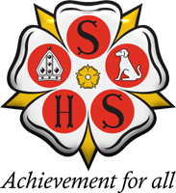 | 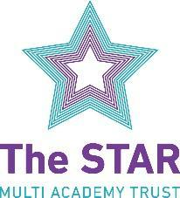  Sherburn High School  Headteacher: Ms Miriam Oakley  Garden Lane, Sherburn In Elmet, Leeds, LS25 6AS  Tel: 01977 682442  Web: www.sherburnhigh.co.uk Email: admin@shs.starmat.uk

Pastoral Support Assistant with Midday Supervisory Assistant (MSA) duties
36.25 Hours per week with MSA duties at lunchtime
Permanent - Term Time Only
Monday – Friday 8.15am till 4.15pm
Required from September 2021

Pastoral Support Assistant – Grade C point 2-4 (£14,199 - £14,772)

Are you an inspirational and enthusiastic individual who is looking to develop your skills with a new challenge?
Due to career progression there is an exciting opportunity for a well-qualified and highly effective person to gain experience and support our forward- thinking team in the Inclusion and Support Unit.

We are looking for someone with initiative, creativity and excellent people skills. Are you up for the challenge?

MSA – Grade B point 2 (£1,028)

Required to supervise students during their lunch break. This may also involve working outdoors.

Job descriptions, person specifications and application packs can be downloaded from our website at www.sherburnhigh.co.uk and emailed to recruitment@shs.starmat.uk

Potential applicants are encouraged to contact the school if further information is required. Please contact Ruth Marsh on 01977 682442 or by email on ruth.marsh@shs.starmat.uk

Closing date: 9am Monday 11th October 2021

Interviews to be held: Thursday 14th October 2021

Sherburn High School is a friendly, top performing and innovative school set in an attractive position in the North Yorkshire rural village of Sherburn in Elmet, which is only 10 minutes from the A1(M) hence making it easily and quickly accessible from Leeds, York, Doncaster, Bradford, Pontefract and the surrounding areas.

Enhanced DBS clearances and references will be obtained prior to appointment.

Sherburn High School is committed to safeguarding and promoting the welfare of children. We welcome applications from all sections of the community; we appoint on merit.

Sherburn High school is part of The STAR Multi Academy Trust which is an exciting new venture strengthening our existing partnership with other local schools.

Age range 11-18 mixed comprehensive with Sixth Form Current NOR 826
.
The STAR MAT is committed to equality, and to making fair and equitable treatment an integral part of everything we do.

The Trust is committed to safeguarding and promoting the welfare of children and expects all staff to share this commitment. The post is subject to a successful DBS check and pre-employment checks will be undertaken before an appointment is confirmed.

If you require assistance in applying for this position please contact us on 01977 687969.

