Junior Class Teacher - September 2019
  - Information for Candidates about the role and the School: A Guide to Nottingham High School
Table of Contents
Nottingham High School 2
The Infant and Junior School 4
Job Description for a Junior Class Teacher at the Infant and Junior School 7
Benefits of Service 12
Safeguarding and Child Protection at Nottingham High School 14
Selection Process 15

Nottingham High School

The High School is an independent day school (HMC), founded in 1513, which relocated to the Arboretum in 1867 and become co-educational from 2015. A Junior School was established in 1905, moved into new accommodation in 1978 and admitted infants in September 2008.

The High School foundation includes the Infant and Junior School (ages 4 – 11) with over 260 pupils. The Senior School selects for entry at age 11+ and 16+. There are over 500 pupils in the Senior School including a vibrant Sixth Form of over 200. The school’s move to co-education has been a great success with approximately 180 girls in School during the third year of co-eduaction.

The High School has a strong reputation for outstanding academic results and for its pastoral care and it achieved the best examination results in the region in summer 2017.

The High School is a school of national reputation, the Headmaster having membership of HMC, the Infant and Junior Head membership of IAPS. Staff from cluster groups of local independent schools and national large day schools meet annually.

The School has an extensive pupil catchment and is first choice for much of Nottinghamshire, Derbyshire, Lincolnshire and Leicestershire. The School operates a number of coaches to transport pupils.

Pupils come from a wide range of backgrounds and the School is committed to maintaining a representative entry, supporting with generous bursary and scholarship funds. Together, these mean that about a fifth of pupils receive some form of financial assistance.

Entry is by competitive assessment in the Spring Term.

The Future

The person appointed will be joining a dynamic innovative school. Staff are keen to embrace new methods and technology. The website www.nottinghamhigh.co.uk contains links to Twitter accounts for various parts of the school.

Each of the parts of Nottingham High School has a comprehensive development plan for the future.
In the last few years, the School has undergone a number of developments of varying sizes as a result in growth in pupil numbers. The most recent being the extensive, ambitious extension to the Junior School which will add additional classrooms, a new library, a Sports Hall and offices to our facilities.
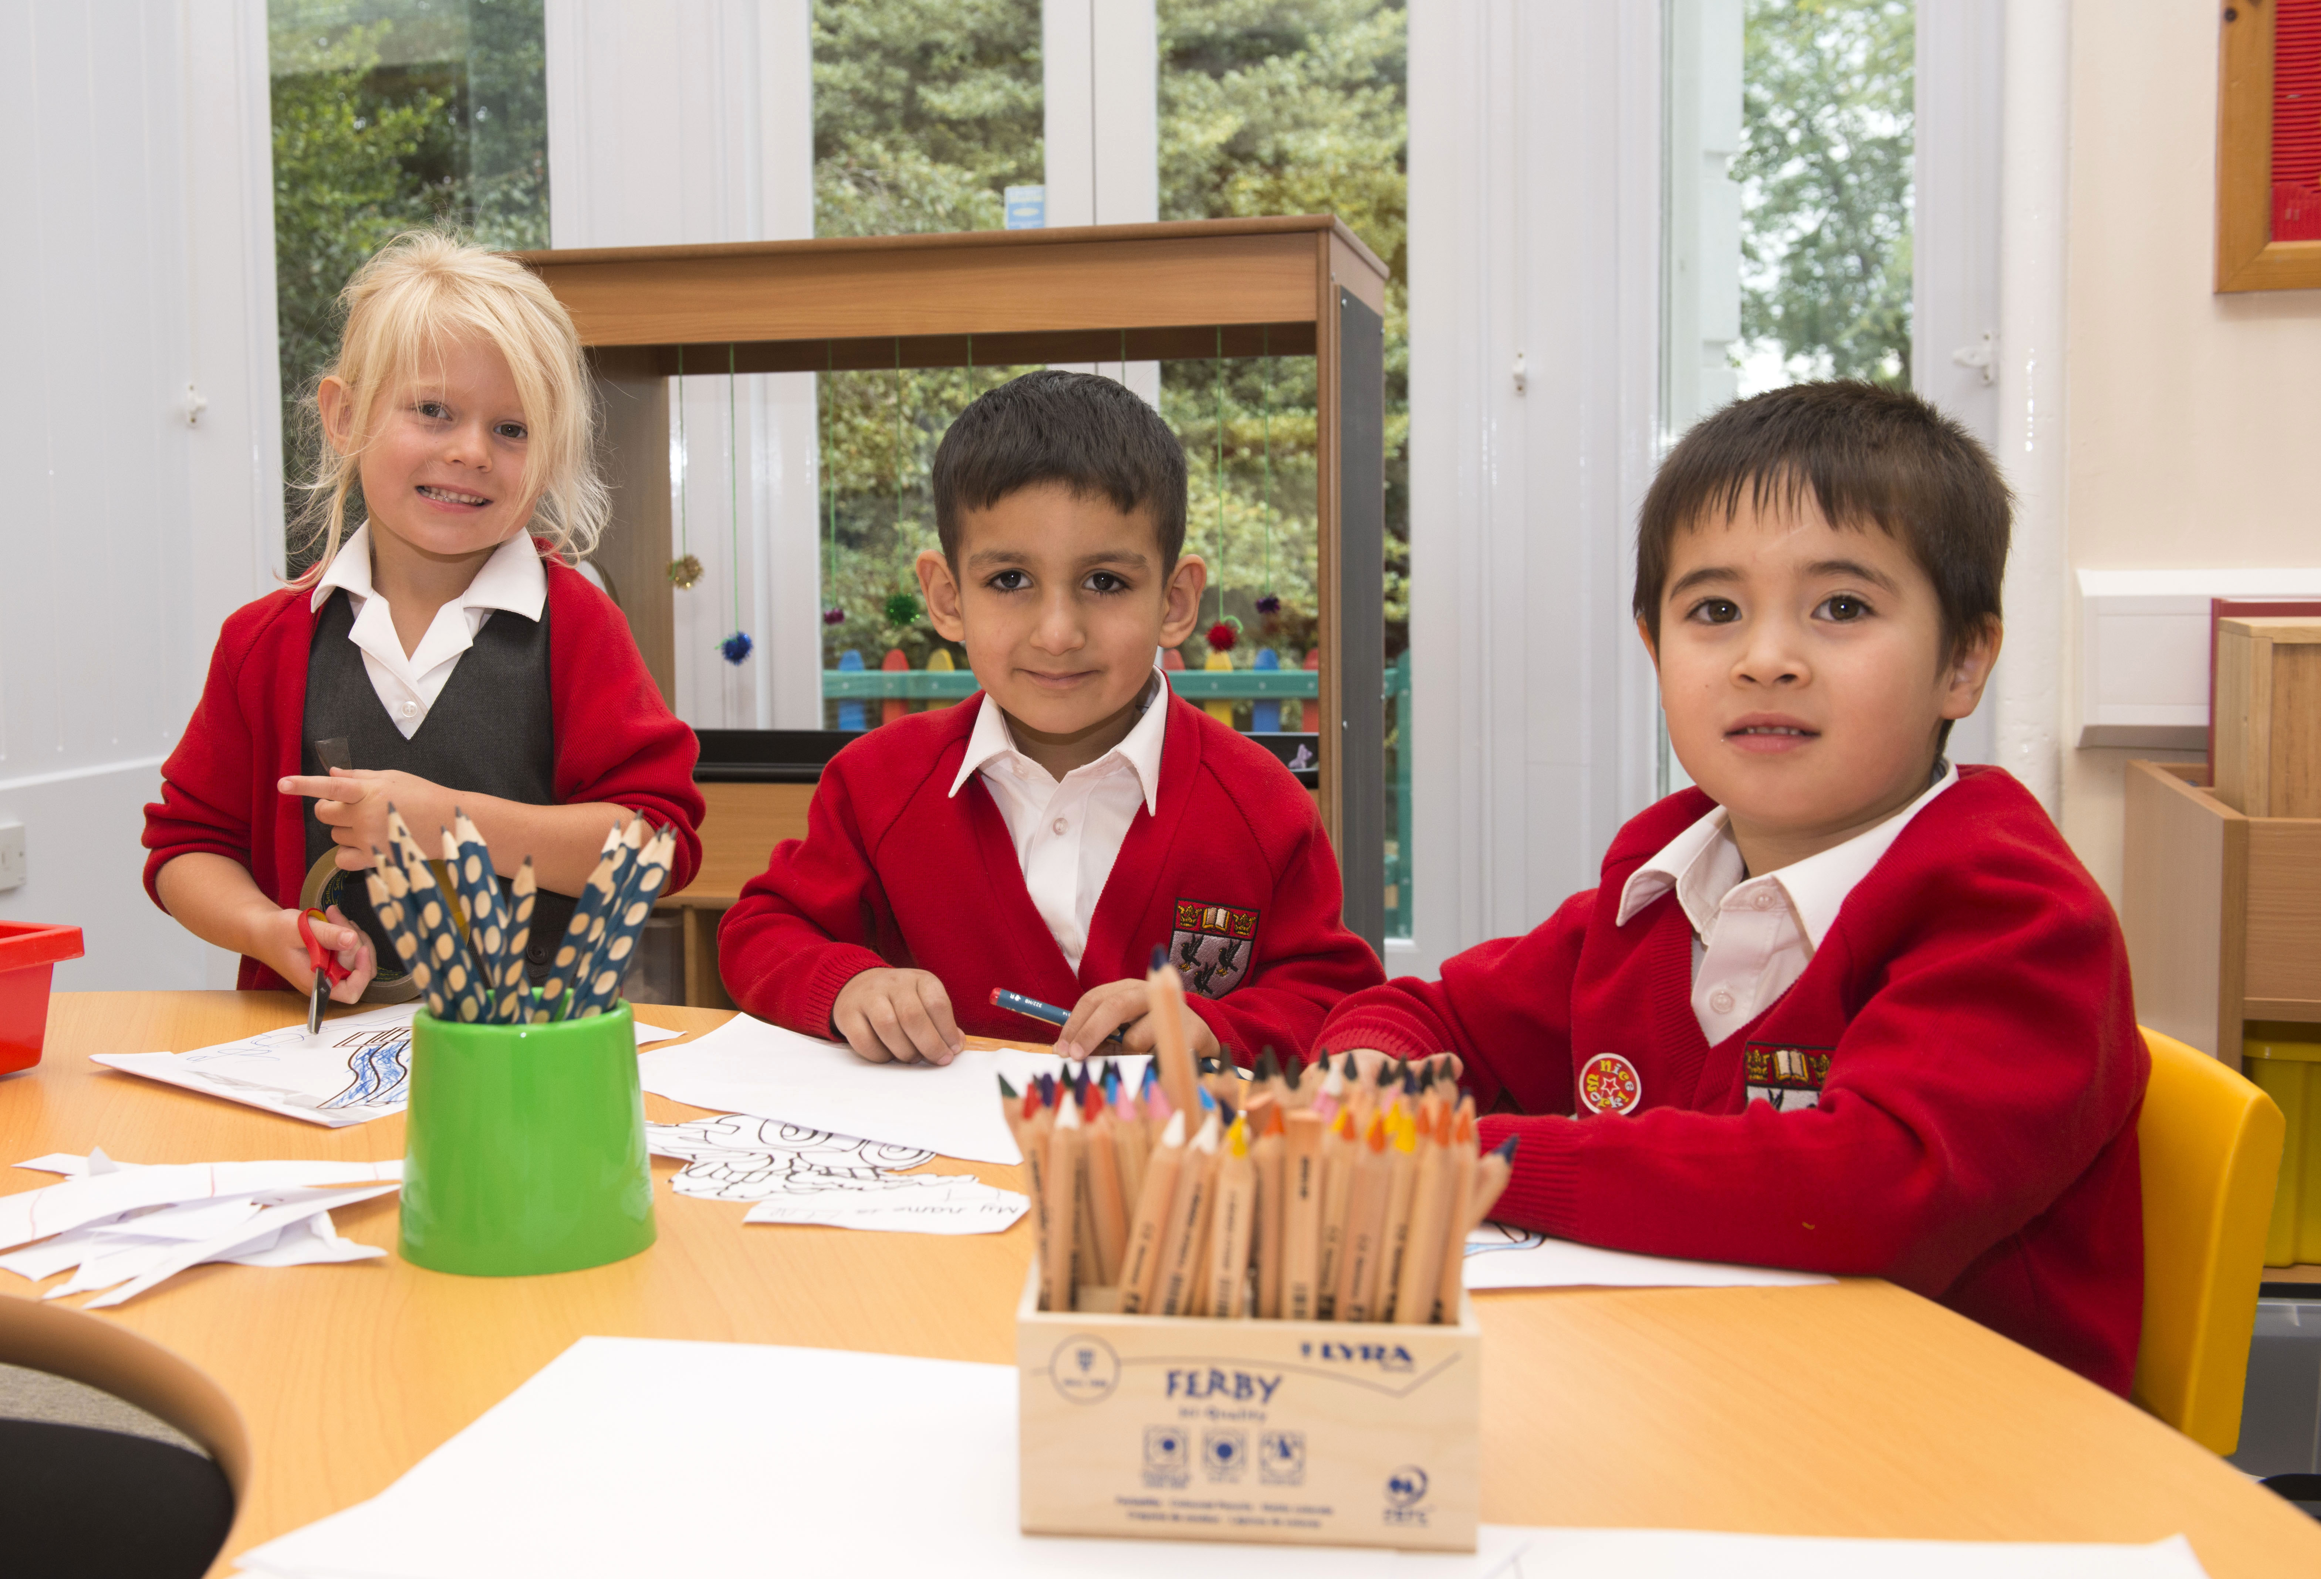

The Infant and Junior School

Aims
Nottingham High Infant and Junior School is a selective school, with high academic, cultural and sporting standards, which aims to develop each pupil’s potential and personality to the full.
The Infant section focuses on Early Years and Key Stage One education, and the Junior section Key Stage Two.
In both age ranges we aim to work in a caring, stimulating environment, providing a friendly, welcoming, yet efficient atmosphere where education is tailored to pupils’ learning needs and is relevant and changing. We encourage each child’s development and promote their confidence, social responsibility, self-worth and integrity, as well as their talents and range of interests. Staff encourage enough freedom to build self-esteem and trust, whilst maintaining stability and individuality.

Entry
The main entry point is at the age of four for Reception, although pupils can join in other years if there are spaces available. At all stages, entry is by an assessment process which is held in the Spring Term. Any entry to the School is considered on individual merit based on criteria including standardised tests.
The majority of the pupils come from a wide range of background and the School is committed to maintaining entry from the state and independent sectors.

Curriculum
The Infant and Junior School follows many parts of the National Curriculum, but as an independent school, there is freedom to broaden the learning for all pupils. The curriculum is taught in a creative way with a lot of hands-on learning and the use the impressive outdoor area.
The Infant Section follows the National EYFS curriculum and the National Curriculum for Key Stage 1 in Years 1 and 2. The emphasis is on literacy and numeracy with more of a topic-based approach in the afternoons. All infant pupils swim, enjoy games lessons, PE lessons, as well as music and modern foreign language lessons. Years 2 and 3 also have chess tuition. There are a number of enrichment activities designed to extend the pupils’ learning.
In the Junior School, the curriculum is broad-based to include the National Curriculum subjects as well as Computing, Drama, French, Spanish, PE, Swimming and Games. On one afternoon a week, pupils are based at the High School’s Valley Road Playing Fields as part of our games’ programme.

Trips and Visits
It has long been our belief that the learning process is greatly enhanced by well-organised purposeful and constructive trips. Every effort is made to encourage links between the world of the classroom and world outside. Each year group enjoys one visit each term to enhance pupil experience. These are predominantly day trips both local and further afield.
In the Junior School, an annual residential trip supports academic study as well as personal and social development.

Co-Curricular
There is an extensive range of co-curricular activities for infants and juniors. An example of the range of activities that we provide for our pupils would be a wide variety sports and music clubs, dance, knitting, Chess and film clubs. Junior School staff are expected to contribute to the extra-curricular programme.
Junior pupils benefit from many fixtures with both state and independent schools. From Reception, each child is affiliated to a ‘House’ in which they stay for their time at Nottingham High School.

Facilities
The Infant section occupies its own site across the road from the Nottingham High School campus. The building has its own hall, music room, art room, ICT suite and dining room as well as an impressive EYFS setting. Infant pupils use some of the sporting facilities of the Senior School campus, including the swimming pool. The Infant section is fortunate to have a developed, secure school garden to enable the pupils to play and learn outside.
The Junior School occupies the western part of the Nottingham High School site in purpose built accommodation, built in 1978, further developed in 2012 and again in 2017/8 with its own specialist teaching facilities in science, computing, art and design, and its own sports hall. The Junior pupils use the Senior School swimming pool and sports fields, at Valley Road.
We feel that the dual site arrangement helps to provide nurturing and supportiveness and the best educational experiences and facilities for all our pupils. The secure enclosed site for Early Years and Key Stage One provides an almost entirely self-contained, safe accommodation and the Junior building on the main school site helps to provide specialist teaching facilities and close links to the excellent facilities of the Senior School.

Staff
There are around 30 teachers who work only at the Infant and Junior School, and they are supported by teaching assistants, administrative and support staff.

Job Description Class Teacher at Nottingham High Infant and Junior School

Teaching:
- To be fully responsible for the physical, emotional, spiritual, moral and academic education for the pupils under their care.
- To provide a broad, balanced and relevant curriculum according to the school guidelines, recognising the various needs, interests and abilities of the pupils.
- To plan and prepare lessons in order to best deliver the Nottingham High School Curriculum ensuring breadth and balance in all subjects.
- To identify clear teaching objectives and learning outcomes, with appropriate challenge and high expectations.
- To maximise the learning of all pupils by ensuring effectual differentiation of learning activities and effective use of support staff.

Assessing and Reporting:
- To keep careful and accurate records of pupil progress (both formative and summative assessments) using our online pupil progress tracker.
- To ensure work is regularly marked in accordance with Nottingham High Infant and Junior School Assessment Guidance.
- To build a strong home school partnership and be available for consultation and liaison with parents at all reasonable times as well as at termly Parents’ Evenings.
- To formally report to parents by means of interim and yearly written reports.

Pastoral:
- To share with colleagues the responsibility for the supervision and welfare of all the children in the Infant and Junior School.
- To promote high expectations of behaviour and implement the Infant and Junior School behaviour policy.
- To take an active part in our assemblies programme.
- To take an active part in our extensive co-curricular and trips and visits programme.
- Support and contribute to the school’s responsibility for safeguarding students.
- Work within the school’s health and safety policy to ensure a safe working environment for staff, students and visitors.

Professional Responsibilities:
- Work towards and support the school vision and the current school objectives outlined in the School Development Plan.
- To participate in staff meetings and to help to plan, to contribute to and take part in in-service training.

- To participate in the Nottingham High School Appraisal arrangements for the review of her/his performance.
- To be prepared to continually update practice and participate in professional development opportunities.
- Maintain high professional standards of attendance, punctuality, appearance, conduct and positive, courteous relations with students, parents and colleagues.
- Undertake other reasonable duties related to the job purpose required from time to time.
Other
- To participate in the extra-curricular programme and wider life of the school.

Benefits of Service

Professional Opportunities and Career Development
The High School believes in, supports and resources an extensive system of continuing professional development and all teachers and non-teaching staff participate in it throughout their careers. The School has developed an Appraisal Scheme for teaching staff. Each member of staff has a Line Manager with whom they have Professional Review or appraisal meetings for their individual personal development. In this case, the relevant Phase Leader is the line manager.
Working Environment
This is an enjoyable and stimulating place to work. Staff Rooms are provided where complimentary tea, coffee, fruit and biscuits are provided during the day. Lunch is also provided during term-time in our Dining Hall and other food outlets. There are also a series of social events during the year for teaching and support staff to enjoy. Many of the facilities of the School are open to staff and their families, including the swimming pool.
The School is on the Nottingham Tram system with its own ‘High School’ tram stop. Employees who have children in the School currently benefit from some remission of fees in accordance with School policy, at the discretion of the Governors and are subject to amendment or withdrawal at one calendar year’s notice.
Living in Nottinghamshire
Good quality housing in Nottinghamshire and the surrounding counties is affordable and as a result many of our teaching staff have a good choice of areas to live in and experience a good quality of life. Most live within a twenty-minute commute of school. There are many attractive villages surrounding the city in which staff choose to live as well as a good stock of suburban housing in the city. In the centre of the city there has been considerable development of high quality apartments.
As well as the facilities which would be expected of a city with two universities, Nottingham boasts the Royal Concert Hall and two theatres.
Conditions of Service
This is a full time post. The successful candidate will be expected to contribute to the extra-curricular programme and wider life of the school.

Safeguarding and Child Protection at
Nottingham High School
Nottingham High School is totally committed to doing all it can to ensure the safety and wellbeing of all its pupils.
A comprehensive policy document, ‘Child Protection at Nottingham High School’ is published on the school website via the following link:
http://www.nottinghamhigh.co.uk/welcome/policies/child-protection-policies/
All adults who work at the School must recognise that there is an absolute duty to respond to any issues that are brought to their notice and as such, this post is subject to an enhanced DBS check. The post holder’s responsibility for promoting and safeguarding the welfare of children for whom s/he is responsible, or with whom s/he comes into contact will be to adhere to and ensure compliance with the School’s Child Protection and Safeguarding Policy at all times. Any safeguarding concerns must be reported to the School’s Designated Senior Lead.
Training in safeguarding children is given to new members of staff and covers essential issues such as:
- Definition of Child Abuse.
- Typical Indicators of child abuse.
- Details of what an adult must do if a child wishes to make a disclosure of abuse.
- The procedure for recording a disclosure.
- The need to discuss any Child Protection concerns with the appropriate Designated Senior Lead (DSL) without delay.
- The requirement to lodge any ‘Record of Child Protection Concern’ with the (DSL) immediately.
- An outline of how the work of the DSL relates to the City and County Safeguarding Children Boards.
The DSL for the Infant and Junior School is the Head, Mrs Clare Bruce.
Phone: Direct 0115 8452211/2283 or internal 211/283
Email: bruce.ca@nottinghamhigh.co.uk
The DSL for the Senior School is the Deputy Head (Pastoral), Miss Lisa Gritti.
Phone: Direct 0115 845 2206 or internal 206
Email: gritti.l@nottinghamhigh.co.uk

Selection Process
Equal Opportunities
The High School seeks to recruit individuals of the highest calibre. We welcome applications from all sections of the community. The High School recognises its responsibility to treat equally each person who comes into contact with the School.
All members of the School are equally valued so that they can develop a sense of self-esteem. No-one is discriminated against because of actual or imagined differences.
This policy applies to both staff and students, and it is the responsibility of all staff to promote practices which overcome prejudice in our society.
The Application Process
Candidates should complete their application form electronically and email it to teach@nottinghamhigh.co.uk addressed to Clare Bruce, Head of Infant and Junior School. There is no need to submit a CV.
Application Form
- Applications will only be accepted from candidates completing the enclosed Application Form in full. CVs will not be accepted in substitution for such forms.

- Candidates should be aware that all posts in the School involve some degree of responsibility for safeguarding children, although the extent of that responsibility will vary according to the nature of the post. Accordingly, this post is exempt from the Rehabilitation of Offenders Act 1974 and therefore all convictions, cautions and bind-overs, including those regarded as ‘spent’ must be declared.

- The successful applicant will be required to complete a Disclosure from the Disclosure and Barring Services at the appropriate level for the post.

- We will seek references on shortlisted candidates and may approach previous employers for information to verify particular experience or qualifications, before interview.

- If you are currently working with children, your current employer will be asked about disciplinary offences, including disciplinary offences relating to children or young persons (whether the disciplinary sanction is current or time expired), and whether you have been the subject of any child protection allegations or concerns and, if so, the outcome of any enquiry or disciplinary procedure. If you are not working with children but have done so in the past, that previous employer will be asked about those issues. Where neither your current nor previous employment has involved working with children, your current employer will still be asked about your suitability to work with children, although a current employer may, where appropriate, answer not applicable if your duties have not brought you into contact with children or young persons.

- You should be aware that provision of false information is an offence and could result in the application being rejected or summary dismissal if the applicant has been selected and possible referral to the police and/or DfE Children’s Safeguarding Operation Unit.
Invitation to Interview
If you are invited to interview this will be conducted in person and the areas which it will explore will include suitability to work with children.
- The interview process for this role may include the requirement to teach a lesson, coach a games session or to undertake relevant activities.

- All candidates invited to interview must bring documents confirming any education and professional qualifications that are necessary or relevant for the post (e.g. the original or certified copy of certificates, diplomas etc.) Where originals or certified copies are not available for the successful candidate, written confirmation of the relevant qualifications must be obtained from the awarding body.

- We will provide full information about the documents to confirm identity required for those invited to interview. Please note that originals of these documents will be required. Photocopies or certified copies will not be sufficient.
Conditional Offer of Appointment: Pre-Appointment Checks
Any offer to a successful candidate will be conditional upon:
- receipt of satisfactory references (if these have not already been received)
- verification of identify and qualifications
- evidence of the right to work in the UK
- a Barred Check List
- a satisfactory Enhanced DBS disclosure (original certificate must be shown to school staff) and Staff Suitability Self-declaration
- verification of professional status such as QTS Status (where required)
- (for teaching posts), verification of successful completion of statutory induction period (applies to those who obtained QTS after 7 May 1999)
- a check of the list of teachers prohibited from the profession
- where the successful candidate has worked or been resident overseas in the previous ten years, such checks and confirmations as the School may require in accordance with statutory guidance
- verification of medical fitness in accordance with DfE Circular 4/99 Physical and Mental Fitness to Teach of Teachers and Entrants to Initial Teacher Training
- satisfactory completion of the probationary period
Warning
Where a candidate is:
- found to be on DfE list 99 or the Barring List, or the DBS disclosure shows s/he has been disqualified from working with children by a Court: or
- found to have provided false information in, or in support of, his application or
- the subject of serious expressions of concern as to his/her suitability to work with children the facts will be reported to the Police and/or the DfE Children’s Safeguarding Operation Unit.
Applications should sent electronically to teach@nottinghamhigh.co.uk no later than 10 am on Wednesday 20th March. Interviews will take on Friday 29th March 2019.
Applications (by email) to:
teach@nottinghamhigh.co.uk
Nottingham High School  Waverley Mount  Nottingham NG7 4ED |  | 0115 978 6056 |  | info@nottinghamhigh.co.uk  www.nottinghamhigh.co.uk

