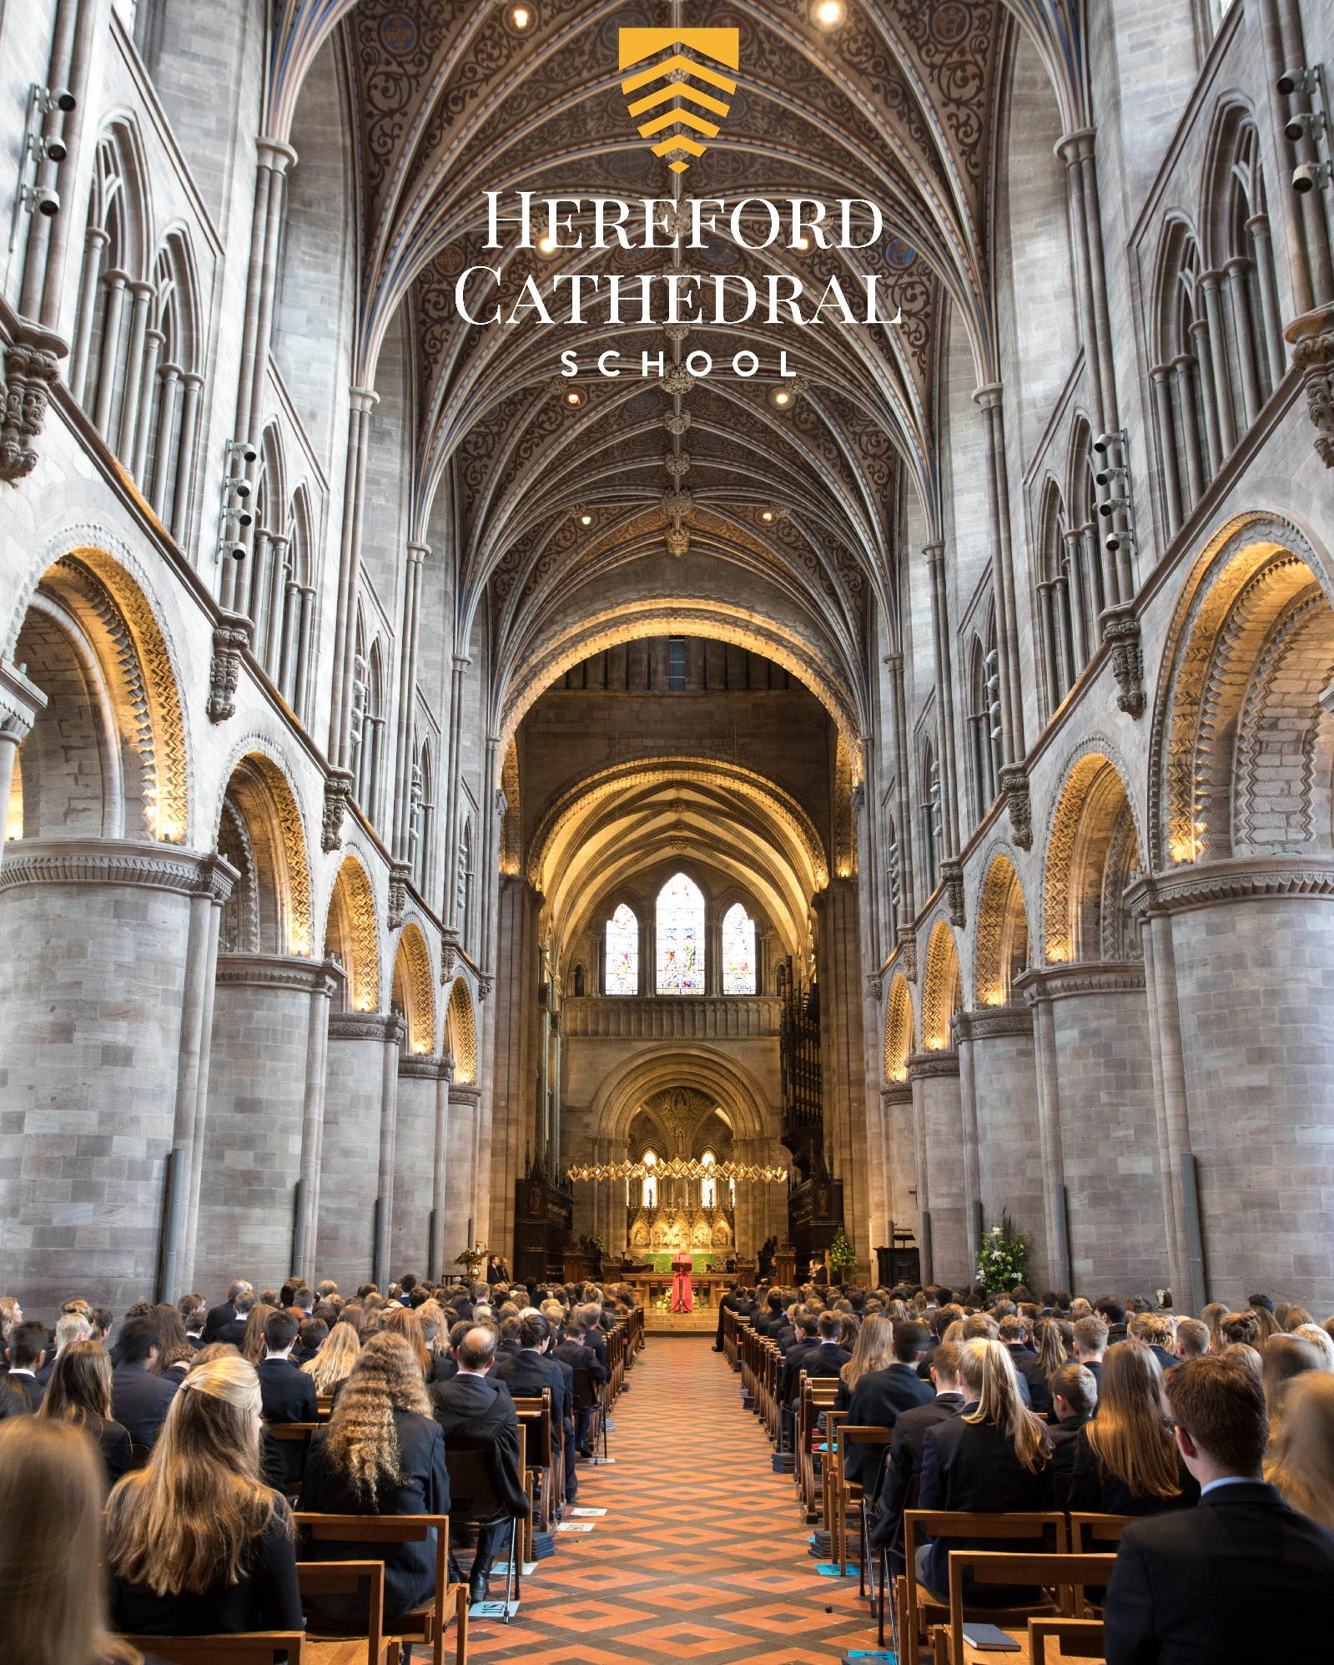

Teacher of Mathematics
Candidate Information Booklet
HEREFORDCS.COM
01432 363511

Welcome

Welcome
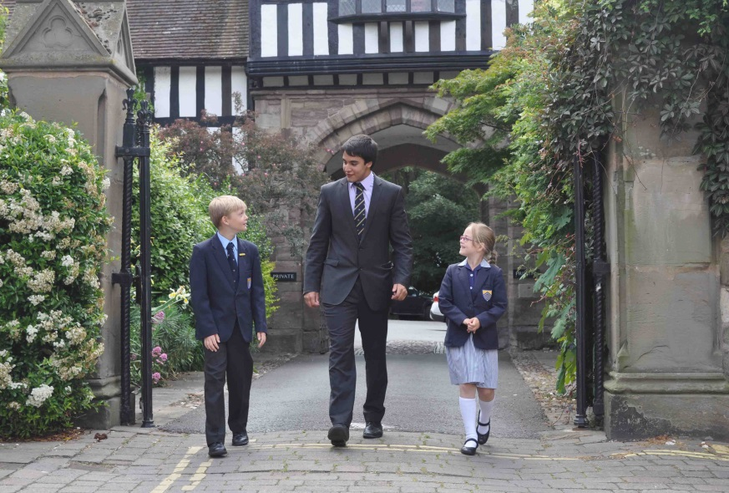
Thank you for your interest in working with us at Hereford Cathedral School. I hope that this information booklet will help provide you with some insight into our Cathedral School, Hereford city, and the outstanding county in which we are privileged to be located.

From our three year-olds in Nursery to our 18 year-olds in the Sixth Form, we seek to meet the specific needs of every pupil – providing stretch and challenge in the classroom and a wide variety of opportunities to develop individual interests, skills and self-esteem.

Alongside our small class sizes, excellent results and the outstanding range of opportunities on offer, we feel that our greatest strength lies in our friendly, family, inclusive ethos, encouraged by excellent staff pupil relations and a highly supportive parent body. It is this ethos, widely recognised as a special characteristic of the school, which enables pupils, young and old, to excel both in and out of the classroom.

The school is one of the UK’s leading independent co-educational day schools. We also benefit from the finest of settings, adjacent to a beautiful Cathedral and within a stone’s throw of the thriving city centre.

This is an exciting time in the development of the school and all of our teaching staff play their part in helping the school provide a lively, enriching and relevant curriculum.

I hope that the information provided in this pack gives you a sense of what to expect at Hereford Cathedral School and helps you to decide whether you might be interested in working with us. Please feel free to contact me directly if you have any further questions.



Paul Smith,
Headmaster

“Justifiably growing more self-assured, a school with a great deal to offer and an ethos of careful, thoughtful, nurture. Much to impress, with truly outstanding arts and music, a wide curriculum, a great sense of community service and genuine commitment to developing courage, confidence and a sense of adventure in even the quietest child.”

The Good Schools Guide Review 2013 of Hereford Cathedral School

Aims, Ethos & Vision

We provide boys and girls aged 3 to 18 with an excellent standard of teaching and individual care, offering them a broad range of opportunities to develop every aspect of their potential. The Hereford Cathedral School culture produces well-balanced, confident and considerate young adults ready for the wider world.

We seek:

- To meet pupils’ academic and personal needs and to promote the acquisition of moral values.
- To provide an environment in which pupils feel valued and learn to work co-operatively in a community.
- To provide a balanced, appropriate and challenging curriculum and a wide range of extra-curricular opportunities.
- To encourage pupils to achieve their academic potential and to foster a climate in which teaching and learning of high quality are given central priority.
- To ensure a high degree, within and outside the formal pastoral structure, of personal care, support and guidance.
- To respond to pupils’ aspirations and to be attentive to those of parents, and to their views.

As part of an ancient Cathedral foundation, and as a Choir School, which has the privilege of a Cathedral as its chapel, we are a Christian School in the Anglican tradition, although we welcome and value those of other denominations and faiths. Each pupil is encouraged to consider seriously and openly the Christian tradition within which the School is founded.

We place great value on maintaining close, constructive communication with parents and seek to establish the education of each pupil as a joint endeavour. While the academic development of each pupil is a central objective of both the school and the parent body, we seek, through example and ethos, to prepare our pupils for life beyond school by developing certain qualities and values. These include: self-discipline, diligence, acceptance of responsibility and challenge, regard for proper authority, honesty, courtesy, fairness, trustworthiness, loyalty, and sensitivity to the needs and views of others, courage, and the capacity to look to the future.

Our aim is to fulfil our charitable status through service to the local community by support for Cathedral choristers, charitable fundraising, the loan of buildings and other services to the community. Through competitive fee levels and the award of choristerships, scholarships, and bursaries, the pupil body reflects a wide cross-section of the local population.

A Brief History

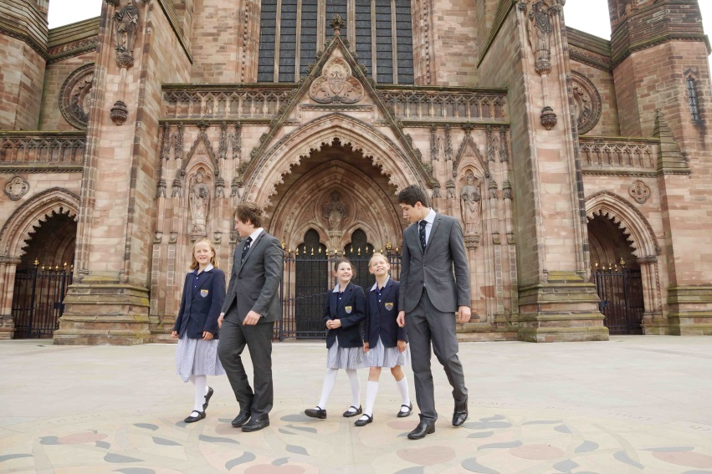
Hereford Cathedral School is amongst the oldest schools in the United Kingdom and is thought to have been founded as a song school attached to Hereford Cathedral in Anglo-Saxon times. The first written reference of the School dates back to Bishop Gilbert’s letter of 26th December 1384 appointing Richard of Cornwall as Headmaster.

The Junior School (formerly Hereford Cathedral Preparatory School) is also equally rich in history and was founded in 1898, moving to its current location in 1925.

Life at the School

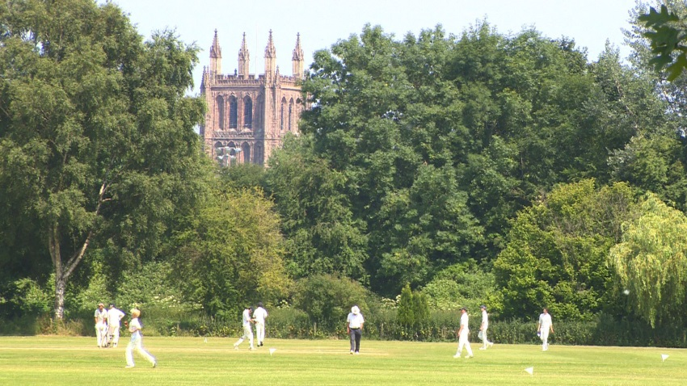
We are very much a family school, catering for pupils from age 3 to 18. Many of our pupils have siblings at the school, and in some cases their parents were here too. Pupils and parents are very loyal and supportive of ‘their’ school. We have a reputation for outstanding pastoral care and as a result pupils are remarkably tolerant and understanding of one another. It is important to us that every child is valued within our community. Good academic results are not enough: we seek to provide young people with the necessary skills and self-confidence to become well rounded, balanced adults who will make a positive contribution to those around them.

As a Cathedral School we expect pupils and staff to be sympathetic to our Christian ethos, although we welcome and value those of other faiths too.

“The children, from the nursery class eagerly talking about their book choices in the school library, to the reception children, busy with puzzles and problem solving, to Year 4s enthusiastically reciting poetry, are the best possible advertisement for the school. Each child we spent time with was friendly, relaxed, happy and engaged. Bouncing about full of things to talk about. You can pretty much hear their little brains fizzing. A delightful place to start exploring life’s possibilities.”

The Good Schools Guide Review 2013 of Hereford Cathedral Junior School

The Curriculum

Our curriculum is well planned, wide ranging and enriching. Its balance and focus on individual development, helps us to stimulate an enquiring mind, establishing key skills and a wealth of experience in our pupils that will be of great benefit to them for the future.

Whole School A Level Results: (of all grades)

 | % A* grade | % A*/A grades | % A*-B grades | % A*-C grades
2017 | 25 | 49 | 70 | 90
2016 | 16 | 45 | 73 | 87
2015 | 23 | 55 | 80 | 93
2014 | 19 | 48 | 76 | 93
2013 | 16 | 52 | 76 | 91

Whole School GCSE Results: (of all grades)

 | % A* grade | % A*/A grades | % A*-B grades | % A*-C grades
2017 | 22 | 55 | 82 | 95
2016 | 28.2 | 56.7 | 81 | 95
2015 | 35.3 | 58.3 | 77.3 | 87.2
2014 | 32 | 59 | 82 | 94
2013 | 35 | 63 | 84 | 97
“Pupils’ success is the result of teaching of high quality within a broad and interesting curriculum, which includes many trips and talks from visitors, as well as the provision of a wide range of extra-curricular activities.”

ISI Integrated Inspection 2014 of Hereford Cathedral Junior School

Maths at Hereford Cathedral School
The Maths Department at Hereford Cathedral School consists of a team of six happy, co-operative mathematicians. The pupils are enthusiastic and polite; it is a pleasure teaching Maths at Hereford Cathedral School.
Recent achievements and activities of note include wholesale participation in Alan Turing Cryptography Competition (80 teams this year), twice reaching the National Final of the UKMT Team Challenge (21st and 15th positions) in the last five years and a typical take up of over 50% at A Level with a healthy Further Maths set. A significant number of pupils go on to read Mathematics at University (last year at Trinity, Cambridge and St Catherine’s, Oxford).
The Department runs an Outreach programme for local primary schools including lectures, INSET and competitions.
The post will include opportunities to teach mathematics from Year 7 to Year 13 Further Maths for a suitable candidate.
Maths
Maths is a subject which should be enjoyed by all. Happy pupils learn faster and the team of enthusiastic maths lovers in the Department will support, stretch and encourage pupils during an exciting five years (or more!).
The Department believes that pupils should be happy to come to their Maths lessons and has the following aims: to teach pupils at a level at which they experience success but are frequently challenged. To extend the most able pupils and support those who require it and get the best out of every individual pupil.
Maths is taught in sets based on ability: the most able are accelerated with a view to early entry for GCSE. The programme of study is the same for all groups, which are taught at the same time, enabling movement between sets when appropriate. The Maths Department follows The Centre for Innovation in Mathematics Teaching course (www.cimt.org.uk).
GCSE
The setting in GCSE years ensures that all pupils are given the best possible chance to fulfil their potential. Regularly the most able take GCSE at the end of Year 10 and then study for AQA Level 2 in Further Mathematics. The majority take GCSE at the end of Year 11. Maths is taught exclusively by subject specialists who aim to communicate their love of the subject. The Maths Department expects all pupils to pass their GCSE Maths (9 to 4).
A Level
The School takes full advantage of the flexibility in the MEI A Level Mathematics scheme to offer everything from AS Mathematics to two A Levels in Maths and Further Maths with support for STEP, MAT, TMUA et al! At Hereford Cathedral School, Maths is a popular choice at A Level and results are outstanding. The use of both traditional and electronic resources is encouraged, in order to produce independent learners.

ISI Integrated Inspection 2014

Main Findings | ISI Grading: HCS | ISI Grading: HCJS
The quality of academic and other achievements and learning:
- The quality of the pupils’ achievements and learning | Excellent | Excellent
- The contribution of curricular and extra-curricular provision | Excellent | Excellent
- The contribution of teaching | Excellent | Excellent
The quality of the pupils’ personal development:
- The spiritual, moral, social and cultural development of the pupils | Excellent | Excellent
- The contribution of arrangements for pastoral care | Excellent | Excellent
- The contribution of arrangements for welfare, health and safety | Excellent | Excellent
The effectiveness of governance, leadership and management:
- The quality of governance | Excellent | Excellent
- The quality of leadership and management, including links with parents, carers. | Excellent | Excellent

HCS: Hereford Cathedral School / HCJS: Hereford Cathedral Junior School
ISI use a four point grading scale when making judgements of quality, these are ‘Excellent’, ‘Good’, ‘Sound’ or ‘Unsatisfactory’.

“Staff know the pupils well and create a happy, friendly atmosphere, in which the pupils feel safe, secure and supported. They provide a high standard of help, guidance and monitoring, valued by the pupils and parents.

ISI Integrated Inspection 2014 of Hereford Cathedral School

A beautiful city, culture and a taste of tranquil countryside
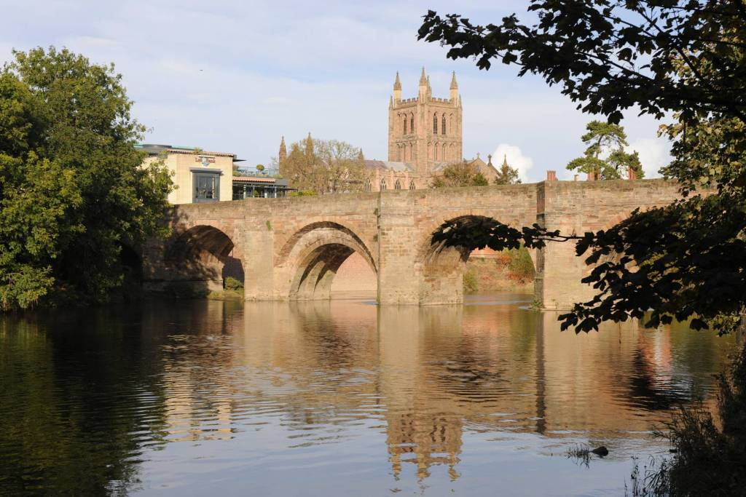
As a school we are fortunate to enjoy a position at the very heart of a fine cathedral city, at the centre of one of England’s least spoiled counties.

Hereford and the county beyond - with a range of housing to suit all tastes and price brackets, and ready access to beautiful countryside - affords an enviable quality of life. The River Wye flows past our doorstep through the city down to the Forest of Dean, while the Brecon Beacons, the Malvern Hills, Hay-on-Wye, with its internationally-acclaimed literary festival, and Ludlow, famous for its food festival, are all within easy commuting distance.

Hereford itself also offers a wide-range of independent eateries, great places to eat and drink; a new Odeon and a great shopping centre. Commuting is easy with great transport links to London, Birmingham and Cardiff.
A city renowned for its wonderful music, Hereford was also home to the composer Elgar for a significant period in his life. The cathedral and school play host to the Three Choirs Festival every three years, and everyday choral music of the very highest standard can be enjoyed at Evensong. For those with a more eclectic taste, the county is home to a host of talented musicians who regularly perform at venues and festivals across the region. It is little wonder that many people who have visited Hereford on holiday choose to settle in the area permanently.
www.visitherefordshire.co.uk

House Prices in Hereford (taken from www.rightmove.co.uk, 17.01.18)

Last year most property sales in Hereford involved semi-detached properties which sold for on average £196,241. Terraced properties sold for an average price of £160,973, while detached properties fetched £290,181.

Hereford, with an overall average price of £200,868, was similar in terms of sold prices to nearby Credenhill (£204,230), but was cheaper than Lugwardine (£265,714) and Fownhope (£232,105).

During the last year, sold prices in Hereford were 3% up on the previous year and 5% up on 2015 when the average house price was £191,767.

“Pupils are an absolute delight – very supportive of one another, articulate and appreciative. Comfortable in their own skin, but not full of themselves. Extremely positive about the School and proud of their achievements, but no trace of entitlement or arrogance – if they are a little on the quiet side one gets the impression that this is the result of not having to shout in order to be heard.”

The Good Schools Guide Review 2013 of Hereford Cathedral School

Quick Facts:

Hereford Cathedral Junior School (Head of Junior School: Mr Chris Wright)
28 Castle Street, Hereford HR1 2NW
Tel: 01432 363511, Email: enquiry@herefordcs.com, Website: www.herefordcs.com

Type: Day/Co-Education
Age Range: 3 to 11 years
Roll: 226 pupils
Fees: £2,624 to £3,373 per term
Inspection: ISI – Excellent in all areas (2014)
Affiliation: IAPS

Hereford Cathedral School (Headmaster: Mr Paul Smith)
Old Deanery, The Cathedral Close, Hereford HR1 2NG
Tel: 01432 363522, Email: schoolsec@herefordcs.com, Website: www.herefordcs.com

Type: Day/Co-Education
Age Range: 11 to 18 years
Roll: 486 pupils
Fees: £4,536 per term
Inspection: ISI – Excellent in all areas (2014)
Affiliation: HMC, CSA

“Parents are overwhelmingly positive and supportive of the School, and are very happy with the education their children receive.”

ISI Integrated Inspection 2014 of Hereford Cathedral Junior School

The Role: Teacher of Mathematics
September 2018

Location: Hereford Description: Full time

Hereford Cathedral School seeks to appoint an outstanding Teacher of Mathematics for September 2018.

This is an exciting opportunity to join a happy, successful department and teach Maths right across the age and ability range. The post will suit a high-calibre Mathematics graduate, either an NQT or more experienced teacher, with the enthusiasm, energy and commitment to really support, stretch and encourage their pupils.

Results at GCSE and A-Level are consistently excellent. The post will include opportunities to teach mathematics from Year 7 to Year 13 Further Maths for a suitable candidate.

The School was inspected by ISI in 2014 and graded “excellent” in each of the eight categories.

Hereford Cathedral School has a well-established and thriving extra-curricular programme, and the successful applicant will be expected to play an active part in this.

An application form and information pack may be downloaded from the school website www.herefordcs.com/job-vacancies. Completed applications should be accompanied by a covering letter and sent to Cath Knowles, HR Department, Hereford Cathedral School, Old Deanery, The Cathedral Close, Hereford HR1 2NG or to c.knowles@herefordcs.com.

The closing date for applications is Midday on Wednesday 7th February 2018 with interviews scheduled for Wednesday 14th February 2018

The School is committed to safeguarding and promoting the welfare of children and young people and expects all members of staff and volunteers to share this commitment. Appointments are subject to enhanced DBS clearance and satisfactory employment references and other safer recruitment checks.

Registered in Cardiff No 2081261 (Limited by Guarantee)
Registered Charity No 518889


Job Description: Teacher of Mathematics

Post Title | Teacher of Mathematics  Based at Old Deanery, The Cathedral Close, Hereford HR1 2NG
Work pattern | Full time
Salary | Competitive

Purpose of this Job Description:
Hereford Cathedral School considers this document as a “snapshot” of the job and the tasks listed are not an exhaustive list. It aims to provide a clear guide at the time of writing to all that is involved about the requirements of the job. It will also be used to communicate expectations about performance and will be used to monitor effective performance.

The job description which follows may, occasionally, be reasonably amended by the Headmaster:

The Organisation
Hereford Cathedral School is one of the UK’s leading independent co-educational day schools. Providing boys and girls aged 3 to 18 with an excellent standard of teaching and individual care, offering them a broad range of opportunities to develop every aspect of their potential. The Hereford Cathedral School culture produces well-balanced, confident and considerate young adults ready for the wider world. We also benefit from one of the finest settings, adjacent to the beautiful Cathedral. We enjoy an air of tranquillity within a stone’s throw of the thriving city centre.

The School is committed to safeguarding and promoting the welfare of children and young people and expects all staff and volunteers to share this commitment.
Further information from http://www.herefordcs.com

Reporting Lines:
The post holder reports to the Head of Department.

Accountabilities:
- To contribute to the Mathematics Department by carrying out the professional duties of a teacher.
- To maintain the department’s strong academic record.

Responsibilities:
- To teach mathematics and deliver an inspiring, challenging and balanced curriculum to students that supports the subject areas, in line with National Teaching Standards.
- To assess, record and report on the development, progress and attainment of pupils.
- To liaise with the Head of Department to ensure a coherent programme of study for pupils.
- To maintain good standards of behaviour amongst students, both when they are on School premises and when they are engaged in authorised School activities elsewhere.
- To participate in the development of the department and contribute to the departmental and overall School aims and objectives.
- To take part in the School’s professional development programme and take responsibility for your own professional development. Actively seeks to reflect on and enhance your own practice.
- To maintain appropriate records and provide relevant and accurate information for information systems to ensure that all records are up-to-date.
- To provide pastoral support to pupils as a form tutor or similar role as required.
- Undertake whole school duties as outlined annually including parents’ evenings.
- To support through involvement, the School’s co- and extra-curricular activities.
- Safeguard and promote the general well-being of pupils and to be a role model for pupils at all times.

Safeguarding and Protection of Children and Young Persons
In accordance with the Children’s Act 1989, on appointment post holders will be required to commit to their responsibilities with regards to safeguarding. In addition, offers of appointment will be subject to an Enhanced criminal record check from the Disclosure and Barring Service (DBS).

These checks will highlight cautions, reprimands and final warnings as well as any convictions. The post holder must not have any spent or unspent convictions that would prevent them from working with children.

Staff must inform the school if they are subject to criminal investigations or convicted while in the employment of the School.

Health and Safety:
As an employee you are expected to:
- take reasonable care of your own health and safety
- take reasonable care not to put other people - fellow employees and members of the public - at risk by what you do or don't do in the course of your work
- co-operate with your employer, making sure you get proper training and you understand and follow the company's health and safety policies
- not to interfere with or misuse anything that's been provided for your health, safety or welfare
- report any injuries, strains or illnesses you suffer as a result of doing your job
- tell your employer if something happens that might affect your ability to work (e.g. becoming pregnant or suffering an injury)
- if you drive or operate machinery, to tell your employer if you take medication that makes you drowsy

Particular H&S issues for this post are:

 | Person Specification
 | Essential Criteria | Desirable Criteria
Qualifications | Strong academic record: evidence of success at A-level and degree level  Degree level qualification  Evidence of involvement in relevant CPD | Master’s degree or above  Qualified Teacher Status  Other relevant professional qualifications
Experience and Knowledge | Excellent knowledge and understanding of the curriculum and a passion for the subject.  Knowledge and experience of lesson planning, use of resources and assessment.  Understanding of the theory and practice of effective teaching.  Knowledge of Safeguarding and Child Protection of Young People | Experience of creating a positive learning environment for pupils.  Development of schemes of work  Successful teaching at secondary/sixth form level (can be teaching practice)  Worked effectively as a form tutor
Skills/Abilities | Build and maintain relationships through effective interpersonal skills  Strong organisational and administrative skills  Excellent communication skills to  inspire, challenge, motivate and empower others  Think creatively to anticipate and solve problems  Inclusive approach to education  Ability to manage own time effectively  Good IT knowledge in Microsoft Office applications to include Word, PowerPoint, Excel. | Motivate and inspire confidence in pupils, staff, parents, governors and the wider community in order to further develop and promote the school  Ability to deliver feedback effectively.
Aptitude | Naturally demonstrates a ‘can do’ helpful attitude  Work under pressure, maintaining a sense of perspective and humour  Reliability and integrity  Resilience and tenacity  Commitment, honesty and dedication  Shares the School’s values and vision and committed to the School’s vision for learning experience and outcomes for pupils.
Circumstances | Able to work flexibly, some earlier starts, evenings and weekends will be required.  A strong commitment to support the School’s extra-curricular activities programme.
Safeguarding Children, Young People and Vulnerable Adults | Understands their role in the context of safeguarding children, young people and vulnerable adults  Ability to form and maintain appropriate relationships and personal boundaries with children and young people
Equal Opportunities | Understanding of the requirements of Equality and Diversity

Declaration
I have received a copy of this job description and undertake to carry out the duties as described.

Employee Signature ………………………………………….Date……………………………..

Print name ……………………………………………………………………………………………………

