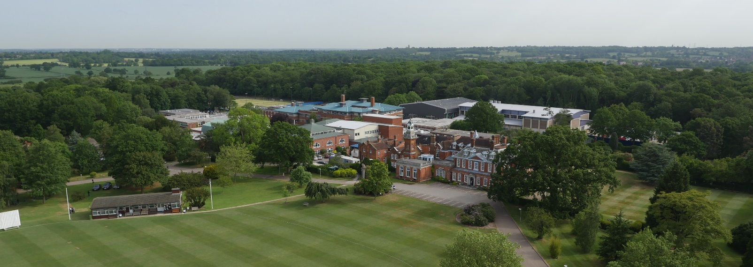

Head Theatre Technician – Drama

Full-time
40 hours per week – Up to £31,064

The Drama department at Haberdashers’ is a vibrant and enjoyable place to work. We are looking to recruit someone to support the Drama Department to meet the technical and production requirements across all areas of our work and to oversee the running and management of performance spaces and support with training pupils in the use of some technical equipment.

Applications
If you wish to discuss this post informally, please contact Mr Richard Weinman, Head of Performance Drama on (+44) 0208 266 1808.
An application form is available from the School’s website: www.habsboys.org.uk. Curriculum Vitae are not accepted.
The completed application form should be sent to the Human Resources Department (staffvacancies@habsboys.org.uk) as soon as possible (preferably electronically).
Closing Date: 8am on 24th May 2019.
We intend to interview for this post on Thursday 6th June 2019

The School
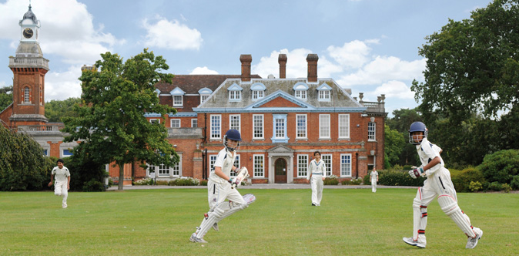
The Haberdashers’ Aske’s Boys’ School (‘HABS’) has an international reputation for academic excellence and success, combined with exceptional pastoral care and extra-curricular achievements.
The School is an independent day school with around 1,200 11–18 year old boys in the Senior School and another 200 boys from the age of 7 in the Preparatory School, which is situated on the same site. A Pre-Prep School for 75 boys aged 5 and 6 is located in nearby Park Street. The School’s grounds adjoin those of its sister school, the Haberdashers’ Aske’s School for Girls and an extensive and long-established coach service brings pupils and staff from across a wide area.
HABS moved to its current 100-acre rural location in 1961, occupying the grounds of a former stately home: Aldenham House, a Grade 2* listed building, located 15 miles North of the centre of London. A series of magnificent new buildings have been opened in the last decade including a new £13m Sports Facility in 2016. The construction of a state-of-the-art classroom complex at the heart of the campus, specifically designed to reflect international best practice in school design and pedagogy will open in 2018/2019.
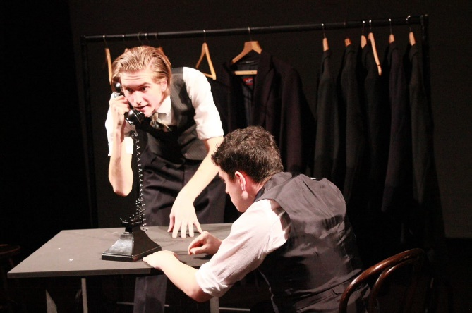
HABS’ aim is to nurture excellence within its established values of wisdom, integrity and humility. The most recent ISI inspection report (2012) graded the School as outstanding in all aspects. The members of the teaching staff are united by a caring approach, passion for their subject areas and the aspiration to be dynamic, modern and reflective practitioners.
Examination results are outstanding placing the School 7th in the UK League tables; places are heavily oversubscribed; and entry is extremely competitive. Boys achieve national prominence in many fields from music, drama and sport to science and Mathematics Olympiads, chess and public speaking.
The current intake of boys is exceptional, also graded as Excellent in the ISI inspection report, and the School has been placed at the top of the national league tables. Education at HABS, however, is about more than just academic success. The boys are bright, articulate and open, interested and extremely rewarding to teach. They have a great sense of humour and are very well mannered.
Pastoral care is exceptional, with a strong House-based system. Out-of-class activities abound, with many boys assuming responsibility for the running and organisation of events and societies. Music, drama and sport are strong, and there is also a thriving Outdoor Leadership programme and CCF together with a strong and active Community Service programme. HABS’ boys regularly reach the finals of national competitions, such as chess, bridge and debating, but there is also a remarkable commitment to outreach and charity work, reflecting the rich and harmonious ethnic and religious diversity of the School. A Church of England School by tradition, other religious communities flourish with popular, voluntary assemblies on Thursday mornings for the many different faith groups which are represented in the School. This approach to all faiths was highly commended in the current ISI inspection report.

The School awards a number of scholarships on entry, but the majority of its funding goes into the provision of bursaries for cases of financial need. A very successful Development Foundation exists to broaden participation in the life of the School and encourage philanthropic giving.

More detailed information about the School and its history is available on the School website: www.habsboys.org.uk and through the Good Schools Guide www.goodschoolsguide.co.uk

The Drama Department
The Drama department is an exciting and invigorating place to work, surrounded by engaged and passionate subject specialists and those with current industry experience and backgrounds. Drama at HABS is at an exciting and ambitious stage, aiming to make a wide-ranging programme of work, including new writing, devised work, creative adaptations and more established plays. There is a strong focus on creativity and process, whilst aiming to make innovative professional standard work that would sit alongside the best young peoples’ theatre in the country. We regularly collaborate with professional writers, directors, choreographers, puppeteers and video designers to support our work.
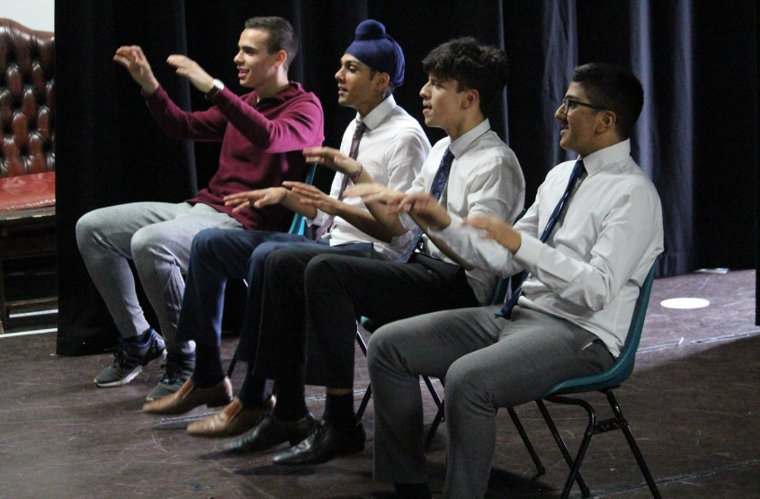

Departmental Facilities
The Drama department offers a flexible 120 seat black box studio space and 700 seat main performance space with modern lighting and sound systems and full fly system. The School is currently planning a new building project, which would incorporate a new studio space and rehearsal room.
Departmental Staff
The Department is friendly and informal, with high standards and a general readiness for creativity, innovation and collaboration. It is always keen to respond to individual interests and enthusiasms.
At present, there are 7 members of the department, with 4 Drama teachers supported by a full-time Director of Performance and the Graduate Director and Production Assistant. In-service training is encouraged, and teachers regularly attend courses and conferences.
Drama Curriculum
AQA is used for both GCSE Drama and A-level Theatre Studies classes.
We always aim to stretch all students beyond the confines of the exam curriculum.

The Role
Responsible for supporting the Drama Department to meet the technical and production requirements across all areas of our work and to oversee the running and management of performance spaces and the training of pupils. This is also an opportunity for an individual to creatively feed in to the work we are producing.

Responsible to:
Head of English & Drama with day to day responsibility to the Head of Performance Drama
Hours:
Average of 40 hours per week, with the need for flexibility based on the School performance calendar, to include evenings and weekends.
Major responsibilities:
- Practical daily management of all performance spaces
- Supervision and maintenance of all technical equipment, resources and props across Drama facilities
- Overseeing the rigging of lighting in performance spaces.
- To provide technical support for all School productions and academic practical pieces.
- Designing the lighting for school productions and collaborating with the Head of Drama on set design.
- Co-ordination and production of set -building, liaising with maintenance departments and external companies
- Training of pupils in sound, lighting, stage management and set construction.
- Co-ordination of SCS groups involved in stage management, lighting, audio visual, costume and props. Liaison with staff and departments involved in these activities.
- Liaison with the Estates Manager on any maintenance requirements
- To advise on technical equipment, especially lighting, sound and Audio Visual required by the School in the main public areas.
- Support for other departments, i.e. music school concerts, prep school productions, charity events.
- The ability to support students taking design skills for the practical section of their GCSE/A Level exams.
- Health and Safety for areas of responsibility

Personal Requirements
We are looking for a dynamic theatre technician with experience of providing quality support of theatre productions in terms of lighting, sound audio visual and set. In addition to technical skills the successful candidate will also demonstrate creativity, innovation and a desire to collaborate.
Key Requirements:
- 3 years’ experience or degree equivalent experience in the theatre industry
- Excellent knowledge of IT systems and software
- Design, building and crewing experience on productions
- Up-to-date knowledge of lighting systems, lighting control apparatus, lighting equipment and its maintenance, refurbishment and use
- Up-to-date knowledge of digital audio and audio-visual equipment and its use as it relates to both live, recorded and playback techniques
- Experience of adhering to Health and Safety regulations and procedures
- Excellent interpersonal and communication skills
- Ability to manage and support students of technical theatre
- Experience of working with young people is desirable but not essential
- Ability to work independently
- Good organisational skills and ability to work under pressure.
- A full, clean UK driving licence would be useful but not essential

Support Staff Salary and Benefits
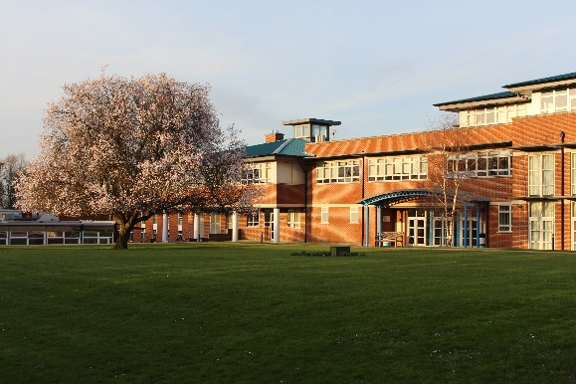
The School has its own generous salary scale. The salary for the successful candidate will depend upon their qualifications and experience and will be discussed at interview.
Candidates should note that all appointments are subject to an enhanced check with the Disclosure & Barring Service and references from past employers.

Benefits
Currently the School offers a wide range of benefits to staff, including:

- A strong commitment to professional development, with a substantial budget for whole school training and individual courses. Support is given for sabbaticals, post-graduate degrees and other relevant qualifications;
- Enrolment into the School’s pension scheme, with 12% employer contribution, based on 5% individual contribution
- Group Life Assurance (4 x salary);
- Fee Remission of up to 66% for each eligible child at the Boys’ and Girls’ Schools who is offered a place; pro rata for part time staff
- Childcare Vouchers; where eligible
- Free lunches, other meals and refreshments;
- Free parking on the School campus;
- Free coach travel on the service provided by the School (subject to availability);
- Tax free bicycles for work through the Cycle to Work Scheme;
- Free use of the state-of-the-art Medburn Centre including fitness suite, swimming pool and squash courts, including free training programmes and advice from the School’s Fitness Coach;
- Access to the School Counsellor.
- Free lunch provided
- Employee Assistance Programme

We look forward to receiving your application.

Gus Lock
Headmaster

