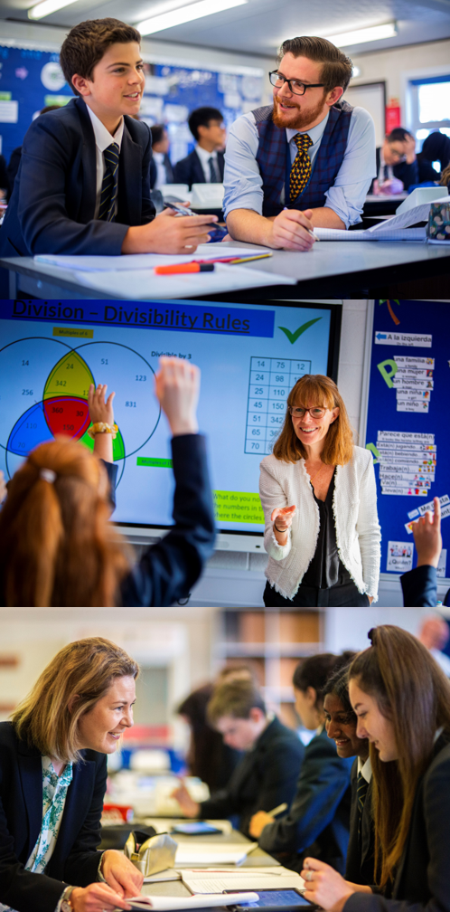
TEACHER OF RELIGIOUS EDUCATION

Starting your Salesian journey
Salesian
Enlightening minds, uplifting hearts

Celebrating 100 years of Salesian Education 1919-2019

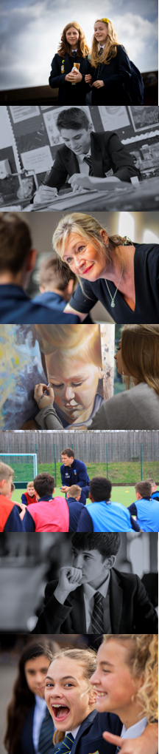
Teacher of R.E. Appointment – Information for candidates
To commence: January 2020
Salary: Main Scale / Upper Pay Spine (+TLR for those seeking additional responsibility)
Closing date for applications: 21st November 2019
Salesian School is seeking to appoint an exceptional individual to teach R.E. We welcome applications from trainee teachers and experienced colleagues alike, including those looking for positions with additional responsibility. If you are energetic, enthusiastic and love teaching children then we’d be delighted to hear from you. We are always happy to meet potential applicants prior to interview; please don’t hesitate to contact us if you would like any further information or to visit the school.
James Kibble
Headteacher
jkibble@salesian.surrey.sch.uk

The Religious Education Department at Salesian
We look forward to welcoming you to our Religious Education Department.
Religious Education is a key department at Salesian and we work together with Chaplaincy to develop the academic, spiritual and moral life of our students. We are enthusiastic, engaging and proud to work with the vision of St. John Bosco. Our connection to Don Bosco and the Salesian community are evident throughout the whole school. His vision to educate to a high standard, instil moral value and foster positive experiences both inside and outside of the classroom is supported and furthered by our department.

Housed in six specialist rooms, including one at the college site, the RE department consists of a team of eight specialist teachers. RE's place at the core of the school is further enhanced by the additional roles of these staff which include; a deputy headteacher, two teaching chaplains, and the assistant SENCO. The department also has co-coordinators for Key Stages 3 and 4.
Collaborative teaching and mutual support are key to the workings of this enthusiastic department. The department regularly trains teachers both from its own SCITT and from other providers. We when receive visits from those outside our school community, they often comment positively on the quality of the learning, the behaviour and the engagement of students.
For Key Stage 3, the department delivers its own carefully planned in-house scheme of work. In Key Stage 4 all students complete AQA B (Themes and Judaism) GCSE with just under 40% achieving 9-7 grades. We have large take up at A level where we offer AQA 'Philosophy and Ethics' to around 50 students across four groups. Last year over 60% of our A level students achieved A*-B grades. All students in the college undertake Sixth Form R.E. within which the EPQ is completed. All three key stages have a complete set of shared lessons and resources.

In the spirit of Don Bosco, the founder of the Salesian order, RE offers many trips and experiences outside of lessons. These include: a trip to Rome, A level conferences, retreat days for Key Stage 3, trips to places of worship, and a visit from a local Rabbi.
We are extremely proud of our department at Salesian and look forward greatly to welcoming a colleague who is as passionate about the progression of our students both academically and spiritually, as we are.
David Legrand
Head of Religious Education
dlegrand@salesian.surrey.sch.uk

Salesian School is committed to safeguarding and promoting the welfare of children. Enhanced CRB checks will be sought prior to appointment

Appointments at Salesian

Information for Candidates
Thank you for your interest in the positions currently being advertised at Salesian School. I would like to take this opportunity to share some thoughts with you.
Salesian is a co-educational 11-18 Catholic comprehensive school and part of the Xavier Catholic Education Trust. The school ethos is based on the work of Don Bosco, a Salesian priest. Community and great relations are central to our work. As a consequence, both students and staff are happy, positive and enjoy their time at school.
Standards at the school are outstanding and students achieve exceptionally well. In last year’s GCSE examinations 90% of students gained five or more standard passes including English & Maths and our Progress 8 was +0.95. The pass rate at A’ level was 100% with 66% A*-B grades.
The school has 1650 students and is situated on two sites approximately one mile apart, near to the centre of Chertsey. The main school is situated at Guildford Road and our Sixth Form College has 350 students on its own site at Highfield Road.
A great deal of emphasis is placed on extra-curricular life at Salesian and outside the formal curriculum there are numerous opportunities for students to take part in a wide range of activities - drama, sport, music, exchanges, away days, Duke of Edinburgh, retreats and trips.
We work hard to ensure that staff and students are well looked after but we also set exceedingly high expectations of everyone at the school and underperformance is always challenged. When you get the balance right between challenge and support you get great teaching, when you have great teaching the school becomes heavily-oversubscribed and when this is the case parents believe in what you are trying to do and support you in doing it. All of this results in us having the privilege of working with children who are, on the whole, an absolute delight!
Our last Ofsted Inspection was in September of 2013 when we were judged to be “outstanding” in all categories. We were obviously delighted with this recognition and are all very proud of our achievements which are a great tribute to the staff and students who have worked so hard to enable us to reach this point.
Salesian was designated as a Teaching School in September 2014 in recognition of our track record of success in training teachers and supporting schools in difficulty. The Teaching School offers a range of exciting opportunities for staff to engage in professional development and school-to-school support activities and from 2015 we have been accrediting our own trainee teachers as part of the Teach South East SCITT partnership.
Regardless of all this, we don’t think we’ve got it cracked; the challenge now is to keep improving on what we do. Are you the person to help us continue on this journey?
Candidates are welcome to contact the school to find out more information about specific departments or pay us a visit. We take recruitment very seriously and want to do all we can to find the best staff for our students.
The ideal candidates will be energetic, enthusiastic, ambitious and excellent practitioners. We would expect at least two years’ hard work and good service. In exchange we will prepare you for the next step in your career.
I believe Salesian is a fantastic place to work and I am excited about the prospect of appointing colleagues with whom we can work closely in order to drive the school forward. There are great opportunities here for the right candidates to provide a high quality service for our community and make a real difference to children’s futures. I very much look forward to meeting you.

James Kibble
Executive Headteacher

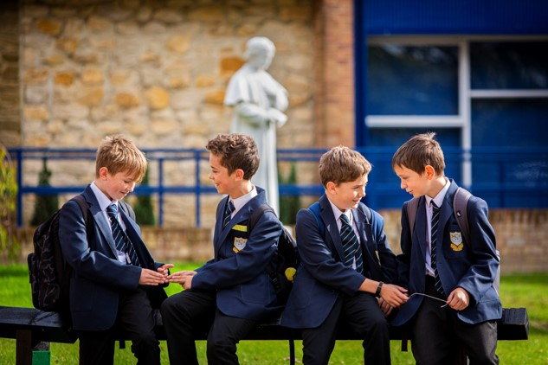

Job Profile: Teacher
Salary: Main Scale or Upper Pay Spine
Responsible to: Head of Department
Person Specification
- Commitment to supporting the distinctive nature of a Catholic school
- Qualified Teacher status
- Recent and relevant professional development
- Willingness to further develop professional skill
- Ability to enthuse, inspire and develop students under the Catholic ethos
- Ability to challenge, motivate and empower students
- Ability to recognise the needs of students and raise standards
- Ability to manage resources efficiently
- Commitment to promoting the educational principles of St. John Bosco
- Genuine enjoyment of working with young people
- Commitment to inclusion for all
- Commitment to excellence in terms of teaching and learning
- Knowledge and understanding of recent developments in learning and teaching
- Excellent grasp of new technology and its potential to support learning
- Excellent communication, interpersonal and organisational skills
- Commitment to working as a team player
- Ability to be an effective Form Tutor
- Commitment to supporting and promoting the extra-curricular life of the school
- Boundless enthusiasm and a positive outlook
- Capacity to work very hard under pressure
- Personal integrity and the drive to do what is best for the students
- Ambition and potential for promotion
- Sense of humour
- Commitment to ensuring that Salesian becomes the best school in the country

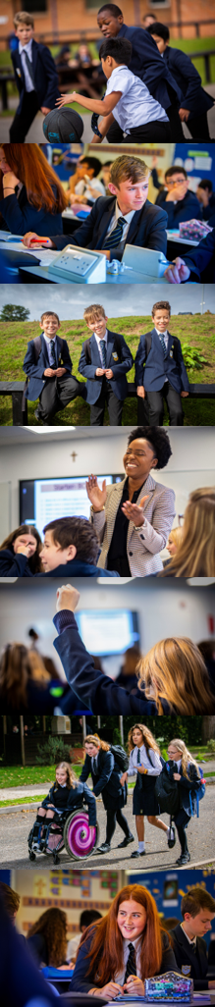
Responsibilities
In short, love the children and teach great lessons but see below for the detailed version:
The responsibilities outlined in this job description are in addition to those covered by the latest School Teachers' Pay and Conditions Document.
Professional Values & Practice
Teachers should:
- Have high expectations and commit to raising the students’ educational achievement
- Be committed to safeguarding and promoting the welfare of students
- Seek and use opportunities to work collaboratively with colleagues to raise standards by sharing effective practice
- Liaise effectively with parents or carers on students’ progress and achievements
- Show a commitment to professional development by identifying areas in which they need to improve their professional knowledge, understanding and practice in order to teach more effectively in their current post, and, with support, take steps to address these needs
- Attend staff, departmental and other meetings as required
- Participate in the arrangements for performance management within the school
- Undertake a due share of duties according to the published rota
- Be aware of the School Health and Safety Policy
Teaching
Teachers should:
- Have a secure knowledge and understanding of the subjects they are trained to teach
- Set challenging teaching and learning objectives which are relevant to all students in their classes
- Plan effectively to meet the needs of students in their classes
- Plan effectively for special educational needs in consultation with the Head of Learning Support
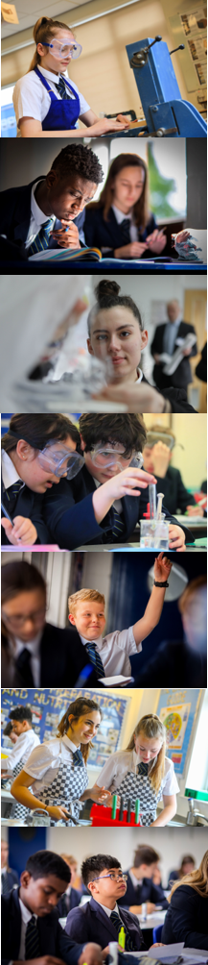
- Work effectively as part of a team and liaise with, deploy, and guide the work of other adults who support students’ learning
- Use a variety of teaching methods and styles appropriate to the range of ability of the students being taught
- Ensure a standard of behaviour that enables students to learn
- Undertake the teaching of those classes assigned under the school timetable
- Plan and prepare lessons in accordance with the Schemes of Work of the department
Monitoring and Assessment
- Make appropriate use of a range of monitoring and assessment strategies to evaluate students' progress towards planned learning objectives, and use this information to improve their own planning and teaching
- Mark and assess students' work on a regular basis in accordance with the school's marking and assessment policy
- Set and mark homework in accordance with school policy and departmental guidelines
- Record and report on student development, progress and attainment as required
Form Tutor
- Take the register each morning session and lead the daily act of worship
- Provide support and guidance to students and monitor performance in accordance with the schools policies
- Monitor students’ attendance and conduct and liaise with appropriate staff
- Liaise with parents and carers regarding issues as they arise
- Complete student reports in accordance with the school policy on Assessment, Recording and Reporting
Extra-curricular
- Make an effective and consistent contribution to the extra-curricular life of the school
Other
- Carry out any other duties at the direction of the Headteacher or as laid out in Salesian School documentation

