THE GRANGE SCHOOL

Specialising in Business & Enterprise



TEACHER OF GEOGRAPHY



THE GRANGE SCHOOL

The Grange School is a well-established, friendly school, specialising in Enterprise.
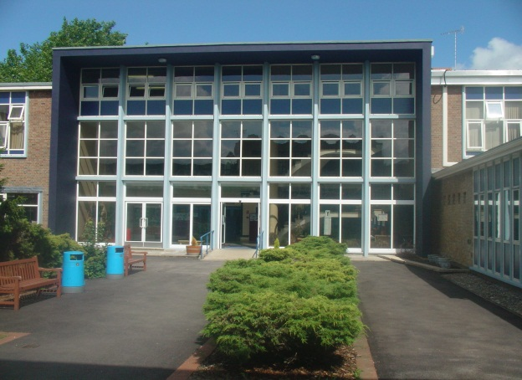
Enterprise is a driving factor throughout learning as evidenced by our Grange Enterprise and Learning Skills (GELS) which are embedded across the curriculum.



We aim to equip all students with the adaptability and flexibility to meet the demands of a rapidly changing world and to promote a sense of responsibility towards others, the school and the wider community. The support and guidance of students is based on a Year system and aims to develop co-operation, involvement and respect in all students.

A broad and balanced curriculum is provided for Years 7 to 9. In Years 10 and 11 all students will study English, Mathematics, Science, PE, RE, ICT/Computing and PSHCE (Personal, Social & Health and Citizenship Education). Students can then choose from a range of additional GCSE, BTEC and vocational courses. We offer a range of traditional and vocational courses at Key Stage 5. The curriculum in all Key Stages is further enhanced through wide ranging extracurricular experiences. We aim to attract energetic and conscientious staff who have a commitment to the education of our students. The professional development of all staff is an important focus for the school. We strive to create a learning environment which serves the needs of all the members of our diverse and vibrant community.

THE GRANGE SCHOOL

TEACHER OF GEOGRAPHY

JOB PROFILE

- To work within the Geography team to ensure that students see the significance of understanding the way in which the world around them works and the way in which they can affect and shape it.

- To contribute to the team’s development of an exciting and dynamic curriculum, which will challenge and motivate all students.

- To have a commitment to an extra-curricular programme, which supports both the academic and cultural life of the school.

- To raise the level of achievement of students.

- To work within a strong and supportive team based on excellent communication and shared good practice.

- To support and contribute to the future development of whole school policies and procedures.

THE GRANGE SCHOOL

HUMANITIES AT THE GRANGE SCHOOL

STAFF AND STRUCTURE

At present we have a Geography, History and Religious Studies department. All members of staff work in at least two of the departments. We are seeking someone who is prepared to teach a variety of the Humanities subjects at KS3 and to embrace the cross curricular ethos of the faculty.

Courses offered:

- KS3 - History, Geography, Religious Studies
- KS4 - GCSE History, Geography, Religious Studies
- KS5 - A Level History, Geography, Religious Education, Sociology, Government & Politics

DEPARTMENT FACILITIES

The Geography, History and Religious Studies departments are located within close proximity of one another. Each department has allocated office/resource space.

All departments have a combination of interactive whiteboards, projectors, televisions and computers.

EXTRA CURRICULAR

The school recognises and values the work of the Humanities team both within the curriculum and through its extra-curricular contributions.

Many wide ranging field visits are organised on a regular basis in each subject discipline. Visits are run for students of all key stages as part of the enrichment programme for their course of study.

Candidates are invited to visit the school prior to interview.
Please contact Mrs Jenny Bell, PA to Headteacher, to make an appointment
The Grange School, Wendover Way, Aylesbury, Bucks, HP21 7NH
Tel: 01296 390900
Fax: 01296 390991
E-mail: office@grange.bucks.sch.uk
www.grange.bucks.sch.uk

