

“A place for everyone…***to work and succeed!***”





[http://northliverpoolacademy.co.uk/latest news/ofsted2017](http://northliverpoolacademy.co.uk/latest%20news/ofsted2017)

**Welcome from the Principal**

Dear candiate

I am delighted you have taken the time to show interest in becoming one of our team.

We are incredibly proud of our recent achievements and during the past 12 months significant progress has been made, and Leadership has been Nationally recognised as being “both effective and ambitious”.

Recently Ofsted commended the academy for ensuring the ‘students feel safe and well supported’ and the ‘students behave well in their lessons and take pride in their work’.

That said, we are looking forwards and not backwards to becoming ‘Outstanding and World Class’.

North Liverpool Academy is more than just a school.

We hope you wish to join our family.

Best wishes

Mike Westerdale

Principal

**History of NLA**

North Liverpool Academy opened in 2006 as one of the first Academies in the country and has benefitted from the various advantages that brings. The Academy is well resourced both in terms of facilities and staff. It is housed in a superbly equipped building, erected in 2009 and enjoys an excellent reputation within the local community.

**The Trust**

Northern School Trust is a not-for-profit education charity. It is a well-developed MAT (Multi-Academy Trust) held in high regard by the DFE. There are currently four schools in the Trust including an innovative Studio School and a Life Sciences UTC in the centre of Liverpool. There is a further Academy (Kingsway) located on the Wirral and a UTC based in Wigan.

The Trust is proud of its collaborative way of working and is developing into a nationally recognised and trusted academy sponsor with an excellent reputation. The Trust has a wide range of expertise and specialised experience to call upon, having access to the FE, University, private and voluntary sectors as well as partner schools and consultant expertise drawn from across the UK.

The Trust has a central team that provides best value and an efficient service delivery in areas of HR, Finance, Enterprise & Marketing, Governance, Strategic ICT Development, Data and Facilities Management to all NST schools.

**Latest Ofsted**

North Liverpool Academy’s recent Ofsted inspection rated the school officially as a **Good School**, along with the exceptional academic results achieved in August 2016 confirms the school as the **most improved in Liverpool.**

Since the appointment of NLA’s new Principal in June 2016, the Academy has made significant changes to move the school forward.

The Ofsted team recognised the significant progress the school has made and continue to make.

The inspectors praised the Principal’s “highly effective leadership, clear vision, high standards” and “strong ambition,” and emphasised that “the school is well placed to continue improving.”

Rated good across the board, inspectors said that: “Pupils enjoy their learning and have positive relationships with one another and their teachers.”

“Pupils behave well in lessons and take pride in their work”

The report also praised the Sixth Form saying: “It is effectively led and consequently has improved since the last inspection. Outcomes are good because students are taught well. When they leave, an increasing number of students move on to university courses, further education, employment and training” showing a sustained picture of improvement.

**Our Amazing Facilities:**

North Liverpool Academy moved into a purpose built state of the art building in September 2009 and has the following outstanding facilities to name a few:

* 7 Technology classrooms
* 13 state of the art Science classrooms which are fully supported by 2 full-time Science Technicians
* Outstanding Drama Theatre which includes movable walls and bleacher seating to accommodate 220
* High quality dance studio with 2 designated teaching spaces
* Music practice and performance rooms
* Designated sixth form provision with LRC, classrooms and space for study or research
* Library
* Fit for purpose ICT suites
* State of the art MAC suite
* TV & Film studio
* Teaching & learning hub
* Sports hall and fully equipped Gym and Fitness Centre
* Full size Astro pitch
* On site Scoot 66 Scooter supplies shop
* Secure car parking with spaces for up to 140 cars

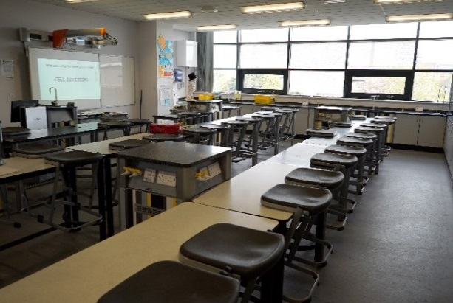 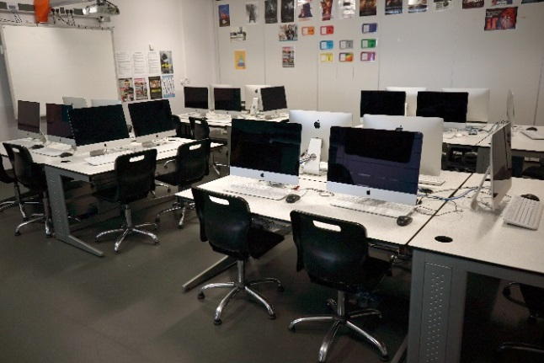

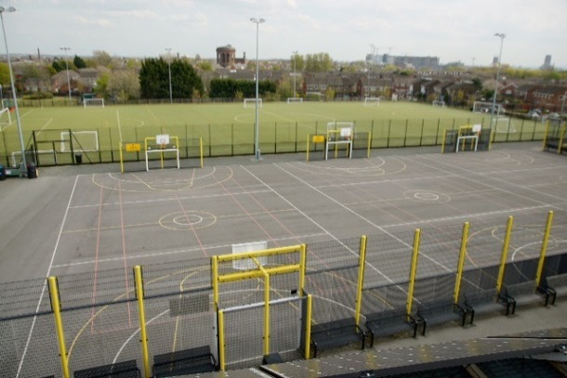 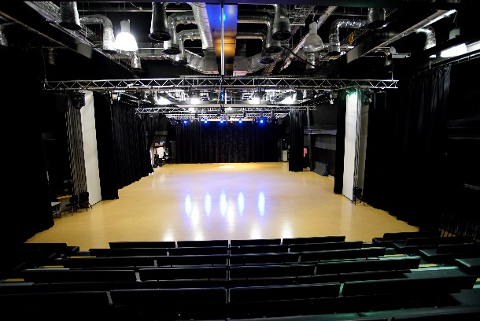

**So why choose North Liverpool Academy?**

**All Staff**

* Excellent opportunities for advancement & promotion
* Regular training and CPD
* Duke of Edinburgh
* Free on-site secure parking
* Free access to Fitness suite
* Complementary tea & coffee facilities
* Inclusive induction programme
* Flexible working request policy
* Designated reprographics support & ICT helpdesk
* Pay related benefits such as Childcare vouchers and Cycle to Work scheme
* Supportive HR Department who can provide access to Wellbeing services such as Counselling & Occupational Health
* Access to FREE staff wellbeing activities such as Yoga, badminton and fitness classes
* Well lead and managed teams
* Extended opening hours to promote a better quality of work/life balance

**Teachers**

* Fast track UPS/Leadership progression
* Main scale teacher have 15% timetabled PPA time
* Comprehensive NQT/School Direct/Teach First programme
* Additional training and support for middle or emerging leaders
* Paid Development post opportunities

**Support Staff**

* 35 days paid annual leave (inclusive of 8 bank holidays)
* Support for staff wishing to progress into teaching through School Direct
* Membership into the local Government pension scheme, where we as employers pay an additional 11% of contributions
* Time off in lieu when available
* Non contractual discretionary leave during school closure periods

**The English Department**

The Department consists of 16 full time teachers with a range of experience and levels of responsibility both within the department and across the Academy. It is led a College Leader who is also an Assistant Principal, and managed by a

* KS5 Co-ordinator
* KS4 Co-ordinator
* KS3 Co-ordinator

“The English Faculty at North Liverpool Academy believe that we are the most important subject in the most important school in Liverpool.

We constantly strive to ensure that nothing is as important as learning in English. We are creating a learning culture in which pupils are accountable for their own learning. We are challenging aspirations through the pursuit of educational goals. We are closing the achievement gap and preparing students for a life of opportunity and choice.

Along the way, we need to recruit the best teachers to help improve and sustain our vision; an outstanding school in North Liverpool is growing today. All it needs is your ingenuity and talent.

To make this vision become a reality, at North Liverpool Academy we need future leaders to commit themselves to the most urgent and exciting work in the Liverpool area. We require future leaders who can inspire students, who put outstanding ahead of everyday, and who are fearless about closing the achievement gap.

We need you to join our highly collaborative team and shape a vibrant culture.”

***Lee McLinden, Assistant Principal***

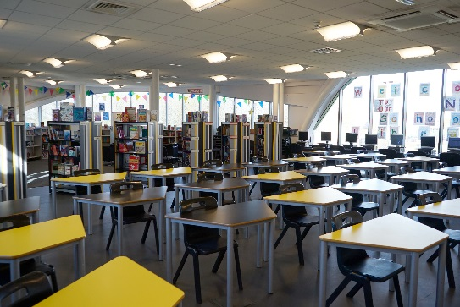 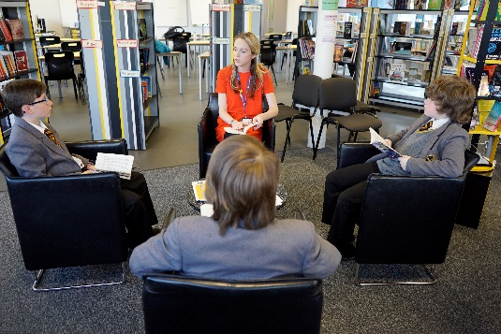

**Curriculum**

**KS3 – Year 7 and 8**

We have adopted 4 x 75 minute lessons a week. Pupils follow rigorous programmes of study which challenge students with the reading and writing skills needed for the new GCSE specifications for English and English Literature. We need to develop critical and reflective readers and writers.

At KS3, in Year 7 and 8 students develop their skills within English by accessing a range of GCSE standard texts and poetry. The challenge is high and the demands of the curriculum means that there is no wasted time in Key Stage 3. From Year 9, students follow the AQA GCSE English Language syllabus and are expected to read, understand and analyse a wide range of different texts covering the 19th, 20th and 21st century time periods as well as to write clearly, coherently and accurately using a range of vocabulary and sentence structures. There are two examination papers, relating reading sources to the topic and theme of writing tasks. The reading sources act as stimulus for writing tasks, providing students with a clear route through each paper.

- Home learning is given once a week.

**KS4 – Year 9, 10 and 11**

- Year 9 begin their GCSE studies

- Students follow the AQA GCSE specification for English and English Literature.

- Students are banded and set, receiving either 5 or 6 lessons a week across the 3 years

- Home Learning is given at least once a week, more if appropriate

From Year 9, students follow the AQA GCSE English Language syllabus and are expected to read, understand and analyse a wide range of different texts covering the 19th, 20th and 21st century time periods as well as to write clearly, coherently and accurately using a range of vocabulary and sentence structures.

In Year 10 and Year 11 there are two examination papers, relating reading sources to the topic and theme of writing tasks. The reading sources act as stimulus for writing tasks, providing students with a clear route through each paper.

Paper 1, *Explorations in Creative Reading and Writing,* looks at how writers use narrative and descriptive techniques to engage the interest of readers.

Paper 2, *Writers’ Viewpoints and Perspectives,* looks at how different writers present a similar topic over time.

Students follow the AQA GCSE English Literature syllabus and are expected to read, understand and analyse a wide range of Literature covering Shakespeare, the 19th Century novel, modern texts and poetry. All examinations are closed-book, meaning that all materials for examination are provided in the assessment.

Paper 1, *Shakespeare,* expects students to answer one question on their play of choice. They will be required to write in detail about an extract from the play and then to write about the play as a whole.

With *The 19th-century novel,* students will answer one question on their novel of choice. They will be required to write in detail about an extract from the novel and then to write about the novel as a whole.

Paper 2, *Section A Modern texts* expects students to answer one essay question from a choice of two on their studied modern prose or drama text. *Poetry* expects that students will answer one comparative question on one named poem printed on the paper and one other poem from their chosen anthology cluster. In *Unseen Poetry,* students will answer one question on one unseen poem and one question comparing this poem with a second unseen poem.

**KS5 – Year 12 and 13**

- We offer AS and A-level English Language and English Literature

- Small and focused numbers of A-level students

- Relentless focus on academic achievement

- Home Learning is given at least once a week

**English staff profiles**

**Stacey Meighen, KS3 Co-ordinator**

“Since joining the Academy in 2007, I feel like I have grown up here. Originally employed as a Graduate Learning Support Assistant, I found great satisfaction in developing and implementing a range of interventions to better support students in overcoming their own personal barriers to learning, particularly with literacy. Many of the kinaesthetic practices we adopted proved to be very successful, and I was quickly promoted to the new and exciting role of GLSA Team Leader, before progressing further to Wave II Co-ordinator.

My successes were noticed, and I was identified and supported by SLT, who ardently encouraged me to progress to QTS. Following my acceptance onto the Schools Direct programme which was run by NLA, I completed in-school training, on a timetable that was specifically tailored towards my professional development, with full support from my university-based tutor at LJMU. I qualified in 2014 and was offered a post teaching within the English department.

During my NQT year, I was selected to join a Teaching and Learning Development team of exemplary practitioners, with the aim of supporting colleagues across the academy to further improve their pedagogical practice. From this experience, I was successful in my application for my first leadership role, KS3 Leader of English.

NLA has played as massive role in my personal and professional development. The job is not easy, but it is easily the most rewarding, and has provided the opportunities for me to progress through an empowering, satisfying and promising career.”

**Melissa Clegg, Assistant KS4 Progress Leader**

I started working at North Liverpool Academy when I was 21 and fresh out of University. Employed as a GLSA, I instantly felt part of the English team and was eager to stay on at the school and become a teacher, due to the atmosphere and character the school and students had. I’d been on placement in other schools but NLA felt like home. After my first year, I was promoted to a UQT of English where I was able to get the hands on classroom experience that would set me apart from other trainee teachers. NLA then funded my place on the Schools Direct programme, where I taught four days a week at NLA and went to University one day; in order to gain QTS. Due to the career opportunities here; I applied for the position of More Able and Talented Progress Leader and was appointed during my training year, this is a role I continued with through my NQT year. This role gave me vital experiences that enabled me to apply for my current position within the academy, of Assistant KS4 Progress Leader. Having started working here at such a young age, I feel like I have grown up in North Liverpool Academy and personally wouldn’t want to work anywhere else.

**Liverpool and Merseyside Region**

Whether you are a native to Merseyside or looking at relocating, it’s clear that Liverpool and Merseyside as a whole has a lot to offer. Being European Capital of Culture in 2008 it’s evident why.



Here in Liverpool, there is something for everyone to enjoy, whether it’s visiting one of the many museums for a spot of history and culture, to experiencing a taste of the orient – Liverpool has the biggest Chinese arch outside of mainland China!

Here are some other reasons to enjoy our City

* 2 amazing Cathedrals
* Amazing parks and gardens
* 2 top premier league football clubs – both of which are located within walking distance of the Academy
* House prices in the North West are amongst the lowest in the UK
* Excellent transport links
* Top tourist attractions
* Fantastic range of shopping, restaurants and nightlife

Why not visit [www.visitliverpool.com](http://www.visitliverpool.com) to see why Liverpool is great!

