

ICT Network Manager
Grade 6 – Pts 20 – 25

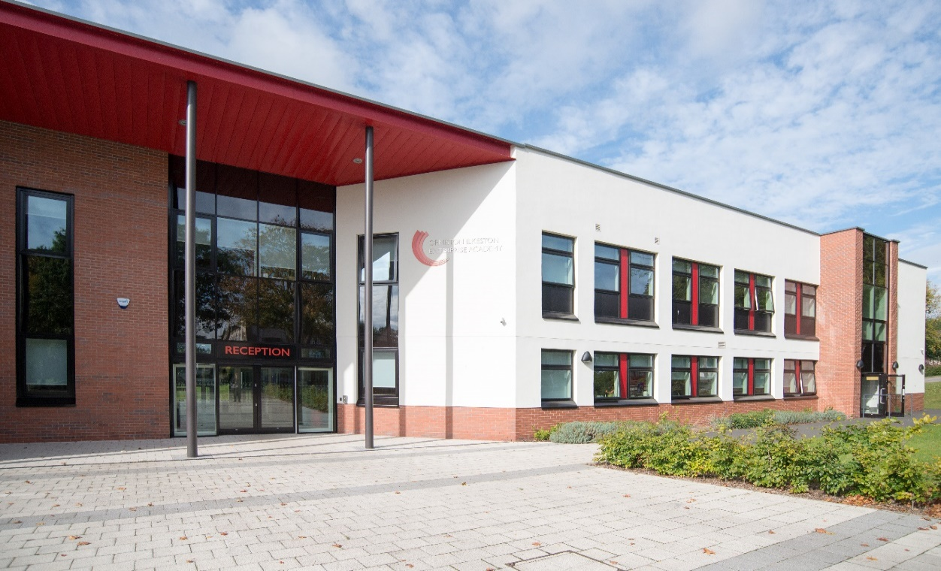

OIEA
King George Avenue
Ilkeston
Derbyshire DE7 5HS
0115 930 3724

 facebook.com/oieacademy  @oieacademy  www.oiea.co.uk

WELCOME

I am so proud to welcome you to Ormiston Ilkeston Enterprise Academy, a school dedicated to achieving the highest standards of teaching and learning.

We work in partnership with parents and carers in order to ensure students achieve
and are fully prepared for their next steps.

We pride ourselves on our calm and purposeful atmosphere around the academy, with high standards for every aspect of academy life.

We strive to work in an atmosphere of trust and to enjoy our education, developing a drive to explore the world in which we live.

Ormiston Academies Trust (OAT) is the sponsor of Ormiston Ilkeston Enterprise Academy.
OAT is a not for profit sponsor of both primary and secondary academies. Their vision is for all young people to have the highest academic, social and practical skills to allow them to lead a fulfilling life. They are determined to become the Trust that makes the biggest difference.

Find out more on the Ormiston Academies Trust website.

The academy is easily accessible to the M1 (J25-26) and the A50 link to the M6. The major city centres of Derby and Nottingham are only 15 minutes’ drive and Leicester, Sheffield and Birmingham are all within 45 minutes travel time.

Ilkeston is also on the doorstep of Shipley Country Park and only a short distance from the Peak District National Park. The local area is an attractive and pleasant place to live, Ilkeston people are renowned for their warmth and humour – it is a close and friendly community in which to work and live.

Miss Nia Salt
Principal


ICT NETWORK MANAGER

Required as soon as possible.

SCALE: Grade 6, Pts 20 – 25
£25295 to 28785

HOURS: 37 hours per week – full time
7.45 am – 3.45 pm (Mon–Thurs)
8 am – 3.15 pm (Friday)

If you are someone who is passionate about their job, enjoys working with young people and is determined to make a real difference to the children, then this could be the role for you.

We are looking for an outstanding ICT Network Manager to join this forward thinking academy and develop the quality of teaching and learning. We are seeking to employ staff who have a thirst to develop young people and build teams committed to academic and pastoral success. This is a fantastic opportunity to play a key role in influencing positive learning outcomes for our students.

This is an exciting time to be joining our new Academy. Our new building houses the English, science and mathematics departments in state of the art facilities. Our Academy is a vibrant and friendly place to teach, with 829 students currently on roll 11-16 yrs. We are pleased to announce that we have again recruited to full capacity in Year 7, with regular
in-year enquiries to join our academy. We offer excellent CPD opportunities for staff at all levels.

For an informal chat or to arrange a visit please contact Oli Forster, Vice Principal on
0115 9303724.

If you are interested in applying please download the information and complete the application form which can be found at www.OIEA.co.uk/vacancies . Please return your completed application form together with a covering letter saying why you feel you are suitable for the post to lashby@oiea.co.uk.

Closing date for applications: 10 am on Monday 6th January 2020.

Ormiston Ilkeston Enterprise Academy is committed to safeguarding all our students. Successful candidates will be required to undergo enhanced DBS checks and reference requests will indicate specific questions relating to their suitability to work with children.


Post: Academy ICT Network Manager
Reports to Finance Director/Business Manager
Location: Academy based, Academy contract
Salary: Grade 6 £25295 to £28785
Status: Full Time permanent, all year round
Hours: 37 hours a week, flexible to meet the needs of the business. Work out of academy hours may be required.
Typical working week: 7.45 am to 3.45 pm – Monday to Thursday (30 minute lunch break)
7.45 am to 3.15 pm – Friday (30 minute lunch break)
Holiday leave to be taken during school holidays

Responsible for:
The provision of ICT technical support and services within the Academy. To support the use of ICT through maintenance of software, hardware and related equipment, and providing support to staff and pupils to ensure administration and learning outcomes are maximised. Provide training and coaching for staff to upskill and enable access to systems to maximise student learning and improve deliver whilst reducing workload for staff.
In conjunction with the Cloud Services and Support Manager, plan and implement the school’s ICT strategy and service provision, including managing many aspects of ICT technical support. Focus on availability of technology of systems, security and connectivity issues (local academy active and passive networking).

Main duties and responsibilities
Key Duties / Responsibilities
- Academy’s designated E-Safety Co-ordinator.
- Install and maintain computer hardware, clients, laptops, audio/visual equipment and peripherals.
- Manage the inventory of ICT equipment and ensure it is up to date, ensure starters are equipped and leavers return academy property.
- Maintain equipment onsite to a high standard.
- To manage the expansion of the academy network infrastructure including switches, cabling and wireless network equipment.
- Routine administration including, data backups, Active Directory maintenance.
- Software installation, maintenance and upgrading in line with the academy development policy.
- Maintain up to date workstation images and deploying them where necessary.
- Administration and development of Internet, Intranet, Extranet and E-mail systems, including Learning Platforms and the academy website.
- To keep abreast of technological developments and encourage the use of ICT at all levels.
- To support staff and students with the use of ICT.
- To support staff and students with the set-up and preparation of ICT equipment around the academy.
- Manage the checking and re-fitting of toner and cartridges and the carrying out of periodic printer maintenance within the academy such as head cleaning and alignment.
- Manage stock including ordering, returns, liaising/negotiating with suppliers.
- Manage staff and student accounts and, where necessary, add new members of the academy community and organise the archiving of user materials from school leavers before removal of their user accounts.
- To manage the ICT Helpdesk, to ensure all tickets are resolved effectively and within an adequate time frame.
- To be aware of the academy’s Health and Safety Policy and to assist in carrying out
- the responsibilities detailed therein.
- Maintain stocks of spare parts and consumable items, including projector bulbs.
- Support the regional and central ICT Staff maintain and update Web site and other forms of web based media communication.
- Support and manage the database infrastructure for onsite servers and system that are not cloud based. I.e. door access control, wifi, SIMS, Hoge or similar.
- Support the regional and central ICT Staff in the operation of cloud services for system that are either being moved to the cloud or are already cloud based.
Training and development
- Provide individual and group training as required to all staff and students.
- Carryout staff inductions and keep records of staff training and compliance.
- Maintain appropriate levels of training in the role, keeping up to date with new initiatives and developments in ICT.
- Attend events and training as required.
Data Protection
- Adhere to the Trusts data protection polices and processes.
- Support the Trusts Data Protection Officer (DPO), carry out data protection impact assessments (DPIA) on new and developing areas that require data processing & recording.
- Support the Trusts Data Protection Officer (DPO) by providing information to ensure that the Trusts eco system which tracks, and records types of data stored and where is kept is accurately maintained.
- Support the DPO to ensure that where required; evidence of compliance is recorded as required in the Trust data protection polices and processes.
- To ensure the academy’s local ICT infrastructure, data storage and usage are GDPR compliant.
- Report any data breach of the academy’s ICT acceptable use policy to the Data Protection Lead.
General responsibilities
- To adhere at all times to the Trust’s policies and procedures.
- Maintain confidentiality of information acquired in the course of undertaking duties.
- Ensure that work is completed in compliance with relevant legislation and procedures relating to this role.
- Ensure GDPR principles are embedded in normal working practices.
- Post holders may be required to work flexibly in order to meet the business needs. All staff are required to partake in performance management and training activities.
- Be aware of safeguarding and promoting the welfare of children and to report any concerns in accordance with the school’s safeguarding policy.
- The above list is not exclusive or exhaustive, and the school may require the post holder to undertake duties commensurate with the level of the role. As part of your wider duties and responsibilities, you are required to promote and actively support the Academy’s responsibilities towards safeguarding.
- The Trust expect that employees deal with people politely and tactfully, communicating with colleagues both formally and informally, modelling the Academy’s Code of Conduct and the equality policy objectives.
DBS
- An enhanced disclosure and barring check will be a requirement of the post.

Person Specification
Knowledge and experience
- Ability to articulate technical ideas to non-technical people, both verbally and in writing.
- Able to self-lead, develop and motivate to achieve goals.
- Analytical and problem-solving skills.
- Understanding of networks, LAN, WAN and internet topologies, protocols and techniques together with a proven technical background in desktop computers, peripherals, software and other hardware.
- Working knowledge of relevant policies, procedures, codes of practice and awareness of relevant legislation.
- Ability to perform the physical tasks required by the post.
- Understanding of budgets in relation to project management.
- Minimum of 2 years’ relevant experience of web development.
Skills and qualification
- Degree in relevant subject or equivalent qualifications.
- Good knowledge of Office 365 and/or Google cloud services.
Personal qualities and attributes
- Tact and diplomacy.
- Business and Customer service focused.
- Commitment to working as a positive and constructive part of a team.
- Ability to maintain confidentiality.
- Ability to work on own initiative and as a team player.
- Effective leadership and management skills.
- Excellent communication skills (written and verbal).
- Proactive, flexible and resilient.
DBS
- An enhanced disclosure and barring check will be a requirement of the post.

