
Job Title: Premises Officer

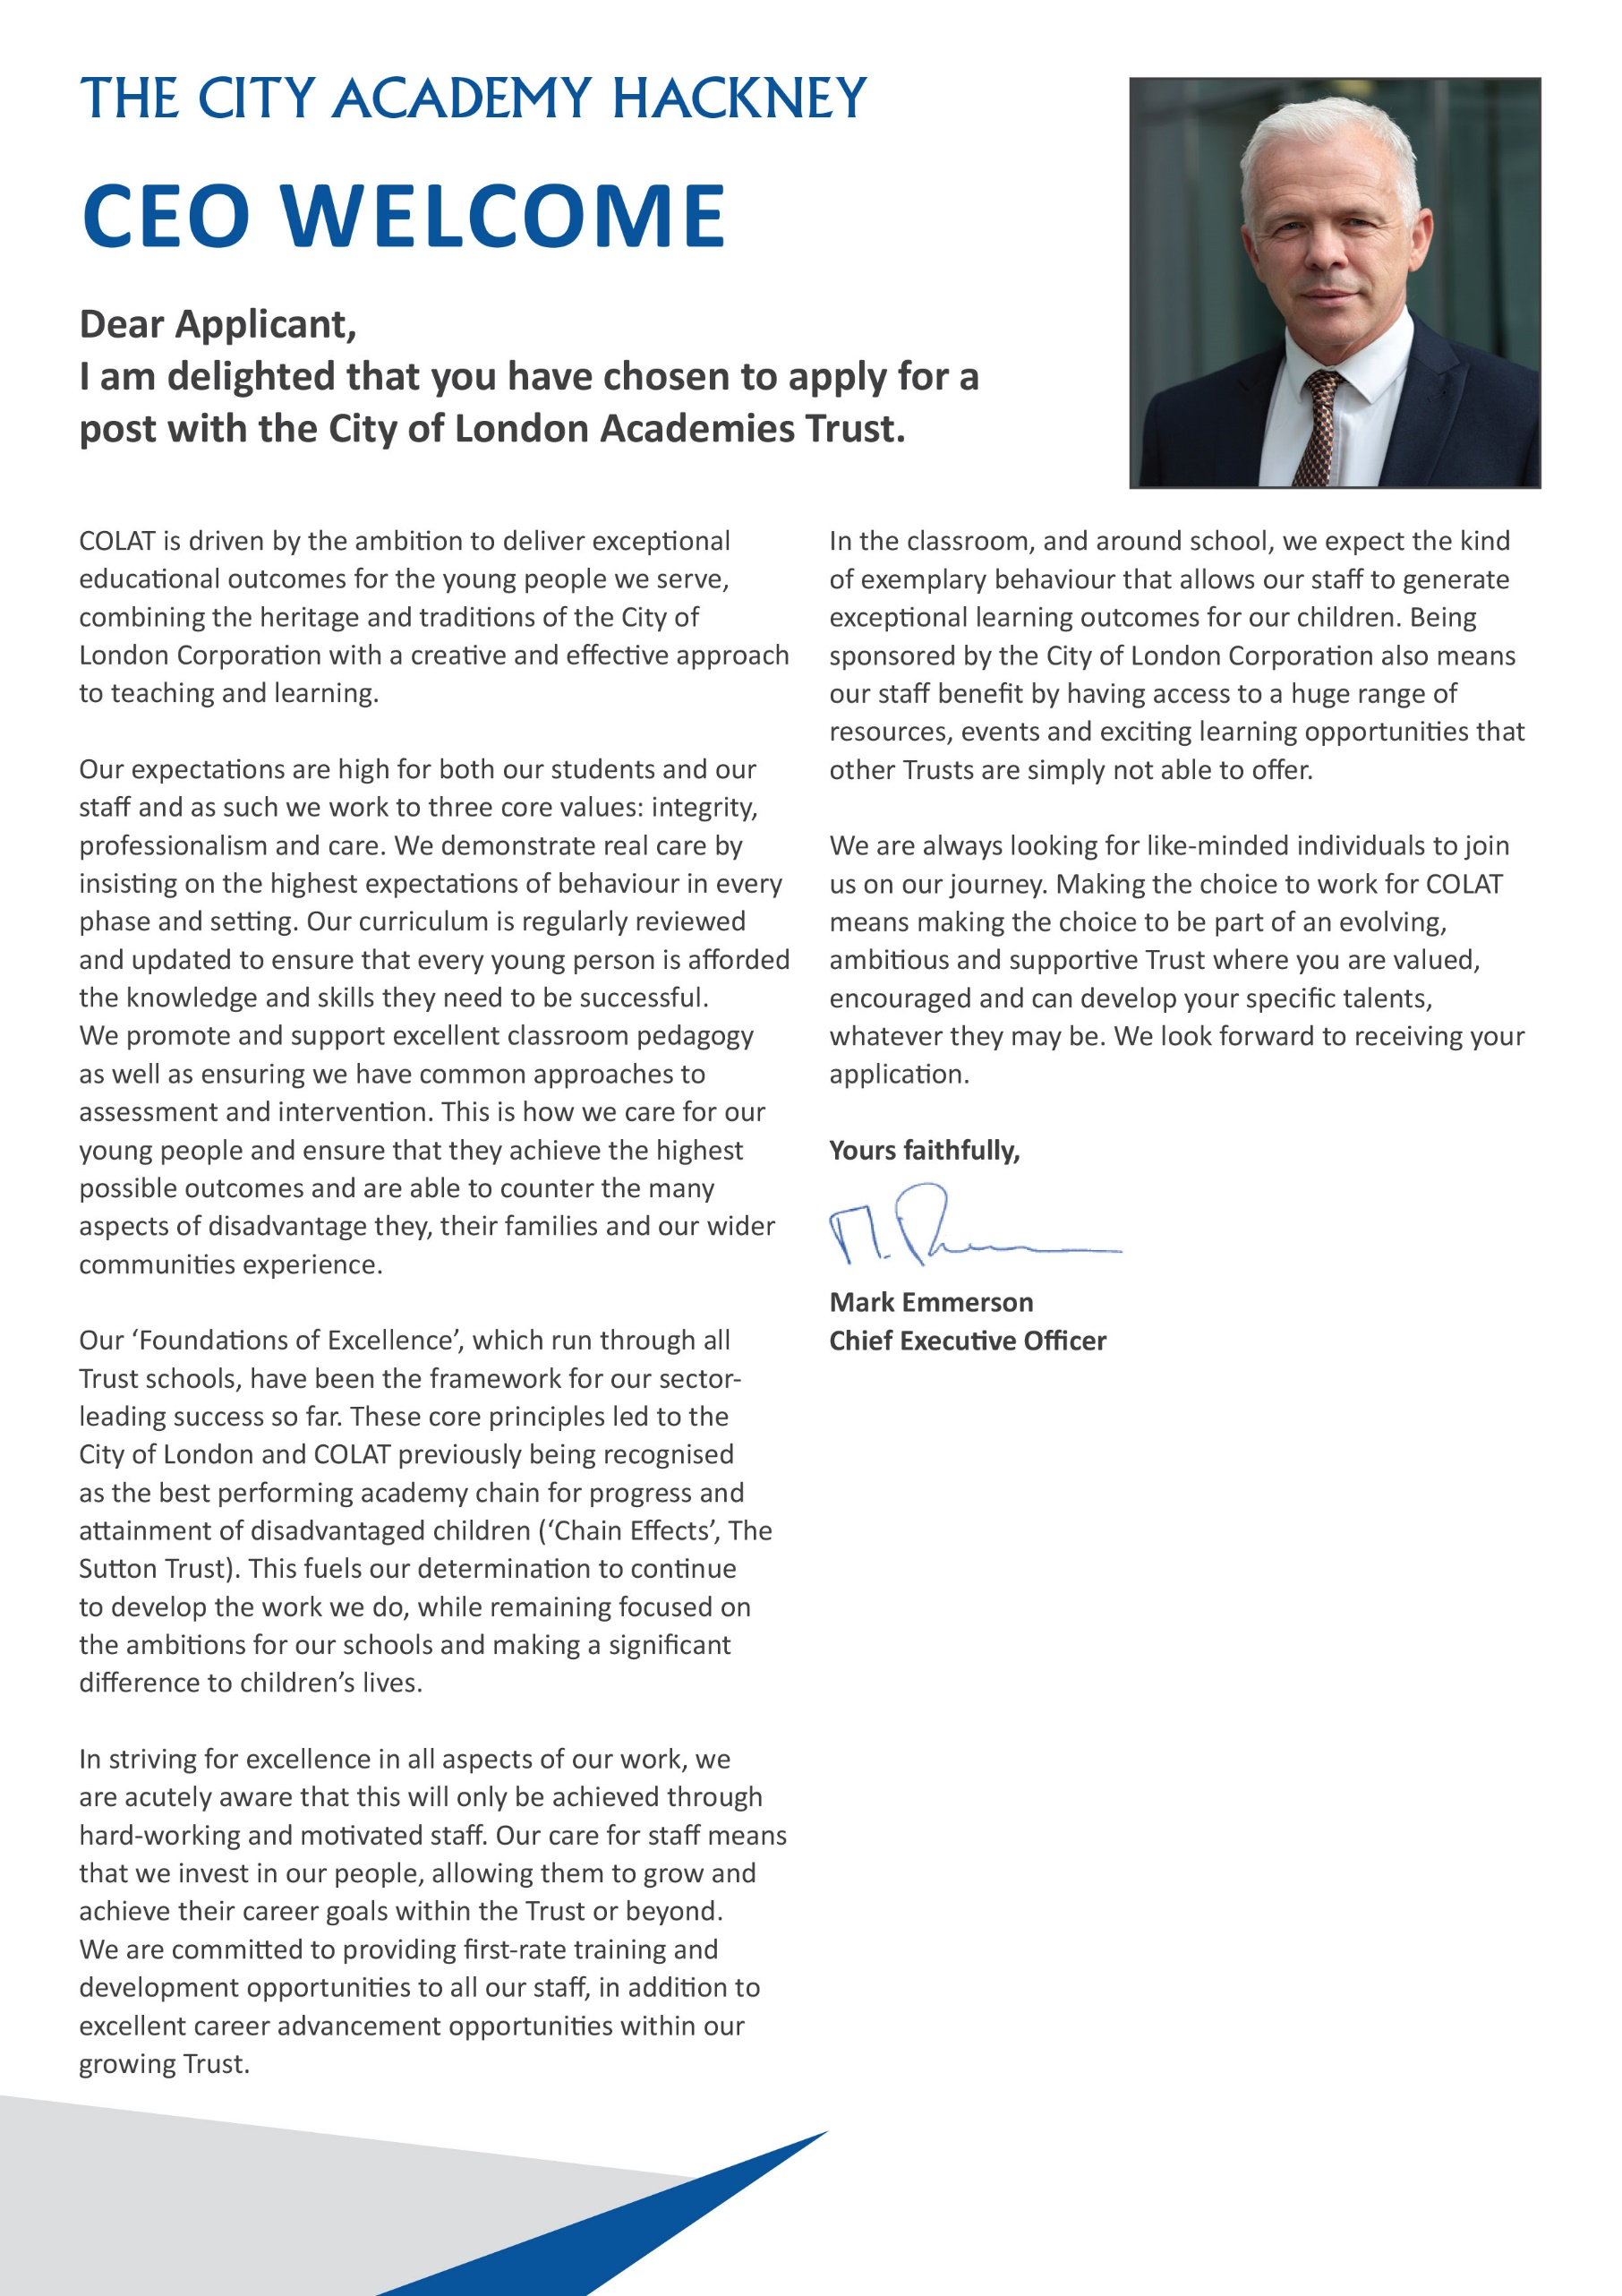

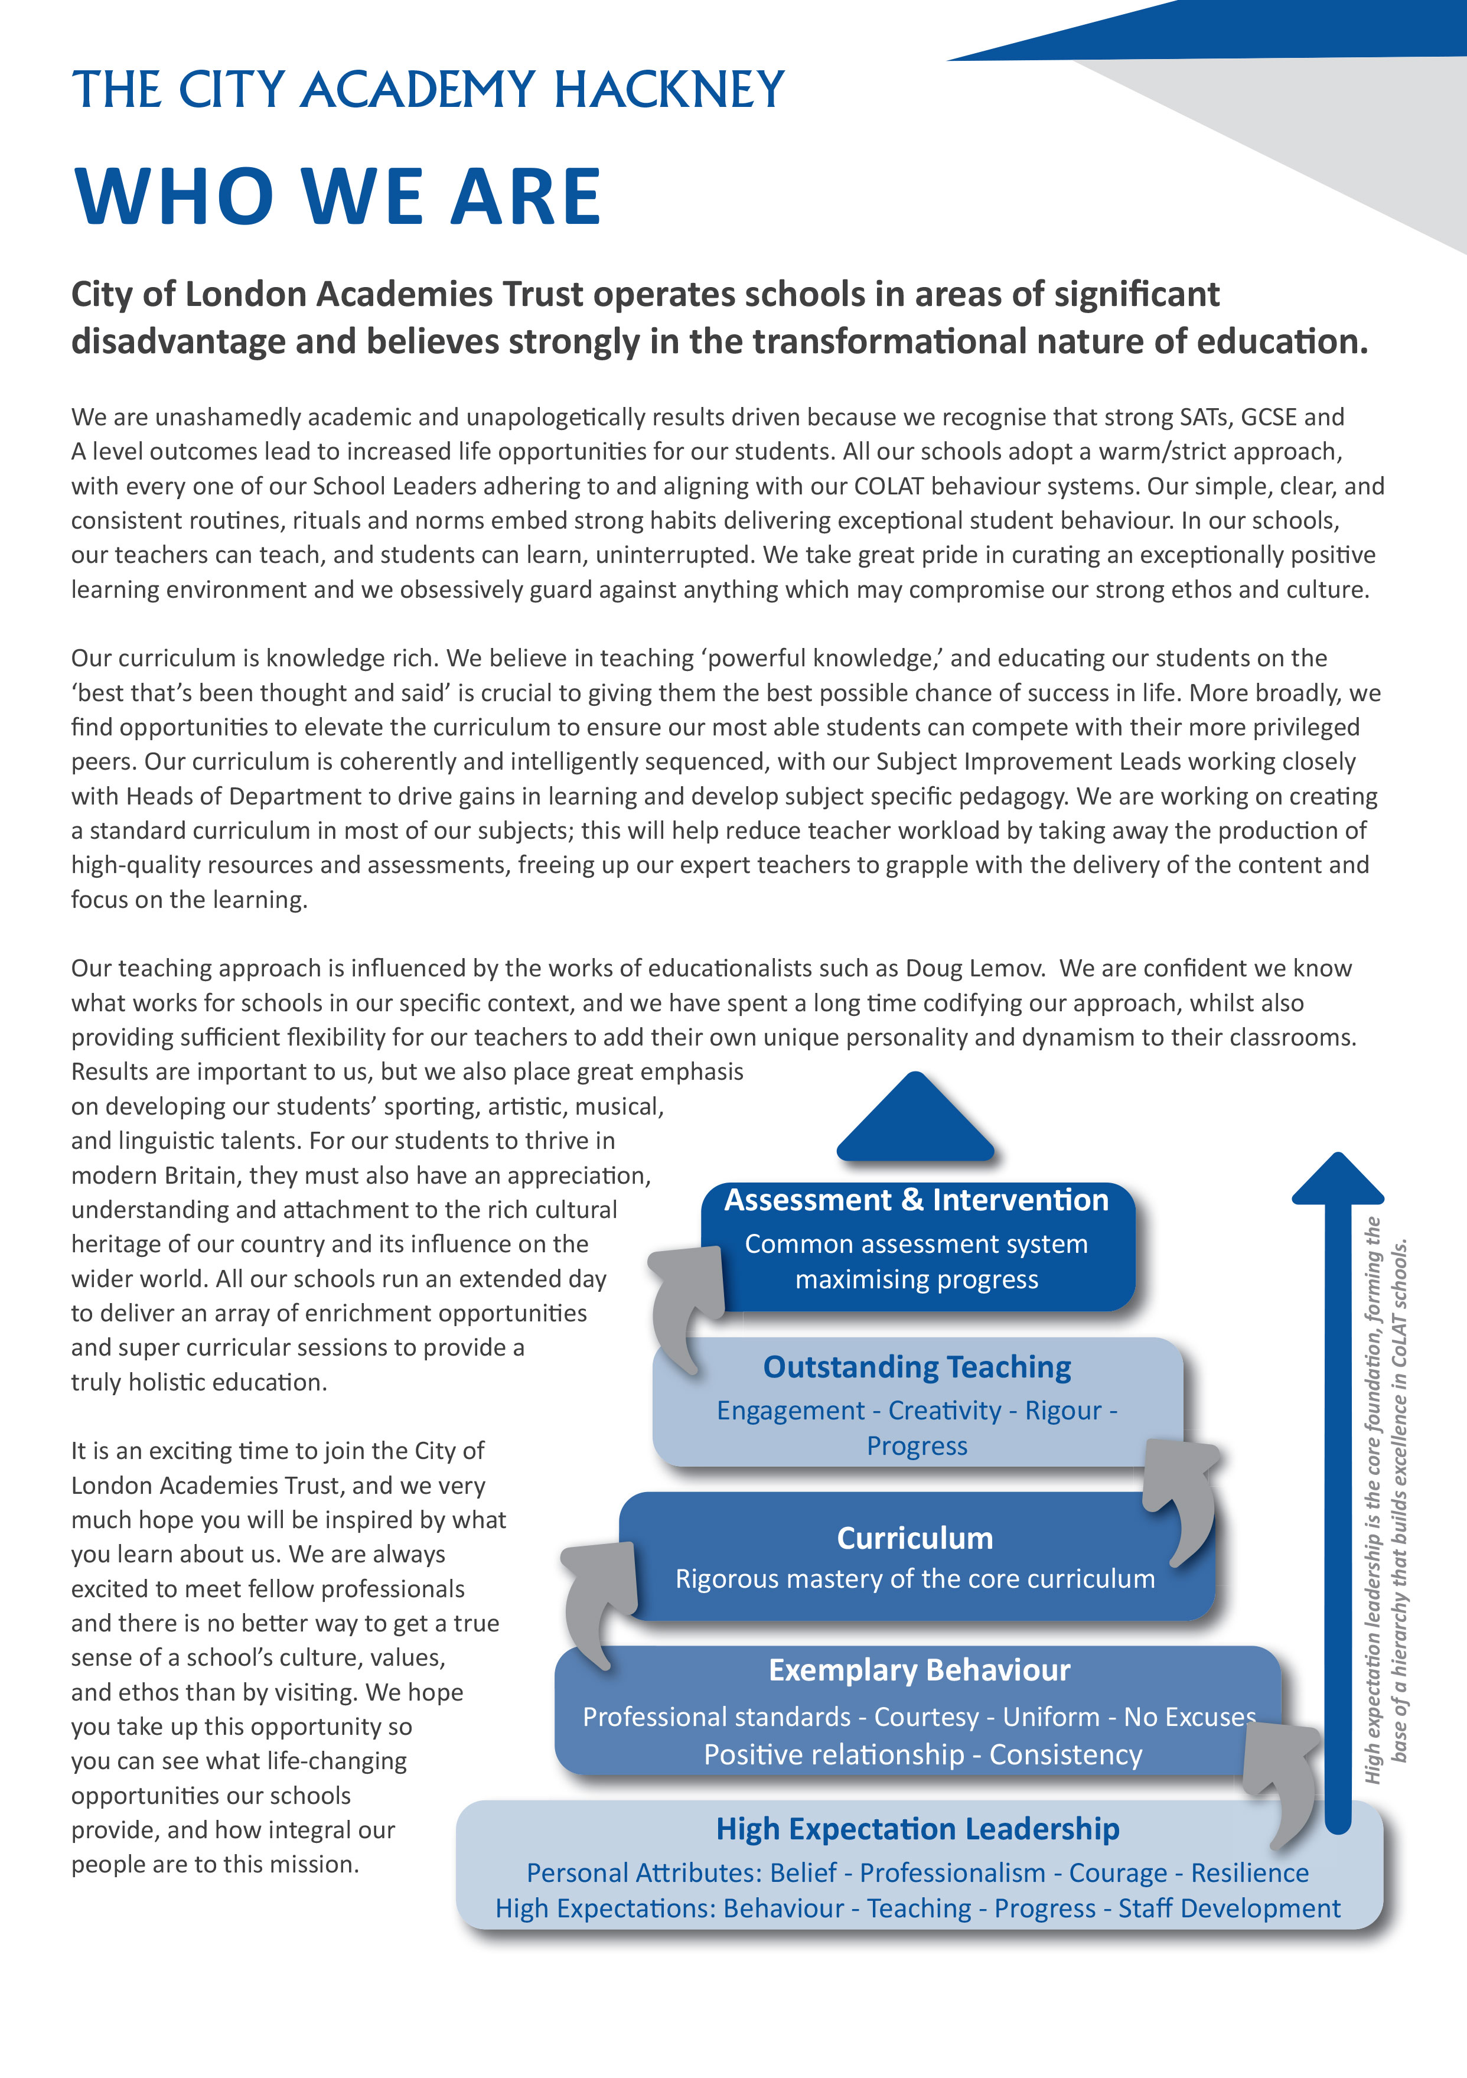

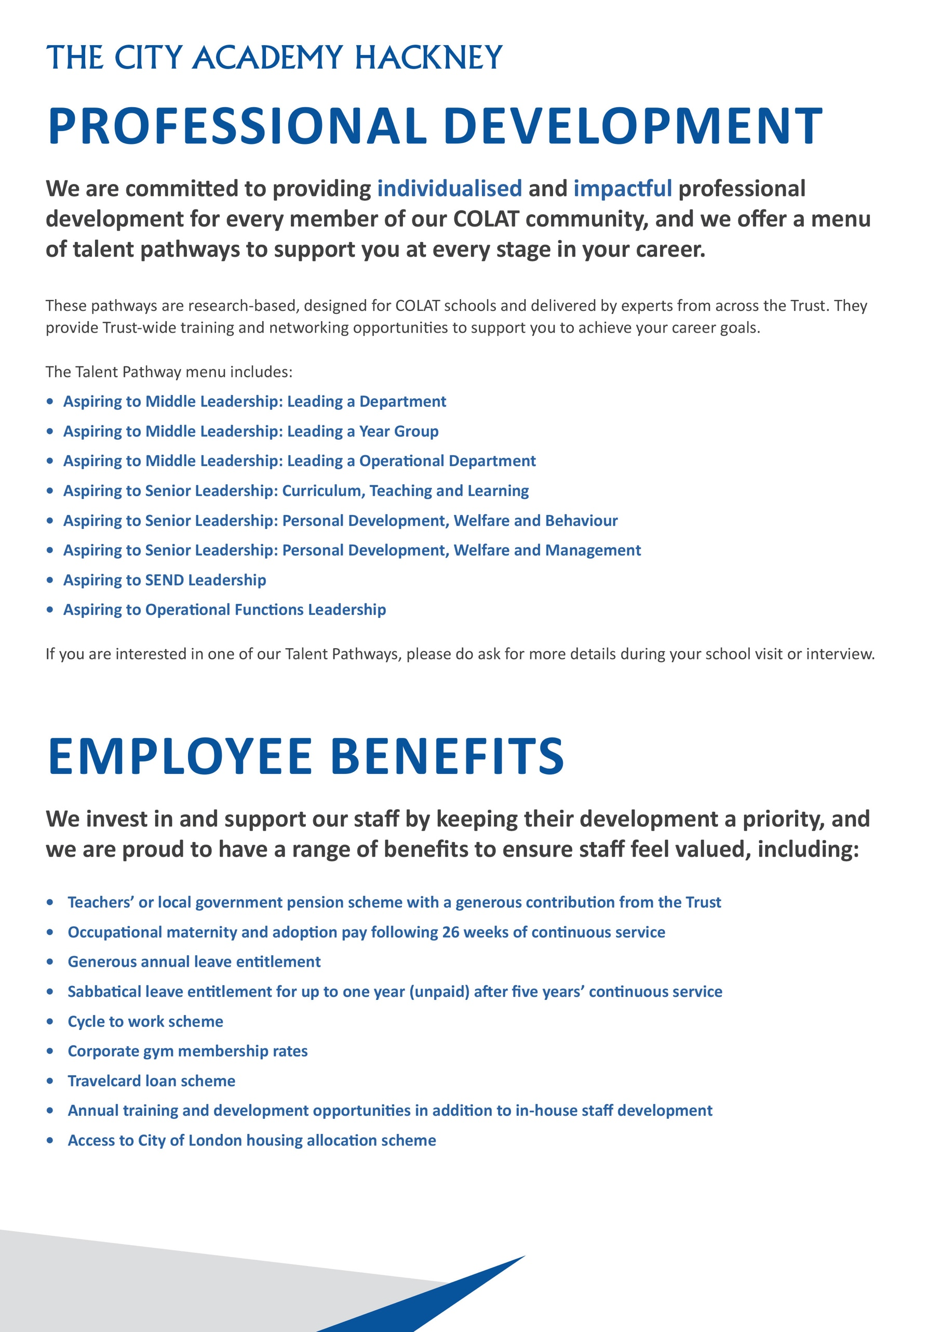
Headteachers Welcome

Dear Candidate,

Thank you for expressing an interest in the post of Premises Officer at The City Academy, Hackney.

At The City Academy, Hackney, we are dedicated to providing all the students in our community with the best possible educational opportunities. We believe excellence is achieved through three key ingredients: clear structures, high expectations and strong relationships. Our outstanding curriculum is built around 'The City Experience' which places equal value on academic, creative, sporting, linguistic and personal development.
We pride ourselves on being a school which offers young people a warm and supportive environment, enabling them to meet our very high expectations. Our inspirational staff are skilled and committed and we are generously supported by The City of London Academies Trust. As a result of this, our students make exceptional progress.
We are looking for staff who are committed to working with students of all abilities, who constantly seek to learn and improve and who are ambitious for themselves as well as for their students. We expect hard work, skill and dedication, and in return will provide a supportive, flexible working environment, first class training opportunities and a comprehensive benefits package.

If you have the experience and passion to join our team and inspire the next generation, we look forward to hearing from you. Please apply via our website: https://www.thecityacademyhackney.org/

If you have any questions or would like to arrange a visit to the academy please contact our HR team at hr@thecityacademy.org. I look forward to reading your application.

Yours sincerely,

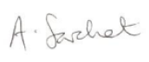

Anna Sarchet
Principal

Premises Officer –Job Description

Accountable to: Facilities Manager

Grade Scale Point Range: Scale 4 sp7 - 10

Salary Range: £30,987 - £32,346 FTE

Working Pattern: Full time 35 hours per week, all year round
10am – 6pm or 11am – 7pm

Location: The City Academy Hackney

Disclosure level: Enhanced

Responsible for: N/A

Main Purpose:
To assist the site team with aspects of site management including a wide range of duties and responsibilities connected with the fabric and grounds of the site. This includes the safe and efficient opening of the academy, porterage, routine maintenance and refurbishment, minor repairs and advising on improvements. Ensure Trust policies, processes and procedures are always followed and that the site is fully compliant with health and safety requirements. Ensure high quality service delivery is always maintained, using the Facilities System for logging, and managing of jobs and for statutory recording.

Key Accountabilities

Key Responsibilities
- To undertake repairs and smaller DIY projects.
- As required, oversee the opening of the site, ensuring all morning walk rounds are completed before welcoming students to site.
- Assist the academy leadership team to ensure the premises are in fit working order to enable them to achieve the best possible student outcomes.
- Provide premises support to staff when Site Manager is away from site.

Planned and Reactive Maintenance
- Undertake the scheduled day-to-day maintenance, repair and cleaning of the academy site, both internally and externally.
- Support with the daily, weekly, and other regular duties, as well as reactive duties. Including, but not limited to the below:
- Using tools and equipment for general maintenance work that is required, appropriate to skills and qualifications.
- Refer larger, more complex work where specialist knowledge may be needed as appropriate.
- Use electronic Facilities System to manage jobs, including logging and closing of jobs.
- Inspect and clear drains and/or gutters when required.
- Support the site team to ensure the heating systems are always operational.
- Check and maintain grounds ensuring these are safe for public use.
- Liaise with contractors carrying out work on site as directed by appropriate managers.

- To assist the site team with small tasks relating to the program of redecoration/ refurbishment
- Ensure the academy site is kept clean, safe and in a good state of repair and report to the Site Manager if stocked of necessary supplies are low.
- Responsible for carrying out premises compliance checks, when instructed by academy operation leaders, keeping accurate records for their approval.

Security
- To support with the unlocking and locking of the academy, liaising with key holding company when cover is required.
- Carry out security checks and procedures for the buildings and grounds, including setting intruder alarms and ensuring boundaries are secure and that all gates and doors are locked when required.
- Undertake routine and non-routine security process when opening and closing of site.
- Respond to emergencies on site as required.
- Support with operation of CCTV equipment if required, in line with Trust policies and procedures with due regard to GDPR regulations.
- To act as additional keyholder for the site on callouts.

Cleaning and Waste
- Carry out reactive cleaning duties when required – e.g., cleaning up spillages or cleaning graffiti.
- Ensure consumables are replenished as required (e.g., toilet roll, soap, hand sanitisers, hand towels)
- Ensure the site is kept clean and tidy and is conducive to learning e.g. litter picking, collection and disposal of refuse, disinfecting bins, ensuring toilets checked daily for fresh supply of disposables etc.
- Emptying bins as required and disposing of waste appropriately and in line with legislation.

Health & Safety
- Ensure you comply with Health & Safety legislation and all practices and procedures are conducted in a way that meets the relevant requirements for the wellbeing of others.
- Support with reactive duties as required in the event of fire, flood, breaking and entering, accident or major damages.
- Gritting and snow clearance, when required in bad weather.
- Keep site clean, safe, and tidy at all times, including site staff work areas and offices.
- Liaise with contractors, ensuring they are following Trust and Health & Safety processes and procedures.

General site duties
- To ensure the site is fit for use each morning, reporting any problems to the Site Manager/Caretaker.
- To ensure that all tools and cleaning products are stored correctly and are not accessible by pupils and that hygiene standards and regulations are met
- To manage the provision of a portering and furniture moving service as required in order that academy activities can proceed and that the entrance is welcoming.

Other
- Undertake such other duties as reasonable correspond to the general character of the post and commensurate with roles of this level within the academy.
- To work within a framework of best practise governed by the relevant occupational standards to support excellence in teaching and learning.
- To promote the safety and wellbeing of students, ensuring that the school’s Child Protection and Safeguarding policies and procedures are promoted within the school
- To be responsible for your own health and safety and that of students and your colleagues, in accordance with the Health and Safety at Work Act 1974 and relevant EC directives.
- To adhere to the GDPR framework.
- To adhere to the COLAT Equality policy in all activities, and actively promote equality of opportunity.

Safeguarding Children
COLAT is committed to safeguarding and promoting the welfare of children and young people. We expect all staff to share this commitment and to undergo appropriate checks, including enhanced DBS checks.

The above responsibilities are subject to the general duties and responsibilities contained in the Statement of Conditions of Employment. The duties of this post may vary from time to time without changing the general character of the post or level of responsibility entailed.

The person undertaking this role is expected to work within the policies, ethos and aims of the Trust and to carry out such other duties as may reasonably be assigned. The post holder will be expected to have an agreed flexible working pattern to ensure that all relevant functions are fulfilled through direct dialogue with employees, contractors and community members.

English Duty
This role is covered under part 7 of the Immigration Act 2016 and therefore the ability to speak fluent spoken English is an essential requirement for this role.

Premises Officer – Person Specification

Our Values and Vision
The City of London Academies Trust, sponsored by the City of London Corporation, aims to provide high-quality education for students and pioneer educational innovation. We are driven by the ambition to provide world-class experiences and deliver exceptional educational outcomes for the young people we serve.

All City of London academies draw upon the traditions, institutions, heritage and historical successes of London to furnish each of their diverse communities with life-transforming learning experiences. In doing so, we believe that the young people we serve develop into successful, compassionate young adults, who make a positive contribution to their local, national and global communities.

Our schools are characterised by a common understanding of what makes outstanding schools, based on five key principles which are known as our 'Foundations of Excellence'​.

Our Staff
Our staff have high expectations, are consistent and driven to provide the best teaching and opportunities for our students. Teachers work in a well-disciplined environment where they are able to teach creative and engaging lessons, and all staff are given exciting opportunities to develop and learn from exceptional practitioners.

Equal Opportunities
The postholder will be expected to carry out all duties in the context of and in compliance with the COLAT Equalities policies.

 | Essential | Desirable
Qualifications
GCSE (or equivalent) in English Language and Maths grade C or above
First Aid trained
Health and Safety training
Experience, Skills and Knowledge
Confident user of a range of desktop and MIS applications
Excellent customer service skills
Ability to use a range of maintenance tools
Experience working within site maintenance
Knowledge and experience of audits
Knowledge of Health and Safety legislation and compliance
Ability to use own initiative
An ability to relate to and communicate effectively to staff and students
To be organised, efficient and work to deadlines
Polite, friendly and flexible approach to work
To keep calm and professional at all times
Personal Qualities
Genuine interest in pursuing a career within premises management
A commitment to ongoing training
Presentable and professional at all times
Other
Commitment to safeguarding and promoting the welfare of children and young people
Motivation to work with children and young people
Willingness to undergo appropriate checks, including enhanced DBS Checks
Ability to form and maintain appropriate relationships and personal boundaries with children and young people

