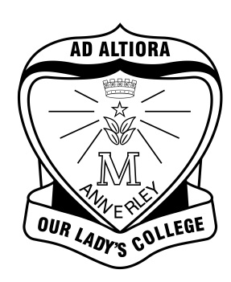
Our Lady’s College
ANNERLEY

POSITION DESCRIPTION
School Officer – Academic Services

School Officer Level 3

QUALIFICATIONS:
Tertiary qualifications at Certificate level or equivalent qualifications relevant to the position may be required or such knowledge, qualifications and experience that are deemed by the employer as necessary to successfully carry out the duties of the position.

CHARACTERISTICS:
The employee in this position is required to demonstrate a high level of competency in organisational management, communication and data management. The nature of the work requires a high level of discretion and ability to observe confidentiality. There is a wide variety of tasks involving the application of knowledge with depth in some areas and a broad range of skills pertaining to academic services. This position requires the School Officer to be competent with a wide range of computer software programs, discrete with dealing with student enquires, and liaison with staff and parents.

An employee in this position may have limited responsibility for guidance for the work of others. Peer assistance may be provided to others and team co-ordination may be required. There are no supervisory responsibilities. Full authority is delegated from the Business Manager/Principal to produce the desired outcomes. Expenditure of funds connected with the position is under the control of the Principal and in her absence the Business Manager.

TYPICAL DUTIES/SKILLS:
Typical duties performed include but are not limited to:
- Carry out a wide range of secretarial and clerical duties at an advanced level including word processing and maintaining manual and computerised records including eMinerva;
- Respond to enquiries from students, staff and parents and the general public and address issues in accordance with routines and procedures;
- Assist in the preparation of internal and external publications;
- Provide administrative support to the Assistant Principal Administration and the Assistant Principal Religious Education;
- Arrange appointments in diaries and prepare correspondence;
- Prepare Mass booklets for liturgies;
- Use software applications to create data base file structures and spread sheets;
- Maintains central filing or record systems in accordance with routines and procedures that include SDCS, SLIMS, e Minerva, and Timetabler;
- Submit data to the QCAA at regular intervals and assist with certification processes;
- Input and maintain data relating to current and future students with regard to personal details and subjects;
- Prepare handbooks and forms for subject information evenings and Awards Night;
- Prepare timetables for students and staff and update the timetable for rotation of subjects in Years 7, 8, 9 and 10;
- Supporting the Reporting process;
- Engaging in all relationships in a manner consistent with the religious nature and ethos of the College.

