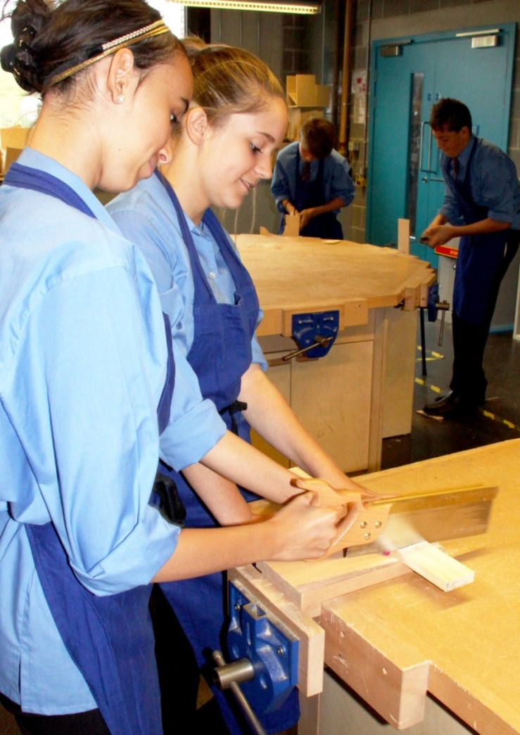
Subject Leader for Design Technology
(RM Specialist)
To start January 2018
Information booklet for prospective applicants

Dear Applicant,
Thank you for your interest in the role of Subject Leader for Design Technology at Christ’s College.
Christ’s College is an exciting place to work with dedicated staff, positive students and supportive parents. At our last OFSTED inspection we were rated as Good and have seen many improvements since that inspection. In 2010 and 2016 we received letters from the Department for Education recognising the improvements we have made. We are looking for colleagues to join us in working to make Christ’s College even better in the future.
In recent years we have seen a significant rise in GCSE and A Level results. In 2015 our percentage 5 or more A*-C including English and Maths was 72%. Our results took a slight dip in 2016 and in 2017 our results rose back to the levels of 2015.
Alongside this rise in academic results, we have also seen a rise in the popularity of the College. In 2014 we increased our intake numbers from 125 to 156. In the last three years we have been significantly oversubscribed and were oversubscribed again for September 2017.
Christ’s College has a small, but growing sixth form. Many staff appreciate the opportunity to teach A Level alongside their KS3 and 4 teaching. At the moment we deliver Food and Nutrition and Resistant Materials to GCSE. We are keen to develop our teaching in DT. This could include extending DT teaching into the sixth form or the introduction of other DT disciplines.
We have a proven track record of excellent professional development opportunities. There are many members of staff who have been given the opportunity of internal promotion and a significant majority of staff who have left us in recent years have gained external promotion.
For all the reasons explained above, I hope you would be interested in finding out more about Christ’s College. I would be pleased to talk to you on the phone or give you a tour of the college if this would help you to find out more about our ethos and vision.
I look forward to receiving an application from you.

Yours Sincerely
Steve Knight
Principal

About Christ’s College
Christ’s College is a thriving 11-18 school serving the non-Christian and Christian community of Guildford, Woking and the surrounding areas. We are proud of our Church heritage and hope that this has helped us to create an environment that is inclusive and supportive of all. Our aim for the children at Christ’s College is that they should develop the character traits of perseverance, resilience and optimism. We know that success only comes through hard work and perseverance; life can be difficult and therefore we all need resilience; but we need to work with optimism and believe that our hard work will open up great opportunities for us.
Over the last few years Christ’s College has been on a journey of sustained improvement. We have seen a significant rise in the percentage of children gaining 5 or more A*-C grades including English and Maths. We are determined to maintain our high standards and ensure that the students at Christ’s College make higher levels of progress than the national average. At the last OFSTED inspection (February 2013) the College moved to being rated as good in all aspects. OFSTED said of Christ’s College:

“Students make good progress from relatively low starting points. They achieve well and enjoy school and the opportunities it presents.”
“The ethos of the school promotes learning. Students feel safe and relationships at all levels in the school are warm and supportive. Students conduct themselves well around the school.”

Alongside the improvement in examination results, the popularity of the College has risen sharply. In 2014, the Governors decided to increase the intake number from 125 to 156. In the last three years the College has been significantly oversubscribed and is likely to be oversubscribed in September 2018. The plan is that Christ’s College will grow from its present size of 750 pupils to approximately 950 pupils by 2020. This increase in size will require an increase in the capacity of both the main building and also the new Sixth Form Centre.
The Faculty System
Christ’s College is split into five Faculties which drive the school forward. To increase the sense of collegiality and collaboration each faculty is located in an area of the College with dedicated teaching rooms, a Faculty office, workroom with PCs and a break-out area for mentoring.
Design Technology is within the Science and DT Faculty. The Science and DT staff are a good team who support each other well and share ideas to improve the opportunities for the students. There is an excellent Food and Nutrition teacher and incredibly dedicated technicians for Food and RM.

Advantages of working at Christ’s College
- There is a real sense of belonging, camaraderie and mutual respect amongst the whole community
- The parents and governors are very supportive of the College and appreciative of the work we are doing
- The children want to do their best and will work hard as they know their teachers are working hard and want the best for them
- The staff are dedicated, skilful and hard-working
- Good opportunities for internal promotion in a growing school which has a tradition of acknowledging and rewarding hard work
- Excellent opportunities for external promotion
- As a relatively small school which offers a full suite of extra-curricular activities, it is easy to be involved in a wide range of enrichment activities in Sport, Performing Arts and elsewhere.

The Role of the Subject Leader at Christ’s College
The Subject Leaders at Christ’s College have a vital role to play in ensuring that the teachers within their subject are delivering excellent lessons, assessing effectively and giving prompt and effective feedback to the students and their parents.
First and foremost the subject leader needs to ensure that they are an effective and successful classroom teacher. They need to meet all the expectations of a class teacher and set a good example for their colleagues to follow.
Schemes of Work and Resources
- Subject leaders need to ensure that there is a robust scheme of work available to all staff.
- It is good practice to involve colleagues in writing schemes of work, but subject leaders need to be conscious of the work load on colleagues and the primary need for teachers to plan and deliver outstanding lessons.
- The subject leader needs to ensure that there are appropriate resources available to class teachers. Again it is good for colleagues to share in the process.
- Class teachers will need to adapt the resources to the particular needs of their class.
- The subject leader must ensure that class teachers are following the scheme of work with an appropriate pace that allows for students to develop a deep understanding of the topic, whilst allowing sufficient time for revision.
Tracking and Progression
- Subject leaders need to develop effective assessments that allow for accurate levelling.
- Subject leaders need to establish effective processes for tracking progress within their subject.
- They need to ensure that each class teacher has a target for their students and is keeping an effective record of student performance.
- They need to ensure that all data for their subject is entered into SIMS on time for each data drop.
- It is essential that data entered in to SIMS is as accurate as possible. Subject leaders need to refine assessment processes to adapt to changes in specifications and any identified inaccuracies.
- After each data drop the subject leader must carry out their own analysis and identify students who need intervention. They must then ensure that the class teacher is implementing these interventions effectively.
- Analysis needs to focus on key groups of learners.
- Information needs to be shared with faculty leaders at every fortnightly meeting and concerns raised at the first opportunity.
Behaviour
- The subject leader must have excellent behaviour in their classes and act as a positive role model to their colleagues.
- Where needed, subject leaders must take a lead in ensuring that behaviour management strategies are shared in subject and faculty meetings.
- Each subject leader needs to have a knowledge of the strengths and weaknesses of their staff so colleagues can effectively share best practice.
- When needed, subject leaders should have students on report to them so they can support colleagues with behaviour management.
- If a colleague has already tried to deal with their own detention, but this has proved problematic subject leaders should support by issuing a subject detention.
Rewards and Sanctions
- Subject leaders should look for ways to enhance the learning experience within their subject.
- Where appropriate they should find extra challenges, clubs or other activities.
- Subject leaders should look for ways to award excellent effort and progress within their subject. This could include letters home and recommendations for faculty awards.
- Subject leaders should monitor house and behaviour points within their subject and identify if there are any underlining issues that need to be addressed.
Personalising learning
- Subject leaders must ensure that their staff have an up to date copy of IEPs or EHCPs for their students.
- Subject leaders should find time in subject and faculty meetings to develop strategies for meeting the needs of the most and least able in their subject. This is particularly important in subjects with mixed ability teaching.
Reporting to parents
- Subject leaders must ensure that colleagues have clear guidance for writing reports to parents.
- They must ensure that colleagues write a meaningful target for improvement that gives at least one tangible way to improve.
- They must also ensure that the achievement section relates to tasks completed and identifiable successes.
- Subject leaders may find it most effective to give colleagues examples of reports that are clear, meaningful and grammatically correct.
- It is recommended that subject leaders work closely with new staff and potentially check a few reports early in the process to ensure a successful report writing process.
- As with data entry, subject leaders must ensure that their staff complete written reports by the published deadline.
- It is hoped that subject leaders will work in a proactive way that ensures that report checking is a fast and simple process.
- If data or reports are ever missing the subject leader must help in ensuring that this is remedied with absolute urgency.
Resource management
- Subject leaders must make sure that college funds are used effectively. They must ensure resources are well managed and find cost effective approaches.
- Where resources are issued in class, subject leaders must ensure that colleagues are following effective processes that ensure equipment is not lost.
- In practical subjects they must ensure that there are effective processes that ensure students are safe at all times.

The job profile for – Subject Leader for Design Technology
JOB TITLE: Subject Leader for Design Technology
DURATION / HOURS: Permanent Post with effect from January 2018
PAY: TLR 2b at £4,574
ELIGIBLE TO APPLY: All teachers with suitable skills and experience
RESPONSIBLE TO: Faculty Leader for Science and DT
LINE MANAGER FOR: A team of Professional staff operating within the Faculty
SELECTION PROCESS: Method: Please complete the application form and write no more than one side of A4 explaining how you would develop teaching and learning across DT at Christ’s College
Deadline: 12.00 noon on Monday, 2 October 2017
Interview date: Friday, 6 October 2017
PURPOSE OF THE POST:
- To assist the Principal in challenging under-achievement with a particular focus on those who are disadvantaged
- To raise attainment and progress in all DT subjects
- To work closely with the Director of Science and DT to ensure the headline statistics for the school are above the national and local averages
- To develop a vision for the future of DT at Christ’s College
- To actively contribute to improvement within DT and the Science/DT faculty
- To promote the Christian ethos of the College
- To carry out any other specific duty assigned by the Principal or his appointed representative

AREAS OF RESPONSIBILITY:
To work with the Principal and Faculty Leader for Science and DT in the following areas:
- Leading and overseeing outstanding practices for teaching and assessment within all DT
- Promoting the latest developments in pedagogical practice within DT
- Building a high performing team of professionals within DT who continually challenge under-achievement and consistently reject mediocrity
- Serving as an ambassador for the school to the wider community, including linked primary schools
- Developing opportunities for enrichment activities within DT especially in STEM fortnight
- Managing academic and other data on all students in DT in order to raise attainment and progress
- Setting up and implementing a rigorous process of self-evaluation which informs future practice
- Promoting Spiritual, Moral, Social and Cultural education (including ‘Britishness’) across DT
- Encouraging and listening to the “student voice” about learning within DT
- Providing quality professional development opportunities for all DT staff

Person Specification – Subject Leader for DT
 |  | Essential | Desirable
1 | Qualifications | Qualified Teacher Status  Honours Degree in Relevant Subject | Post Graduate Qualification
2 | Experience | Proven track record as an outstanding teacher  Proven track record of raising standards in DT  Evidence of using data to track, monitor and motivate students  Experience of implementing change  Excellent track record of attendance | Experience of planning for curriculum change
3 | Knowledge / Skills | Up to date knowledge of examination specifications for GCSE RM  Up to date knowledge of best practice in teaching and learning in RM and the ability to develop the use of this best practice in colleagues  Knowledge of effective strategies for meeting the needs of SEN D and EAL students in RM  Knowledge of effective strategies for meeting the needs of the most able in RM | Up to date knowledge of other DT subjects
4 | Personal Qualities | Resilience, determination and enthusiasm  High expectations of self, students and colleagues  Ability to work as part of a team  Excellent written and oral communication skills  A desire to keep skills and knowledge up to date | A desire for further professional development and promotion  A willingness to contribute to the extra curricular life of the school

