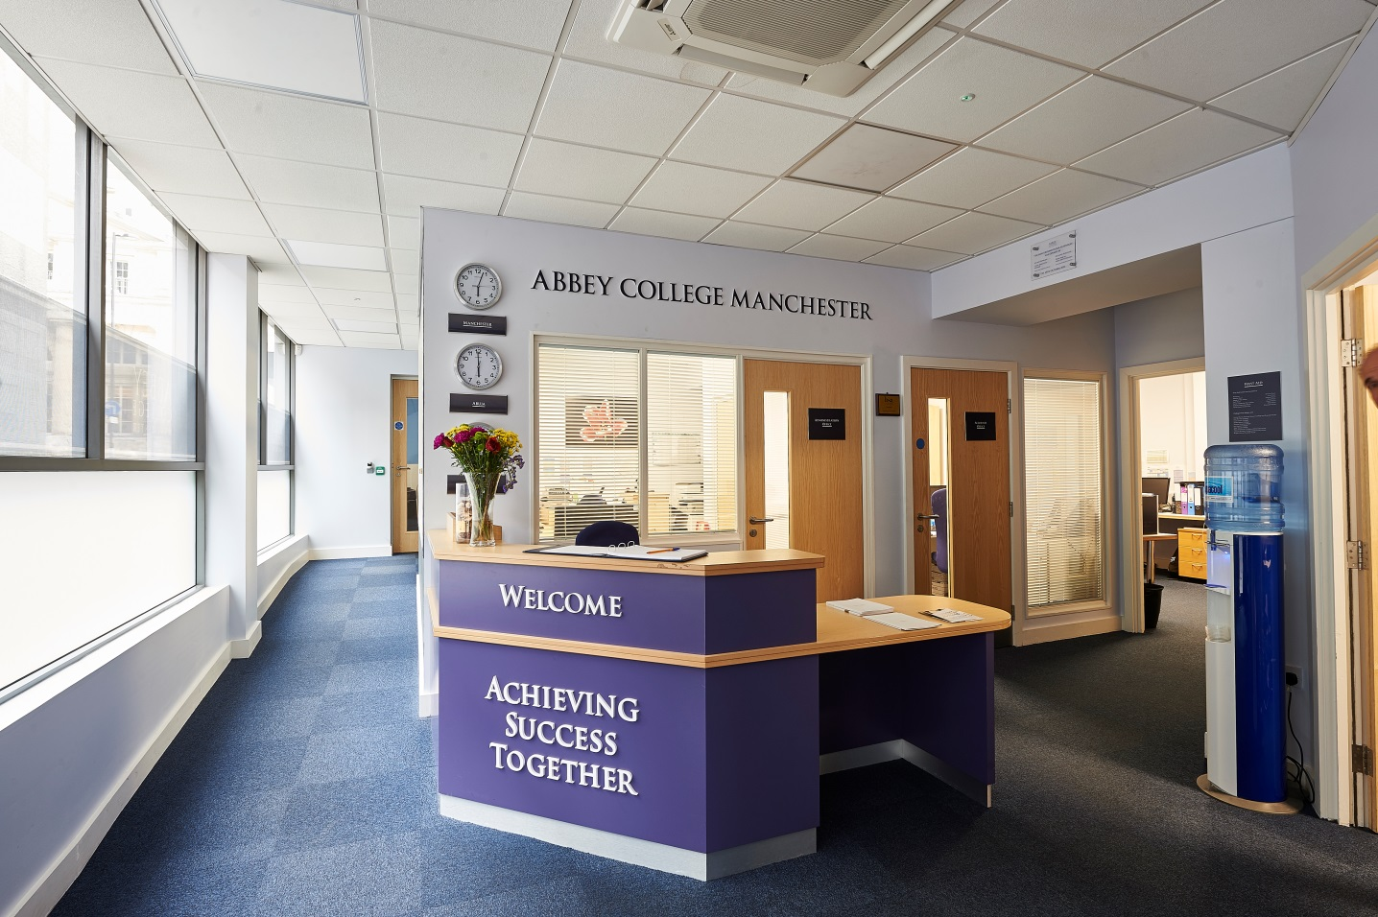

Information Pack:

Economics and Business Studies teacher

October 2019

About Abbey College Manchester

Abbey College Manchester was founded in 1990 and over the past twenty eight years has become one of the leading providers of independent sixth form education in Greater
Manchester. There are approximately 220 students in the college. Within this around 40% are from the Manchester area with the remainder coming from 25 different countries across Europe; Africa; Asia and the Americas.

We aim to:

• guide our students to achieve academic success and fulfil their aspirations
• respect and value each student providing a friendly, safe, supportive environment where students are happy and grow in confidence
• show a sensitive understanding of the challenges facing young people in the 21st Century by
empowering students to make informed decisions and have the determination to achieve their goals
• prepare our students for university, their future careers and to make a positive contribution to the community.

We are a dynamic, exciting college, situated in the heart of Manchester providing high quality, flexible A Level, International Foundation and GCSE programmes. We have recently introduced two unique programmes to complement our offering; these being the Combined Studies Programme and the Academic Studies with football Training Programme. Our modern building provides an environment conducive to study and in our small classes each student can develop their individual aptitudes aided by a strong system of tutorial guidance.

Teaching and learning is rigorous whilst being creative and responsive to individual need. Our enrichment activities include sport, voluntary work, charity events and many other opportunities led by the students and staff. We encourage students to raise their own expectations
and standards to the highest possible level. Staff, students and families get to know each other well and enjoy working together.

At Abbey College Manchester we offer a unique alternative to the traditional school whilst maintaining a strong academic ethos. Everyone contributes, everyone is appreciated; our committed teachers love their subjects and seek to inspire their students, in their turn, to love learning and value the acquisition of knowledge.

The Economic and Business Department

Economics and Business studies are very popular subjects in the college. The department is part of the Maths and Humanities Faculty. Both subjects are studied at A-level and form strands on the Abbey College International Foundation Programme and Combined Studies Programme. Business Studies is a popular subject at GCSE.

The Faculty is expanding under the leadership of an innovative and highly experienced Director. This is an opportunity to make a contribution to respond to the needs of our dynamic college population and recent changes in the subject specifications.

Description of the post

The primary responsibility is for the effective delivery of the curriculum to students and to ensure that students realise their full potential in the subject area. The teacher must be able to deliver Economics at A-level and it would be desirable that they can deliver Business Studies at GCSE and A-level.

Teachers should be aware of the college’s academic targets and be able to contribute to achieving them. Close liaison with the Director of Faculty, Heads of Department Tutors and Heads of House is important. New staff will attend an induction programme and read the Staff Handbook. Staff should make themselves familiar with College Policies and Alpha Plus Group policies.

Responsibilities:

- Preparation of lessons and schemes of work for classes and students in consultation with the Heads of Department
- Delivery of curriculum to students within timescale including the provision of notes, learning materials etc. in accordance with demands of the examination boards, departmental schemes of work and department policy
- Delivery of lessons to accommodate students with moderate learning and language difficulties using the college’s support systems
- Assessment of student work and monitoring of effort for lesson work and independent study and input of the data into SIMS as part of the reporting cycle
- Preparation and marking of tests, homework and mock examinations.
- Preparation of reports to parents.
- Organisation and assessment of coursework and practical work where applicable in liaison with the Head of Department.
- Completing registers at the start of every lesson on SIMS
- Reporting student performance to Tutors/Heads of House and Heads of Department
- Reporting student performance at Parent’s Evening and attending meeting with parents where necessary
- Maintaining a record of marks and grades obtained by individual students.
- Communicating concerns about students to the appropriate person
- Carrying out invigilation duties where required in place of normal teaching hours.
- Weekly cover, study and break duties as timetabled
- Full time teachers will be tutors and will contribute the PHSE programme and writing ucas support statements
- Attendance at department meetings, staff meetings and other college CPD
- Attendance at relevant training courses as advised or requested by Head of Department
- Discussing with Head of Department the examination entries.
- Selection of learning/teaching resources to be used in lessons as approved by the Head of Department/Director of Faculty
- Meeting all college deadlines
- Participation in the college CPD cycle and review of targets set on an annual basis
- Contribution to the general marketing of the college through participation in college events
- Contribution to the recruitment of students
- To report on and be trained in Safeguarding
- Report Health & Safety concerns, ICT or building faults to the appropriate officer in writing or by email. Use of ICT in line with the college policy
- Contribution to the overall wellbeing and good behaviour of students in and around college

If a problem arises with regard to any aspect of a teacher’s working day, then a teacher should seek advice, in the first instance, from their Head of Department or the Director of Faculty.
Salaried staff may be asked from time to time by the Principal to carry out additional duties that allow for the smooth running of the college.

Note: This job description is indicative of the duties and responsibilities of the post but does not form part of any contract of employment. All jobs within the college evolve over time and their features vary from year to year.

Person specification

1. Personal skills and qualities

- High levels of personal and professional integrity
- Commitment to academic excellence
- High degrees of self-confidence, personal energy and dynamism
- Personal warmth, good rapport with students, colleagues and parents
- Excellent organisational skills
- Appropriate levels of personal presentation
- Confident use of ICT
- Confident oral and written English skills

2. Knowledge and experience

Qualifications
- Good academic achievement including A-level Humanties/Maths (or equivalent) and a relevant honours degree in Economics.
- This position is ideal for someone who is looking initially for part time work – there is potential for the position to grow in September 2020

Teaching and Learning
- Experience of teaching A-level Economics is essential, experience of teaching GCSE/A-level Business is desirable but not essential
- Evidence of creative and innovative approach to teaching and learning
- Commitment to improving, monitoring and evaluating teaching and learning
- Commitment to assessment for learning
- Commitment to reasonable adjustments for those students requiring additional support
- Ability to adapt teaching style to accommodate the needs of students whose second language is English.

Philosophy and Ethos
- High expectations for student attainment, personal development and conduct
- Commitment to delivering the curriculum for students of a range of abilities and with a range of English levels
- Commitment to best practice in pastoral support and student welfare
- Commitment to delivering the enrichment curriculum when required

Reporting to:

The Directors of Humanities and Maths and Heads of Departments

About the Alpha Plus Group

The Alpha Plus Group is the parent company of Abbey College Manchester and nineteen other schools. It was founded in 1931 under the name Davies, Laing and Dick. The schools and colleges within the group have developed a longstanding reputation for delivering premium quality education.

In all its educational establishments, the Alpha Plus Group aims to provide a supportive and controlled environment in which children and young people are encouraged to pursue high academic and personal goals as happy and secure individuals. The Group expects that all its staff will be alert to the needs of its pupils and students - including their need for safety and protection - and will put the interests of children and young people first at all times.

Each school and college retains its own identity, with the Heads and Principals afforded significant management authority, but with the benefits of financial security, camaraderie and opportunities for sharing best practice by belonging to one of the country's leading educational groups.

The selection process

Job title: Part time science teacher

Activity | Date
Deadline for receipt of applications | Friday 15th November
Shortlisting of candidates | w/c 18th November
Interview dates | w/c 25th November
Start date | 1st January 2020

Applications will only be accepted from candidates completing the Abbey College Manchester Application Form and Equal Opportunities Monitoring Form. These forms, together with a short covering letter explaining why you believe you are suitable for the role, should be addressed to the Principal and sent to: Abbey College Manchester, 5-7 Cheapside, off King Street, Manchester M2 4WG.

Safeguarding Statement
Candidates should be aware that all posts in the college involve responsibility for safeguarding children. The Abbey College Manchester Safeguarding Statement is as follows: “We recognise our moral and statutory responsibility to safeguard and promote the welfare of all students. We endeavour to provide a safe and welcoming environment where children and young people are respected and valued. We are alert to the signs of abuse and neglect and follow our procedures to ensure that children and young people receive effective support, protection and justice”.

Rehabilitation of Offenders Act, 1974
This post is exempt from the Rehabilitation of Offenders Act 1974 and therefore all convictions, cautions and bind-overs, including those regarded as ‘spent’ must be declared. Please provide full details in a sealed envelope marked ‘Confidential’. The letter will be opened after shortlisting, prior to interview.

References
These will be taken up after interview. As part of this your referees will be asked about your suitability to work with children and whether they know of any disciplinary offences relating to children or young persons (whether the disciplinary sanction is current or time expired) and whether you have been the subject of any child protection allegations or concerns and if so the outcome of any enquiry or disciplinary procedure.

Interview
If you are invited to attend an interview this will be conducted in person and will include questioning on your suitability to work with children. All candidates must bring original documents confirming any educational and professional qualifications that are necessary or relevant for the post (e.g. the original or certified copy of certificates, diplomas, etc.). All candidates invited to interview must also bring their passport or photo ID and proof of the right to work in the UK (if applicable).

Terms and conditions

Remuneration
- The starting salary is dependent on qualifications, knowledge and experience as outlined in the job description.

Hours of work
- The post is sessional (part time) and is dependent on a January intake of students. It is likely to be up to 10 hours in the first instance with potential growth in the future. The post is ideal for an experienced teacher wanting less hours.

Holidays
- All college holidays

Pension provision
Abbey College Manchester is part of the Alpha Plus Group and automatically enrol all new employees (unless requested not to by the employee) onto the company pension scheme. Notification of the pension plan (and all further details including opt out / opt in rights) will be provided.

Offer of appointment
Any offer of appointment is conditional on receipt of satisfactory references, an enhanced DBS clearance, the interrogation of qualifications and proof of the right to work in the UK.

We are committed to safeguarding and promoting the welfare of children and young people.

We expect all staff to share this commitment and to undergo appropriate checks, including enhanced DBS checks.

