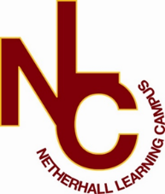

Classroom teacher (fixed term)
Netherhall Learning Campus Junior School

Applicant Welcome Pack


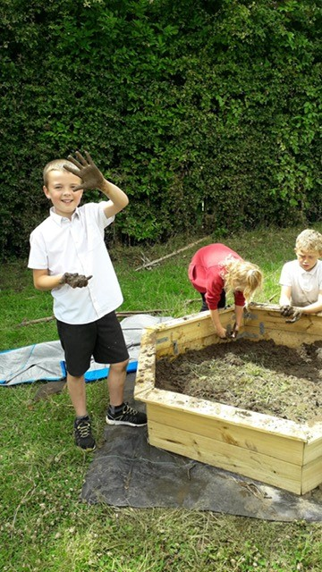


“Success For All”

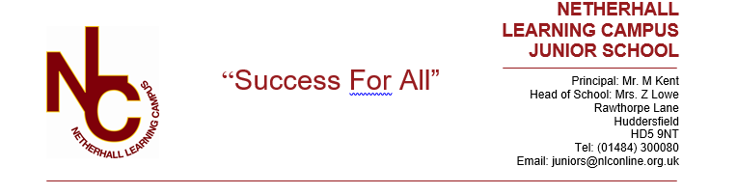
Letter from the Head of School

Dear Applicant,

Welcome and many thanks for your interest in the vacancy at our school. This information pack will provide you with an outline of the role for which you are considering applying and I would encourage you to undertake further research into our school and its community to make sure this is a role in which you can make a significant, positive impact on the lives of our pupils. Additionally, it needs to be the right place for you to develop professionally and to be happy in the next stage of your career.

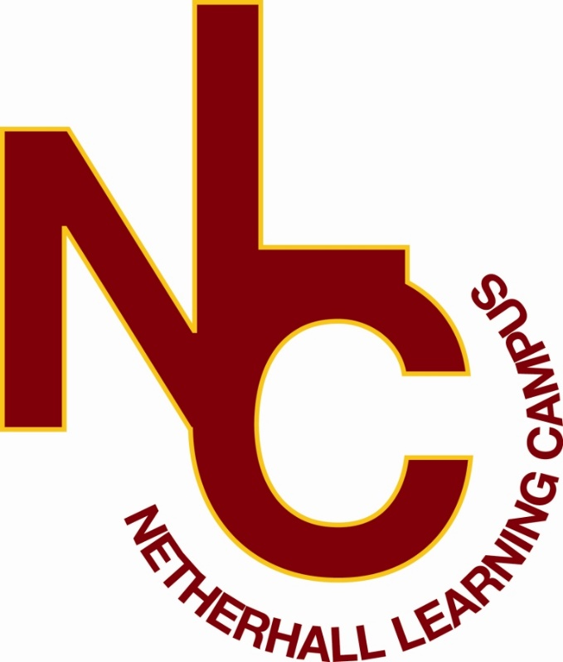
Netherhall Learning Campus consists of four schools, covering the full age and ability range from 3 – 19 years, each with its own distinctive ethos; each with its own individual identity and each catering to the specific needs of its pupils. Whilst the four schools are linked by a common philosophy and by common expectations, each school has its distinct and own characteristics that offer all pupils a continuous journey from Early Years entry through Key Stages 1 to 4 and beyond to Key Stage 5 via the Studio School. We are made up of a diverse community, yet we are all Netherhall.

Our ethos of ‘Success for All’, caring for each other and achieving excellence, underpin everything that happens in our school. I believe education should have a positive impact on all pupils and that Netherhall is the right place for this to happen. We have the highest expectations of all our pupils in every area of school life. Our school is a caring, nurturing and ordered community with an atmosphere of calm and purposeful learning. Pupils are treated as individuals and we recognise and celebrate different abilities, aptitudes and interests and believe that everyone can develop through dedication and hard work. We aim to create an enjoyment for learning and a resilience that is essential for achieving excellence. We work hard to ensure every young person is happy, safe and successful – a credit to themselves, their family and Netherhall. We aim high.

A culture of excellent teaching and learning is at the heart of everything at Netherhall Learning Campus and it isn’t just for pupils; we invest heavily in the continuing professional development of all our staff to improve the pupil experience. Success is not down to one thing but needs some key ingredients: strong classroom practice, an appropriate and personalised curriculum, rigorous tracking and monitoring of progress, commitment and positive behaviour for learning from pupils and support from home. These coupled with a love for learning and a passionate belief that all can achieve are crucial so that every pupil can be the best that they can be.

We look forward to welcoming you into our school community.

Ms Z Lowe
Head of School

Our Vision
The vision of the Campus is one where everybody will aim to achieve the highest standards and where the Campus will maximise everyone’s potential.

“Success For All”
We will:

- provide relevant learning experiences that will enable pupils to acquire the essential knowledge, understanding and intellectual, physical and creative skills to equip them for later life.
- leave pupils at the end of their formal and full-time education with an appetite for acquiring further knowledge, skills and awareness throughout their lives.
- create high expectations of work and behaviour so that each pupil achieves their maximum potential.
- create a caring community whose basis is tolerance, understanding and concern for other people.
- create an inclusive and supportive environment which helps pupils become informed, confident, independent, involved and responsible citizens.
- encourage attitudes that enable pupils to be responsible members of both the school and local community and grow into well-adjusted adults and useful members of society
- recognise our responsibility to provide a safe environment in which all pupils feel included and valued, and in which there is celebration of all personal achievements and acceptance of diversity.
- broaden pupils’ horizons and increase their awareness of the world.



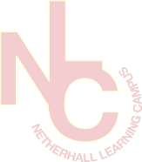

About the Campus

Among Kirklees schools, only Netherhall Learning Campus offers children and young adults with a continuous journey from Early Years entry through Key Stages 1 to 4 and beyond to Diploma, AS and A level studies, via the Studio School.

A continuous journey

Pupils may join any of the schools at any time. Regardless of the stage at which they start to attend, all pupils will experience the unique benefit of an education that has been planned by specialist teachers for all stages of a child’s learning journey.

A common standard and expectation of dress, behaviour and standards of presentation:
- All pupils, regardless of age, are expected to observe common rules of courtesy, respect, honesty and reliability.
- Uniform is the same across the campus.
- From the start of their school career, all pupils are expected to arrive on time and with the correct equipment.
- Work is always to be presented to the best of the pupils’ ability and books are to be respected and kept in good condition.

A recognition of the importance of parents and carers as partners in the learning journey of our children. A dedicated community team works across the campus to:
- Work with parents to help support their children.
- Encourage greater parent and carer participation in school.
- Support adults who may have had a career break, back into learning and into the workplaces.

High quality teaching
- Teachers across the campus meet regularly to share ideas and good practice.
- They share their expertise and help identify and meet the needs of pupils with special aptitude in their subject area.

Innovative curriculum development
- The curriculum is jointly planned by specialist teachers across the campus to prevent unnecessary repetition and stalling of progress at change of school.
- Creativity and opportunities for artistic and musical development are actively promoted and encouraged.

Information
Thank you for taking the time to read this pack where you will find information about the post and the school.
If you would like to be considered for the post, please complete the application form in full, alongside a letter of application, no more than two sides, outlining your relevant experience to date and the contribution you feel you could make to our school.
Please be assured that we take the time to read and consider all applications we receive. However, it is not possible to give feedback to candidates who have not been shortlisted.
We are committed to safeguarding and promoting the welfare of children and young people we expect all our staff to share our commitment. Further information regarding our safeguarding approaches can be found on our website. The successful applicant to this post will be subject to an enhanced DBS check and other pre-employment checks before the appointment is confirmed. Please note CVs will not be accepted.

Position: Classroom teacher (fixed term)
Grade: MPS/UPS
Hours: Full time
Contract: Fixed term 12 months
1st September 2025 to 31 August 2026
Closing Date: 21st April 2025 at 12pm
Interviews: w/c 28th April 2025
Completed application forms should be returned to: admin@nlconline.org.uk
For a tour of the school, please contact juniors@nlconline.org.uk or call 01484 300080

Joining Netherhall Learning Campus

- Netherhall Learning Campus High School is committed to developing all staff within their roles and creating opportunities for further career progression
- Pension – Every employee has access to the Teachers’ Pension Scheme or West Yorkshire Pension Fund.
- Emotional Wellbeing Support via Employee Healthcare Service including Care First a free confidential counselling service.
- Wellbeing Benefits include annual flu vaccination, staff gym and exercise classes
- Cycle to work scheme
- Corporate gym membership – as a Kirklees employee you are entitled to the corporate rate at all Kirklees Active Leisure gyms
- Vivup - discounts across hundreds of the UK’s high-street and online retailers
- Totum Pro – NUS card for professionals

Job Description

SCHOOL: Netherhall Learning Campus Junior School

POST HELD: Teacher MPS

SALARY SCALE: Mainscale

RESPONSIBLE TO: Headteacher

RESPONSIBILITIES:

- To be responsible for carrying out the professional duties set out in the Teacher’s Pay and Conditions document as directed by the Head of School
- To have responsibility for a class of children
- To have a shared overview of the KS2 Curriculum

DUTIES:

CURRICULUM

- To undertake classroom teaching duties across the school
- To contribute towards curriculum development
- A working knowledge of the National Curriculum and Foundation Stage where required
- To have due regard to the requirements of the Curriculum, the School’s aims and objectives, schemes of work and any policies of the Governing Body

PASTORAL

- To have pastoral oversight of the children being taught and to show corporate responsibility for the well-being and discipline of all pupils

GENERAL

- To carry out duties appropriate to the level of a teacher relating to the efficient organisation of the school
- To share responsibility for the best use of the display areas in Key Stage 2.
- Committed to safeguarding and promoting the welfare of children

Person Specification

Qualifications and experience | Essential | Desirable
Qualified Teaching Status | 
Evidence of current Teacher training scheme/course | 
Evidence and willingness to undertake further training and professional development |  | 
Relevant INSET record |  | 
Professional Knowledge and Skills | Essential | Desirable
Knowledge and understanding of recent developments and initiatives in Primary Education – Primary Curriculum | 
Knowledge of the primary age range – KS2 | 
Effective class teaching experience within the 7-11 age range | 
Experience of implementing current educational developments | 
Experience of working with children with additional needs | 
Management of classroom support |  | 
Ability to create a stimulating learning environment | 
Good classroom management and organisational skills | 
Commitment to parental/community involvement | 
Knowledge of current educational issues and developments | 
Knowledge of issues related to the education of children with additional needs. | 
Personal Qualities | Essential | Desirable
Willingness and ability to work as part of a team | 
Willingness to provide extracurricular activities. | 
Flexibility and adaptability to deal with situations as and when they occur | 
Committed to safeguarding & promoting the welfare of children | 

