Barking Abbey School  A Specialist Sports and Humanities College  Sandringham Road  Barking Essex IG11 9AG  Head Teacher: Jo Tupman | 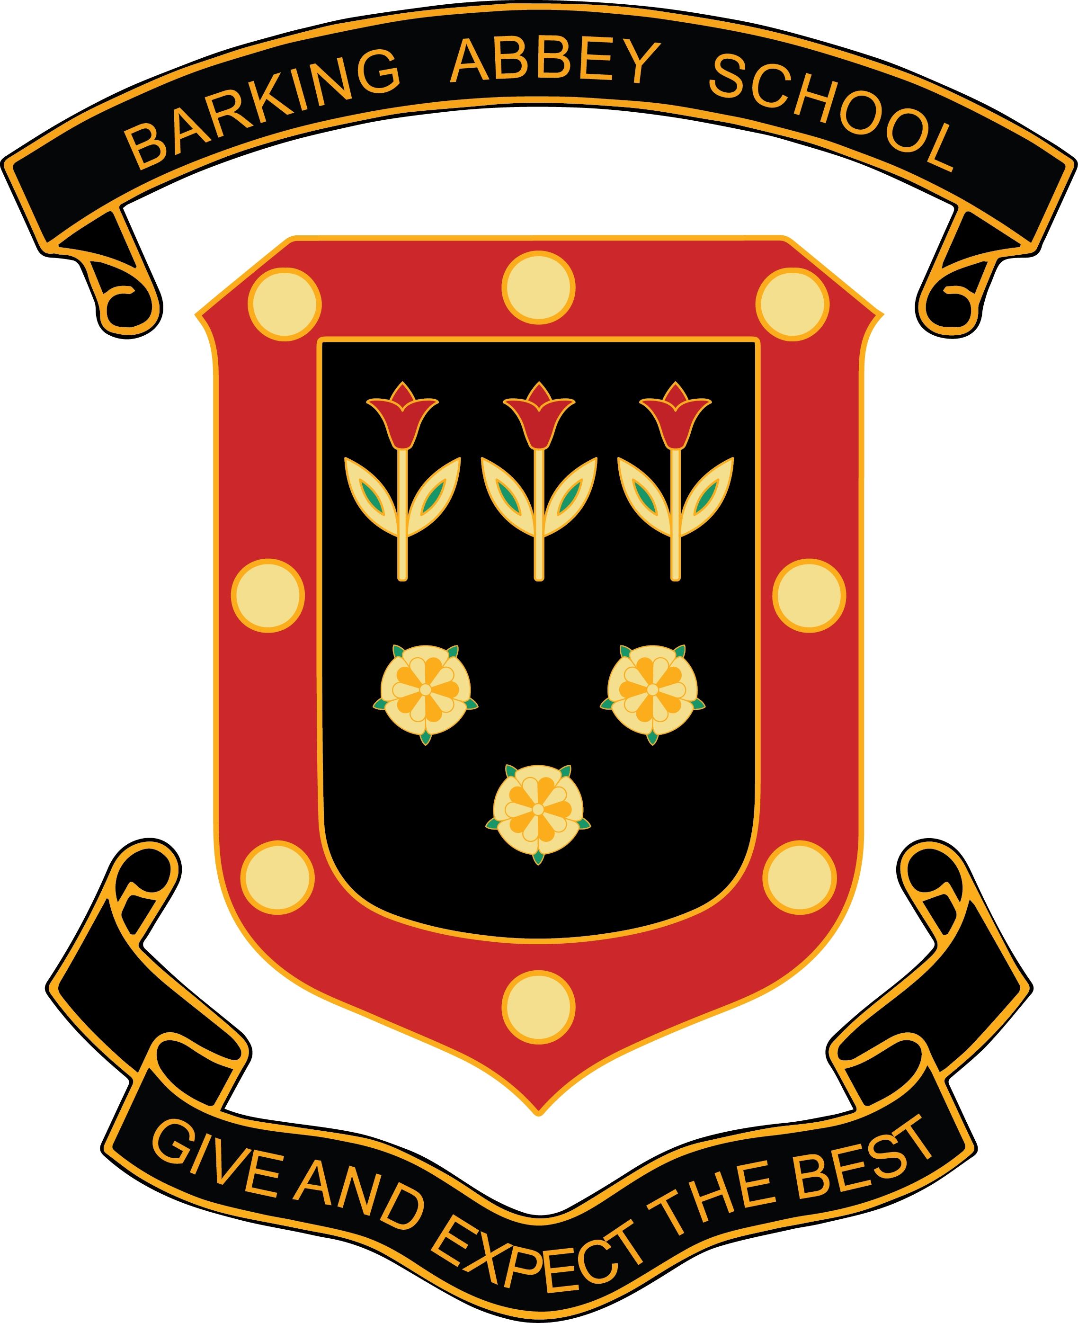
Teacher of Physics
Permanent
Full Time
Start: ASAP
Salary £29,664 - £48,244 (M1 to UPS3) per annum
(depending on experience)
Ref: 0199

NQTs Welcome

An exciting opportunity has arisen at Barking Abbey School for an enthusiastic and innovative Teacher of Physics. The successful candidate must have experience of teaching physics at KS3, KS4 and KS5 for a range of abilities with a QTS qualification.

About Barking Abbey School:
- A good school with outstanding features (OFSTED 2017)
- Visitors regularly tell us how our students are calm and well mannered
- A school where we get to know our students well, find out what they are good at and develop their talents
- Best ever GCSE results in 2017 with 80% of students achieved grades A*-C in Science and 23% obtaining A-A*

Barking Abbey is a heavily over-subscribed split site secondary school in the London Borough of Barking and Dagenham, and has a well-deserved reputation for its friendly and supportive atmosphere and its excellent academic achievements.

Interested applicants should download the teachers application form, found on-line at www.barkingabbeyschool.co.uk

Only fully completed application forms will be accepted, CV applications will not be considered.

Please send applications to jobs@barkingabbeyschool.co.uk

Closing date for this post: Midday 18th March 2019
Interviews: Week Commencing 25th March 2019

Barking Abbey is committed to safeguarding and promoting the welfare of children and is an Equal Opportunities Employer.

This post is exempt from the Rehabilitation of Offenders Act 1974 and a comprehensive screening process, including Disclosure check, will be undertaken on all successful applicants.

