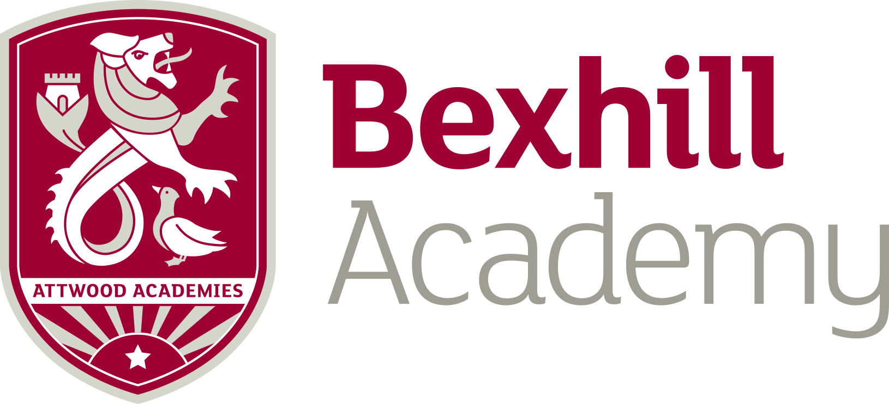

Job Description

JOB TITLE: Reprographics Technician/Administrative Assistant

GRADE: Equivalent to Single Status Grade 3, Points 5-7 currently £16,755 - £17,007 per annum pro rata. Actual salary £14,370.34 - £14,586.77 per annum.

RESPONSIBLE TO: Graphical Design and Print Officer/Principals PA/Business Manager/Business Director

MAIN PURPOSE OF THE JOB: To assist the GD and Print Officer to provide a reprographics service for all staff in the school and also to support the PA to the Principal to fulfil administrative duties required for the Academy.

Bexhill Academy is committed to safeguarding and promoting the welfare of children and young children, therefore all positions are subject to an Enhanced Disclosure and Barring Service check (DBS).

Main Functions

- To assist in producing reprographics work for the whole school

- To help to prepare work for reproduction, to include: word processing, DTP, pasting up, designing, colour work including merits, certificates, letters to students, newsletters, school calendar, exam papers and timetables, work sheets and other similar items

- To assist in the production of school reports and help to copy and prepare them for issue to students

- To assist in the production of posters, programmes and tickets for specific events

- To help to keep the photocopying and print machines in good working order

- To undertake all work in the most cost effective way

- To order, as directed by the GD and Print Officer, appropriate supplies

- To help ensure that the quality of documentation being produced in school and meets house style and standards

- To assist in the provision of a binding and laminating service

- To file original materials

- To deal with internal and external clients in person or on the telephone on a clear professional manner

- Subject to training and experience, the post holder will provide cover for duties of the Graphic Design and Print Officer.

Assisting the Principals PA

- To assist the PA/GD and Print Officer in the production of ‘The Bexhill Beacon’ booklets, leaflets etc

- To assist the PA to the Principals’ to carry out duties effectively.

- To help with the arrangements and setting out for parents evenings and other events such as Graduation and Speech Day.

- To answer the telephone in a clear professional manner and take messages for the Principals PA as required.

- To assist with various Administrative tasks as required including sourcing and producing paperwork for meetings, producing and sending out large mail-outs to parents/carers, sourcing information on the internet and managing data etc.

This job description sets out the duties of the post at the time it was drawn up. The post-holder may be required from time to time to undertake other duties within the Academy as may be reasonably expected, without changing the general character of the duties or the level of responsibility entailed. This is a common occurrence and would not justify a reconsideration of the grading of the post.
Person Specification
Knowledge and experience

Good knowledge of Computers, Word Excel and ideally Publisher
The preferred candidate will have finished their GCSE or other skills qualifications in English and Maths, though consideration will be given to highly motivated young people willing to achieve a qualification in Functional Skills (English, Maths & ICT) at Levels 1 & 2.

Desired skills
- Good Literacy and Numeracy skills,
- Good organisational skills,
- Strong communication skills,
- Professional and clear telephone manner
- Ability to work off of own initiative and also as part of a team

Personal qualities

- A level of maturity commensurate with working in a school environment will be required.
- Motivated, willing to learn and professionally develop
- Committed to self-development
- Does what they say they will do when they make a commitment – i.e. show up on time and not let people down
- Values and respect others
- Effective communicator – good listener, sincere and able to win people over
- Written and verbal communication skills
- Confident to take the lead when appropriate
- Flexible and adaptable
- Committed to collective success
- Socially adept
- Creative and innovative
- A pleasant sense of humour

