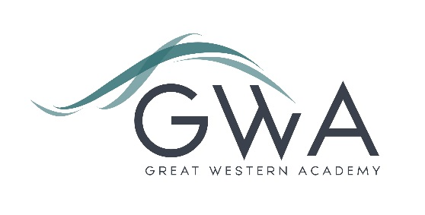

Information for Applicants

SENDCo
Great Western Academy will open in September 2018 in North Swindon. The Academy will educate pupils from Years 7 to 13. The first students will be admitted into Year 7 (PAN 150) and Year 12 (PAN 80) in September 2018. The Academy has attracted a good level of interest from parents of students with additional needs so the role of SENDCo is key to ensuring that these students are well supported to make excellent progress.
An applicant’s briefing pack with full information about Great Western Academy and the role is available on the GWA website at www.gwacademy.co.uk/school-information/vacancies . The role is flexible from 0.4 FTE if acting as SENDCo only through to a full-time role for someone able to offer classroom teaching (in any subject).
As the Academy expands the SENDCo role will need to grow. There will also be opportunities arising for middle and senior leadership roles which our ‘founding staff’ could be in strong positions to fill.
Application process

Please complete the application form supplied and enclose a supporting letter, either in the space provided on the application form or as a separate document. The application form should be completed in full in black ink or type. A CV is not required and should not be submitted as part of the application.

Your supporting letter should be no more than 2 sides of A4 (with a font size no smaller than 11) and should enhance your application by providing further information, matched to the person specification, about your suitability for the post. This should include evidence of the impact on student outcomes you have made in your current and previous roles, particular for students with additional needs. You should also make it clear whether you are applying for a part-time or full-time role and, if more than 0.4FTE, the teaching subject(s) you can offer.

Electronic applications should be returned via email to gwa.recruitment@newcollege.ac.uk. Postal applications can be returned to:

Graham Davis
Principal, Great Western Academy
c/o New College
New College Drive
Swindon SN3 1AH

Applications will be acknowledged within 3 working days of receipt.

Closing Date: 9am Monday 19th February 2018
Interviews: Tuesday 27th February 2018

The interview process will include observation of your teaching and a variety of other tasks and activities.
Great Western Academy is committed to safeguarding and promoting the welfare of children, young people and vulnerable adults and we expect all staff to share this commitment and undergo appropriate checks. All posts within the Trust are therefore subject to an Enhanced DBS and barred list check.

References: References will be taken up prior to interview.

