

Applicant Pack

Student Area Supervisor

Salary: £16,658.54 to £17,195.93 (£23,807.00 to £24,575.00 per annum FTE) – Points 3 to 6 of the Support Staff Pay Scale

Working hours:
- Monday to Wednesday – 7.30 am until 3.00 pm (30 minute unpaid break) – 7 hours per day
- Thursday – 7.30 am until 12.30 pm (no break) – 5 hours
- Friday – 10.00 am until 3.00 pm (no break) – 5 hours

Total weekly hours – 31

Term-time only, minus 5 inset days (38 weeks per year).

FTE: 0.6997

Pension: West Yorkshire Pension Fund, plus Death in Service Grant of 3 x your annual salary

Contract type: Fixed-term contract from 26 August 2025 to 19 December 2025

Other benefits:
- Access to Kirklees Employee Healthcare (e.g. private counselling, physio, etc).
- Eye test vouchers.
- Flu vaccination vouchers.
- Cycle to work scheme.
- Health and wellbeing events throughout the year, including dedicated staff wellbeing day.
- Enhanced maternity and paternity pay.
- Personal and professional development opportunities.

Reports to: Student Area Supervisor Team Leader

Closing date: Wednesday, 02 July 2025

Start date: 26 August 2025
Welcome Letter

On behalf of Greenhead College, thank you for your interest in the post of Student Area Supervisor. We are pleased that you are considering Greenhead College as the next stage in your career, and we hope, subject to matching our criteria, you will apply.

Greenhead College is located on an attractive campus close to Huddersfield town centre, adjacent to the picturesque Greenhead Park. We are a short drive from the M62 and within walking distance of the train and bus station. Therefore, the College is an easy commute from much of the Northwest and Yorkshire.

Approximately 2750 students attend the College studying predominantly A Level courses across 35 subjects, and the College has ambition to grow to at least 2900 students by 2025-26. The academic structure of the College is based on Heads of Curriculum who are subject specialists. The College also maintains a unique tutorial system, with all Personal Tutors being fully qualified teachers, highly experienced in pastoral care, careers guidance and trained in Mental Health First Aid. Students are also offered numerous extra-curricular enrichment activities and a comprehensive programme of projects and work placement opportunities as part of our ‘Step Into Your Future’ scheme.

In March 2025, OFSTED once again graded the College as ‘Outstanding’ and as making a strong contribution to skills needs, with no areas of weakness identified. In July 2024 the College secured the Further Education Mental Health Gold Award, due to the level of support it provides to both students and staff. Both the Ofsted outcome and the Mental Health award recognise the resilience, ambition and success of our students, and the hard work and support provide by all staff, irrespective of their role. Most recently in April 2025, we have been awarded ENA Further Education College of the Year.

The College is a great place to work, with a warm, inclusive atmosphere existing between students and staff. Our staff are recognised for their hard work and are encouraged to inspire each another, and to develop and grow. We are proud to have a strong and able College Leadership Team, and a highly experienced Board, who work collaboratively to deliver the College’s purpose and principles, and strategic priorities.

This is an exciting time to be joining Greenhead College. We were one of only 50 schools and colleges nationally to be granted a multi-million-pound funding to build a new four-storey science block, which opened in November 2023. The final building work and landscaping is ongoing but will be completed by August 2025. The College has ambitious plans for future growth and development on its estate on site.

If you have any queries about this role, please contact our Human Resources Team via email jobs@greenhead.ac.uk who will be happy to help.

We look forward to receiving your application.

Best wishes,

Mo Bunter
Principal

Job Description – Student Area Supervisor

Duties & Responsibilities:
The College looks to appoint a friendly & confident Student Area Supervisor. The successful applicant will join a very friendly, hardworking and dedicated team supporting each other at all times. Applicants should be comfortable within such a team, but equally at ease using their own initiative to solve problems that come their way.

Role-specific responsibilities:

- Ensure that only enrolled students and authorised visitors are on the College premises and deal appropriately with unauthorised visitors.
- Ensure that students are wearing the College I.D. lanyards and take appropriate action if not.
- Encourage good behaviour from students and diffuse potentially difficult situations in a tactful and appropriate manner.
- Carry out routine patrols of the College grounds, car park and buildings.
- Provide assistance to the College Premises team.
- Provide support to other staff members as required.
- Assist in clearing minor spillages as required.
- Intervene to ensure students dispose of litter appropriately.
- Report inappropriate behaviour to personal tutors or senior staff.
- Be a designated First Aider.
- Undertaking further relevant training as appropriate.
- Any other duties as may be reasonably requested by the line manager to allow for the efficient running of the college without changing the general character or level of responsibility.

Safeguarding:

- All staff and senior postholders have a duty for safeguarding and promoting the welfare of children and young persons. Staff must be aware of the College’s procedures for raising concerns about children's welfare and must report any concerns to the Designated Person without delay. Staff must also ensure they attend the appropriate level of safeguarding children training identified by the College as relevant to their role.

General duties - the post holder will also:

- Promote, act as a role model and implement the College’s policies, practices and procedures including those relating to diversity and inclusion.
- Take reasonable care of the health and safety of self, other persons and resources whilst at work. This entails supporting the college’s responsibilities under the Health and Safety at Work Act.
- Demonstrate day to day commitment to the College’s core values of community and mission statement.
- Carry out such reasonable additional duties as may from time to time be determined by or on behalf of the Corporation.

Diversity and inclusion Statement:

The College will seek to ensure that all existing and potential employees and students are given equal opportunities for employment and education. It is committed to the elimination of unlawful or unfair discrimination on the grounds of sex, age, marital status, colour, race, nationality or other ethnic or national origin, disability, sexual orientation, trade union membership or activity and religious background.

The College will seek to ensure that no applicant for employment or education is disadvantaged by conditions or requirements which cannot be justified. The College provides an open, welcoming and safe environment for all its students, employees and visitors.

Employee Wellbeing Statement:

The College is committed to promoting and supporting employee wellbeing to improve working lives and allow our staff to flourish and reach their potential. The employee wellbeing priorities of the College are integrated throughout, embedded in our culture, leadership, and management. Staff are encouraged to talk about mental health, have good self-care routines, and seek help where needed. Employee wellbeing is an integral part of the College’s performance management process, which allows Heads of Departments and the College Leadership Team to regularly review workloads and deadlines in a meaningful way. The College has a holistic framework in place to support staff, including early access to specialist sources of help, such as counselling and physiotherapy, as well as an employee assistance programme, occupational health service and dedicated employee wellbeing days.

Prevent Statement:

The successful applicant will be required to uphold the values of democracy, rule of law, individual liberty and tolerance and have mutual respect for those with different faiths and beliefs.

Mo Bunter
Principal

Student Area Supervisor

Closing Date:

The closing date for applications is Wednesday, 02 July 2025 and interviews will take place shortly after.

Applicants for this post are asked to:

- Complete the College’s application form or TES application form and Equality and Diversity form.
- Write a supporting letter of application, with CV if you consider it useful.

Please send the completed documents to:

Jen Rothery, HR and Recruitment Manager, as an email attachment to jobs@greenhead.ac.uk

Safer Recruitment:

Greenhead College is committed to safeguarding the welfare of all of its students and staff. The successful candidate will have to meet the requirements of the person specification in order to be offered the post and will be subject to safer recruitment checks. This position is working in regulated activity and therefore exempt from the Rehabilitation of Offenders Act 1974. Applicants will be required to self-disclose particular criminal convictions should they be shortlisted for interview. Further details can be found within the DBS filtering guide at https://www.gov.uk/government/publications/dbs-filtering-guidance

All offers of employment are subject to the following pre-employment checks:

- Two satisfactory references
- Enhanced DBS check with barred check list
- Overseas check if you have lived or worked abroad within the last five years
- Evidence of the right to work in the UK
- Prohibition check order
- Qualifications
- Fitness for Work

In line with KCSIE 2024 guidance, all shortlisted candidates will be subject to an online search.

If you apply and are unsuccessful in being called to interview, can we thank you in advance for your time and trouble in making this application. Due to time constraints, it would be impossible to respond to everyone individually - we hope that you will understand.

The college is committed to Diversity and Inclusion and welcomes applications from all sections of the community.



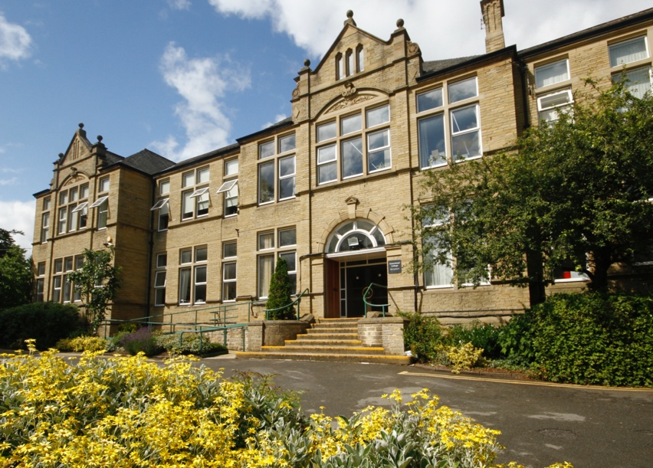


Person Specification – Student Area Supervisor

 | Essential | Desirable
QUALIFICATIONS:
First aid qualification or willingness to undertake one. | x
Mental Health training / qualification |  | x

 | Essential | Desirable
KNOWLEDGE / UNDERSTANDING:
To be prepared to explore and develop new skills | x

 | Essential | Desirable
EXPERIENCE:
Experience of working in an educational environment |  | x

 | Essential | Desirable
SKILLS / ABILITIES:
Ability to maintain a diplomatic and fair but firm approach | x
Strong interpersonal skills, with the ability to build and maintain professional relationships with students and staff | x
Ability to maintain disciplining students in student social areas | x
Ability to work under own initiative and flexible in work if required | x
Basic knowledge of Health & Safety matters |  | x

Essential | Desirable

ATTRIBUTES
Courteous, positive, and can-do approach | ×
A commitment to quality | ×
A willingness to be flexible | x
A proven commitment to safeguarding and promoting the welfare of young people | x
A proven commitment to diversity and inclusion and an understanding of the College’s policies | x
Positive and professional approach with a high level of commitment to the College | x

The above criteria will be assessed by the: Letter of Application, Interview & Assessments.

