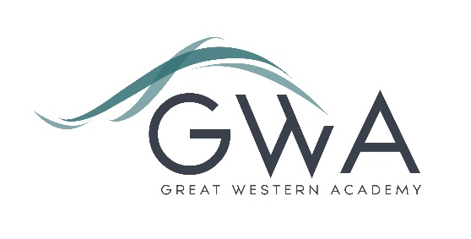

Information for Applicants

Teacher of English (Full-time)
Great Western Academy opened in brand new, state-of-the-art facilities in North Swindon in September 2018. The Academy is heavily oversubscribed in years 7 and 8 and our first cohort of Year 12 students formed our new Sixth Form in September 2019. This includes strong groups of A-level English Language and English Literature students. The foundations we have laid in English are excellent; our small but growing team ensures students enjoy their learning, and the progress made by our first cohort during year 7 was nothing short of phenomenal.
This role is available due to the expansion of the school, and you will join a dynamic and forward-thinking team of four experienced teachers. The post is equally suitable to an experienced or newly-qualified teacher.
As the school grows in future years there is an excellent opportunity for existing staff to shape and develop their role including potentially moving into leadership positions.
An applicant’s briefing pack with full information about Great Western Academy and the role is available on the GWA website at http://www.gwacademy.co.uk/joining-us/vacancies. If you have any questions prior to application you are very welcome to contact us.
Application process

Please complete the application form supplied and enclose a supporting letter, either in the space provided on the application form or as a separate document. The application form should be completed in full in black ink or type. A CV is not required and should not be submitted as part of the application.

Your supporting letter should be no more than 2 sides of A4 (with a font size no smaller than 11) and should enhance your application by providing further information, matched to the person specification, about your suitability for the post. This should include evidence of the impact on student outcomes you have made in your career to date.

Electronic applications should be returned via email to recruitment@gwacademy.co.uk . Postal applications can be returned to:

Graham Davis
Principal, Great Western Academy
William Morris Way
Swindon
SN25 2PP

Closing Date: 9am Monday 27th January 2020
Interviews: Shortly after this date

The interview process will include observation of your teaching, and a variety of other tasks and activities.
Great Western Academy is committed to safeguarding and promoting the welfare of children, young people and vulnerable adults and we expect all staff to share this commitment and undergo appropriate checks. All posts within the Trust are therefore subject to an Enhanced DBS and barred list check.

References: References will be taken up prior to interview.

