Head Teacher Application Pack

Oak Wood Secondary School



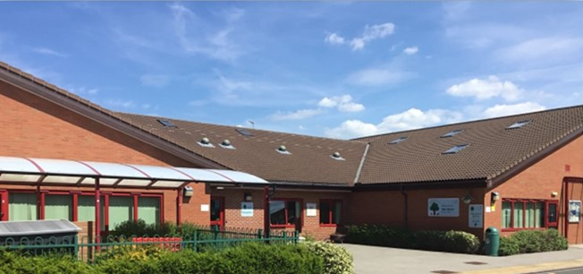







Contents
Letter from the CEO/Principal 3
Letter from the Chair of Trustees 4
Oak Wood Secondary School Overview 5
Ofsted Outcome March 2018 6
Local Area and Location 7
Application Process 8
Selection Process 8
Job Description 9
Main Purpose and Key Responsibilities of Job 9
Duties and Responsibilities 10
Strategic Direction and Development of the Secondary School 10
Teaching and Learning 10
Leading and Managing Staff 11
Headteacher Standards 11
Accountability 12
Person Specification 13

Letter from the CEO/Principal
Dear Applicant,

I am thrilled that you are interested in working for Central England Academy Trust (CEAT). Our Secondary School is part of a thriving three school Multi-Academy Trust (MAT). Oak Wood Secondary School shares the same site with our sister school Oak Wood Primary School. Both schools are oversubscribed generic special schools, meeting the educational needs of young people aged 3 to 19 and are independent of each other but work very closely towards ensuring that resources are fully utilised for maximum impact. In addition, Oak Wood Secondary School manages the educational provision at Jade Unit for young people with significant SEMH needs based at Brooklands NHS Hospital in Solihull. Also part of the Trust, is Higham Lane School which is a high-performing 11-18 Comprehensive School also located in Nuneaton. There is great scope for collaborative work across the MAT.
Oak Wood Secondary School works very closely with the Local Authority (LA), to ensure pupils with Special Educational Needs and Disabilities (SEND) in the local and surrounding areas receive the very best educational provision to meet their specific learning needs. The LA overviews important statutory duties such as admissions and transport; whilst also ensuring that there are enough quality school places for pupils with SEND. As such, we are supported by the LA to ensure that all pupils, regardless of their learning needs, are afforded the very best educational opportunities in our schools.
Both special schools are supported to be as inclusive as possible, with the needs of pupils being met in a variety of settings so that they can flourish and take their rightful place in society. The four broad ‘areas of need’ are Communication and Interaction, Cognition and Learning, Social and Emotional Difficulties, and Sensory and Physical Needs. The curriculum provides a seamless learning pathway for pupils aged 4 - 19 and prepares pupils for their next stage in education and into adulthood.
Fundamental to an excellent education is the importance of forging strong links with parents/carers to gain their support. This promotes a collaborative and proactive approach putting both learning and the wellbeing of pupils at the very core of everything we do. Furthermore, a team approach is very evident in the close work staff undertake with multi-agency professionals where expertise and knowledge are shared towards achieving the very best outcomes for pupils.
We are in a very fortunate position where we have exceptionally strong and talented teams in each school and across the Trust. Staff well-being, welfare and professional development are priorities which are underpinned by our academy core values of collaboration, equity, aspiration and trust. In addition, working towards a work life balance is something we strive to do. We fervently believe that if we get it right for staff, we then get it right for pupils.
You are very warmly welcomed to visit us and this is something I do encourage you to do.
I very much look forward to hearing from you.

George Smith, CEO/Principal



Letter from the Chair of Trustees
Dear Applicant,

We are delighted that you are interested in the post of Head Teacher in Oak Wood Secondary School. The school is part of Central England Academy Trust (CEAT), currently including Oak Wood Primary School, Higham Lane School and with the educational management of an NHS secure unit. In common with all MATs there is a governance structure of Members, Trustees and a Governing Committee for both Oak Wood Secondary and Primary Schools. The strategic management of the Trust is overseen by the CEO.
Oak Wood Secondary School has been judged as good at all OfSted inspections, including at the last short inspection in April 2018. There have been a number of restructures, both of the senior leadership team and of governance in the last few years to consider updated guidance from DfE for MATs and to meet the needs of the academy. CEAT benefits from experienced and highly committed trustee and governor members who are very supportive of the senior leaders. We would like to assure the new Head Teacher that we intend this support will continue to be both challenging and supportive.
Any applicant will need to be willing to embrace change and be a team player. Both the Primary and Secondary schools are increasing in pupil numbers to help meet Warwickshire Education Services demand for special school places. Additionally, we are developing outreach services to better support mainstream schools in meeting the special educational needs of their pupils. This is an area we hope Oak Wood Secondary will develop further in the future.
The DfE has indicated its wish to see the multi academy trust system grow and expects all MATs to look at bringing more schools into the Trust. This is another area of strategic growth we are working on and which will require commitment from the new Head Teacher.
Our 14-19 provision has developed under the direction of the Deputy Headteacher, to improve the vocational curriculum and to increase work experience and work placement opportunities. Although the Covid pandemic negatively impacted some of these opportunities, they are again being built up. Two of our priorities are to ensure our pupils are given the best opportunities possible for their future lives and also to support the mental health and well-being of both pupils and staff. We will expect our new Headteacher to support these principles. There are many challenges to face in this post and we are looking for a candidate who will embrace the challenges and be ready to take Oak Wood Secondary forward from its already strong position to match the current and changing needs of pupils and students in Nuneaton and surrounding areas.
We hope you will want to take your application forward and look forward to receiving it.

Hilary Ward, Chair of CEAT Governing Board

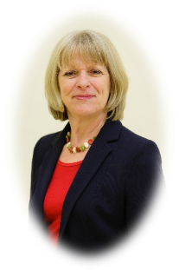

Oak Wood Secondary School Overview

Summary

Oak Wood Secondary School is part of Central England Academy Trust, joined currently with Oak Wood Primary School. We take young people from Year 7 to Year 11. We also have a thriving Post 16 department. We are a generic broad-spectrum special school and all of our pupils have an EHC Plan. Most of our pupils come from Nuneaton, Bedworth and North Warwickshire. We work hard as part of the community to support all the needs of our pupils and families, to develop links and pathways with others and to ensure that our young people leave school ready to take part in the world as valued citizens.

Pupil Data
Pupils on roll | Total | Boys | Girls
Pupils on roll | 171 | 122 (71.35%) | 49 (28.65%)
Free School Meals | 81 (47.37%)
What do our families think…?

“My son has come a long way since attending school”

“We are very pleased for all the outcomes and support that we receive”

“I have been very impressed how much my son has moved on in Secondary”

“My child has really come along. He is happy and content”

“Everyone is good and helpful”

“My daughter is so much so much progress and her confidence has increased no end”

“My son adores coming to school. Whatever you’re doing you’re doing it right”

A Values Driven Trust

Our core values Collaboration, Equity and Aspiration and Trust underpin everything we do. We provide a broad, enriching learning environment for all of our young people, whatever their special educational need or disability.
We are committed to being a safe, caring school, which provides a curriculum, dedicated to the needs, development and aspirations of every individual and family.
We believe that our personalised approach enables, challenges and supports our young people to become valued members of society in the future. It is our belief that our young people, where at all possible, should have opportunities to excel in field of employment. To this end the school has focused on developing its vocational
provision and has forged links with many local businesses.

Ofsted Outcome March 2018
Rated Good

“The leadership team, through visionary leadership, have maintained a good quality of education. This is shared by governors, leaders and staff.”

“The pastoral care provided by the school is a significant strength.”

“The good ethos of the school is followed into practice.”

“Pupils enjoy coming to school. They have a real sense of community.”

“There is a high focus on learning targets.”

“Pupils are engaged in their learning.”

“Staff are skilled in using a range of communication methods.”

“There is an analytical approach to pupil outcomes and identifying areas for developing opportunities”

“Safeguarding arrangements and support of well-being is clear and highly effective.”

“Pupils feel safe and know what to do to ask for help”

“As a senior team there is a clear understanding of the priorities for improvement and how to achieve them.”

“Staff work together effectively to ensure that the school is a calm and friendly place”

“Staff make a positive difference to the lives of pupils and their families”

“Governors are well informed and have an excellent overview of the school’s effectiveness”

Local Area and Location
Local Travel
Oak Wood School is less than 2 miles from the M6 junction 3 which provides easy access to the Midlands motorway network of the M6, M69, M42 and M5. This means it is easy to reach Midlands towns and cities and their attractions including:

Coventry - Cathedral, Coombe Abbey, Transport Museum, Belgrade Theatre, Ricoh Arena Birmingham - NEC, NIA, Cadbury World, numerous theatres, shops and sporting venues Leicester – Resting place of Richard III, New Walk Museum, Abbey Park, Cultural Quarter Warwick, Royal Leamington Spa and Shakespeare’s Stratford-upon-Avon.

Birmingham Airport can be reached within 30 minutes’ drive and good rail links include
London Euston less than an hour away and Birmingham and Leicester only 30 minutes.
Nuneaton
Nuneaton is a market town, the largest in Warwickshire, with a population of
approximately 87,000. It is currently
undergoing a significant house building
programme with new estates containing a variety of housing.

It is the home of George Eliot, with a town
museum and art gallery, Pingles Leisure
Centre, several private gyms, the Arbury Hall Estate and Hartshill Hayes Country Park, all within its boundaries. Bosworth Water Park, Hoar Park Craft Village and Children’s Farm and the smaller market towns of Atherstone, Hinckley and Coleshill are all nearby. There is a cinema, ten pin bowling alley, a soft play centre and Bedworth Civic Hall hosts a variety of music, comedy and theatre.

Oak Wood Primary and Secondary School
Morris Drive
Nuneaton
CV11 4QH

Tel: 02476 740901
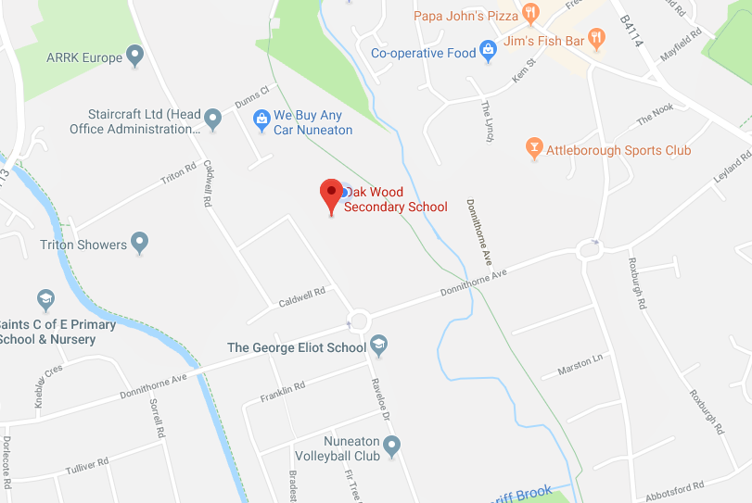

Application Process

Closing date for applications: 9am, Thursday 26th January 2023

Interview date: Monday 30th January 2023

Please return application by email to: JWalters@oakwoodschools.co.uk

Selection Process
Stage 1

Send completed application form to Julie
Walters by 9am, Thursday 26th January 2023. Please include a covering letter evidencing how you fulfil the person specification.

Please use the application form
provided.
Stage 3

Interviews will take place on Monday 30th January 2023.

Candidates will take part in a number of recruitment activities, an unseen presentation and a formal interview.
Stage 2

Applications will be
reviewed and a short list produced for interview. Short listing will take place on Thursday 26th January 2022.

Successful applicants will be notified by email and by telephone on that day.

Please Note
We welcome and strongly encourage informal visits to the school by prior arrangement.
Please telephone Victoria Sheppard, HR Officer to arrange a visit on 02476 740901.
We very much look forward to meeting you.

Job Description

Name: | Starting Date: April 2023
Salary Grade: L28 – L34 | Status of Post: Head Teacher
Responsible to: Chief Executive Officer/Principal | Review Date: Annually
Hours: Full Time

Main Purpose and Key Responsibilities of Job

To support the Chief Executive Officer in providing strategic leadership for Oak Wood Secondary School constantly striving for success and continuous improvement and ensuring high quality education for every pupil. To deputise for the CEO when he is absent from school. In conjunction with the Board of Trustees to provide professional leadership which secures the success and improvement of the school. To ensure high quality education and care for the pupils so that they are safe and happy at school, enabled to be successful learners and thus achieving high standards. To drive forward and promote the shared vision and values of the Trust and ensure that robust systems and structures are in place to enable all staff to meet the needs of every pupil. To relentlessly strive to raise standards.

- Principal lead for teaching and learning across Secondary School
- Designated Safeguarding Lead and Child Protection Coordinator for Secondary School including overviewing the Single Central Record and completion of related whole school documentation
- Lead appraiser and coordinator for staff performance management across Secondary School (SLT, multi-agency staff, and all classroom staff)
- Strategic lead for budgetary control and finance management across the Secondary School supported by the School Business and Operations Officer
- Principal lead and coordinator for Secondary School development and evaluation procedures including quality assurance
- Coordinate the development and implementation of whole school policies within the Secondary school
- Coordinator for recruitment of new staff induction for the Secondary School and Lead Mentor for ECTs
- A member of the Trust Executive Team

This job description covers the overall areas of strategic responsibility; however, further specific tasks and responsibilities will be determined through consultation and discussions with the CEO.

This job description may be amended at any time, following consultation between the CEO and member of staff, and will be reviewed annually.

Duties and Responsibilities

You are required to carry out the professional duties as set out in the School Teachers’ Pay and Conditions Document.

Strategic Direction and Development of the Secondary School

- Support the CEO and Board of Trustees in promoting the vision and direction of the Trust through the implementation of a range of well-planned strategies to enabling staff to work to their full potential
- Lead and advise on the best teaching and learning strategies and ensure that the curriculum and where appropriate external accreditation meets the specific needs of all pupils. To make certain that pupils have the very best life opportunities to meet their current needs and beyond
- Work closely with the Trust board as a member of the Executive Team
- Ensure the commitment of all who are involved in Oak Wood Secondary School so that Trust aims and objectives are successfully realised. To hold staff to account when necessary through rigorously following Trust policy and procedures
- Strategically lead on the Secondary School Development Plan and School Evaluation Summary ensuring reports are presented professionally and is submitted in a timely manner
- Lead on and manage the school budgets to ensure financial efficiency for the best value with support and guidance from the School Business and Operations Officer and Finance Manager
- Report directly to the CEO and the Board of Trustees on a termly basis on pupil progress and impact of various initiatives. To ensure that Trustees and CEO have full access to pupil data on pupil progress, behaviour and standards in teaching and learning when this information is requested
- Collaboratively work with the Local Authority on expanding the school to meet the increasing needs for special school placements in Nuneaton and the surrounding areas
- Support the Trust to forge links with the local community

Teaching and Learning

- Lead on teaching and learning in the Secondary School ensuring that there is excellent provision covering all SENDS
- Overview the curriculum and where appropriate accreditation and in order to provide bespoke and personalised learning programmes for every pupil across the school.
- Oversee pupil progress ensuring that all pupils achieve well whatever their starting points or circumstances
- Overview total communication with the aim that it is an expectation that all staff and every pupil to communicate in a manner that suits their personal learning needs
- Model exemplar classroom practice to support staff development
- Lead teaching and learning training initiatives
- Collate evidence of impact from lesson drop-ins
- Lead on supporting and monitoring teachers to meet standards set out in the professional development framework with a view of each teacher being consistently good or better.
- Overview high standards of pupil behaviour and ensure that reports on behaviour are submitted in a timely manner
- Oversee learning and support well-being programmes that promote pupils’ welfare, Fundamental British Values and health and sex education
- Constantly strive for consistently high standards of education and that learning programmes are developed and kept under review through holding teachers to account
- Lead on TA training programmes and provide evidence of impact
- Have an in-depth understanding of current educational theory and practice relating to pupils with special needs and inform staff of these developments through leading on training initiatives

Leading and Managing Staff

- Lead on the Secondary school’s Performance Management of all classroom and selected multi
agency staff
- Overview CPD across the Secondary school so that all staff receive training that is appropriate to the current School Development Plan. Map out and cost training plans to ensure fairness of opportunity for staff and that training is directly related to the Secondary SDP. Report on the impact of training through staff feedback and consequent training sessions led by staff
- Overview IBPs, Risk Assessments and relevant documentation related to pupils. Expect and ensure that these documents are consistently implemented, monitored, evaluated and updated in line with Trust policy
- Lead staff INSET and develop a staff training programme for Secondary staff for identified training days and Monday and Wednesday twilight sessions.
- Overview pupil annual reviews and plans
- Coordinate robust induction and support for new staff during their first term
- Lead Mentor for ECTs

Headteacher Standards

These standards underpin best practice and will shape the professional and personal development of the Head Teacher to raise standards and support the successful implementation of whole school initiatives and priorities. The ten Headteachers’ Standards outline the expectation of the Trust:

- School Culture
- Teaching
- Curriculum and Assessment
- Behaviour
- Additional and Special Educational Needs and Disabilities
- Professional Development
- Organisational Management
- Continuous School Improvement
- Working in Partnership
- Governance

Ensuring leadership has a decisive impact on the quality of teaching and pupils’ achievement is at
the core of everything we do to facilitate the best outcomes for all young people in the school.

Accountability

Accountable for measured outcomes and impact of strategies and initiatives in relation to:

- Pupil progress
- Behaviour
- Keeping children safe

Evidenced through:

- Termly pupil progress data report. Outcomes and impact.
- Half-termly Behaviour Watch Reports
- Secondary School Development Plan
- Secondary School Evaluation Summary
- Termly Secondary School Reports to Trustees
- Head of School termly Plan of Action
- Termly appraisal meetings with the CEO

Other

- Directly work with the Local Authority on matters relating to pupil admissions through representing the school on the Admissions Panel
- Undertake other reasonable duties as may be requested by the CEO



Central England Academy Trust is committed to
safeguarding and promoting the welfare of all pupils
and expects staff and volunteers to share this
commitment.

Person Specification
Qualifications and Training | Application Form | Reference | Lesson Observation | Task | Interview
Qualified Teacher Status | ✓
Preferably relevant qualification in special educational needs | ✓
Substantial teaching experience in a special school | ✓
Recent and relevant involvement in professional development | ✓
NPQH or willingness to undertake this qualification | ✓
Experience | Application Form | Reference | Lesson Observation | Task | Interview
Substantial experience at a senior level in a special school | ✓ | ✓ |  |  | ✓
Proven track record of raising standards and challenging underachievement | ✓ |  |  |  | ✓
Experience of holding others to account including challenging underperformance | ✓ |  |  |  | ✓
Knowledge and Skills | Application Form | Reference | Lesson Observation | Task | Interview
A thorough knowledge of safeguarding and safer recruitment procedures | ✓ | ✓ |  |  | ✓
Ability to develop and promote a shared vision and the leadership and management skills to ensure its realisation | ✓ |  |  | ✓ | ✓
Effective leadership skills in Performance Management to enable good outcomes or better and proven track record of holding staff to account | ✓ |  |  | ✓ | ✓
Understanding and knowledge of budget management to ensure best value | ✓ |  |  | ✓ | ✓
Ability to lead school self-evaluation and link outcomes to school development and MAT priorities | ✓ |  |  | ✓ | ✓
Full knowledge of different curriculums and assessment procedures | ✓ |  | ✓ | ✓ | ✓
Creating the Future | Application Form | Reference | Lesson Observation | Task | Interview
Can think strategically and communicate a coherent vision that promotes high standards for all | ✓ | ✓ |  | ✓ | ✓
Has the skills to inspire, motivate, compel and expect others to carry the school’s vision forward | ✓ | ✓ | ✓ |  | ✓
Is able to contribute towards the vision of the MAT as a leader and a member of the Executive Team | ✓ |  |  |  | ✓

Leading, Learning and Teaching | Application Form | Reference | Lesson Observation | Task | Interview
Excellent knowledge and understanding of the curriculum | ✓ |  | ✓ | ✓ | ✓
Sound knowledge of different SENDs | ✓ | ✓ | ✓ | ✓ | ✓
Ability to demonstrate outstanding practice in the classroom | ✓ | ✓ | ✓ |  | ✓
Understands the importance of managing data and analysis of pupil progress | ✓ | ✓ | ✓ | ✓ | ✓
Developing Staff and Working with Others | Application Form | Reference | Lesson Observation | Task | Interview
Is a leader and a team player | ✓ |  |  |  | ✓
Have an in-depth understanding of leading with emotional intelligence | ✓ |  |  |  | ✓
Commitment to lifelong learning for self and others within the school and community | ✓ |  |  |  | ✓
Possess a passion to perform the role and the persistence in achieving goals | ✓ |  |  | ✓ | ✓
Adaptable and flexible, adjusting to multiple demands | ✓ | ✓ |  | ✓ | ✓
Well-developed interpersonal and communication skills |  | ✓
Experience of working with a wide range of services and partners providing support to children and you people with special educational needs | ✓ | ✓ |  |  | ✓
Successful experience of working with pupils with SLD, PMLD, ASD, MLD and SEMH | ✓ | ✓ |  |  | ✓
Strong people management skills with evidence of impact
Have an in-depth understanding of leading with emotional intelligence
Have a very good sense of humour |  |  |  |  | ✓
Be passionate, calm and driven |  |  |  |  | ✓
Have excellent personal skills and proven ability to communicate effectively with stakeholders | ✓ |  |  | ✓ | ✓

While the majority of the responsibilities will relate specifically to the Secondary School there will be occasions for team activities related to whole school priorities across the Trust

