Information for applicants  Clifton School and Nursery  (St Peter’s School, York)  Foundation Stage Teacher to lead the Nursery from April 2018 (September for an exceptional candidate)  (Full Time – Permanent) | 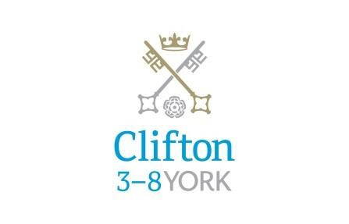

The Post

We are seeking to appoint a creative and innovative Foundation Stage Teacher to lead our Nursery. The successful candidate will have a strong ethos and passion for Early Years education, as well as a commitment to continuous improvement of their own practice.
The successful candidate will contribute wholeheartedly to deliver the exciting vision at Clifton School and Nursery and St Peter’s School (3-18). The school can offer a supportive environment for ambitious teachers to thrive.
The post is suitable for experienced practitioners with a proven track record of working in Nursery and of leading a team.

Salary

Competitive salary based on the St Peter’s Teachers’ Salary Scale.

Overall Purpose of the Post:

- To follow and show full support for the aims and ethos of Clifton School and Nursery and St Peter’s School (3-18)

- To create and develop a positive, happy culture where every child feels safe, valued and has fun learning through high quality play experiences.

- To be an energetic, innovative and creative teacher catering for the needs of each child.

- To lead the team of staff in Nursery effectively and support them in developing their own practice.

- To reflect on current practice, improve and lead positive change in Nursery.

- To build relationships with parents that benefit the child’s learning and development.

- To work closely with the EYFS co-ordinator to deliver a cohesive EYFS.

Key Responsibilities

Teaching and Learning

- To deliver the EYFS curriculum.

- To recognise and meet the individual needs of each child within the class.

- To plan and facilitate the next steps for each child in collaboration with Nursery staff.

- To plan and resource a stimulating and exciting enabling environment based on the needs and interests of the children.

- To engage in appropriate continuing professional learning and keep abreast of current educational initiatives.

- To support the school in achieving its aims as outlined in the School Improvement Plan.

- To teach within the framework of the school policies (St Peter’s Teaching Standards)

Assessment and Reporting

- To monitor children’s progress and keep meaningful records evaluating progress and performance.

- To communicate fully with parents both verbally and in writing, by means of parents’ meetings and reports.

Pastoral

- To establish and maintain good relationships with children, parents and colleagues in line with the principles of inclusion.

- To share pastoral responsibility for the welfare and safety of all the children in the care of the school.

Other Professional Duties

- To undertake supervisory duties as allocated by the Head Teacher.

- To take a full part in all aspects of school life.

- To participate in meetings to discuss curriculum, pastoral and other issues including staff meetings, departmental and whole school meetings as required.

- To undertake any other suitable duties that the Head Teacher may require from time to time.

- To attend school events and activities as necessary.

- To comply with all relevant school policies and procedures including Health and Safety requirements.

- To work effectively with subject co-ordinators and support staff.

The School is committed to safeguarding and promoting the welfare of children and young people and expects all staff and volunteers to share this commitment. The successful applicant will be required to undergo checks with the Disclosure and Barring Service.
All staff at St Peter’s School are required to observe all relevant Health and Safety, Equality and Data Protection legislation and procedures.
Note: This job description is not a comprehensive definition of the post and the post holder will be expected to undertake any other tasks commensurate with the duties and responsibilities of the post. The job description will be reviewed as part of the cycle of appraisal, and it may be subject to modification or amendment at any time after consultation with the post holder.

Person specification
Criteria | Essential | Desirable | Assessment
Experience | Relevant classroom teaching experience at Foundation Stage  Experience of leading a team |  | Application  Interview  References
Qualifications | Qualified teacher status.  A degree or equivalent qualification in a relevant subject area | Evidence of continuing professional development | Application
Specialist Knowledge | A thorough up to date knowledge of the range of teaching, learning and behaviour management strategies and how to implement them effectively  A thorough understanding of the EYFS curriculum and assessment requirements and arrangements  Knowledge and understanding of the implications of equal opportunities, multicultural education and inclusion  Knowledge and understanding of the computer technology and its ability to enhance the curriculum  Thorough knowledge of the legal requirements and national guidance on the safeguarding of children | Use of local, national and statistics to evaluate the effectiveness of teaching | Interview  References
Skills / Abilities | Effective teaching skills with the ability to prepare and plan effectively  Ability to prioritise and manage time effectively  Excellent communication skills with the ability to develop and maintain good relationships with colleagues, pupils and parents  Willingness to participate in a range of co-curricular activities |  | Application  Interview  References
Personal Attributes/Competencies | A commitment to safeguarding and protecting children and young people  Passion for teaching with the ability to motivate and inspire students as well as acting as a role model  Commitment to the ethos and values of the School and make a positive contribution to all aspects of school life |  | Application  Interview  References

How to Apply

Applications

To apply for this post, submit a school application form, completed in full, with a covering letter. Please do not send CVs, either in place of or as an attachment to the application.

If you would like to visit the school prior to application please contact the Head’s PA via the details below.

For an informal discussion, please contact:

Mr Philip Hardy, Head of Clifton School and Nursery (St Peter’s School),

Tel: 01904 527372 or 01904 527361
E-mail: c.fattorini@cliftonyork.org.uk
Appointment schedule

Application deadline: Friday 26th January at 10.00am
Interview: Week commencing 5th February

About St Peter’s
Background

St Peter’s School, York comprises three schools: St Peter’s School (pupils aged 13 – 18), St Olave’s School (pupils aged 8 – 13) and Clifton School and Nursery (pupils aged 3 – 8 years). The school is fully co-educational with 1,100 pupils, of whom 158 are full time boarders and 231 are in the Sixth Form. There are over 300 teaching and support staff. It is one of very few schools in the North of England to offer three distinct phases of education, each sharply identified and focused towards the needs of its pupils at each age group and set within an overall context of trust, confidence-building, inspiration and opportunity.

St Peter’s is one of Europe’s oldest schools, founded in 627AD, and is ranked in the top 100 schools in the country for its academic results. The school is located within a short walk of York city centre, with its thriving cultural, educational and commercial life. Many of St Peter’s facilities are modern and spacious, with playing fields adjacent to the main building that stretch down to the River Ouse.

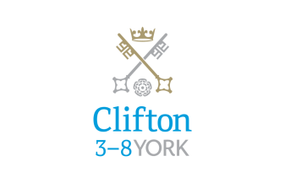

Clifton School and Nursery

Clifton is a thriving and successful co-educational IAPS school for day children from ages 3-8 years. It is part of the St Peter’s School’s 3-18 which includes the Junior School, St Olave's and The Senior School, St Peter’s.

The three schools have their own identities and separate Heads, who work closely together in the Whole School Leadership Team, which is chaired by the Head Master of St Peter’s. Clifton has around 200 children from Nursery to Year 3.

In our last inspection in April 2017 we were rated as excellent in all areas. Clifton has also been shortlisted as a finalist for the TES awards for best Prep school which take place in February.

At Clifton we believe that education should be full of wonder and awe and capitalise on children’s natural curiosity. Our children are full of energy and anticipation, eager to learn and ready to discover what will be next in their learning adventure. Throughout our school children can be seen engaged and engrossed in their learning. They are keen to proudly share their achievements, as well as their struggles which they accept as an integral part of the learning process. Our school is a vibrant and exciting place to be. It is a positive place to be. It is a place where everyone is celebrated and accepted. Our school offers more than mere academic success, it offers an innovative and inspiring place for our pupils to learn and develop in every sense.
“Everyone that comes into contact with Clifton feels the buzz of learning and enthusiasm.” Year 3 Parent
Our curriculum is designed with pupil experience, engagement and enjoyment as the key to achieving our goal of creating a lifelong love of learning in each and every child. We acknowledge that when our pupils are excited, motivated and inspired to learn they will achieve and develop the necessary attributes and skills to enable them to be truly successful.
“The thematic curriculum for Clifton pupils aims to foster and embed lifelong learning.” ISI Inspection April 2017
At Clifton we have a thematic curriculum. Our themes are chosen to inspire and excite the pupils and always with the children’s interests in mind. They provide the vehicle through which we teach the key skills from the EYFS framework and our Learning Ladders, the curriculum that we have created. Themes are original, they are purposeful and they draw together all subject areas, so that they are interwoven to provide a rich learning experience.
“The Clifton pupils are absorbed in a richly colourful, themed environment, rapidly learning new vocabulary, using it in conversations and applying it as they confront new situations and solve problems.” ISI Inspection April 2017
There are no school rules at Clifton as we want our pupils to learn about and develop the school values within themselves, rather than impose a list of rules upon them. Instead, we teach pupils about and live by our seven school values. These values enable our pupils to make choices and consider how to act engendering tolerance, respect and celebrating difference and diversity within our school community and beyond. The values are displayed around school and each half term we focus on a value in assemblies and in PSHE.
At Clifton we have four Learning Superheroes with their Learning Superpowers. We use them to teach the children about the process of learning to encourage them to take ownership for their learning and to be engaged, motivated and confident learners. We believe that it is important that our children understand how to learn effectively and that they can talk about their learning and develop a ‘toolkit’ of specific strategies that support effective learning. Our children know that they can call on their learning superpowers and all be learning superheroes!
“Children at Clifton find out to be better learners, relating to the four ‘learning superheroes’ displayed in their setting and developing their four ‘heroic’ skills of resilience, collaboration, resourcefulness and being reflective.” ISI Inspection April 2017
Our teachers model and reflect the skills that we aim to develop in our pupils namely, creativity, innovation and motivation. Our teachers want to teach and want to always be that little bit better. To facilitate this we have a clear and purposeful programme of professional learning. Our culture is one of openness and the sharing of best practice. We are involved in research projects with other schools and at present we are working with Huntingdon Research School and the Education Endowment Foundation as part of a project entitled Maximising the use of Teaching Assistants. At Clifton we host a hugely successful annual conference which over 200 delegates attend. It includes a range of inspirational educational speakers and workshops.

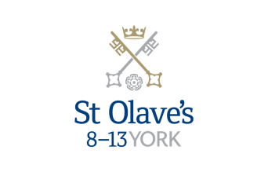

St Olave’s School

St Olave’s School (pronounced ‘olives’), for girls and boys aged 8 to 13 years, is adjacent to the main campus of St Peter’s and introduces boarding as an element of the School. Under the leadership of the Master, the teaching staff provide expertise in the 8 to 13 range, guaranteeing subject specialism to challenge and support every pupil.

The curriculum is wide and challenging with expert teaching from the earliest age. There are many opportunities for recreational and competitive sport with girls’ and boys’ teams enjoying success both regionally and nationally. There are numerous co-curricular activities to choose from on a weekly basis. Music plays a central role in school life, involving the full range of orchestral instruments.

Boarding is an integral element of the School and is accommodated in Wentworth, a boarding house on the main school campus.

St Olave’s has retained its own identity – a school within a school – giving all pupils a sense of pride and identity. It is recognised as a school in its own right, playing a vital role in the success of Clifton and St Peter’s.

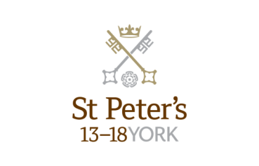

St Peter’s School

St Peter’s School, for children aged 13 to 18 years, is underpinned by academic rigour and challenge. Through outstanding teaching, first rate facilities, high expectations and sheer determination on the part of its pupils, St Peter’s achieves considerable success across a broad curriculum.

The four vibrant and successful boarding houses for boys and girls lend vitality to the pastoral life of the School. Inspiration from living in close proximity to a cultured and historic city adds further richness to the pupils’ lives. The Ofsted inspection of Boarding in December 2010 found the School’s provision to be Outstanding.

The School Chapel stands at the centre of the campus and regular services (three mornings a week) give pupils and staff the opportunity to reflect together on the spiritual values of the community and on the meaning and significance of what is happening locally, nationally and globally.

Music, Art and Drama are central to the cultural and academic depth of the School. The Sports programme is extensive, providing a wide range of choice for both girls and boys. Results are excellent, and St Peter’s pupils’ co-curricular achievements are considerable. The excellence of the teaching and facilities allows pupils to thrive.

The school’s website can be visited at www.stpetersyork.org.uk. The most recent inspection report is available on the ISI website.

About York

St Peter’s School is situated five minutes’ walk away from York’s compact city centre. York is one of the oldest and most beautiful cities in Europe, famous for its gothic Minster and winding medieval streets. York has won a number of tourist awards and further details are available on the Visit York website. York is regularly voted as one of the best places to live in the UK. Such is the size and layout of York, walking and cycling are ideal ways to get around, including taking in the famous sights of this historic city; an ancient Roman and Viking capital.

York is a central rail hub between Edinburgh, London and Manchester. The main railway station is only a 15 minute walk from the School. In addition it has a large variety of restaurants, pubs, theatres, cinemas, parks, museums and galleries, and life in York is always interesting, by day or by night.

Finding somewhere to live is also comparatively easy. York’s rental sector is in good health, though demand remains high. If you are trying to buy you will find York prices are around the national average.

York is a family friendly city. Attractions such as the Jorvik Viking Centre, the Barley Hall, the York Dungeons, the National Railway Museum and the York Chocolate Story are immensely popular with people of all ages.

The city lies in the Vale of York, a valley that runs north to south between the heathery North Yorkshire Moors to the east and the famous Yorkshire Dales to the west. Both areas offer an excellent escape for walkers, cyclists, climbers – indeed anyone with a love of fresh air and rolling countryside.

A guide to the City of York can be found at http://www.visityork.org/

Employee benefits

Our vision is to be a happy, thriving 3-18 co-educational day and boarding school community that combines a classical, high quality, all-round education with a forward-looking and exciting approach to learning.

Our staff are the key to our success. It is their expertise, enthusiasm and commitment that is reflected in our high standards and continued success. In return, we offer all our colleagues a competitive total reward package from day one of their employment with us.

Annual Leave

The academic year is around 35 weeks, giving 3 weeks at Christmas and Easter and 8 in the Summer. We also have a two week half term in October, a week in February and a week in May, including Bank Holidays.

Childcare Vouchers

Eligible employees can join our Childcare Voucher Scheme that allows tax and National Insurance savings through a salary sacrifice arrangement. This scheme is available for employees with children up to fifteen years old (or sixteen years old for disabled children).
A salary sacrifice arrangement is an agreement between an employer and an employee to change the terms of the employment contract to reduce the employee’s entitlement to cash pay. This sacrifice of cash entitlement is in return for some form of non-cash benefit. Salary sacrifice is financially beneficial for the employee as tax and national insurance contributions are not paid on the non-cash benefit.

Cycle to Work Scheme

Eligible employees can join our Cycle to Work Scheme (also a salary sacrifice arrangement) that allows tax and National Insurance savings on the purchase of a bicycle (and related equipment).

Discounted school fees

A discount on school fees is offered to eligible staff for a maximum of two children at a time, if a place is available and entry requirements are met. The discount is offered for children at St Peter’s and St Olave’s Schools only.

For part-time staff the discount would be pro-rata based on the employee’s working hours.

Enhanced Maternity Pay
After one year’s continuous service with the School by the 11th week before the EWC, you will be entitled to receive enhanced maternity benefits as well as Statutory Maternity Pay (SMP).
You will receive the following benefits for a fixed period of 39 weeks:

First four weeks of absence Full pay

Following two weeks 90% of average weekly earnings

Following 12 weeks Half pay, plus Statutory Maternity Pay (SMP)

Following 21 weeks Statutory Maternity Pay (SMP)

Free School Lunches

Staff can enjoy a free meal during the lunch period in the School Dining Room. Lunch is provided on normal working days during term time. A selection of hot and cold food, beverages and sandwiches are available.

Parking
There is extensive free parking available to staff on the school site.

Pension

For teachers, their employment with the School is pensionable under the Teacher's Pension Scheme. Teachers are automatically enrolled when required by law. Both the teacher and the School will make the appropriate contributions based upon the teacher’s pensionable salary.

Eligible support staff are automatically enrolled into the St Peter’s School Pension Scheme. Those who do not meet the government criteria for eligibility will be given the option to join/opt in. The School pays a contribution of 12% of the monthly salary and the employee is required to pay 6%.

School Chapel

School Chapel is available to former pupils, staff and people connected the school for weddings, christenings and other appropriate events. Extensive grounds and gentle green lawns provide an excellent location for a marquee or champagne reception. The School is licensed for regulated entertainment and the Memorial Hall is ideal for evening functions.
Sick Pay

Where employees are unable to attend work due to sickness, there is a provision for sick pay. The amount of sick pay increases according to the employee’s length of service and current contract.
Sports Facilities

All staff can use the school sports facilities free of charge when they are not in use by the pupils. This includes a modern gym and swimming pool.

Training and Development

Our employees are encouraged to continually develop their skills and knowledge. Training and development opportunities may include gaining a professional qualification and other learning opportunities.

How to find us

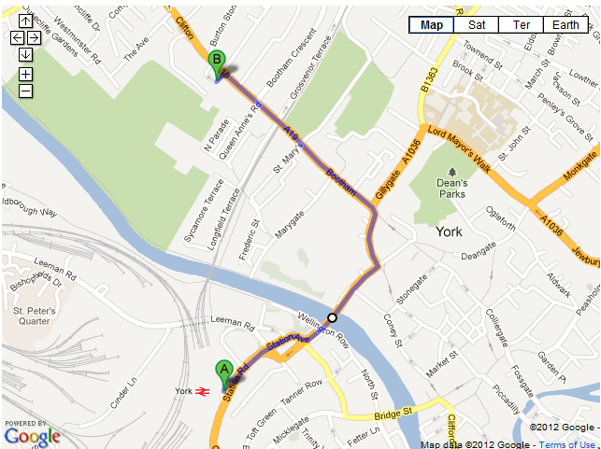
You can find St Peter’s School, York, at YO30 6AB.
The School (point B) is less than fifteen minutes on foot from York Railway Station (point A).

By car:

From York City Centre: Take the Thirsk Road (A19) at the Bootham Bar traffic lights. The school is 700m on the left, immediately after the footbridge.

From the A64: Take the Northern Ring Road (A1237). At the A19 roundabout turn towards the city centre. The school is two miles on the right, 300m after Clifton Green. Turn right into the school immediately before the footbridge that crosses the road.

Parking is available on site.

