Ffôn/ Tel: 01970 624811
Ffacs/Fax: 01970 625830
E-bost/E-mail: slb@penglais.org.uk
Gwefan/Website: www.penglais.org.uk

Waunfawr
Aberystwyth
Ceredigion
SY23 3AW

September 2021

Dear Applicant,

Thank you for expressing an interest in the post of Teaching Assistant (Level 3) at Ysgol Penglais School. You will be joining the school at a very exciting time as we live our vision for Penglais.
‘Ysgol Penglais School is a happy, ambitious and high-achieving school where everyone is ‘respected and valued’. We are working hard with staff, students, parents and the governing body to ensure that Ysgol Penglais School becomes the school that our students and community deserve. We are continually working to achieve the highest standards of student achievement, behaviour and teaching and learning. Our recent GCSE results show significant improvements with 33% of all grades awarded at A*/A and 80% at A* - C.
We have an experienced body of staff who work hard and manage to maintain a supportive and friendly ethos. Our students want to achieve more than they thought possible and want to be challenged and supported to do so. There are many different needs within the school and the ALN department work hard across the school to support students when needed. The 6th form is very strong with nearly 300 students, achieving excellent results again this year.
By joining Ysgol Penglais School, you will be supported professionally to achieve excellence in your role. I can promise you a demanding but ultimately rewarding experience as we move forward to becoming an excellent school.
The enclosed information gives you a snapshot of the school. If you would like further information, please contact Helena Clements by email at hcl@penglais.org.uk, or on 01970 624811. I look forward to receiving your application.
Yours sincerely
Mair Hughes
Pennaeth/Headteacher
Mair Hughes
Pennaeth/Headteacher

Pennaeth / Headteacher:- Ms Mair Hughes

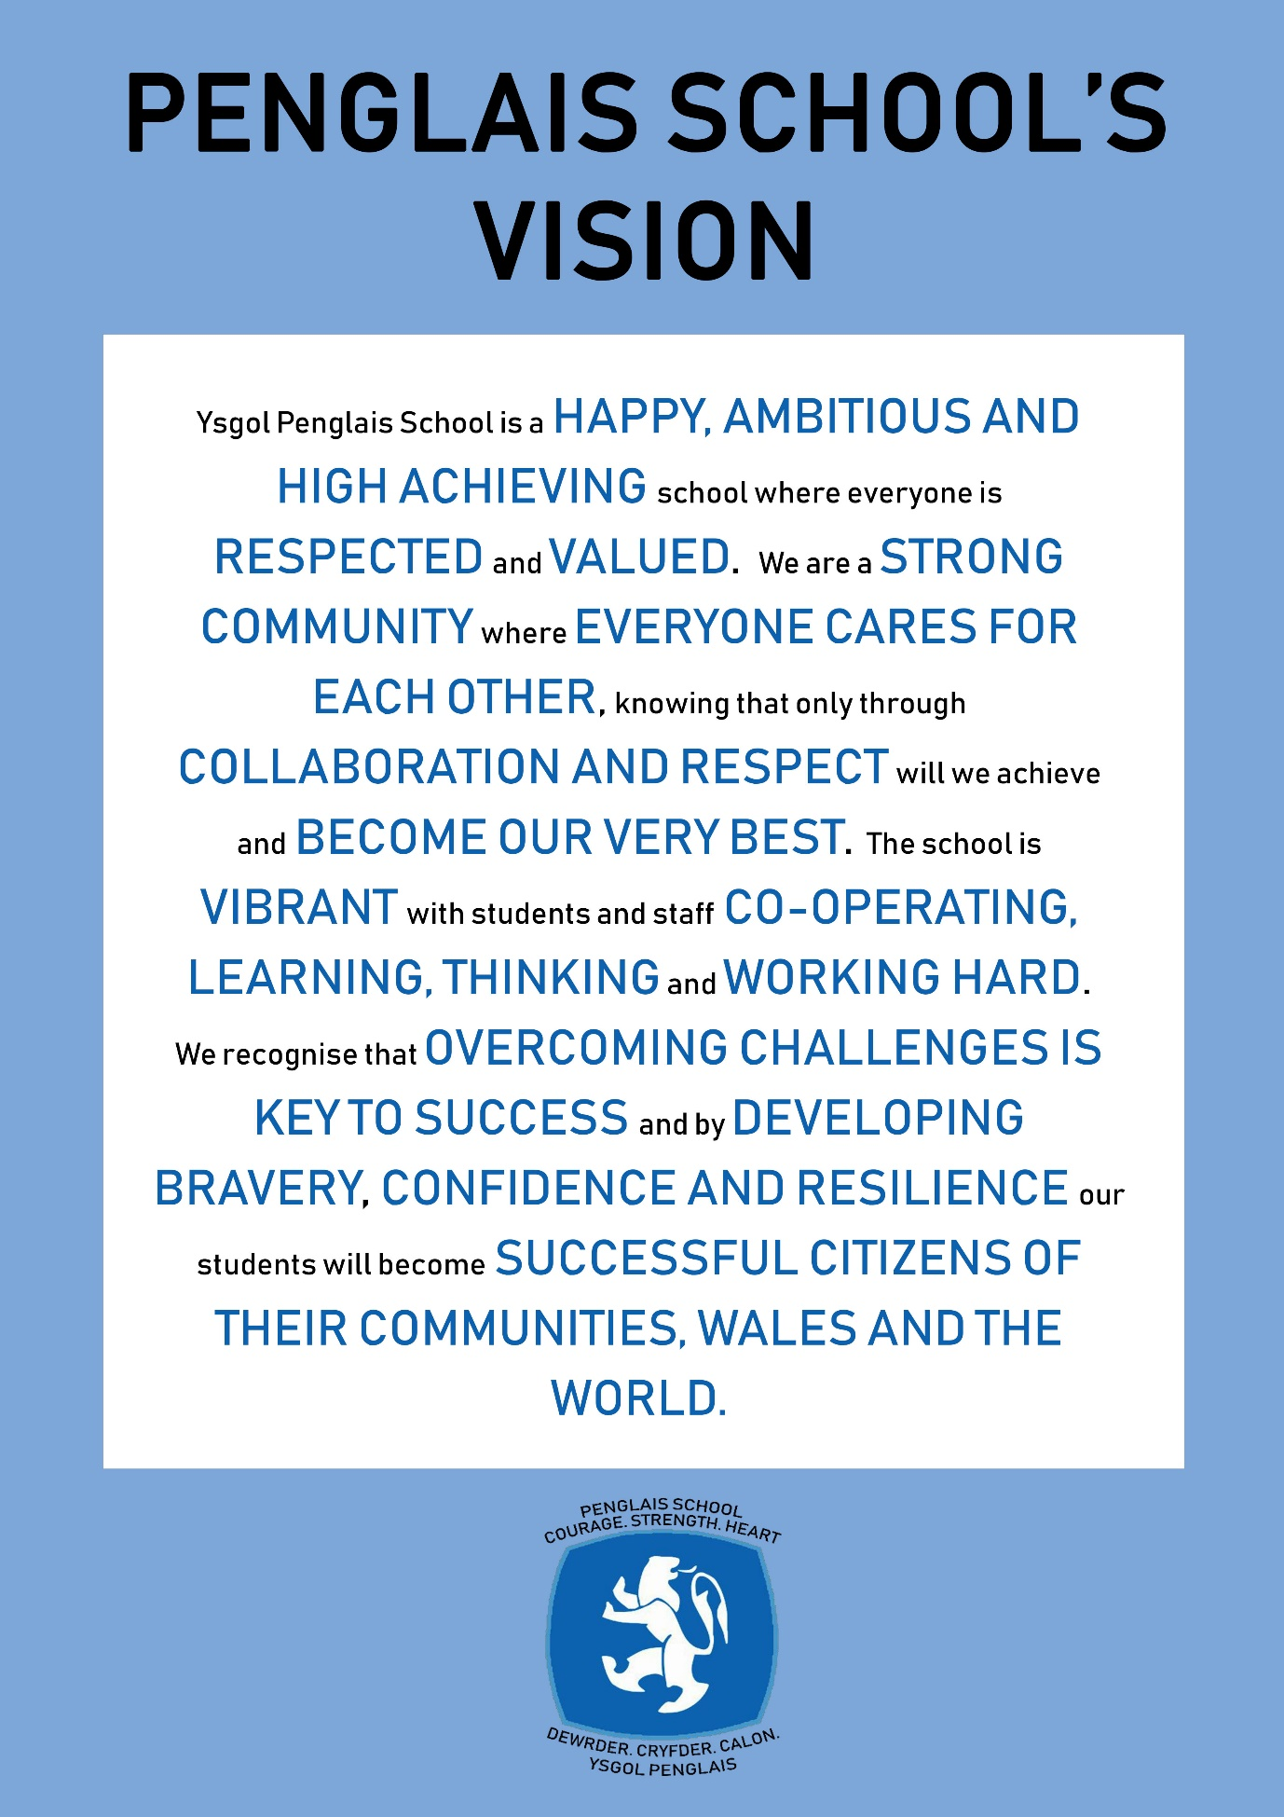

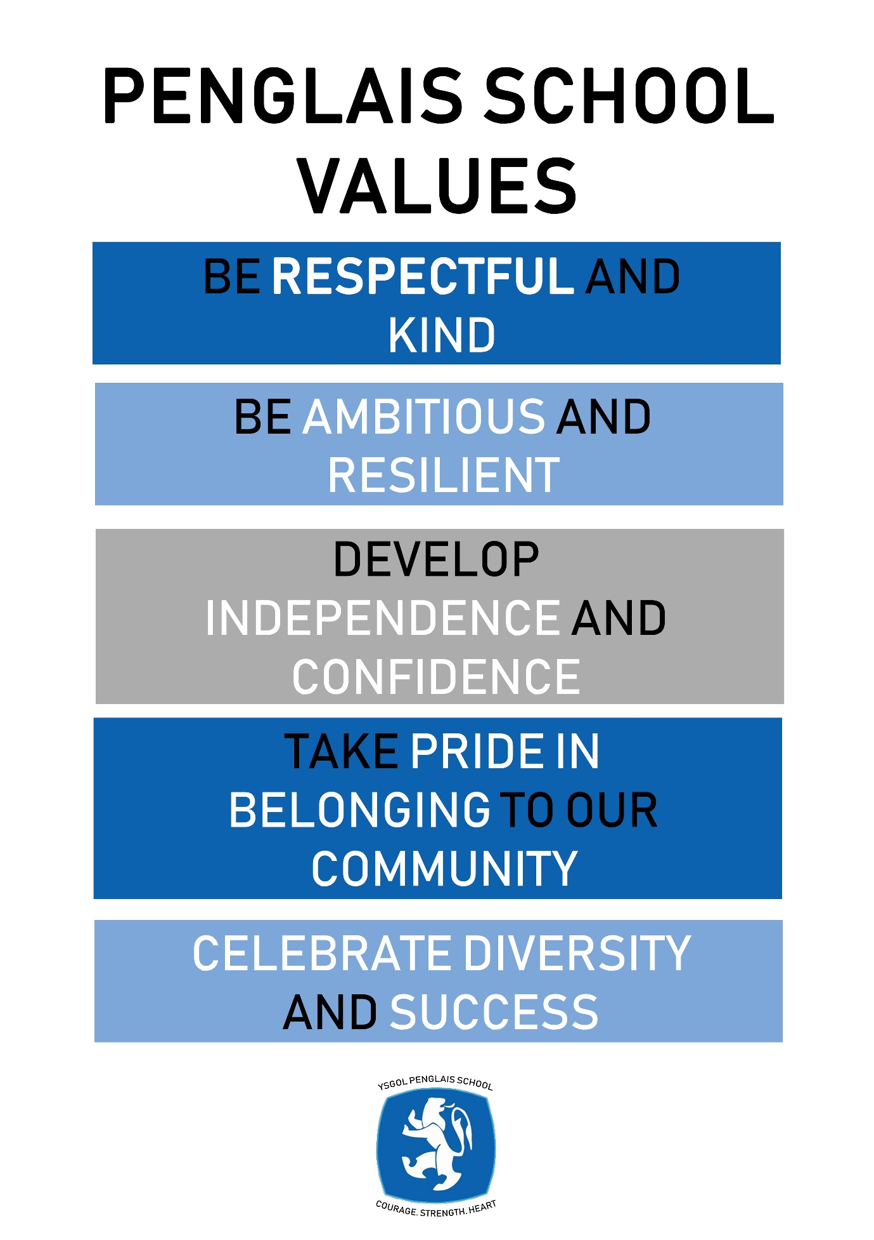

Please read these notes before completing the application form
It will help us if you follow these instructions:
- We would prefer you to fill in your application using Word or a word compatible format and submit it by email. Please include everything you wish the panel to consider on the form rather than in any separate document or covering email.

- Please give the full name and title of both your referees, and ensure that the full address, telephone numbers and email addresses are included. Your referees will be contacted if you are short-listed.

- If you are short-listed we will contact you by telephone or email

- Please submit your application form by 12 noon on the closing date to hcl@penglais.org.uk

- You will be asked to sign a hard copy if you are appointed

- Ysgol Penglais School is committed to safeguarding and promoting the welfare of students and expects all staff to share this commitment. All our staff are required to complete a DBS (Disclosure Barring Service) check and declare previous convictions.

- We are fully committed to equality of opportunity and aim for our staff to reflect the school community. It will help us to monitor the success of our recruitment strategies if you complete the ethnic monitoring information page of the application form. The information you provide will be treated as confidential and will not be made available to the short-listing panel.

Teaching Assistant Level 3 Grade: 6 scp 7 – 10 £20,092 - £21,322 pro rata term time only

We seek to appoint a Teaching Assistant who will join an enthusiastic and dedicated team working within the Learning Support Centre with children with a variety of additional learning needs. The post will be varied depending on the needs of the pupils and that of the Teacher in Charge. This post is full time 32.5 hours per week, term time only. Due to the nature of the role, the successful candidate will need to be a Welsh language speaker.

The right candidate will enjoy working in a busy environment. You will be required to use your own initiative to ensure that students can access the curriculum and that they are making good progress in their learning. This is a role that would suit an ambitious individual who has a genuine interest in supporting students to meet their potential.

Ysgol Penglais School has much to offer:

- a rapidly improving school with good relationships between staff and students
- a commitment to the professional development of all its staff to become outstanding teachers and leaders
- access to the bustling university town of Aberystwyth
- located on the beautiful Ceredigion coast, an area of natural beauty

For further details please contact Helena Clements (PA to the Headteacher) on 01970 624811or email hcl@penglais.org.uk

Ysgol Penglais School is committed to safeguarding and promoting the welfare of children, young people and vulnerable adults and expects all staff and volunteers to share this commitment. Successful candidates must be willing to undergo Enhanced DBS and other checks appropriate to the post.

Ysgol Penglais School is an equal opportunities employer.

Closing date: 19th September 2021
Interviews: TBC

Job Description – Teaching Assistant – Level 3

Job title: Teaching Assistant Level 3
Salary grade: Grade: 6 scp 7 – 10 £20,092 - £21,322 pro rata
Hours and weeks: 32.5 hrs per week, term time
Accountable to: SEN Co-ordinator/Assistant Headteacher

Core Purpose:

To work under the guidance of teaching/senior staff and within an agreed system of supervision, to implement agreed work programmes with individuals/groups, in or out of the classroom. This could include those requiring detailed and specialist knowledge in particular areas and will involve assisting the teacher in the whole planning cycle and the management of staff and the management/preparation of resources. Staff may also supervise whole classes occasionally during the short-term absence of teachers. The primary focus will be to maintain good order and to keep pupils on task. Cover Supervisors will need to respond to questions and generally assist pupils to undertake set activities.
Key accountabilities | Key tasks
Support for students | - Supervise and provide particular support for pupils, including those with special needs, ensuring their safety and access to learning activities.  - Use specialist (curricular/learning) skills/training/experience to support pupils  - Assist with the management of Individual Education/Behaviour Plans and Personal Care programmes  - Establish constructive relationships with pupils and interact with them according to individual needs  - Establish productive working relationships with pupils, acting as a role model and setting high expectations  - Promote the inclusion and acceptance of all pupils  - Support pupils consistently whilst recognising and responding to their individual needs  - Set challenging and demanding expectations and promote self-esteem and independence  - Challenge and motivate pupils, promote and reinforce self-esteem  - Encourage pupils to interact and work co-operatively with others and engage all pupils in activities  - Promote independence and employ strategies to recognise and reward achievement of self-reliance  - Encourage pupils to act independently as appropriate  - Provide feedback to pupils in relation to progress and achievement
Support for the Teacher | - Work with the teacher to establish an appropriate learning environment  - Work with the teacher in lesson planning, evaluating and adjusting lessons/work plans as appropriate  - Monitor and evaluate pupils’ responses to learning activities through observation and planned recording of achievement against pre-determined learning objectives  - Provide objective and accurate feedback and reports as required, to the teacher on pupil achievement, progress and other matters, ensuring the availability of appropriate evidence  - Be responsible for keeping and updating records as agreed with the teacher, contributing to reviews of systems/records as requested  - Undertake marking of pupils’ work and accurately record achievement/progress  - Promote positive values, attitudes and good pupil behaviour, dealing promptly with conflict and incidents in line with established policy and encourage pupils to take responsibility for their own behaviour  - Liaise sensitively and effectively with parents/carers as agreed with the teacher within your role/responsibility and participate in feedback sessions/meetings with parents with, or as directed  - Administer and assess routine tests and invigilate exams/tests  - Provide general clerical/admin. Support e.g. administer coursework, produce worksheets for agreed activities etc.
Support for the Curriculum | - Support pupils in gaining access to the curriculum  - Implement agreed learning activities/teaching programmes, adjusting activities according to pupil responses/needs  - Implement local and national learning strategies e.g. literacy, numeracy, KS3, early years and make effective use of opportunities provided by other learning activities to support the development of relevant skills  - Support the use of ICT in learning activities and develop pupils’ competence and independence in its use  - Help pupil to access learning activities through specialist support  - Determine the need for, prepare and maintain general and specialist equipment and resources
Support for the School | - Be aware of and comply with policies and procedures relating to child protection, health, safety and security, confidentiality and data protection, reporting all concerns to an appropriate person  - Be aware of and support difference and ensure all pupils have equal access to opportunities to learn and develop  - Contribute to the overall ethos/work/aims of the school  - Establish constructive relationships and communicate with other agencies/professionals, in liaison with the teacher, to support achievement and progress of pupils  - Attend and participate in regular meetings  - Participate in training and other learning activities as required  - Recognise own strengths and areas of expertise and use these to advise and support others  - Provide appropriate guidance and supervision and assist in the training and development of staff as appropriate  - Undertake planned supervision of pupils’ out of school hours learning activities  - Supervise pupils on visits, trips and out of school activities as required
Other | - Be aware of and comply with policies and procedures relating to child protection, health, safety and security and confidentiality, reporting all concerns to an appropriate person  - Be aware of and support difference and ensure equal opportunities for all  - Establish constructive relationships and communicate with other professionals  - Attend and participate in relevant meetings  - Participate in training and other learning activities and performance development as required  - Recognise own strengths and areas of expertise and use these to advise and support others  - Undertake other duties commensurate with the status of the post as may from time to time be determined by the Headteacher

This job description is not necessarily a comprehensive definition of the post. It will be reviewed at least once each year, but may be subject to modification or amendment at any time after consultation with the holder of the post

Person Specification Teaching Assistant – Level 3

Qualifications | - Very good numeracy/literacy skills.  - Completion of DfES Teacher Assistant Induction Programme.  - NVQ 3 for Teaching Assistants or equivalent
Experience | - Experience of working with or caring for children or young people of a relevant age is desirable  - Training in the relevant strategies e.g. literacy and/or in particular curriculum or learning area e.g. bi-lingual, sign language, dyslexia, ICT, maths, English, CACHE etc.  - First aid training as appropriate.
Skills | - Effective use of ICT to support learning.  - Use of technology – computer, video, photocopier  - Full working knowledge of relevant policies/codes of practice and awareness of relevant legislation.  - Working knowledge of national/foundation stage curriculum and other basic learning programmes/strategies.  - Understanding of principles of child development and learning processes.  - Ability to self-evaluate learning needs and actively seek learning opportunities.  - Ability to relate well to children and adults  - Work constructively and flexibly as part of a team, understanding classroom roles and responsibilities and your own position within these
Qualities | - A willingness to develop your own professional skills and knowledge by attending appropriate courses / training  - A flexible, patient and hardworking approach to working as part of a team  - A demonstrable commitment to the safeguarding of students and child protection  - A demonstrable commitment to equal opportunities  - Excellent attendance and punctuality
Other | - Commitment to the school’s ethos, aims and its whole community

September 2021

