TEACHER OF HUMANITIES
MPS + Federation Benefits
To start September 2019

Full or Part Time applications considered
Applications from NQTs welcomed or returners to the profession
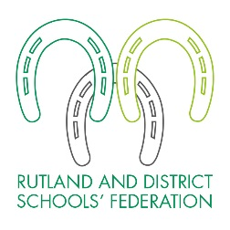
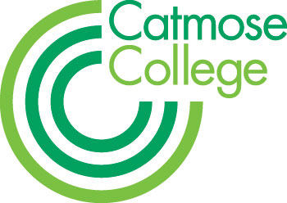

Humanities is a highly valued subject at the College with the talented team achieving outstanding outcomes in the summer 2018 series in History, Religious Studies and Geography. Alongside high standards of academic progress, the team have a strong commitment to providing extra-curricular opportunities for students such as trips, visits and entering local competitions. Examples last year included a Year 12 trip to Sicily, a Year 9 battlefields trip to Belgium, a cross-curricular Years 12 and 13 trip to Krakow which included visiting Auschwitz, and a Year 8 trip to the Norfolk coast. You will be joining an experienced team who have high expectations of themselves and the students they teach.

Applications are welcomed from either NQTs, who will be well supported by experienced mentors and through our teaching school alliance; or from more experienced candidates where there are exceptional opportunities for further professional development and promotion. All Humanities specialisms will be considered. In Years seven and eight colleagues may be asked to teach across all subjects within Humanities.

We offer suitably qualified candidates the opportunity to teach their A level specialist subject through our partner school Harington.

There are outstanding facilities throughout the College offering excellent teaching resources and access to numerous iPads, laptops and computers. Catmose College and Harington School are part of the Rutland and District Schools’ Federation, both of which have been graded outstanding by Ofsted.

For successful candidates there are exceptional opportunities for further professional development and promotion across the Federation.

Teachers are able to enjoy many additional benefits that come as part of working within the Federation. These include, amongst others:

- Teachers at top of scale may receive up to a 2% pay award annually for good performance.
- Relocation support for hard to recruit subjects.
- Vast range of staff training including a funded Masters scheme, through our teaching school.
- Primary, Secondary and Sixth-form teaching opportunities.
- Staff laptops.
- Priority admission for children of staff to the College and Primary.
- Flexible working; part-time and a job share considered.

We are committed to being an inclusive employer and welcome applications from candidates looking for a variety of flexible working arrangements including, but not limited to; part time working and a job share.

The Federation is committed to safeguarding and promoting the welfare of all students in our care and expects all staff to share this commitment. All staff are responsible for ensuring safeguarding, health and safety policies are implemented in line with Federation policy and current legislation. Applicants must be willing to undergo child protection screening appropriate to the post including checks with past employers and the Disclosure and Barring Service. We are an equal opportunities employer.

HOW TO APPLY
Application forms and information are available online at www.rutlandfederation.com or by emailing office@rutlandfederation.com.

- You should write a letter of application on no more than 2 sides of A4.
- You should complete all sections of the application form.
- On the form clearly state the names, addresses, telephone numbers and e-mail address of two professional referees; it is our usual practice to ask for references before shortlisting and always to ask for references before interviews.
- It is a condition of employment that you have a successful DBS check made and can provide proof of identity and qualifications gained.

Please note that due to the high number of applications we receive for positions, your application is unlikely to be considered if you do not follow these requirements. CVs are not accepted. Closing date is 12 noon on Wednesday 1 May 2019. You should send your application to Stuart Williams, Executive Principal, Catmose College, Huntsmans Drive, Oakham, Rutland, LE15 6RP. Applications can also be emailed to office@rutlandfederation.com.

