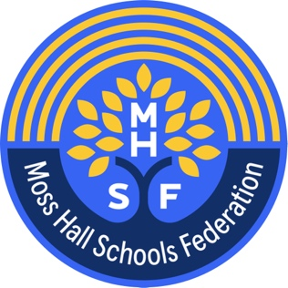 **Moss Hall Schools Federation.**

**Executive Headteacher Application Pack**

March 2025

**Contents**:

1. Co-chairs of Governors welcome
2. Information about the Federation
3. Information about the Staff Team and Leadership structure
4. Application information
5. **Welcome from the co-chairs of governors**

*Dear Applicant*

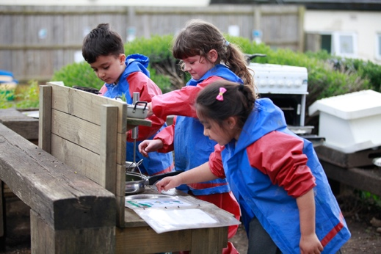

*Thank you for your interest in our Executive Headteacher vacancy at Moss Hall Federation, which consists of Moss Hall Infants and Moss Hall Juniors schools. As co-chairs of the Governing Board, we would like to tell you a little bit about our Federation and what we are looking in for in this role.*

*Having federated the two schools in 2020 and despite the impact of external factors such as the COVID-19 pandemic, workforce markets and changing demographics in the local area, Moss Hall has been led through sustained improvement by our former Executive Head. This has involved strengthening the quality of teaching, ability of our workforce and relationships with our wider school community – as well as integrating the two schools into a more cohesive, efficient and consistent federation.*

*During this time both schools have received ‘Good’ Ofsted ratings, with elements noted as ‘Outstanding’. This is something we are incredibly proud of and speaks to both the quality of previous leadership but also the capacity and investment of our entire workforce. We are keen to appoint a leader who can build on progress to ensure Moss Hall maintains its strong offer to children and families and develops further as a leading federation, across Barnet and the wider local area. This will need to include setting a clear strategic vision for Moss Hall, for the next 5 years, working with governors and other members of the school community.*

*We are incredibly proud of what the federation has achieved to date, but there always remain areas for improvement, particularly in the context of increasingly challenging headwinds that many schools face. For Moss Hall our priorities include improving outcomes and provision for our pupils with SEND – including working towards more inclusive mainstream provision at our schools; addressing changing demographics – such as declining pupil numbers locally and increasing numbers of pupils with EAL; continuing curriculum improvement – ensuring a high standard and continuous curriculum through the two schools; more effectively utilising our estate; and safeguarding – including work to address the contextual safeguarding challenges we have identified (domestic abuse, online safety, organised crime and religious / racial hate).*

*In our next Executive Headteacher we are looking for someone who can work confidently with staff, governors, families and others, using an evidence-based approach to shape both the day-to-day operations of the federation and the long-term strategic direction. This role offers the opportunity to lead a strong staff body, who remain focussed on continual improvement, and have a real impact in improving outcomes for the children that attend our schools. We expect an Executive Headteacher to work closely with governors on both the challenges mentioned but also identify ways in which we can improve as a federation that we may not have considered before.*

*Yours sincerely*

Mo Choonara & David Dunn

1. **Information about our Federation**

In 2020 Moss Hall infant school and Moss Hall Junior School joined together as one Federation With a motto of Be Kind, Work Hard and Make a Difference underpinning our culture, the aim of the federation was to provide an “all-through”, cohesive, excellent school journey for children and their families. Focussing on the quality of pedagogy, the curriculum offer, staff development and seeing children holistically we have made extraordinary progress.

Extensive access to high quality music teaching and experiences, sports and a wide range of extra-curricular experiences coupled with sky high behaviour expectations have ensured children’s personal development and attitude to learning is of a very high standard across each school.

We operate as if a primary school, across 2 school sites joined via various access points. The schools currently offer 4 forms of entry across both sites however leaders are mindful of and responsive to the falling pupil rolls in this part of Outer London. The leadership team are responsible for impact across both schools and staff move between the schools in both support and teaching roles.

You will see from publicly available information that both schools have been inspected by Ofsted in the recent past and both are rated Good overall; Moss Hall infants being rated outstanding for EYFS and Personal Development. Pupil outcomes are strong and increasing year on year and are amongst some of the best in Barnet and Nationally.

(Moss Hall:

<https://mosshall.school/> ; <https://www.compare-school-performance.service.gov.uk/> ; <https://reports.ofsted.gov.uk/provider/21/101294> ; <https://reports.ofsted.gov.uk/provider/21/101295> )

The Federation’s commitment to evidence informed pedagogy is directly attributable to this improvement. All teaching staff engage in Instructional coaching using Steplab and our bespoke CPD programme. Applicants to this post will be expected to align with and be able to lead and/ or support instructional coaching.

The schools were built in the 1950s and are set in extensive grounds, with a swimming pool, large field and 4 playgrounds. There are 2 libraries, 2 large halls and separate dining rooms and 2 music rooms We keep chickens on the Junior site and the school dog works with children across both sites.

The executive head works very closely with the Federation Business Manager, managing 2 budgets and 2 sets of statutory information as required by the DfE and other external partners and stakeholders. Additional revenue generation is a major focus of the federation’s business operations and strategy.

Our schools are proud of the excellent relationships we have with our parents and carers. Our parent / staff association (MHSA) co-ordinate a wide range of very popular and highly regarded community events and raise a substantial amount of additional funds for the Federation annually. Our relationship with the adjacent Moss Hall Nursery school and all other local nurseries is strong.

1. **Information about our staff team and leadership structure**

3.1 Our staff team:

As a 4-form entry federation of 2 schools we have a total of 150 staff across both sites.

3.2 The Leadership team:

The current substantive structure comprises Executive Headteacher, Head of Schools, 2 x Deputy Heads of the federation, an Assistant Head and Federation Business Manager. Phase leaders lead across EY/ KS1/ L KS2 and U KS2. SEND is lead and managed by a SENCO and one of the Deputy Heads. There is an interim leadership structure currently in place. A senior staff member leads all CPD and Professional development; we are local Ambition Institute hub for ECT training A number of leadership staff work part time. Roles and responsibilities are clearly defined and regularly reviewed and a key part of the EHT role will be to ensure the federation adopts a sustainable and strong leadership structure.

1. **How to apply for this role** 
   1. 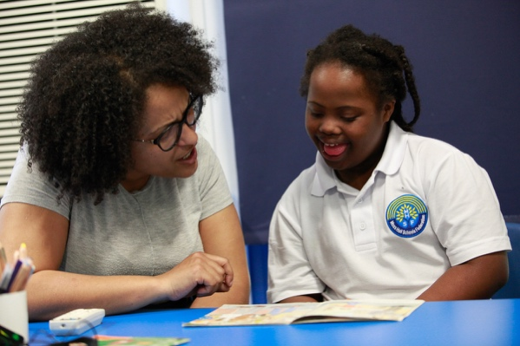Visit the federation
      1. We view this a fundamentally important part of the selection process as much for the applicant as the school
      2. We warmly invite you to visit on any of the dates/ times set out below.
      3. Contact Toral Patel, Business Manager to book a visit with a senior staff member [tpatel110.302@lgflmail.org](mailto:tpatel110.302@lgflmail.org) or via the school office, clearly stating the nature of your call, leaving a return call number and time if you do not get through. Tel: 0208 445 7965/ 0208 446 6559

|  |  |  |
| --- | --- | --- |
| **Day** | **Date** | **Time** |
| Tuesday | 25.03.2025 | 13.00-14.00pm |
| Friday | 28.03.2025 | 09.00-10.00am |
| Monday | 31.03.2025 | 11.00-12.00pm |

In the event that a visit cannot be arranged at these times, we are happy to speak to interested applicants on the phone. Contact Toral Patel above to arrange this.

4.1.4 Complete the application form including CPD record and additional personal statement and email them to [recruitment@mhi.org.uk](mailto:recruitment@mhi.org.uk) In accordance with our safeguarding duties, **we will not** accept CVS. All gaps in employment history must be fully explained and accounted for.

4.1.5 Personal statements may be completed on a separate document from the LBB application form. If this is done, the applicant should clearly state on the LBB form that a separate document is provided. This should clearly include the applicant’s name. This section/ the personal statement should be no longer than 3 sides of A4 paper, Arial font, size 12.

* 1. The decision to invite candidates for interview will be based on the information included in the application documents above. Setting out experience as indicated in the person specification will enable those shortlisting to assess your suitability to be called for interview.
  2. **References** will be requested from your **existing employer** and one other professional reference if shortlisted. Open testimonials are not accepted for this post. If you are not currently working with children, references will be requested from a previous employer where this was the case. You are, therefore, requested to supply full contact details for this organisation and also to alert all referees to expect a request, should you be shortlisted. References from relatives or people writing solely in the capacity of friends will not be accepted.
  3. **Security**: Due to this post having access to children and/or vulnerable adults, candidates will be required to undertake a Disclosure and Barring Service check. The possession of a criminal record will not necessarily prevent an applicant from obtaining this post, as all cases are judged individually according to the nature of the role and information provided. Candidates who are foreign nationals, or a UK national who has lived abroad at any point in their adult life, MUST provide a Certificate of Good Conduct prior to taking up an appointment.

March 2025