SENCo

Required from September or January (full time)

We are looking for an inspirational SENCo to devise and implement targeted support and challenge for individuals and small groups. The SENCo will ensure that our students’ special educational needs are met effectively by coordinating annual reviews and overseeing the implementation of the resulting strategies. Working with the Assistant Head Academic, the SENCo shapes the school’s SEN policy and champions SEN awareness with both students and staff. The role is varied, challenging and incredibly rewarding.

The ideal candidate will:
- have specialist knowledge and experience of identifying, evaluating and providing effective strategies for pupils with SEN
- hold a current SpLD Assessment Practising Certificate or equivalent Level 5 qualification
- have the capacity to deliver outstanding teaching
- have strong communication, interpersonal and administrative skills
- be familiar with JCQ regulations regarding the processing of access arrangements for public examinations would be an advantage

We welcome applications from experienced secondary teachers looking to specialise further, who are willing to undertake an Accredited Level 7 Diploma in Assessment and Intervention.

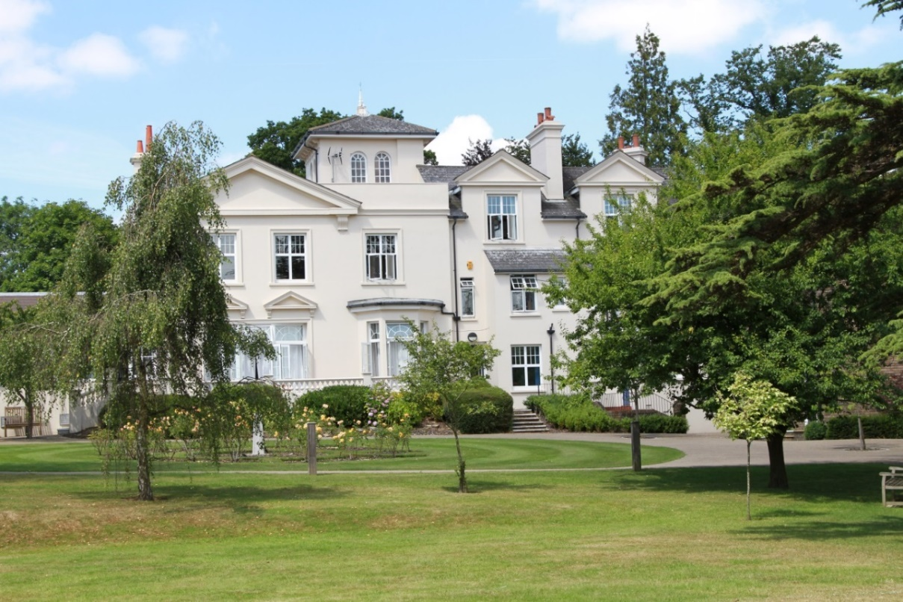

ABOUT THE SCHOOL

Burgess Hill Girls is a GSA day and boarding school, with 520 students aged between 3 and 18 years. The majority of students are of above average ability and the school has an outstanding record of academic success at both GCSE and A level. Last year, nearly all pupils obtained at least 9 or more GCSE passes at Grade 4 or above and the vast majority of sixth formers proceeded to Higher Education.

Location
The School is situated in a very pleasant thirteen-acre site in the conservation area of the town. Burgess Hill is a medium sized town with its own theatre, orchestra, cinema and leisure centre. Burgess Hill is approximately ten miles from Brighton and Lewes, fifteen miles from Crawley and fifty miles from the centre of London. It is well served with fast roads – the M23 and M25. The school is a three minute walk from the railway station.

Facilities
The School is a blend of Victorian buildings and ultra-modern facilities and there has been a steady development of the facilities.

Curriculum
The School offers a full range of GCSE and A level courses in preparation for university entrance.

Pastoral care
Our pastoral system is designed to encourage and support the development of each individual student from the moment she arrives in school until the time she leaves. We want to provide each student with the skills and confidence to help her to make the most of her time with us, at university and beyond. Implicit in the School aims is the expectation that every teacher will accept responsibility for the development in each pupil not only of the highest academic standards, but also of the confidence and self-esteem, which comes from being valued as an individual within a community.

Co-curricular activities
We believe that education is about giving young people the chance to be successful in as wide a range of areas as possible, and to feel a sense of pride in their achievements. Co-curricular activities give each student wonderful opportunities to explore her own talents and develop her individual skills to her full potential. The successful applicant will be expected to work effectively as part of the teaching team and participate in the wider life of the school.

SENCo ROLE

The SENCo works to raise educational achievement of pupils with SEN by coordinating and delivering the school's SEN provision. Working closely with the Assistant Head Academic, the SENCo manages provision in the school and provides support to teachers and parents. Responsibilities include designing and delivering interventions with pupils in the classroom and implementing the school’s SEND policy, training staff in strategies to improve the experience and outcomes of students. Effective communication with parents, carers and teaching staff is a central part of the role.

The successful candidate will be an experienced teacher with a passion for supporting pupils with special educational needs.

LEARNING SUPPORT DEPARTMENT

The Learning Support Department comprises a SENCo, an Assistant SEN teacher and an administrative assistant. Support is provided from other departments where required. In addition to the members of the departmental team, the SENCo works closely with the Assistant Head Academic and the Examinations Officer.

The Department is located in the centre of the school with a classroom and office providing a welcoming space for students to access academic and pastoral support.

The Department is well-resourced with assessment and other support materials. The Learning Support Department has a classroom with five networked computers equipped with specific software to support the development of literacy and numeracy. Technical support is outstanding.

KEY TASKS AND RESPONSIBLITIES

Strategic Overview:
- To implement the school’s SEND Policy
- To ensure SEN is an integral part of School Improvement Plan
- To evaluate the impact yearly with SLT and Governors as required

Overseeing the day-to-day operation of the School’s SEN policy:

Admission:
- Liaise with Admissions over transition arrangements for prospective pupils
- Review prospective pupil details and advise the Head
- Liaise with the SENCo at the Prep School, other feeder schools and overseas schools where appropriate
- Monitor pre-admission by seeing parents and Ed. Psych. reports where necessary

The Pupils:
- Initiate or respond to concerns raised by teachers and tutors
- Decide when an IEP is necessary and follow the required course of action to devise the plan, with necessary evaluation and monitoring
- Follow up with relevant staff and pupils as required
- Prepare IEPs and advisory notes
- Make referrals to Educational Psychologists as appropriate
- Provide high quality teaching to small groups of SEND students across Key Stages 3, 4 and in the Sixth Form, where appropriate

Managing the Department:
- Monitor and evaluate quality of the department provision and act as appropriate
- Manage and organise the timetables for intervention lessons
- Develop the use of ICT in supporting literacy skills
- Devise, monitor and update schemes of work where appropriate
- Manage and monitor the information on the SEN register and ISAMS, including appropriate up-to-date summaries, strategies and IEPs for SEN students
- Liaise with external staff as necessary e.g., Educational Psychologists, occupational therapists
- Advise teachers on appropriate classroom strategies for SEN students including whole school or targeted INSET as necessary
- Liaise and share information with all relevant staff on an ongoing basis to support students including SLT, form tutors and heads of department.
- Administer tests for access arrangements
- Liaise with the Examinations Officer to apply for access arrangements for public examinations
- Collect information from staff to provide evidence of need for access arrangements
- Keep clear secure records of all pupils, including assessments and external results
- Oversee staff professional development, in discussion with the Assistant Head Academic and encourage appropriate INSET
- Manage the departmental budget and determine spending priorities

Examinations
- Ensure access arrangements are in place for students undertaking internal and public examinations.
- Process Access Arrangements Online applications in accordance with JCQ regulations

Parents:
- Keep parents informed through consultation on a one-to-one basis and through parents’ evenings
- Maintain close contact with parents for advice on organisation, study skills, behaviour management, dyslexia support, assessment and coursework.

Undertake any additional duties as may be reasonably delegated by the Head or SLT.
Salary will be dependent upon skills and experience. A management allowance is paid in addition to salary.
The Assistant Head Academic, Ms Rohaise Flint can be reached by email on rohaise.flint@burgesshillgirls.com for any further questions about the department and the role.

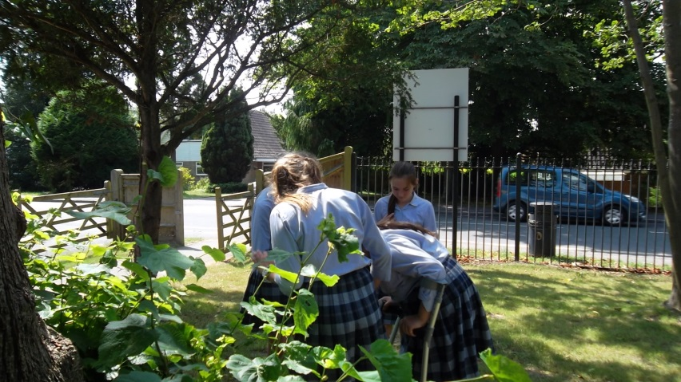

RECRUITMENT PROCESS

Candidates are required to submit an application form with supporting letter and details of two referees. One reference should be able to comment on the teaching skills of the candidate. References will be taken up prior to formal interview.

We are operating a rolling application process. On receipt of a completed application form we are keen to meet interested candidates so they can find out more about the role, and then initiate the formal interview process which will include the following elements:

- prepare and teach a small group Learning Support lesson (the details of which will be forwarded)
- undertake a simulated task appropriate to this middle management role
- meet key staff and tour the school and
- attend an interview.

All appointments are made in accordance with our equal opportunities policy and applicants should let us know of any special needs they may have.

The School is committed to safeguarding and promoting the welfare of children and applicants must be willing to undergo child protection screening appropriate to the role, including checks with past employers and the Disclosure and Barring Service.

