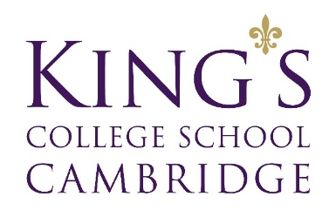
Reference Checking Consent Form
Please read the information on this form carefully and completely and sign below:
I have applied for employment with King’s College School and have provided information about my previous employment. I authorise King’s College School to conduct a reference check with my present and / or previous employer(s) and other referees. I understand that reference information may include, but not be limited to, verbal and written inquiries or information about my employment performance, professional demeanour, rehire potential, dates of employment, salary and employment history.
My signature below authorises my former or current employers and referees to release information regarding my employment record with their organisations and to provide any additional information that may be necessary for my application for employment with King’s College School, whether the information is positive or negative. I knowingly and voluntarily release all former and current employers, referees, and King’s College School from any and all liability arising from their giving or receiving information about my employment history, my academic credentials or qualifications, and my suitability for employment with King’s College School.
I give my consent under the UK GDPR and Data Protection Act 2018 for King’s College School to process my personal data and special categories of personal data specifically for the purpose of, and limited to, progressing my application. I will notify King’s College School should I wish to withdraw my consent and, therefore, remove myself from the application process.
I agree that this form may be digitally copied, scanned or photocopied; these copies will be as effective as the original which I sign.
Signature:

Date:

Print Name:

Telephone Number:

Email Address:

