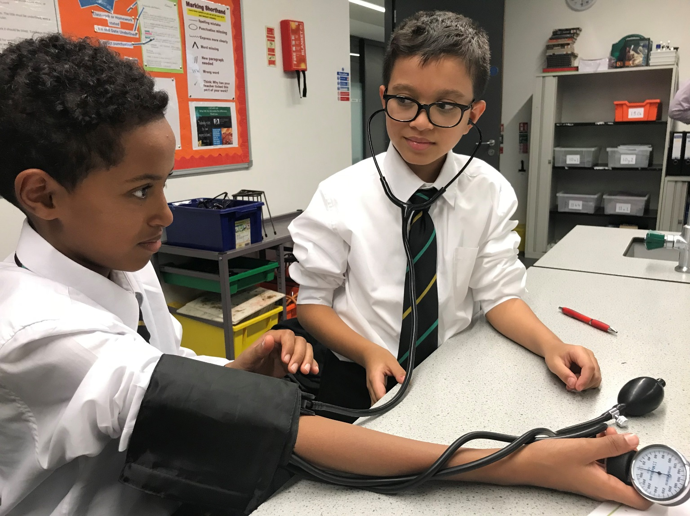
Regional Lead Teacher for Modern Foreign Languages | Ark

Start Date: Easter 2019
Salary: £45,000-£60,000 depending on experience
Closing date: Friday 25th January 2019
Interviews: Friday 1st February 2019
Base school: Evelyn Grace Academy

Extensive travel across parts of the region will be required. The region covers South London, Hastings and Portsmouth, all of which are commutable within a day and should not require more than occasional overnight stays. Where capacity allows, other schools in the network may request assistance and this may require further travel across London.

Ark is an international charity, transforming lives through education. We exist to make sure that every child, regardless of background, has access to a great education and real choices in life.
We know that great schools need great teachers, which is why we offer you the very best training and support at every stage of your career - from starting out as an NQT to running your own school.
Our highly-successful network of 38 schools educates over 22,000 students across Birmingham, Hastings, London and Portsmouth. They are achieving some of the best results in the country despite being largely in areas of historic academic underachievement.
But we want every child to succeed, whether they go to an Ark school or not, so we are constantly developing new teaching techniques and programmes, discovering what works in our schools before rolling them out more widely. Innovative programmes that started life at Ark include English Mastery, Maths Mastery, and Ambition School Leadership.
We are currently looking to recruit an outstanding teacher, ideally with leadership experience, to work as Network Lead Teacher for Modern Foreign Languages in some of our highest priority schools across South London, Portsmouth and Hastings.

The support you offer our leaders and teachers will be vital in ensuring that all of our schools achieve the same successes. Joining a regional leadership team led by a Regional Director, you
will use your passion, subject knowledge and expertise in MFL to drive forward the quality of teaching and learning. Based in one school, you will model great practice through a partial teaching timetable but you will also travel around the region to coach and lead others. This in an exciting role that requires flexibility, a team spirit, and a willingness to learn and it will suit individuals who want to take a step-up and work at a senior leadership level in MFL, across a range of schools.

Our expectations are high. We are aiming to ensure that all our schools show strong progress in Languages so that students can progress onto further study, university or employment of their choice.

The successful candidate will:
- be an outstanding teacher with a proven track record of securing excellent outcomes, in all components of GCSE and GCE examinations
- have an up-to-date knowledge of the subject curricula and assessment requirements
- have had experience of leading a subject area or holding a leadership responsibility within a school where a clear impact has been made through the proactive work they have done
- be proficient in teaching both Spanish and French to GCSE, and one of those to GCE
- have proven experience of identifying and implementing effective strategies for improving attainment in Modern Foreign Languages in urban schools at KS3, 4 and preferably 5
- have a highly effective style that is both consultative and influential
- be able to demonstrate resilience, motivation and commitment to driving up standards of achievement
- be able to work across a group of schools and show significant impact in developing capacity and improving outcomes for young people (involving being based in South London but working also in Hastings on a weekly basis as needed)
- be aligned with Ark’s ethos of growth mindset, high aspirations and high expectations of self and others.

To apply, please go to http://evelyngraceacademy.org/vacancies. Please submit your application by Friday 25th January 2019 at 11am. If you would like to discuss the role, or have any queries, please contact the recruitment team on 0207 737 9520 or zeena.agha@evelyngraceacademy.org.

Ark is committed to safeguarding children; successful candidates will be subject to an enhanced Disclosure & Barring Service check

Job Description: Regional Lead Teacher for Modern Foreign Languages

Reports to: Principal
Responsible to: Regional Director
Start date: Easter 2019
Salary: £45,000-£60,000, depending on experience
Contract: Permanent

The Role

The Regional Lead Teacher for Modern Foreign Languages will promote and implement Ark strategies for improving attainment in MFL across the South London & Hastings region. Working in partnership with the regional leadership team, Principals, Heads of Department and Ark staff, the role involves both a strategic overview of the subject across the region with a regional approach to planning and school improvement, alongside day to day involvement with MFL departments through activity such as coaching, planning, leadership development, modelling strong practice, data analysis, curriculum development, support with student intervention and leading regional subject meetings.

Based in one school, the postholder will undertake a partial timetable (20% teaching*) at that school and will work as Head of Department, or as a coach to the existing Head of Department, depending upon the school’s context at any point.
*This may increase if there is less demand for support in other schools in the network.

Key responsibilities

- Provide the strategic lead for Modern Foreign Languages across the region
- Lead regional subject initiatives and meetings; sharing, innovating and disseminating good practice, including co-planning and moderation
- Support Heads of Department in each allocated academy as needed, ensuring agreed best practice is being followed, training Heads of Department and providing extra support and capacity where it is needed at a leadership level
- Support the development of teaching capacity within allocated academies, working in partnership with the academy’s teaching and learning lead and the Ark Professional Development team
- Work with allocated academies to ensure that the curriculum, delivery model and assessments being used are in line with Ark Curriculum Plus and meet the needs of all students
- Support regional and academy-level work to ensure that curriculum decisions are appropriate; producing strong numbers of MFL entries but ensuring that decisions meet the needs of individual students
- Work with academy staff to promote raised attainment and progress measures in MFL, with an aspirational progress target for each academy
- Provide support to academy leadership teams and subject leaders to address underperformance in MFL departments
- Identify best practice locally, nationally and internationally in order to refine or bespoke the practice to the needs of the region
- Ensure that subject knowledge, curriculum understanding and pedagogy around GCSE and GCE specifications are facilitated in allocated academies
- Take part in monitoring and review work across the region as requested by the Regional Director
- Support recruitment work as requested by the Regional Director

Other

- Undertake other various responsibilities as directed by the line manager
- Undertake the main professional duties of a member of staff as set out in the Ark’s pay and conditions of service document
- Comply fully with Ark policies and procedures, aligned with Ark’s ethos of growth mindset, high aspirations and high expectations of self and others

Person Specification: Regional Lead Teacher for Modern Foreign Languages

Qualification Criteria

- Qualified to degree level and above
- Qualified to teach in the UK
- Able to teach to GCE level in one of Spanish or French and to GCSE level in both

Experience

- Outstanding teacher
- Proven record in delivering outstanding attainment and progress in Modern Foreign Languages
- Experience of identifying, implementing, monitoring and evaluating effective strategies for improving attainment in MFL in urban schools.
- Experience of establishing strategic interventions of MFL across a number of departments or schools, or facilitating the sharing of best practice around effective academic intervention.
- Experience of leading, coaching and mentoring MFL teachers, as well as delivering staff training to support improved attainment and progress.

Knowledge and skills

- Up to date knowledge of the current MFL curriculum and assessment requirements
- Recent experience of delivering results in school
- Highly effective style that is both consultative and influential
- Excellent communication and presentation skills
- Ability to consider both the detail and the ‘bigger picture’
- Self-motivated and resilient
- Effective team worker and leader

Values

- Personal vision is aligned with Ark’s high aspirations and expectations of self and others
- Genuine passion and a belief in the potential of every student
- Motivation to continually improve standards and achieve excellence above norms

Other

This post is subject to an enhanced Disclosure and Barring Service check.

