Primary/Junior School Leading Teacher of Music

August 2020

Vacancies and Requirements

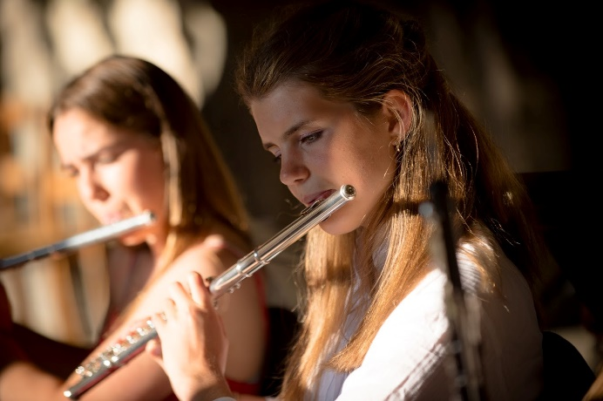
We are now looking to recruit our team of teachers, including some senior leaders, for the Primary and Junior Schools from a variety of subject backgrounds and levels of experience. Applicants should be fully sympathetic with the King’s ethos. They should be highly professional but flexible in their approach, willing to take on a variety of tasks and fit into the wider community life.

It should be pointed out, however, that to fulfil Chinese work permit regulations, all international teachers must have a relevant degree and previous teaching experience.

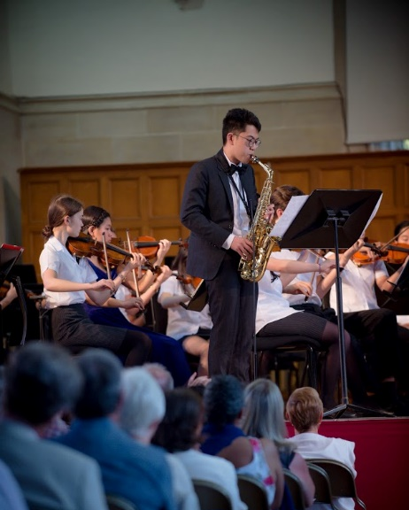
Music at King’s

Music is a key feature of King’s life and the School in Canterbury is widely acclaimed for its variety and outstanding quality, https://www.kings-school.co.uk/co-curricular/music/, with students performing not only in Canterbury Cathedral and other atmospheric King’s surroundings, but in top venues around the UK and around the world. The School’s annual King’s Week festival attracts visitors from around the world.

We expect to continue this tradition in Shenzhen albeit at first being a matter of sowing seeds and helping them to grow. We shall have dedicated music classrooms, fully equipped with technology, rehearsal rooms, and many individual practice spaces.

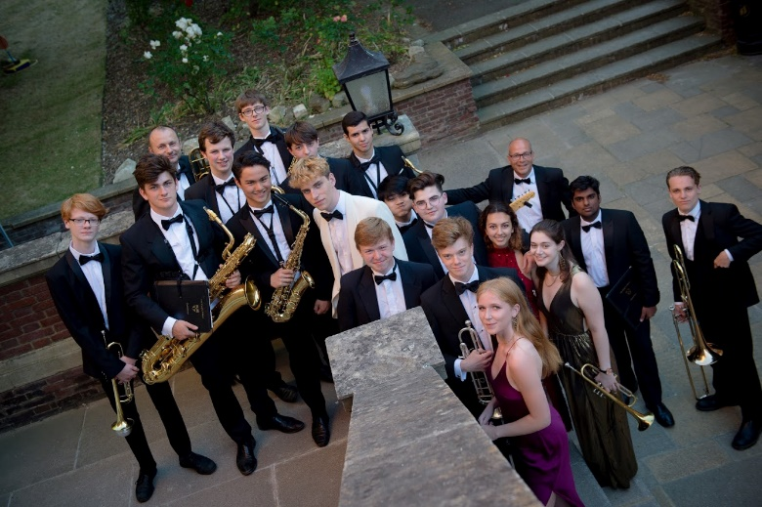

Specific areas of responsibility
      - Primary and Junior Schools, but with a wider scope
      - Curriculum and Teaching & Learning
      - Overseeing the individual lesson programme
      - Developing resources
      - Arranging performing events and opportunities

1. Primary and Junior Schools

The role involves leading on art and its development in the Primary and Junior Schools (Grades 1-6, UK Years 2-7), but, in the first year at least, it will involve (i) liaison with the Pre-Prep / Kindergarten both in terms of teaching but also regarding equipment and (ii) advising on the development of music in the forthcoming Middle and Senior schools.

2. Curriculum and Teaching & Learning

The Teacher will be responsible for ensuring that the students both enjoy and achieve highly in their music throughout the School. This will involve ensuring that teaching & learning conforms to the School’s standards in both delivery and outcome:
- devising and overseeing the music curriculum
- creating stimulating lessons appropriate for the different levels of student
- providing informative feedback to the students, both written and oral
- making use of technology appropriately and effectively

3. Overseeing the provision for individual lessons

The Teacher will be responsible for ensuring that co-curricular individual tuition is available and of an appropriate standard and that all visiting teachers are qualified and fully vetted.

4. Resources

The Teacher will be responsible for the teaching and performing equipment and areas used for music. As this is a start-up, the s/he will be able to advise on the set-up of the areas and the purchase of equipment, books, programmes, etc.

5. Performing opportunities

Although this will undoubtedly start slowly, the Teacher should look for ways to build up a performance tradition, giving the students opportunities (individually in groups and ensembles and, eventually, orchestras) in concerts, recitals, etc.

General areas of responsibility for all teachers
- Responsible for teaching and learning within the designated class as directed by the school leadership team.
- Provide evidence of termly, half-termly and weekly planning of lessons to meet the needs of the students.
- Ensure children learn from playing, problem solving, questioning, and experimenting.
- Take responsibility for the implementation of and compliance with policies and procedures relating to safeguarding, health, safety, security, confidentiality and data protection, reporting all concerns to an appropriate person.
- Be prepared to differentiate teaching levels according to students’ age and ability.
- Set students homework according to school policy.
- Monitor behaviour, relationships and social development of the students in the class.
- Contribute to the co-curricular programme.
- To supervise students at mealtimes and playtimes as directed by the school leadership team.
- Communicate with parents about students’ learning and development according to school policy.
- Participate fully in the School’s Pastoral Care system which means being a pastoral tutor (expected of all teachers).
- Participate in Personal and Professional Development (PPD) organised by, or approved by, the School.
- Communicate with the SENCO (or Head of Pre-Prep if SENCO unavailable) over any children with specific learning needs
- To follow the requirements of the Equality of Opportunity Policy of the School to ensure an environment that is free from prejudice and anti-discriminatory in all aspects
- Support the Admissions and Marketing teams by effectively communicating information to prospective families to the School and to provide guidance, support and reassurance.
- Represent and positively promote the School at local events as required.
- Perform any reasonable duties as directed by the co-Heads or the Founding Executive Principal.

Skills and Experience Requirements

- Bachelor degree or above.
- More than 3 years teaching experience, with corresponding teaching qualification.

Personal Requirements

- Be professional at all times, in tune with the aims of the School, and always prioritises the students’ welfare.
- Be modern and flexible in approach to teaching and learning, prepared to adapt and learn new methods.
- Be comfortable and active in the use information technology for teaching and learning.
- Show initiative and independence but also be a good team-member.
- Be willing and open towards areas of self-improvement.
- Have a good sense of humour.

Applications

Applications should be submitted by 09:00 (China time) on Monday 09 December. There are two steps in the application process:

- Forward a Personal Statement to hr2@kings-school.com.cn. The statement should clearly deal with the following aspects in this order:
- your teaching specialisms including which age groups you prefer to work with
- your personal educational philosophy
- why moving to The King’s School (Canterbury) in Shenzhen is the right move for you at this time;
- how your academic and teaching qualifications/experience support this move

Note, if you wish to include a detailed and more personal curriculum vitae, please include it as a separate attachment.

- Complete our application form obtainable from https://www.kings-school.com.cn/vacancies/.

When both steps have been completed we shall acknowledge the application and inform you of the next steps.

Enquiries or questions prior to application can also be addressed to hr2@kings-school.com.cn. or to the Executive Principal’s Assistant, Jessie Chen on jessie.chen@kings-school.com.cn.

Safeguarding

The King’s School Shenzhen International is committed to safeguarding and promoting the welfare of children and young people in its care. As an employer, the School expects all staff and volunteers to share this commitment. All staff must understand and commit to safeguarding and promoting the welfare of children when carrying out their duties. New staff must sign to state they have read and understood all the required documents and policies. Staff must undertake Child Protection training soon after joining the School.
Equal Opportunities

The King’s School Shenzhen International is an equal opportunities employer. Employees enjoy equal opportunities (recruitment, training, promotion and socialisation, etc.), regardless of race, nationality, religion, gender, age, disability, marital status and sexual orientation, etc.

The King’s School promotes employment practice designed to eliminate discrimination. Therefore, our aim is
- To ensure that no job applicant receives less favourable treatment on the grounds of age, disability, gender reassignment, marriage and civil partnership, pregnancy and maternity, race, religion or belief, sex or sexual orientation.
- All job applicants will be treated equally and fairly in the recruitment process as stated in this policy.
- The successful applicant will be recruited and trained on the basis of ability, experience and skill to undertake the job successfully as defined within the job description and person specification.

