

WALTHAMSTOW SCHOOL FOR GIRLS
“NEGLECT NOT THE GIFT THAT IS IN THEE”

Candidate Information Pack

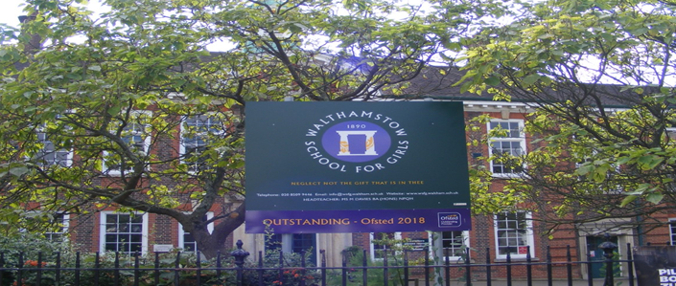

Information for applicants for the post of
French Foreign Language Assistant
Required as soon as possible

Contents of Applicant Pack

- Welcome letter from Helen Marriott – Headteacher
- School Prospectus Link
- School Improvement Plan Link
- Faculty Information
- Additional Information and Key Policies
- What staff value about our school
- Pre-employment checks
- Applying for a job at Walthamstow School for Girls
- Staff Benefits

School Prospectus 2022
2022 prospectus v2 25-9-22 ver 4(1) - Copy law 2.pdf

School Improvement Plan 2021=2024 – introduction
https://sway.office.com/8kD9HWBkxtkwJZUC?ref=Link



Welcome letter from Helen Marriott, Headteacher

September 2023
Dear Applicant
I am delighted that you are considering applying for the role of French Foreign Language Assistant at Walthamstow School for Girls. I consider it a privilege to lead staff and students in this exceptional school where we are passionate about education being a vehicle for promoting equality for all and where our mission is to empower young women to become leaders of the future. We are a truly comprehensive school, proud of our diversity and committed to social justice. Although we are an Outstanding School (Ofsted, 2018), achieve exceptional outcomes and have consistently been in the top 20% of schools nationally for progress, our focus is on developing exceptional young women, not just on academic achievement. Our designation as a Teaching School Hub has given us the opportunity to work collaboratively with leaders and practitioners throughout Haringey, Redbridge and Waltham Forest to improve the life chances of young people in 239 schools across our area. There could not be a more exciting time to join the students and staff at WSfG!
We actively value staff and students: we are committed to their development and the contribution they make to shaping the future direction of the school. Our school SIP, created initially with middle leaders and then with a wider range of stakeholders, demonstrates our commitment to staff and student wellbeing, distributed leadership and creating robust systems, founded on evidence-informed practice. I have included a summary in this pack so that you have a ‘flavour’ of how our key priorities will be developed over the next few years.
We are committed to Safer Recruitment practices and procedures and shortlisted applicants will be questioned about their commitment to the safeguarding of young people. The successful candidate will be subject to an enhanced DBS clearance.
Having read the candidate information, I hope that you feel excited by both the role itself and the chance to be part of WSfG at a pivotal moment in its development.
I look forward to hearing from you.
Helen Marriott
Headteacher MA NPQH



The Languages Faculty at Walthamstow School for Girls is a very successful faculty. All Language staff are fully committed to ensuring our students really enjoy their language learning experience and achieve their full potential in this subject area. We strive to ensure that our students develop a real interest in the cultural aspects of the languages we teach which will enrich their lives and lead them to view language learning as something they will continue with in the future.

Our success as a faculty has been achieved principally by strong teamwork, effective planning, and the delivery of consistently high-quality teaching. We have very high expectations of our students in terms of motivation and effort. They respond extremely well to our teaching and have high expectations of themselves and of us.

We are very well supported by our Leadership Team and this has enabled us to be very well resourced with some of the best language teaching materials available. These include the Pearson Activelearn Studio for French as well as the Viva courses at KS3 and KS4. All students have access to Quizlet in order to support them in vocabulary acquisition both at home and at school.

All of our classrooms are fully equipped with interactive whiteboards enabling staff to fully utilise a range of teaching materials.

Students French or Spanish and there is an option to study Latin and Urdu later at GCSE. Able linguists are able to study both French and Spanish from Year 8. A very high percentage of our students opt to continue with their language to GCSE. Group sizes are usually between 20 and 25.

We are fortunate to have French and Spanish language assistants each year and our students benefit enormously from working with them. Many other extra-curricular activities are organised such as lunch-time language clubs and after-school lunch-time support.

Jan 2023

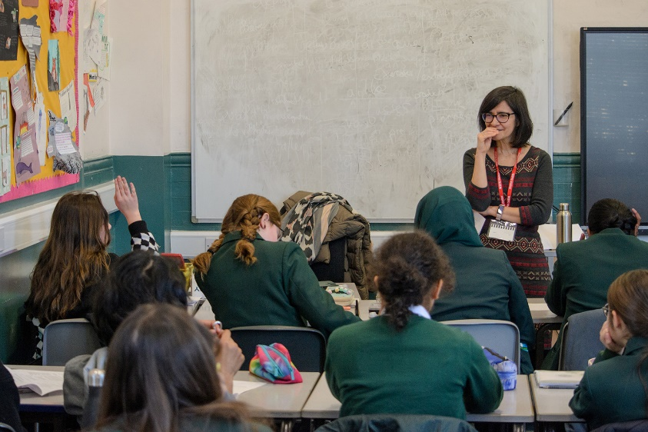

Additional Information and Key Policies

Please follow the links provided below:

Safeguarding:
SAFEGUARDING POLICY 2022-2023.pdf

Keeping Children Safe in Education:
KCSIE_2022_Part_One.pdf

Guideline for employing people with criminal records
LBWF-CRB-Guidance-for-applicants-community-schools.pdf

Applicants Guide to Prevention of Illegal Working:
APPENDIX_17_Applicant_guide_to_illegal_working.pdf

LBWF Safer Recruitment Guidance
WF Safer Recruitment Guidance notes (advertising).doc

LBWF Equalities Policy Statement and Equality Act 2010 guidance
WF Equal_Opportunities_Policy_Statement_(advertising).doc

LBWF Equal Opportunities Policy Statement
APPENDIX_21_Equal_Opportunity_Statement v2.pdf

Candidates are encouraged to visit the school website for additional information:
https://www.wsfg.waltham.sch.uk/

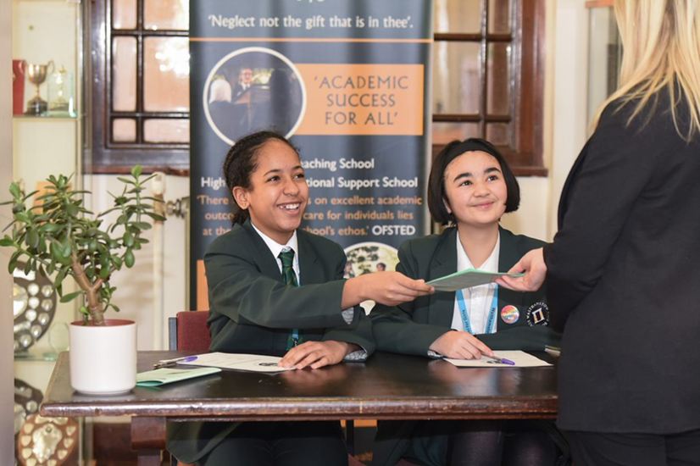

What staff value about the school

- This school feels safe, kind and caring. We are not driven by results – we seem to be driven to produce fabulous young women

- Ethos of the school, supportive colleagues and strong management with compassion
“There are very strong working relationships between staff and pupils based on mutual trust and respect.” Ofsted 2018
- I value the ethos of hard work in the students and how the school promotes kindness, tolerance and maturity amongst the students

- Atmosphere of diversity, respect and inclusion
- Freedom to teach in a range of styles



If you are successful at interview and are offered a post at Walthamstow School for Girls we will be required to carry out a number of pre-employment checks. All offers of employment are conditional on these checks being satisfactorily completed.
The checks completed are:
Identification documents
All staff are required to provide proof of their identity and that they have the right to work in the UK.
Online / Social Media Checks
As recommended in Keeping Children Safe in Education 2022, online searches are carried out on all shortlisted candidates at Walthamstow School for Girls. The searches are carried out to identify any issues or incidents that have happened, and are publicly available online, which the school might want to explore with the candidate at interview. If you are shortlisted you will be asked to complete a form to provide details of your social media platforms and the handles you use on each site.
Criminal Record Checks (DBS)
All offers of employment are subject to a satisfactory Enhanced Disclosure from the Disclosure and Barring Service DBS (formerly the Criminal Records Bureau CRB). Full information relating to this check and the Rehabilitation of Offenders Act 1974 is included in our New Starter Information Pack, issued with offer letters. Before completing the online DBS application you are advised to read the guidance information received with the email link.
Please note any information provided on your application form in the Disclosure and Criminal Background section will only be viewed by those who need to see it as part of the recruitment process. Any information disclosed will be treated in strictest confidence.
Employment history and references
On your application form it is important that you provide your full employment history including information regarding any gaps in your employment. References will be requested, prior to interview, from the information provided on your application form. We reserve the right to seek further references deemed appropriate and all references are verified on receipt.
We may ask you to help us to chase your referees to make sure that we receive your references as quickly as possible.
If you are currently employed in a school we will request a reference from your current Headteacher.
Qualifications
If your role requires you to hold a professional qualification you will be asked to provide evidence in the form of original certificates. Copies of these will be held on your Personnel file.
NCTL Checks (Teaching staff only)
All teachers are checked against the NCTL central register, this includes a Prohibition check.
Pre-Employment Health Check
All staff will be asked to complete a pre-employment health questionnaire. Any information that is disclosed as part of the health check will only be shared with relevant key members of staff and will be treated in the strictest of confidence.

What makes a good application?
You need to make sure your application does you justice and provides you with the best possible chance of getting an interview. This means reading the job description and person specification and taking time over your application to demonstrate your skills and experience.

The Application Form
We do not accept CVs for any post in school, any CVs submitted will not be used for short listing purposes. It is essential that you complete all the sections on the application form. The “monitoring information” section will not be used for short-listing; it is used for administrative purposes only. You must provide full details in respect of two referees, one must be your current or last employer. If you are looking to join us from another school one of your referees must be your current Headteacher.

Do you meet the requirements of the Person Specification?
During the short-listing process we look at the information that you have provided and compare this against the person specification for the position that you are applying for. It is important, therefore, that you provide as much information as possible about how you meet the requirements of the post. You need to be able to demonstrate how you match the criteria, giving examples where possible. This will give you the best chance of being invited for an interview.

Supporting Information
The “general experience and information” section is your opportunity to sell yourself and demonstrate your suitability for the post, be concise but informative and highlight your skills and knowledge. Please include all your relevant experience whether gained at work or outside of the work place environment.

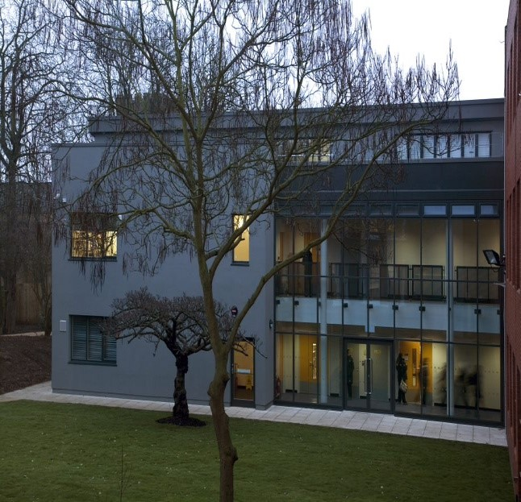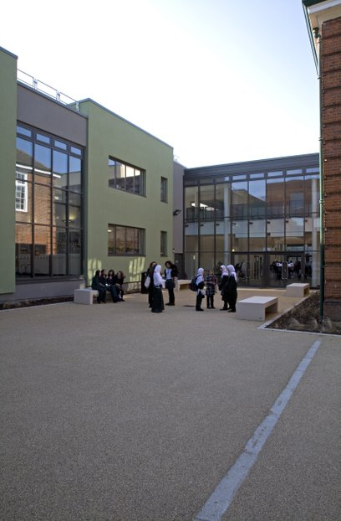

Staff Benefits

Outlined below are some of the additional benefits available to staff working at Walthamstow School.

Commitment to CPD
Excellent staff development is at the heart of our practice at Walthamstow School for Girls, enhanced by our leadership of the North East London Teaching School Hub. We know that, quite simply, we must prioritise continuous professional development if we are going to nurture our staff and enable them to develop the skills and knowledge to maximise their impact on student learning and progress. The best CPD has a measurable impact on the progress of students.

For more information about our CPD offer, including our brochure, please see our website: https://www.wsfg.waltham.sch.uk/page/?title=Staff+Development&pid=56

Cycle 2 work scheme
This benefit offers staff the opportunity to purchase a bike (from a range of providers) making a tax saving, whilst keeping fit at the same time.

Eye Tests
All staff using computer equipment should have eye and eyesight checks at regular intervals. Eyesight testing should also happen where staff experience visual difficulties, which may reasonably be considered to be caused by computer work. Staff working within schools in the London Borough of
Waltham Forest may be entitled to reimbursement of some costs associated with vision testing and the frames and lenses needed to enable them to work safely on display screen equipment.

Staff Wellbeing
Staff Wellbeing is one of our school SIP priorities. There is a staff wellbeing development group which examines both strategic and operational approaches to improving the wellbeing of all groups of staff in our school.

At Walthamstow School for Girls there are also a number of staff organised activities including a running club, yoga and Boxfit exercise sessions.

Workplace Options - Employee Assistance Provider
A confidential counselling, help and information service is provided for all those employed by Waltham Forest and is available free of charge 24 hours a day, every day of the year. This service can help with a range of problems from practical everyday matters to sensitive and emotional issues. For further information please call 0808 1682143 or contact: www.carefirst-lifestyle.co.uk

Non-meeting weeks
There are designated Home and Family non-meeting weeks throughout the year to support with reduced workload and staff wellbeing.

Staff Car Park
There is parking available on site for all staff.

