All Saints Catholic College
A Voluntary Academy

Birch Lane, Dukinfield, Cheshire, SK16 5AP
Tel: 0161 338 2120 Fax: 0161 338 9750
email: schooloffice@allsaintscatholiccollege.com
www.allsaintscatholiccollege.com

Headteacher: Mr A Diamond Be inspired. Be excellent. Succeed.
Executive Headteacher: Mr J Cornally

February 2021

Dear Applicant

re: Vacancy for Teacher of Mathematics

Thank you for your interest in the above vacancy.

Please find enclosed an application pack which includes an application form, job description and person specification. Please complete the application form in full and sign the Declaration at the back of the form. Please be aware that we do not accept CVs or open references. The closing date for applications is Friday 26th February at 9.00am, and interviews will take place week commencing 15th March 2021.

The College is committed to safeguarding and promoting the welfare of children. The successful candidate will be subject to an enhanced criminal conviction check through the Disclosure and Barring Service.

Please return completed applications for the attention of Karen Leigh, Headteacher’s PA, by email to recruitment@allsaintscatholiccollege.com.

Thank you again for your interest in this post.

Yours sincerely
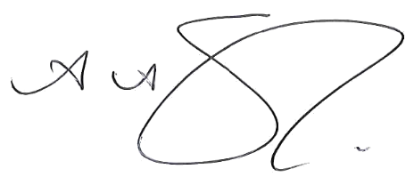
Mr A Diamond
Headteacher

