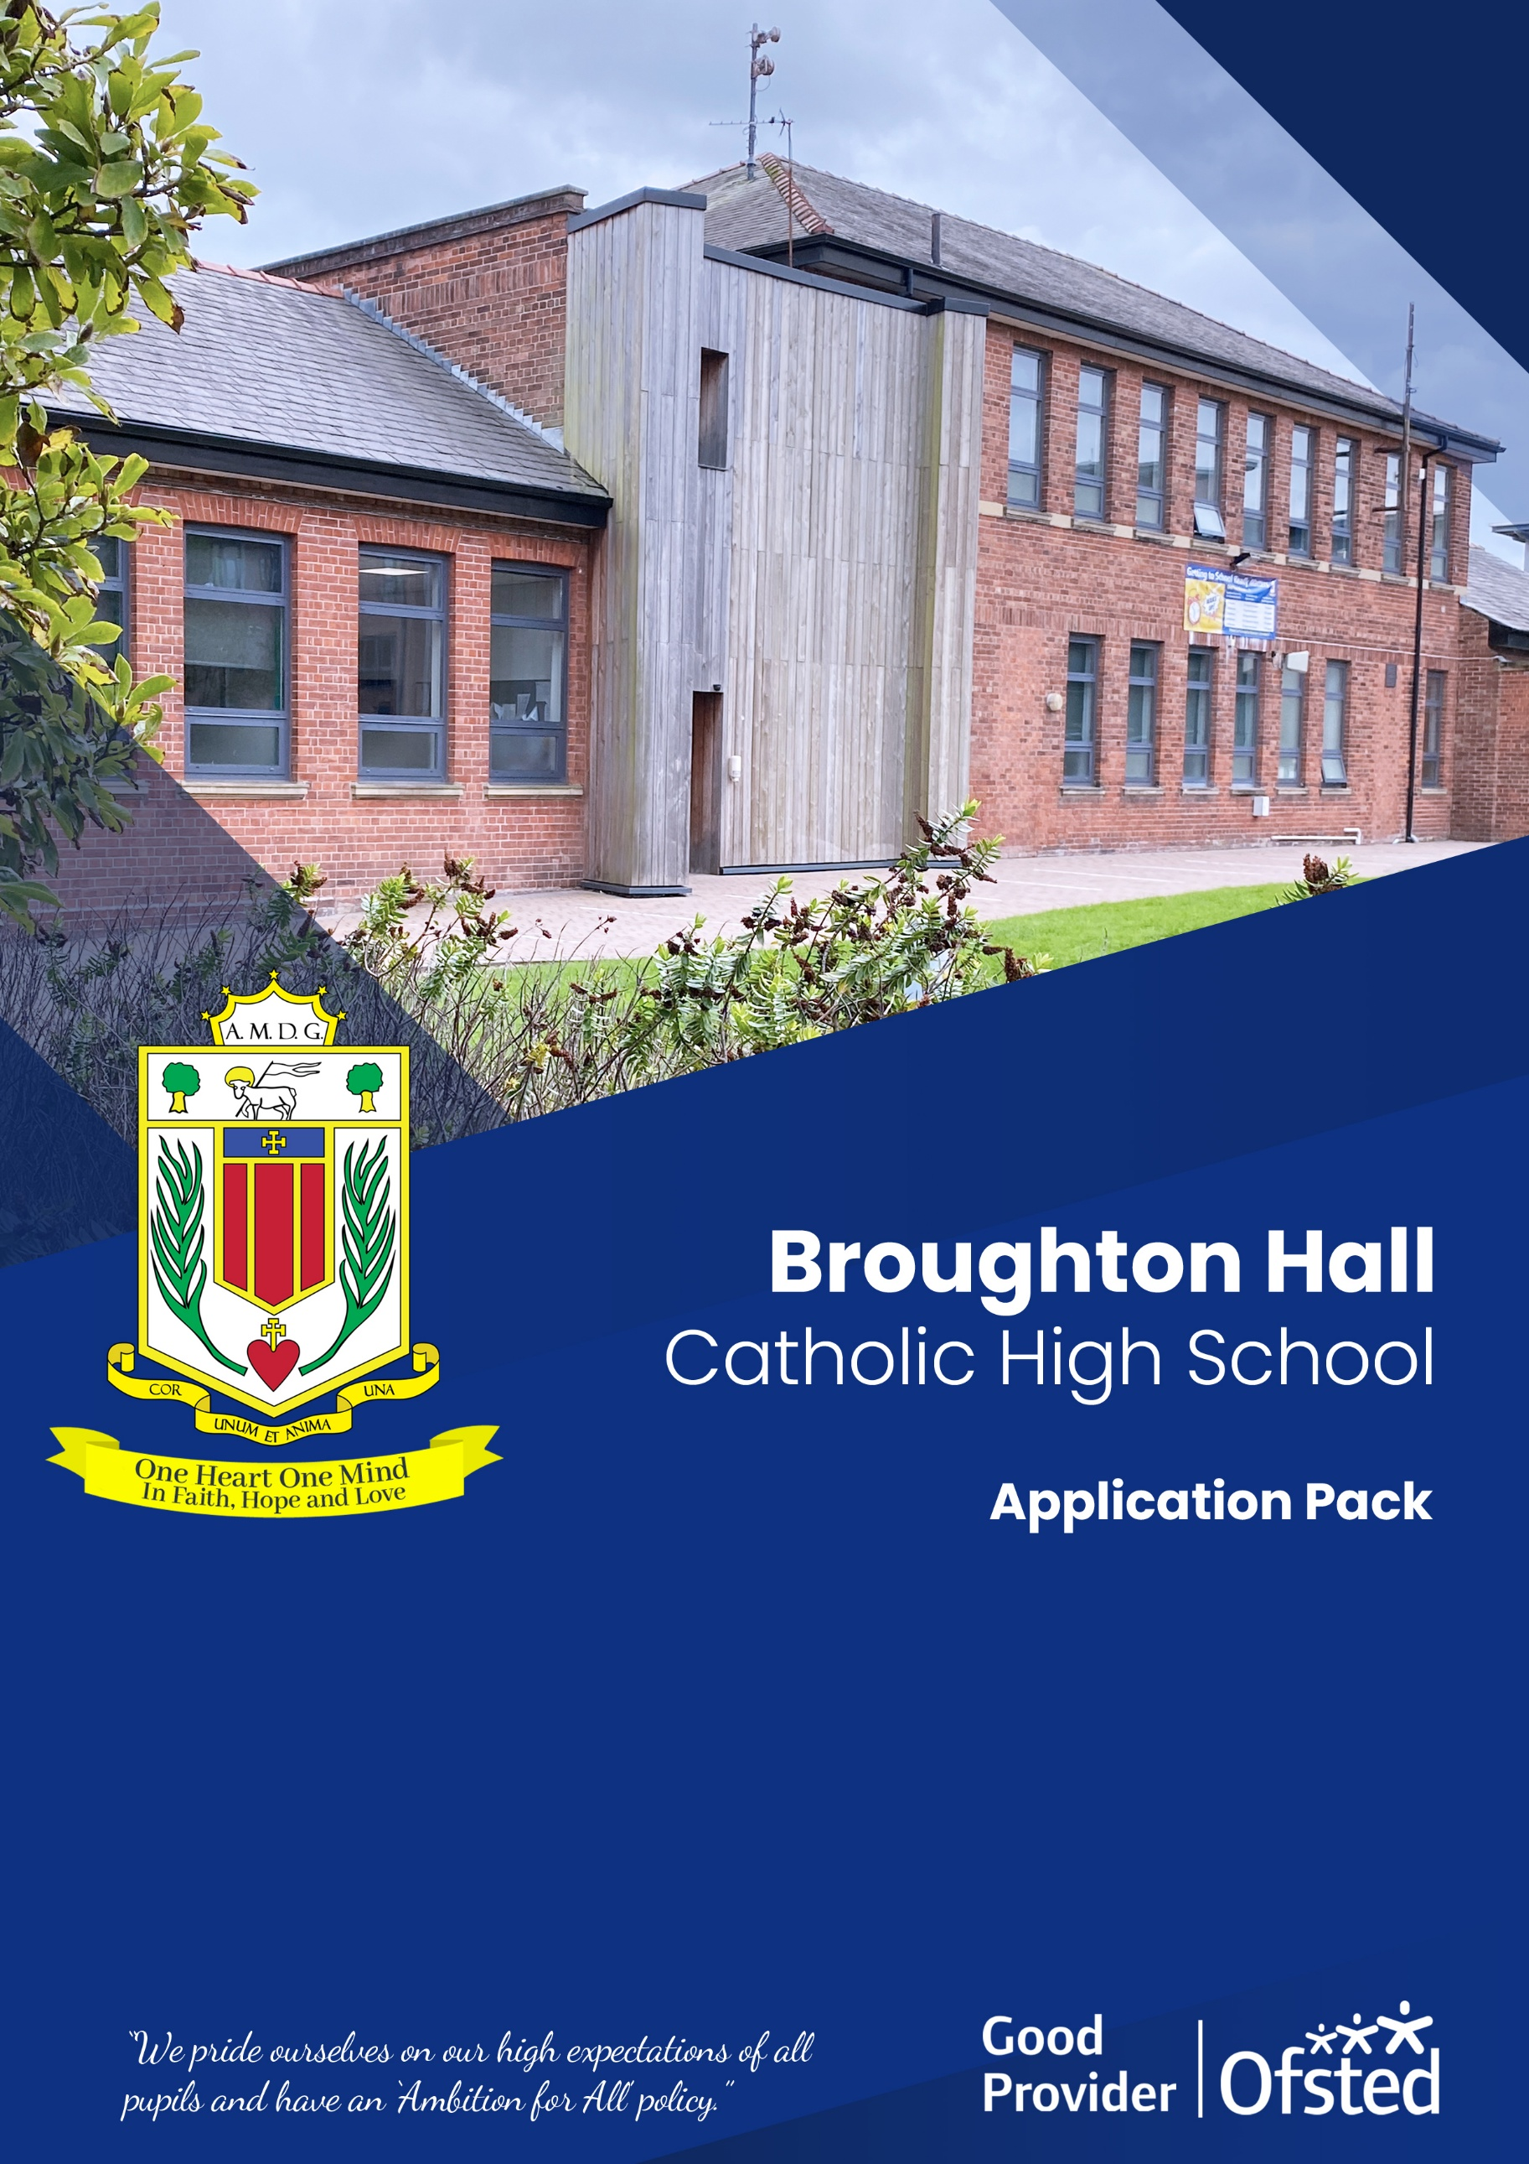
Contract Term: Permanent/Full-Time

Headteacher
Salary Scale: Leadership Scale L10 to L16 (subject to experience)

Headteacher
Interview Dates: Tuesday 6th May 2025

Headteacher
Shortlisting Date: Friday 25th April 2025

Headteacher
Closing Date: 12pm on Thursday 24th April 2025

Headteacher
Preferred Start Date: 1st September 2025
Headteacher111
Role: Assistant Headteacher
Broughton Hall Catholic High School

Founded in 1928 under the trusteeship of the Sisters of Mercy, Broughton Hall Catholic High School, an all-girls Catholic secondary school in Liverpool, provides the very best in modern education based on the Gospel values of mutual respect and care.
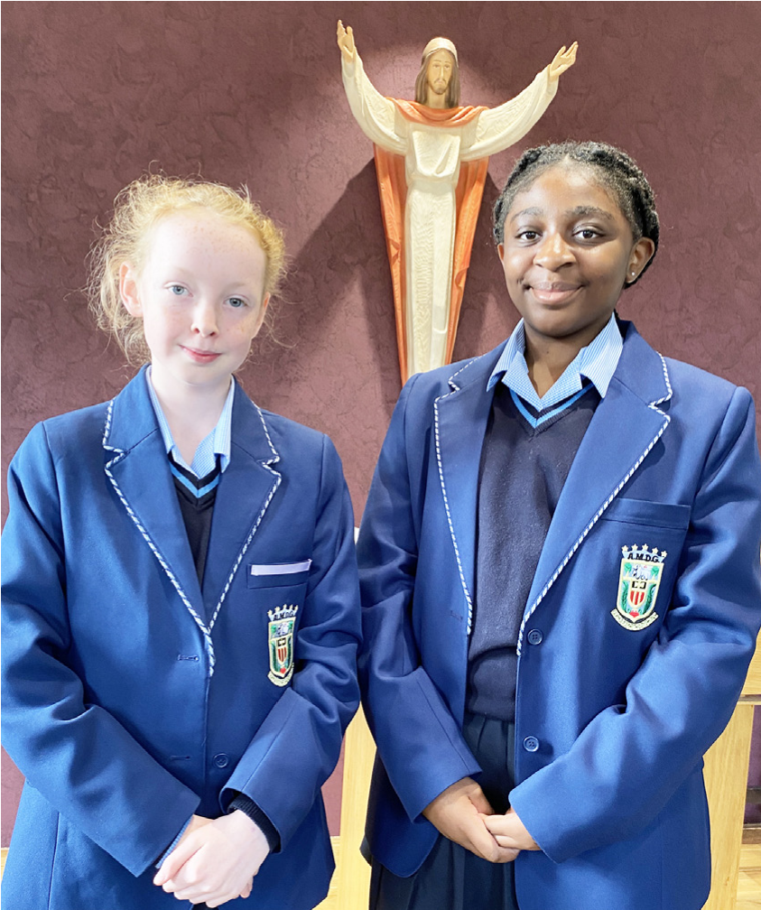
The central aim of our school is to provide excellent educational opportunities enabling each pupil to develop their God given talents, to grow in confidence and self-esteem and to fulfil their potential.

As a Catholic school Broughton Hall centres its mission on the person of Jesus Christ, and promotes the Gospel values throughout the school community and in all aspects of school life: spiritual, academic, pastoral, and personal. By proclaiming and living out the faith of the Catholic Church, we support each other in shared experiences of teaching and learning, prayer, worship and charity. Our mercy values permeate throughout our community.

Broughton Hall is Ofsted rated as a “Good” provider (November 2022).

Our facilities are bright, spacious, high tech and designed to meet the needs of all our pupils. We have a separate 6th Form facility, which is shared with our neighbouring boys school Cardinal Heenan Catholic High School. A full range of extra-curricular activities are provided to further the creative, sporting and academic talents of each pupil and offer Outward Bound and Duke of Edinburgh Award schemes as well as the opportunity to attend educational visits and residential trips.

We pride ourselves on our high expectations of all pupils and have an ‘Ambition for All’ policy. Whatever your role within the school, you will share these values and be able to encourage and motivate pupils with your passion, presence and personality.

Our school motto ‘Cor Unum et Anima Una’ - One Heart and One Mind, reflects the strong sense of community amongst pupils, staff, parents and Governors.

School has a weekly Newsletter – please click here to view our latest edition. https://www.broughtonhall.com/newsletter/

Message from the Chair of Governors

Dear Applicant,

Thank you for your interest in the position of Assistant Headteacher at our school, to start in September 2025.

We hope you find the information included with this advert useful. Should you require more information about our school please visit our website www.broughtonhall.com

We warmly invite you to visit our school. Please contact Gina Smith, PA to the Headteacher, on 0151 541 9465 or email smithg@broughtonhall.com to arrange a visit.

On behalf of the Governing Body of Broughton Hall Catholic High School we thank you for your interest in our school and look forward to receiving your application.

With best wishes,


Karen Holland
Chair of Governors

Headteacher’s Welcome

Thank you for your interest in the Assistant Headteacher role.

This pack has been designed to help you should you choose to submit an application form, which we sincerely hope you do. We hope it answers your initial questions, but if not, please do not hesitate to contact us and we will endeavour to help you through your application process.

Broughton Hall Catholic High School is the largest all-girls school in Liverpool and serves many different areas making us a vibrant a diverse school. Our aim is to be a good school in all areas and we are seeking staff to apply to work with to be of that journey.

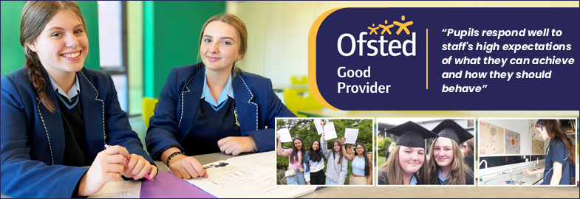

We work hard to ensure Broughton Hall Catholic High School remains a friendly and welcoming environment for all those who work, study or visit here and hope that you are the person we are looking for to bring creativity and innovation to the role.

Our school actively supports the development of all staff, providing a dynamic and nurturing environment where people can thrive. Our team is composed of dedicated support staff and passionate teachers who are committed to crafting exciting and stimulating lessons that not only engage students but also inspire a lifelong love for learning. If you are an enthusiastic and driven educator looking to grow in a supportive and forward-thinking community, we encourage you to join us.

We look forward to receiving your application.

Sarah O’Rourke
Headteacher

We Offer

- Pensions Scheme – Teacher Pension Scheme for teaching staff
- Regular training and development programme
- An enhanced Occupational Health & Well-Being App (Smart Clinic) with access to a wide variety of services e.g.
- Virtual GP
- 24 hour employee assistance line
- Physiotherapy
- Mental Health Services
- Self-support and guidance tools
- Cycle2Work Scheme
- Tax Free Childcare Vouchers
- Supportive work environment where all staff are valued
- Continuous professional development for all staff and follow a whole school approach to staff performance and development

And that’s not all, we place the outcomes of the children in our school at the heart of everything we do, so you’ll wake every day in the knowledge that your role will have a significant positive impact on the lives of others.

Equal Opportunities

Broughton Hall Catholic High school is an equal opportunities employer.

We welcome applicants from all backgrounds and value everyone as an individual. We are committed to organisational practices, which promote diversity and inclusion for all employees and volunteers regardless of age, gender reassignment, marriage or civil partnership status, pregnancy and maternity status, disability, race (including colour, nationality, ethnic or national origin), religion or belief, sex, or sexual orientation. Connecting these differences creates a productive environment in which everyone feels valued.

Monitoring information in relation to job applicants will be to assist us in equality monitoring. The recruitment panel will not have access to job applicant’s monitoring information.

To assist us in monitoring the operation of equal opportunities policy, and for no other reason, please ensure you complete and submit the Equal Opportunities Monitoring Form with your application form.

Safeguarding & Enhanced DBS Checks

Broughton Hall Catholic High School is committed to safeguarding and promoting the welfare of young people and expect all pupils, staff, volunteers and visitors to share this commitment

All posts are subject to an enhanced DBS check and full pre-employment checks to comply with the current Keeping Children Safe in Education statutory guidance for schools.

All staff will be expected to follow Broughton Hall Catholic High School’s child protection policies, code of conducts and managing allegations against staff procedures.

All roles in school, including this post, are exempt from the Rehabilitation of Offenders Act (ROA) 1974. The Ministry of Justice’s guidance on Rehabilitation of Offenders Act 1974 and the Exceptions Order 1975 provides information about which convictions must be declared during job applications and can be accessed here.

All applicants must therefore declare all previous convictions and cautions, including those which would normally be considered ‘spent’ except those received for an offence committed in the United Kingdom if it has been filtered in accordance with the DBS filtering rules. Information about filtering offences can be found in the DBC Filtering Guide, which can be accessed here.

By engaging in this recruitment process, shortlisted candidates consent to an online search in line with the Keeping Children Safe in Education Statutory Guidance 2022.

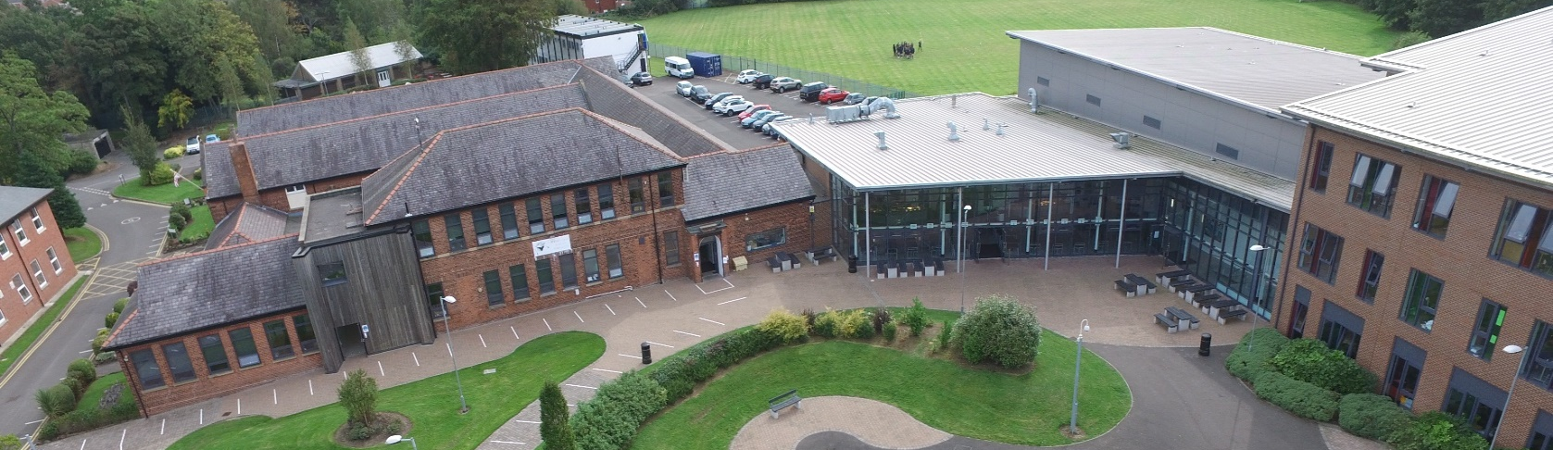

Advert
assistant HeadTeacher
Salary: Leadership Scale L10 to L16 (subject to experience)
Start Date: 1st September 2025
Broughton Hall Catholic High School is seeking to appoint an outstanding and inspirational teacher and leader. The Assistant Headteacher will be an experienced, skilled, strategic leader with the right combination of personal and professional skills to help lead our school.
Broughton Hall Catholic High School is a Voluntary Aided School catering for girls aged 11-18 years. Boys are admitted to the Sixth Form at 16+. There is shared provision and a strong collaboration between Broughton Hall and Cardinal Heenan Catholic High School. Broughton Hall was founded by the Sisters of Mercy in 1928 and throughout its history has maintained its Mercy Ethos and Charism. The School Motto, ‘Cor Unum et Anima Una’ – ‘One Heart and One Mind’ – reflects the strong sense of community amongst staff, pupils, parents and governors. The central aim of our School is to provide the very best educational opportunities enabling all our pupils to develop their God-given talents, to grow in confidence and self-esteem and fulfil their potential.

The successful candidate will be:
- Committed to upholding the Catholic ethos of the school
- An inspirational and visionary leader with a passion for teaching and learning
- An excellent leader, motivator, communicator and role model to staff and pupils
- Able to demonstrate successful leadership and management skills and have relevant experience in school improvement
- Enthusiastic and have the ability to inspire staff to meet the academic and pastoral needs of our pupils
- Able to support the Headteacher in leading the School forward as a “Good’ and ultimately ‘Outstanding’ school
- Able to deal with parents, pupils and colleagues with integrity, transparency, expertise and kindness
- Have a successful experience of implementing and managing change

The specific remit and responsibilities will be confirmed on appointment
In return Broughton Hall will offer you:
- A School which places the development, care and respect of the individual at the heart of our mission
- An outstanding, experienced Governing Board closely involved in all aspects of the school
- A strong, diverse and experienced Leadership Team
- A Catholic school with a long history of educating girls in Liverpool
- Enthusiastic pupils who are keen to succeed

- A warm and caring working environment
- Trustees committed to the continuing success of the school
- Close working links with the Archdiocese of Liverpool and Local Authority

How to Apply:
Application is via email and should be forwarded to recruitment@broughtonhall.com together with a Supporting Statement included within the application. The supporting statement must be in Arial font size 12 and must not exceed four sides of A4 paper.

If any assistance is required contact Mrs G Smith, Headteacher’s PA on
0151 541 9465.

Key Dates:
Closing Date for applications: 12pm on Thursday 24th April 2025
Shortlisting: Friday 25th April 2025
Interviews to take place: Tuesday 6th May

Job Description
Assistant HeadTeacher
Purpose: | - To contribute to the distinctive Catholic ethos of the school, as laid down in its Mission Statement, in all areas of contact and responsibility, in relationships with all staff and pupils.  - To support and follow the school policies and procedures as directed by the Governing  Body.  - To raise standards of student attainment, attendance and achievement and to monitor and support student progress in year groups.  - To develop and enhance the teaching practice of others.  - To manage effectively and deploy teaching/support staff, financial and physical resources within the learning development of pupils.  - To promote and monitor high standards of Health and Safety and Child Protection.  - To develop a whole school curriculum that is inclusive, challenging and well sequenced.
Reporting to: | Deputy Headteachers/Headteacher
Responsible for: | Form Tutors, Managers of Pupil Support.  All students in year groups and other relevant non-teaching personnel.
Liaising with: | Headteacher, Deputy Headteachers, Assistant Headteachers, Heads of Department, SENDCO, Staff, Pupils and Parents.
Working Time: | 195 days per year. Full time.
Salary/Grade: | Leadership Scale L12 - L16 (subject to experience)
Disclosure level | Enhanced
Strategic Leadership: | - To analyse and interpret relevant national, local and school data, research and inspection evidence, to inform, practices, expectations, targets and teaching methods.  - To establish and implement clear policies and practices for assessing, recording, and reporting on pupil achievement for an identified year group and for using this information to recognise achievement and to assist students in further improvement.  - To facilitate and develop curriculum practices in line with National developments.
Operational/  Strategic Planning: | - To monitor the development of appropriate syllabuses, resources, schemes of work, marking policies, assessment and teaching and learning strategies.  - To implement school policies and procedures, e.g., Equal Opportunities, Health and Safety, COSHH, Accommodation Strategy etc.  - To assist in the acts of collective worship and assemblies for the year groups, to meet the school’s distinctive ethos and mission.  - To work with Heads of Departments on curriculum development  - To work with Heads of Department on assessment practices and implementation.
Curriculum Provision: | - To liaise with the Leadership Team with regards to teaching and learning to ensure the monitoring of an appropriate, comprehensive, high quality curriculum programme.  - To be accountable for the development and delivery of appropriate programmes of study.  - To develop appropriate curriculum opportunities which are challenging, inclusive and support the retention of knowledge.
Curriculum Development: | - To lead and manage curriculum development for pupils.  - To keep up to date with national developments in teaching practice and methodology.  - To actively monitor and respond to curriculum development.
Assessment Provision: | - To liaise with the Leadership Team to ensure the monitoring of an appropriate, consistent, comprehensive, high quality assessment cycle.  - To be accountable for the development, delivery and tracking of internal assessment.  - To ensure that assessment feeds into classroom practice and informs departmental intervention.
Assessment  Development: | - To lead and manage assessment to support the development of pupils.  - To keep up to date with national developments in assessment practice and methodology.  - To actively monitor and respond to assessment development.
Staff Development | - To work with the Heads of Department as Line Manager to ensure that staff development needs are identified and that appropriate programmes are designed to meet such needs.  - To ensure effective development of learning network programmes for staff development.
Recruitment/  Deployment of Staff: | - To undertake Performance Management Review(s) and to act as support where appropriate for a group of staff.  - To ensure effective induction of new staff in line with school procedures with a focus on curriculum and assessment.  - To promote teamwork and to motivate staff to ensure effective working relations.  - To participate in the school’s ITT programme.  - To be responsible for the day-to-day management of staff within the designated departments and act as a positive role model.
Quality Assurance: | - To ensure the effective operation of monitoring systems.  - To establish the process of the setting of targets within specific subject areas  - To establish common standards of practice within the year groups and development practices.  - To contribute to the school procedures for monitoring.  - To implement school quality procedures and to ensure adherence to those within the year groups.  - To monitor and evaluate the curriculum in line with agreed school procedures including evaluation against quality standards and performance criteria.  - To seek/implement modification and improvement where required.  - To ensure that the pastoral quality procedures meet the requirements of Self Evaluation and the Strategic Plan.
Management Information: | - To make use of analysis and evaluate performance data to target improvements in curriculum development and assessment.  - To produce reports on examination performance, including the use of value-added data.  - In conjunction with the Leadership Team, to manage the collection of data.  - To provide the Governing Body with relevant information relating to performance and development.

Communications: | - To ensure that all Heads of Department are familiar with aims and objectives.  - To ensure effective communication/consultation as appropriate with the parents of students where needed.  - To liaise with partner schools, higher education, Industry, Examination Boards, Awarding Bodies and other relevant external bodies to support any developments.
Marketing and Liaison: | - To contribute to the school liaison and marketing activities e.g., the collection of material for press releases.  - To lead development of effective curriculum and assessment links with partner schools and the community, attendance where necessary at liaison events in partner schools.
Management of Resources: | - To manage the available resources of space, staff, money, and equipment efficiently within the limits, guidelines and procedures laid down, including deploying the curriculum and assessment budget.
Pupil Development: | - To monitor and support the overall progress and development of students through high quality curriculum delivery and assessment.  - To monitor student attendance together with students’ progress and performance to see if curriculum delivery reflects any patterns.  - To contribute to PSHE, citizenship and enterprise according to school policy.  - To ensure the Behaviour Management system is implemented.
Teaching: | - To undertake an appropriate programme of teaching in accordance with the duties of a standard scale teacher.
Additional Duties: | - To play a full part in the life of the school community, to support its distinctive mission and ethos and to encourage and ensure staff and students to follow this example.

Other Specific Duties:
- To continue professional development as agreed.
- To engage actively in the performance review process.
- To undertake any other duty as specified by STPCB not mentioned in the above.
- Whilst every effort has been made to explain the main duties and responsibilities of the post, each individual task undertaken may not be identified.
- Employees will be expected to comply with any reasonable request from a manager to undertake work of a similar level that is not specified in this job description.
- Employees are expected to be courteous to colleagues and provide a welcoming environment to visitors and telephone callers.
- The school will endeavour to make any necessary reasonable adjustments to the job and the working environment to enable access to employment opportunities for disabled job applicants or continued employment for any employee who develops a disabling condition.

This job description is current at the date shown, but, in consultation with you, may be changed by the Headteacher to reflect or anticipate changes in the job commensurate with the grade and job title.

Person Specification
 |  |  | Assessed by:
 | CATEGORIES | Essential/  Desirable | App Form | Interview/  Task
QUALIFICATIONS
 | A Degree in the relevant subject | E | √ | √
 | Qualified Teacher Status | E | √ | √
 | Evidence of continuous professional development | E | √ | √
 | Middle or Senior Management Qualification | D | √ | √
EXPERIENCE
 | Track record of delivering outstanding teaching and outcomes for pupils | E | √ | √
 | Use of innovation & creativity to engage, enthuse & progress learners | E | √ | √
 | Experience of partnership working and collaboration within a school or local authority context | E | √ | √
 | Effective management of people and team of professionals within a school setting | E | √ | √
 | Analysis and use of data to plan and implement intervention strategies to raise academic performance | E | √ | √
 | Developing and leading strategies to sustain whole school improvement | E | √ | √
 | Leading the delivery of coaching and INSET sessions to support the professional development of others. | E | √ | √
ABILITIES, SKILLS AND KNOWLEDGE
 | Ability to teach to A Level standard | E | √ | √
 | Ability to use ICT and technology in the classroom to deliver engaging lessons and monitor pupil progress effectively | E | √ | √
 | Ability to coach and motivate professionals, individually and within groups, to achieve individual and collective targets | E | √ | √
 | Ability to develop and disseminate effective learning and teaching and classroom management strategies | E | √ | √
 | Ability to communicate, orally and in writing, with a range of people and groups. | E | √ | √

 |  |  | Assessed by:
 |  | Essential/  Desirable | App Form | Interview/  Task
 | Ability to analyse and interpret performance data to inform school improvement | E | √ | √
 | Knowledge and experience of curriculum development and delivery | E | √ | √
 | Knowledge of effective intervention to raise attainment through assessment strategies | E | √ | √
 | Ability to set clear targets, track and manage progress and develop strategies to achieve desired outcomes | E | √ | √
 | Knowledge of curricula, specifications and assessment criteria of the leading subjects | E | √ | √
 | Ability to prioritise conflicting demands | E | √ | √
 | Possesses the necessary ICT skills to develop, manage and report on performance data, curriculum and assessment | E | √ | √
PERSONAL QUALITIES
 | A committed practising Catholic | D | √
 | A passionate belief and commitment to the ethos, vision, values and mission of the school | E | √ | √
 | Highly organised, literate and articulate | E | √ | √
 | Highest levels of professional and personal integrity | E | √ | √
 | Personal resilience, persistence and perseverance | E | √ | √
 | Commitment to the pursuit of continuous professional development by self and others | E | √ | √
 | Commitment to delivering after school and pre-exam sessions as required, in addition to enrichment opportunities for learners | E | √ | √

