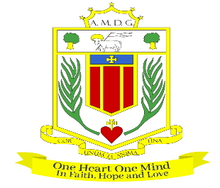

Broughton Hall Catholic High school

assistant HeadTeacher
Salary: Leadership Scale L10 to L16 (subject to experience)
Start Date: 1st September 2025
Broughton Hall Catholic High School is seeking to appoint an outstanding and inspirational teacher and leader. The Assistant Headteacher will be an experienced, skilled, strategic leader with the right combination of personal and professional skills to help lead our school.
Broughton Hall Catholic High School is a Voluntary Aided School catering for girls aged 11-18 years. Boys are admitted to the Sixth Form at 16+. There is shared provision and a strong collaboration between Broughton Hall and Cardinal Heenan Catholic High School. Broughton Hall was founded by the Sisters of Mercy in 1928 and throughout its history has maintained its Mercy Ethos and Charism. The School Motto, ‘Cor Unum et Anima Una’ – ‘One Heart and One Mind’ – reflects the strong sense of community amongst staff, pupils, parents and governors. The central aim of our School is to provide the very best educational opportunities enabling all our pupils to develop their God-given talents, to grow in confidence and self-esteem and fulfil their potential.

The successful candidate will be:
- Committed to upholding the Catholic ethos of the school
- An inspirational and visionary leader with a passion for teaching and learning
- An excellent leader, motivator, communicator and role model to staff and pupils
- Able to demonstrate successful leadership and management skills and have relevant experience in school improvement
- Enthusiastic and have the ability to inspire staff to meet the academic and pastoral needs of our pupils
- Able to support the Headteacher in leading the School forward as a “Good’ and ultimately ‘Outstanding’ school
- Able to deal with parents, pupils and colleagues with integrity, transparency, expertise and kindness.
- Have a successful experience of implementing and managing change

(The specific remit and responsibilities will be confirmed on appointment)
In return Broughton Hall will offer you:
- A School which places the development, care and respect of the individual at the heart of our mission
- An outstanding, experienced Governing Board closely involved in all aspects of the school
- A strong, diverse and experienced Leadership Team
- A Catholic school with a long history of educating girls in Liverpool
- Enthusiastic pupils who are keen to succeed
- A warm and caring working environment
- Trustees committed to the continuing success of the school
- Close working links with the Archdiocese of Liverpool and Local Authority

How to Apply:
Application is via email and should be forwarded to recruitment@broughtonhall.com together with a Supporting Statement included within the application. The supporting statement must be in Arial font size 12 and must not exceed four sides of A4 paper.

If any assistance is required contact Mrs G Smith, Head Teacher’s PA on
0151 541 9465.

Key Dates:
Closing Date for applications: 12pm on Thursday 24th April 2025
Shortlisting: Friday 25th April 2025
Interviews to take place: Tuesday 6th May

