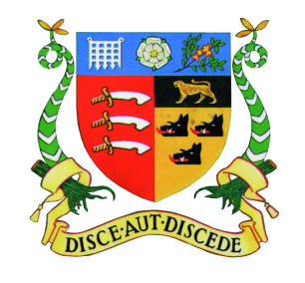
Gosfield School
Information for Candidates
Established in 1929, Gosfield School is an independent co-educational day school for ages 4-18. Set in superb green grounds of 110 acres with an impressive sports hall, award winning Forest School provision and with most Senior classrooms housed in the handsome Grade II listed manor house, we expect all students to reach and exceed their personal best, whilst growing their character in our family, friendly and respectful environment.
Not only does Gosfield School provide inspiring surroundings in which to learn and enjoy School life, we are also engaged in several, significant developments, including:
- Constructing a new Performing Arts Centre
- Refurbishing and redesigning the interior of the main house with our interior design consultant
- Installing new Design Technology equipment and facilities
- Enhancing student social areas so all can enjoy our grounds and Grade II listed main house
- Partnership with the PiXL Club to enhance progress for all students at GCSE and A Level
The Senior School:
The benefits of small class sizes is everywhere apparent at Gosfield. No teaching group exceeds 20 pupils and many GCSE and A Level sets are considerably smaller. This promotes a much more personalised education pathway for our students, which means all children are known to all teachers – who are free to plan and design tailored lessons and have time to teach children as individuals.
Science Department:
There are currently five members of staff in the department: two full-time teachers, three part-time teachers and a full time Science Technician. There are three well-equipped laboratories, one being dry, with the possibility for developments under the direction of a new Head of Department with vision. We follow the AQA GCSE specification and A levels are offered in Biology, Chemistry and Physics following the OCR specifications. The Department runs a variety of trips to museums, exhibitions and lectures, and encourages pupils to participate in regional and national competitions.

Salary:

Gosfield School has its own pay scale. Salary will depend upon the qualifications and experience of the successful candidate.

