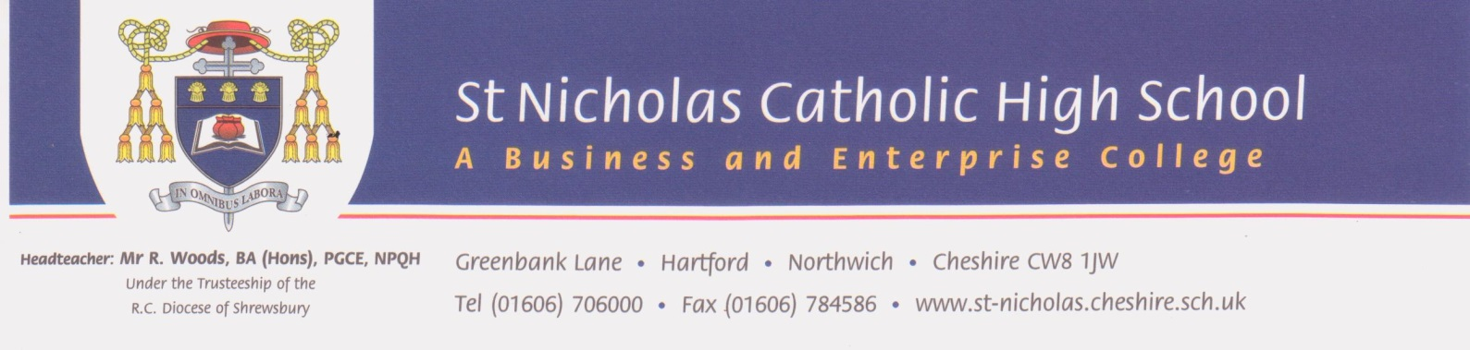

January 2018

Dear applicant

Thank you for your interest in the post of Subject Leader for MFL at St Nicholas Catholic High School. Since taking up post as Headteacher in April 2017, I can confirm that St Nicholas is a truly wonderful Catholic school - a community that enjoys a fantastic reputation for the very highest of standards, outstanding students, exceptional staff and the warmest of welcomes.

We are looking to appoint a Subject Leader for MFL who has a passion and vision for learning and teaching - a highly effective practitioner who will make a difference by inspiring a love of learning in both colleagues and students. The successful candidate will join a forward looking department who are committed to securing the very best for each and every student in their care.

If, having read the person specification and job description, you feel that you have what it takes to help deliver our future vision for MFL then please send your applications either by email, or by post to the school address. The deadline for applications is 12 noon on Thursday 8th February 2018.

Should you wish to visit us prior to submitting your application then you would be more than welcome - please contact Mrs Vicky Hill, Headteacher’s PA at v.hill@st-nicholas.cheshire.sch.uk

I look forward to receiving and reading your application and I thank you for your interest in St Nicholas Catholic High School.

Yours sincerely
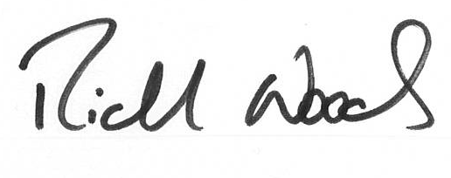
Richard Woods
Headteacher

