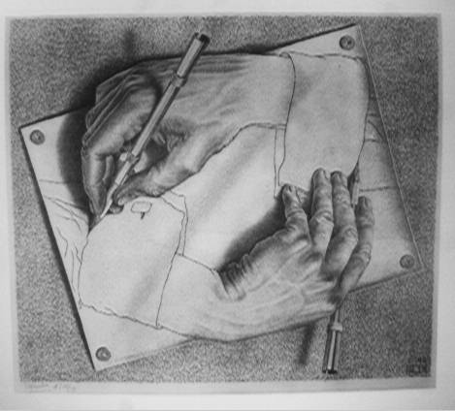
Art Department

Our Community:
In Art we have an experienced team of 7 staff (three of whom are part-time) who complement each other with skills that range from fine art to ceramics, photography and graphics. Art is a thriving and popular subject at Poole High School.
The Curriculum:
In years 7 and 8 we offer a broad curriculum that aims to provide an excellent foundation within the formal elements of art. Drawing in all its forms is central to our teaching. We teach a 3 year GCSE course and use the AQA Art and Design course. Year allows students to develop their skills, knowledge and understanding further whilst taking creative risks without worrying about the pressures of coursework. In years 10 and 11 we run exciting and dynamic projects that are relevant and engaging to our pupils. In the Senior School, students can choose AQA Fine Art and AQA Photography.
Resources and Facilities Available:
The Art department boasts a large, modern self-contained block comprising of 5 large studios, one of which contains a mezzanine for A level students to use in their independent study time. We also have a dedicated computer room, a kiln room with a large electric kiln and a photographic darkroom. The department is very well resourced and our pupils are able to work in a wide range of media.
Our Results and Achievements:
Students make good progress in Art and our results are usually above the national average. The art department at Poole High School has excellent links to a number of local institution including the neighbouring Art University Bournemouth and we are lucky enough to run many projects in conjunction with them that have included student artists in residence, practical workshops and Lower School and Senior School Spring and Summer Schools. We have hosted many visiting artists who have given our students amazing experiences and have enriching insights into careers in the creative industries.
Art students from Poole High School have won numerous awards and competitions including the Dorset Art Prize. A number of our students go on to study art at degree level and many are now professional practitioners and art teachers.

Team Activities, Teamwork and Planning:
One of the strengths of the Art Department is our readiness to collaborate and share ideas, resources and planning. The size of our department and the range of disciplines that we are are drawn from allow for an exciting cross-fertilization of ideas and sharing of best practice. Our teachers are always keen to share and learn new skills either through formal or informal sessions.
Although the Art department’s schemes of learning are comprehensive, teachers are encouraged to teach to their strengths and to the needs of their classes. We value collaborative planning either in small groups or as a department and our schemes of learning are constantly being evaluated and refined in light of our teaching.
Training Support:
The Art Department has supported many NQTs in their first year of teaching many of whom are now experienced teachers and leaders. Through our involvement in the Wessex Schools Training Partnership we also regularly train teachers in their initial teacher training.
Other exciting things that happen:
The Art Department in Poole High School has an excellent reputation in the area through our links and joint projects with other schools and in the local community and through our exhibitions of students’ work both in school and in venues within the town of Poole. The department is proud to collaborative with other departments within the Creative Arts Faculty to help to design and produce the sets for the school’s public dramatic musical performances.

