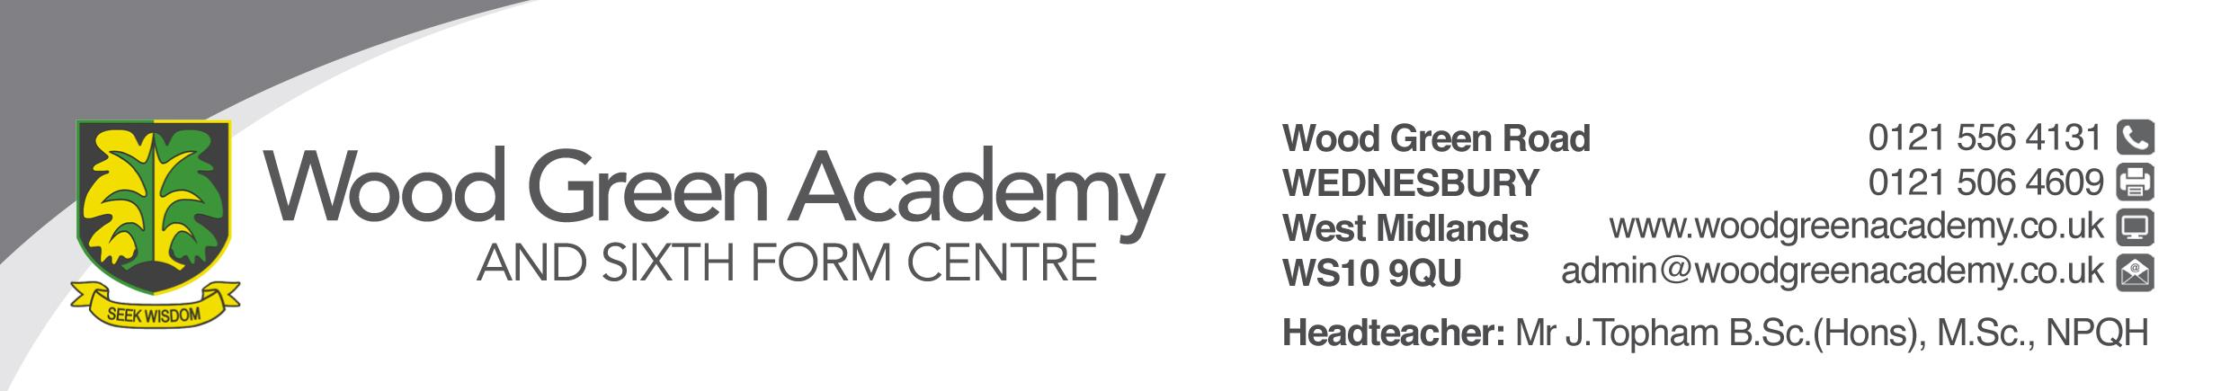
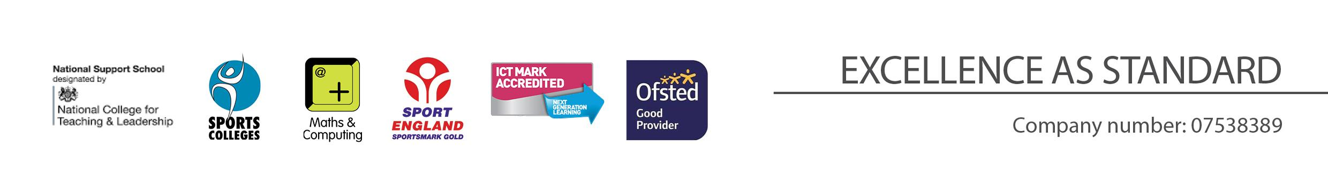
Learning Support Assistant
Person Specification

REQUIREMENT | ESSENTIAL | DESIRABLE
LEGAL REQUIREMENTS | Enhanced DBS checks included children’s barred list and right to work in the UK.
QUALIFICATIONS  Principally assessed through letter and application form | GCSE A* - C / Grade 4 or above in English or Maths. | A*-C/ Grade 4 or above in Science  A*-C/ Grade 4 or above in any other subjects.  NVQ Level 2 or 3 in Childcare, BTEC or NNEB  A levels
EXPERIENCE and PROFESSIONAL COMPETENCE  Principally assessed through letter, application form and lesson observation | Knowledge and understanding of Equal Opportunities  Knowledge of Health and Safety issues and Safeguarding | Experience of working with Primary/Secondary children
KNOWLEDGE  Principally assessed through letter and interview process | An understanding of child development and appropriate levels of childcare | SEN, ILPs and EHCP
COMMUNICATIONS  Principally assessed through letter and interview process | Have excellent written and verbal communication skills  Ability to use IT technology
PERSONAL ATTRIBUTES  Principally assessed through references, letter and interview process | To be committed to safeguarding and promoting the welfare of children and young people  Ability to motivate individuals to perform effectively  Ability to innovate and contribute to new initiatives  Commitment to working in partnership with parents  Awareness of and respect for, the needs of the individual child and their families, including multi-cultural and inclusive practices.  Ability to work when the school is open (Term Time working)  Flexibility and willingness to be involved in the school  Work effectively as a member of a team  Be an effective role model through presentation and personal conduct  Enthusiasm, energy, vigour, reliability and integrity

