Children’s Hospital School

# School Business Manager Application Pack



**Key Dates**

**Advert: Friday 6th September 2019**

**School visits: Wed 11th & Mon 16th September 2019 (4pm)**

**Deadline: Monday 23rd September 2019 (9.00am)**

**Interviews: w/b 30th September 2019**

**Start date: Monday 2nd December 2019 (preferred)**

**Introduction**

The post of School Business Manager at The Children’s Hospital School is a fantastic opportunity for a suitably experienced colleague to join our team.

The school was rated ‘outstanding’ in all areas following our OFSTED inspection in July 2017 and you will find throughout the school a real commitment at all levels to improve what we do. Staff wellbeing is very important to us and the culture of professionalism, mutual support, dedication and care is a real strength of the school. All staff are supported through a coaching framework and have the opportunity to contribute to whole school developments.

|  |
| --- |
| CHS logo 2 |

Our logo ‘Better Together’ says it all. We are a small school, full of caring, supportive and talented staff. It is a place where mutual support goes hand in hand with excellent education and care. A school whose guiding principles are about making the difficult times manageable, giving pupils a great education and helping them move on successfully to their next phase of learning.

**‘Better Together’**

### **Core purpose & values**

*‘Working together in a nurturing and happy environment to break down barriers, inspire learning and provide opportunities for all to flourish beyond their expectations’*

**School Context**

The Children’s Hospital School provides education for students who are too ill to attend their mainstream school. Our students join us following a referral supported by medical evidence. We teach students aged 3-19 across three school sites and also provide home tuition through our outreach team. We are a foundation special school and part of the Well Trust along with a number of other local special schools and partners. Although designated as a Leicester City Local Authority school, we provide education for a number of students from across Leicester, Leicestershire and Rutland. At the Leicester Royal Infirmary (LRI) and Coalville Hospital (Ward 3) we may also provide education to students from across the country and beyond.

Students come from a wide geographic area and also from a range of social and cultural backgrounds. We have a higher than average number of students eligible for Pupil Premium (approximately 32%). During the last academic year, the school provided education for approximately 400 students. The length of stay for these students can be from 2 days up to several years. At the census day in January 2019 there were 91 students on roll, with approximately 67% female and 33% male. The school has a highly mobile population which can vary weekly and across the academic year.

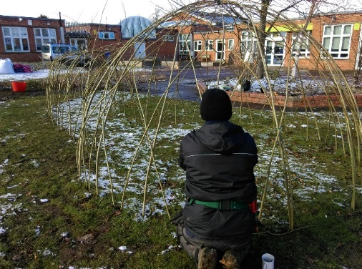Some students have Education, Health and Care Plans (EHCP) from their home schools or may be in the process of receiving one with the support of The Children’s Hospital School. There are a range of medical needs, both physical and mental, experienced by students within the school. Some may have chronic and / or life-threatening medical conditions that bring them into hospital many times over their childhood and adolescence. There will be some with degenerative medical conditions, acquired brain injuries, or those recovering from major surgery. A significant number of students have social, emotional and complex mental health needs. There are some students who are taught by more than one area of the school during their admission and effective communication enables a smooth transition for each child.

There are 27 teachers (25.2 FTE) and 12 teaching assistants (10.6 FTE) employed across the school. A number of staff will work within 2 different areas of the school. The school commissions a further 2.5 days of CAMHS support at Willow Bank Day school.

The Willow Bank Day school was first refurbished through BSF in 2013 and initial planning discussions are taking place to increase accommodation further to meet current demand. In March 2015, the CAMHS adolescent inpatient unit relocated to temporary accommodation at Ward 3, Coalville Hospital in North West Leicestershire which led to a reduction of classroom space from 113m2 to 43m2. A permanent new build has been agreed by LPT NHS Trust for completion in September 2020. This will increase the number of beds from 10 to 15.

At the Leicester Royal Infirmary, there are plans to develop the Children’s Hospital wards over the next 5 years. The school currently has use of a classroom on ward 28 with other teaching taking place at the bedside or in cubicles.

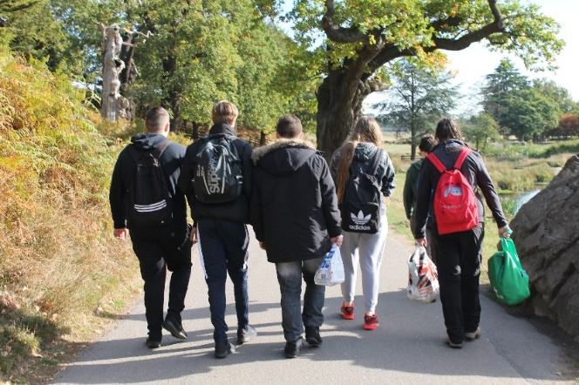

**Willow Bank School**

Willow Bank Day School provides an education for students aged 11-16 who are unable to access education in their own school for medical reasons. Each student has a personalised timetable comprising core and foundation subjects. We also offer Arts Award, Prince’s Trust Achieve programme, a vocational element, and a therapeutic curriculum, as appropriate. Individual timetables are designed to meet students’ academic needs, whilst taking account of health and emotional factors.

**Leicester Royal Infirmary**

At the Leicester Royal Infirmary we offer education to any child of school age during their time as an inpatient. We work in consultation with the family, home school, medical and nursing staff. On the children’s wards we teach in cubicles and at bedsides, bringing laptops, tablets and other teaching resources to the students. Where it is possible, we follow the curriculum provided by the child’s own school in order to minimise the impact of their absence from school.



**Ward 3, Coalville Hospital**

Ward 3 is a residential CAMHS adolescent psychiatric unit. We provide access to education for inpatients, assuming their health permits, providing a range of activities and supporting students to maintain their studies within a safe and enabling setting. We liaise closely with home schools/colleges and other agencies to aid transition back into mainstream settings.

**Outreach**

Our outreach team provides home tuition for primary and secondary students who are unable to leave the home to attend school, on medical grounds. On outreach we endeavour to follow the courses that the students would be covering at their own school. Our offer is focused on the abilities and additional needs of our students across the age, ability and additional needs range.

**Staffing Structure (2019/20)**

|  |  |  |  |  |
| --- | --- | --- | --- | --- |
| Senior Leadership Team | | | | |
| Head Teacher  Stephen Deadman | Deputy Head Teacher  Nikki Cole | Deputy Head Teacher  Diane Davies | Assistant Head Teacher  James Stafford | School Business Manager  VACANCY |
| * Strategic direction, vision and leadership * School improvement * Staffing & personnel * Partnerships & collaboration * Governors | * Quality assurance * Appraisal * Teaching and learning * NQT / ITT students * CPD * Curriculum * Pupil premium | * Willow Bank leader * Assessment, data and tracking * Timetable * Supply / cover * Exams * Referrals | * Pastoral care * Safeguarding * Pupil welfare * Attendance * Early help * Family liaison & support | * School finance * Resource management * Health & safety * Site & premises * Personnel / HR * Income generation * ICT / SIMS development * EVC |

|  |  |  |  |  |
| --- | --- | --- | --- | --- |
| Middle Leadership Team | | | | |
| LRI Leader  Danny Riley | Ward 3 Leader  Lorraine Biddle | Outreach Leader  Amy Thorpe | Pastoral Manager  Micki Handford | SENCO  Stewart Scragg |
| English Leader  Paul Gibson | Maths Leader  Paul Sowman | Science Leader  Elizabeth Hope | Assistant WBS Leader  Claire Mooney | Assistant SENCO  Emma Compton |

|  |  |  |  |
| --- | --- | --- | --- |
| Teaching Staff | Teaching Support | Support Staff | External Support |
| 14 teachers | 6 Higher Level TAs  4 Teaching Assistants  1 Learning Mentors | 6 Admin  Exam / data officer  ICT support  Catering manager  3 Premises staff | CAMHS  Careers advisor  School nurse  Family support worker |

**About the School Business Manager Post**

The current post-holder has made a significant contribution to the development of the school over the past 7 years, during a time of change. Systems, policies and processes have been greatly improved and are in a very strong position, ready for the new business manager to continue the excellent work of supporting the school to grow.

As a school, we need to work closely with many partners including the following:

* Leicester, Leicestershire and Rutland local authorities
* UHL and LPT NHS trusts
* CAMHS and school nursing teams
* Local special, secondary and primary schools
* Other hospital schools and medical needs provisions nationally
* Teaching schools
* Department for Education and Health
* Family support workers / social care
* Community and voluntary organisations

The school receives hospital education funding from the DFE via the local authority’s high needs block. However, as you might expect, the funding arrangements for a school like ours are more complex than some and this will be explained in more detail if you are able to visit the school beforehand or at interview.

We have worked hard over the last 4-5 years to increase funding and to ensure we have a stable funding model to support the increasing number of children being referred to our provision. The current budget is approximately £1.8m and a key aspect of the role is to support the head teacher in maintaining a sustainable funding model.

The successful candidate will also be part of school’s leadership team and be able to make a strategic contribution to our future direction and development. Although we are judged as an outstanding school, we realise that this does not mean ‘perfect’ and the culture within the school is to seek improvements in what we do. Indeed, we feel that huge progress has been made in the 2 years since OFSTED visited.

Attention to detail, tenacity, resilience, organisational skills, communication, leadership and ability to work well with others are essential qualities for the person we are looking for.

The successful candidate can expect excellent support and professional development opportunities. We have a commitment to develop all our staff and you will find many other opportunities to work more widely – locally and nationally. We have excellent links with all our local schools as well as other Hospital Schools across the country. We are an active part of the National Association for Hospital Education (NAHE), the Ash Field Teaching School Alliance and the Challenge Partners network of excellence.

I would encourage you to look at our OFSTED and Challenge Partners reports, alongside the school website to really get a flavour of the type of organisation we are. It really is the most wonderful and inspirational place to work and I hope this will encourage you to apply.

There are two opportunities offered for you to visit the school in advance of your application at 4pm on 11th or 16th September 2019. During these visits, you will be able to meet the head teacher, learn more about the school and the role, and ask any questions you might have.