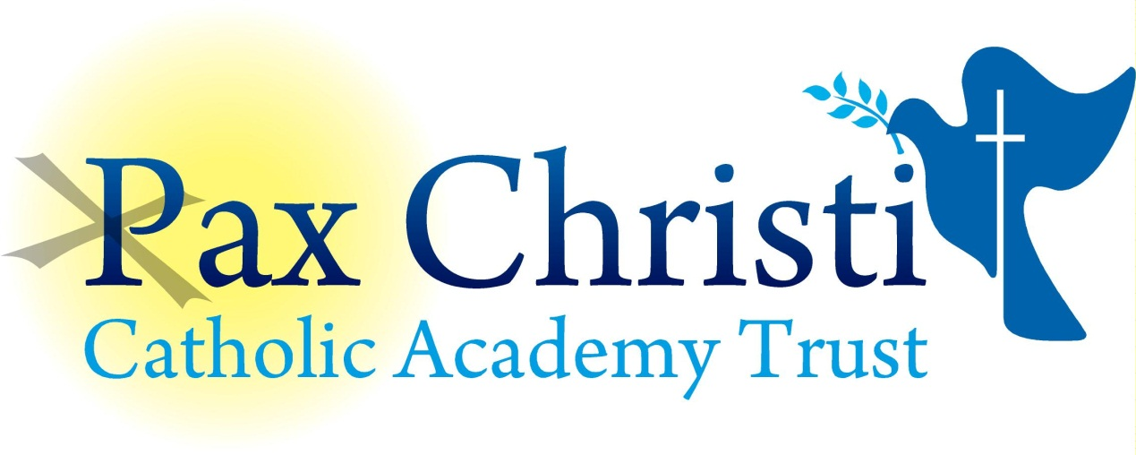

CHRIST THE KING CATHOLIC VOLUNTARY ACADEMY

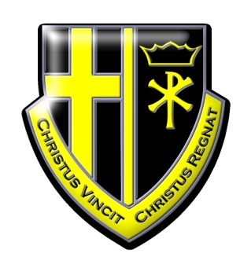

JOB DESCRIPTION

Assistant Cook
NJE Grade 2
Current Post holder: | Vacant
Job Description Review Date:  Signed…………………………………………………………… | June 2017  Date………………………………………..

Job Purpose

To assist in the preparation and serving of school meals and maintaining the cleanliness of the kitchen and dining areas.

Line Management

Responsible to: Principal, Operations Director, Catering Manager
Responsible for: No staff

Specific Responsibilities

- Assist the cook supervisor with the preparation and cooking of school meals.
- Assist cook Supervisor with supervision of staff.
- Kitchen cleaning and cleaning of equipment.
- Assist in the preparation and cleaning of the dining area, including movement of furniture as appropriate.
- Service of meal and washing up after meal.
- Maintenance of health & safety in the kitchen.
- Assist Cook Supervisor in training new staff in cooking methods and methods of work in kitchen.
- Assist Cook Supervisor with health and safety training.
- Assist the other members of the school community with the promotion and implementation of healthy eating.
- Assist with any extra catering required by the school other than the school meal.
- Take control of kitchen in absence of Cook Supervisor.
- Any other duties which may reasonably be regarded as within the nature of the duties and responsibilities/grade of the post as defined, subject to the proviso that normally any changes of a permanent nature shall be incorporated into the job description in specific terms, following consultation with the Recognised Trade Unions

Skills and Abilities
The post holder will be expected to demonstrate the following skills and abilities at all times during the discharge of their duties:

- Work on own initiative and to demonstrate the ability to solve unexpected or new problems in a methodical, efficient manner.
- Learn new skills and expand current skill set and to be able to pass on knowledge and techniques to others.
- Demonstrate good general interpersonal and communication skills.
- Deal with conflicting demands and work flexibly.

Whole Academy Responsibilities
- Be a positive influence on the climate and culture of the Academy and show a positive example at all times.
- Support the catholic ethos of the Academy.
- Be aware of and comply with policies and procedures relating to child protection, health, safety and security, confidentiality and data protection, copyright etc reporting all concerns to line manager.
- Be aware of and support difference and ensure equal opportunities for all.
- Contribute to the overall aims of the Academy.
- Appreciate and support the role of other professionals.
- Attend and participate in relevant meetings as required.
- Participate in training and other learning activities and performance development as required.
- Recognise own strengths and areas of expertise and use these to advise and support others.

General

To work in collaboration with other Pax Christi Academies, sharing good practice and supporting during time of absence and/or heavy workload.
- This job description contains the main accountabilities relating to this post and does not describe in detail all the tasks required to carry them out. All staff are expected to be flexible to ensure the most effective organisation and delivery of services.
- The duties and responsibilities of the post will evolve to meet changes in financial regulations, statutory requirements or the natural development of the Academy and/or Trust. Such changes are, therefore, a normal part of the post and the post holder must be prepared to undertake any other duties commensurate with the general level of responsibility of the post which may be determined from time to time subject to the proviso that any permanent, substantial changes shall be incorporated into the job description and evaluated as such.

