Bordesley Green Girls’ School & Sixth Form
Applicant Information Pack
@BGGS_Birmingham
Welfare and Guidance Manager

January 2021

January 2021
Dear Candidate
I am delighted you are interested in joining the Team at Bordesley Green Girls’ School & Sixth Form.
Bordesley Green Girls’ School is a vibrant 11-18 school at the heart of the community. We pride ourselves on providing a truly inclusive education, enabling all staff and students to reach their full potential.
I was privileged to be appointed to lead Bordesley Green Girls' as the Headteacher in September 2020. Having worked at Bordesley Green for ten years, I have built a strong relationship with our students, staff, parents, community and governors and understand what is needed to take the school forward. It is a very special place of work.
At the heart of our philosophy is that every student matters. We care about the progress our girls make and are committed to their success. Each student has access to a broad and balanced curriculum and a wealth of experience and opportunities. We aim for every girl to grow in confidence and knowledge, leaving us prepared for responsible adulthood, becoming future leaders and having a positive impact on the community.
Our teaching and pastoral staff work tirelessly to create an atmosphere where the girls can perform at their best. Our priorities are to develop innovative and inspirational teaching and learning to ensure our girls become effective, independent learners. This approach undoubtedly has led to excellent outcomes both at GCSEs and at Level 3 qualifications.
We believe that school should be a safe, respectful and hardworking environment, in which staff enable the children to recognise their true potential. We celebrate attitudes and attributes – such as resilience, respect, enthusiasm and creativity as well as academic achievements.
Our leadership team is very strong and each member of the leadership team has key roles and responsibilities. However, we work collectively to seek best solutions to improve the life chances of the students in our care. We have made great progress by working together, transparently, flexibly and honestly.
All key stakeholders have a voice and as a school we are approachable and listen to their concerns or thoughts about the school. Community support is a huge strength of the school and we have a growing range of partnerships with universities, colleges and successful businesses.
Our Governing Body has highly esteemed academics on the board as well as finance and safeguarding experience from leading practitioners in their field. Together, the Governors, the Senior Leadership Team and staff all work in harmony to deliver a great education for our students.
We encourage applications from colleagues with a diverse range of skills and experience. We work hard and we celebrate our achievements. We are a school, which wants our staff to succeed every bit as much as our students. Wishing you good luck and we look forward to receiving your application.

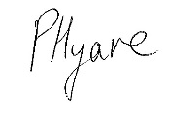
Ms Pritpal Hyare
Headteacher
Bordesley Green Girls' School & Sixth Form is a high achieving, over-subscribed, four-form entry 11-18 multi-cultural, inclusive comprehensive school situated on the eastern side of the City of Birmingham. We have 1,000 students on roll including 380 in the Sixth Form.
The Governing Body is currently looking to appoint a dynamic and experienced
Welfare and Guidance Manager
Grade 4, TTO + 10 days, 36.5 hours/week, permanent
Start Point: Grade 4 Point 23 – 25 £27,741 - £29,577 (pro rata), depending upon experience
Start Date: February 2021

We are looking for an exemplary practitioner, who is motivated, enthusiastic, experienced and committed to supporting young people in their school environment. The successful candidate will work directly with our students and their families, assisting the Head of Sixth Form in ensuring high standards of behaviour, engagement in learning, achievement and the personal development of our students
The post holder will liaise closely with our Designated Senior Leaders for safeguarding and will join a passionate team of staff working within this diverse, community school based in the centre of Birmingham. This post offers many opportunities for professional development in a secure and supportive environment.
In this key, dynamic role you will maximise the successful entry of our students into the world’s top Universities, FE Colleges and Apprenticeship schemes by ensuring all our students are provided with information, advice and guidance to access further education, training and the workplace in order for them to achieve their personal goals and career aspirations. The successful candidate will:

- Support the Head of Sixth Form with all matters in relation to student welfare, including academic and attendance monitoring
- Help improve communication, advice and guidance between school, home, external agencies and the local community
- Manage whole school careers provision including work experience across the school and sixth form
- Supporting with Enterprise and Enrichment days throughout the Academic Year
- Provide careers advice in preparation for curriculum choices at 14+, 16+ and beyond in line with the national statutory Gatsby Benchmarks
- Advise on the preparation of UCAS applications for university with the Head of Y13
- Grow and develop an engaged network of parents, alumni, business partners and other friends of the school and community such as MOSAIC, to provide mentorship, work experience and to co-ordinate networking events
- Develop robust relationships with Universities, FE Colleges, vocational institutions and the business community, including the Chamber of Commerce, the CBI and local employment agencies to identify opportunities in the job market, work experience, apprenticeships and internships
- Ensure a comprehensive programme of pre-employment advice and training is available for our students so they are job ready upon leaving KS4 and the Sixth Form
- Develop, wide-ranging and engaging enrichment interventions for our Sixth Form students
The ideal candidate will have experience of the university admissions and UCAS application process with experience or knowledge of Schools and School curriculum and a Careers, Education, Information and Guidance (CEIAG) qualification or equivalent.
If you can empathise and support students, providing personal warmth to gain their confidence and encourage them to progress and succeed we would be delighted to hear from you.
This post is covered by Part 7 of the Immigration Act (2016) and therefore the ability to speak fluent English is an essential requirement for this role.
An Applicant Information Pack and Application Form are available to download from our website at www.bordgrng.bham.sch.uk
Please submit your completed application form to HR@bordgrng.bham.sch by the closing date:
Monday 25 January 2021 at 12 noon.
If you have not heard from the School within 10 working days of the closing date, please assume that your application has not been shortlisted on this occasion.
We are committed to safeguarding and promoting the welfare of children and expect all staff to share this commitment. An Enhanced DBS check is required for all successful applicants.

Our School

Bordesley Green Girls’ School is an 11-18 multicultural, inclusive comprehensive school situated on the eastern side of the City of Birmingham. We have 1016 students on roll, including 380 in the Sixth Form, 62.7 FTE teaching staff and 46.5 FTE support staff.

Curriculum Arrangements
Our curriculum aims to provide a broad and balanced experience for all our students.
The curriculum is delivered through the taught curriculum and the enrichment curriculum. Learning happens in lessons, form-time, assemblies, games, educational visits, enrichment and enterprise days, school productions, and community work.
The Timetable
The timetable for the school is based on a two-week cycle and comprises of a 25 period week with five periods per day, each period lasts 60 minutes. Lessons can be either single or double periods (usually sixth form lessons).

Key Stage 3
Our three year KS3 programme of study ensures that there is no narrowing of the curriculum. Students secure depth of knowledge and skills and are prepared for an inspirational and challenging KS4.
Our provision follows a three year programme at KS3 that delivers the National Curriculum across the subject areas. The Key Stage 3 Core curriculum: All students study English, Mathematics, Science, PE, RE and PSHE. In addition in Year 7 all students are taught Design Technology, Art, Computing, French, Geography, History, PE, RE, Drama, Music and PSHE.

In Year 8 students study two languages: French and one of Arabic, Spanish and Urdu.

In Year 9 students study one language.
Students in Years 7 to 9 are taught in two separate half year groups for most subjects, known as ‘X’ and ‘Y’. This enables us to target teaching assistants effectively to support students who need extra help. This system also enables students to move up and down the sets during their school career.
- The ‘X’ half is divided into two sets one of higher ability and one of middle ability.
- The ‘Y’ half contains slightly more students and is divided into 3 sets, one of higher, one of middle and one of lower ability.
Key Stage 4
The Key Stage 4 Core curriculum: All students study English, Mathematics, Science (Separate or Dual Award), PE, RE and PSHE. Our most-able scientists study separate Sciences as part of their core curriculum.

In addition to the core curriculum all students will choose up to four option subjects. At Bordesley Green we encourage most of our students to study the full range of English Baccalaureate subjects.
Most students will study one core language from Arabic, French, Spanish or Urdu. In addition, students must choose to study either Geography or History. Students can opt for any combination of a further two subjects at KS4 from Art, Design Technology, Geography, History, Health and Social Care, Music, PE, RE and Computing. Spanish will be offered from September 2021.
In Key stage 4 we teach English and Mathematics at the same time across whole year groups which enables us to set students within 5 different teaching groups.
School follows a 2 week timetable and the number of allocated periods is as follows:
 | Key Stage 3 |  |  | Key Stage 4
Subject | Year 7 | Year 8 | Year 9 | Year 10 | Year 11
English | 7 | 7 | 8 | 8 | 8
Mathematics | 8 | 7 | 7 | 8 | 8
Science | 7 | 7 | 7 | 8/12 | 8/12
Art | 2 | 2 | 2 | Option (4) | Option (4)
Drama | 2 | 1 | 2 | Option (4) | Option (4)
DT | 3 | 3 | 3 | Option (4) | Option (4)
MFL | 3 | 6 | 3 | 4 | 4
Geography | 3 | 3 | 3 | Option (4) | Option (4)
History | 3 | 3 | 3 | Option (4) | Option (4)
ICT | 2 | 2 | 2 | Option (4) | Option (4)
Music | 2 | 2 | 2 | Option (4) | Option (4)
RE | 2 | 2 | 3 | 4 | 4
PE | 4 | 3 | 3 | 4 | 4
PSHE | 2 | 2 | 2 | 2 | 2
Business | / | / | / | Option (4) | Option (4)
Health & Social | / | / | / | Option (4) | Option (4)
Psychology | / | / | / | Option (4) | Option (4)
Key Stage 5
We currently offer a wide range of courses at Bordesley Green Girls’ and are confident that students can choose combinations of courses on which they are most able to succeed.

Students can enrol on 3 different pathways: A Level programme of study over two years, Level 3 BTEC Extended Diploma programme of study over two years, or Level 2 BTEC study over one year alongside retaking GCSE Mathematics and English. A Level students will study 3 A levels. In some cases students will study 4 A Levels. Part of KS5 curriculum is Enrichment. Students are able to choose from a range of activities including sports, arts and STEM projects.
For further information about the Curriculum Arrangements, please visit the following link: http://www.bordgrng.bham.sch.uk/Curriculum/
A new Curriculum Policy was approved by Governors and implemented from September 2020.

Outcomes
Bordesley Green Girls’ has enjoyed success in its Key Stage 4 and Key Stage 5 examinations. Across most of the headline measures our outcomes have continued to improved year on year. There has been a significant increase in the number of students achieving grades 4+ in Maths & English and 5+ in Maths and English in the past 3 years.

Compared to similar schools across England in 2019 we were ranked 5th highest (DfE school performance tables).
The Progress 8 scores have improved and would put us in the significantly above average.
- Overall Progress 8 (0.5) was significantly above the national average and in the highest 20% of all schools in 2019 as well as in 2018.
- The school has been the recipient of SSAT awards year on year particularly for its outcomes at Key Stage 4.
- The EBacc element of Progress 8 (0.7) was significantly above the national average and in the highest 20% of all schools in 2019 as well as in 2018.
- The open element of Progress 8 (0.7) was significantly above the national average and in the highest 20% of all schools in 2019 as well as in 2018.
- Bordesley Green was above the 2019 national figures for 9-4 grades for Maths and English at 66% vs 65% National 2019 in English and Maths.
- The percentage of girls attaining the strong pass, grades 9-5 in Maths and English in 2019 was 41.8%.
- There is no gap between disadvantaged and non-disadvantaged girls.
At Key Stage 4
- The value-added score for A Levels was 0.11 in 2019 and has been increasing for the past 3 years
- The value added score for applied general was 0.74 in 2019
- The value-added score for applied general was significantly above the national average and in the highest 20% in both 2018 and 2019.
Senior Leadership Team

The roles and responsibilities of our SLT are detailed on our website:
http://www.bordgrng.bham.sch.uk/Senior-Leadership-Team/

We currently have some interim arrangements in place which include:

Interim Deputy Head Teacher responsible for Raising Standards
Interim Assistant Head Teacher responsible for KS5
Assistant Head Teacher responsible for Quality of Learning

Sixth Form
Bordesley Green Girls’ School became an 11-18 school in September 2011 admitting its first sixth form cohort. The sixth form was opened as a consequence of the school’s “high performing” status. The sixth form is housed in a purpose built £6 million build. Applications exceeded places by 50% in the first year.
Community Links

A range of after-school and weekend classes for students and the local community are run throughout the year and are coordinated by our internal Lettings Team. We have a group of cleaning staff and lunchtime supervisors who attend weekly English classes run by one of our senior lunchtime supervisors.

The School Sports Hall is open each evening and on Saturday mornings for use by the community. Many local clubs and associations provide a wide variety of activities including; football, badminton, netball and dance.
Bordesley Green Girls’ sees itself as an important part of the wider community; it has established a wide variety of links both with business and educational establishments.

Links with Parents

Good channels of communication that enable two-way passage of information and opinion are vital in our aim of raising achievement. We have well-established mechanisms for consultation and a strong track record of implementing advice.

In addition to annual parent consultation evenings, there is a target-setting day where parents/carers and students have an appointment to discuss progress and set targets.

Overview of the Special Educational Needs Provision

Our staff include a SENCO, an Assistant SENCO, a HLTA with responsibility for EAL and 9 Teaching Assistants.

We have 138 students on the school SEND register, 29 of those with Education and Health Care Plans. The needs of the students are diverse ranging from dyslexia, MLD, physical disabilities and Autism.

The students are supported in class and through targeted, monitored interventions. Our students benefit from interventions such as daily phonics, reciprocal reading, inference and social skills support. We offer bespoke support for students according to their needs and work in partnership with parents and outside agencies. We have excellent relationships with the Local Authority advisory services: Pupil and School Support, Sensory Support, Physical Disabilities Team, Communication and Autism and Education al Psychology. We also commission a visiting Speech and Language Therapist.

We have a very popular Inclusion base which students visit during unstructured times of the day and take part in social activities including art and crafts.

The Hearing Resource Base (HRB)
The school has a SEND resource base for the hearing-impaired students named the HRB with a staff of: 2 full time and 2 part time Teachers of the Deaf and 2 full time Teaching Assistants.
We currently have 12 deaf students from year 7-12. All students have a severe to profound hearing loss and the majority have cochlear implant processors, with only three who use hearing aids. All students use the radio aid system in class to communicate with mainstream staff and use speech or British Sign Language.

HRB students receive in class support from both Teachers of the Deaf and Teaching Assistants. Students may be withdrawn to the HRB for specialist pre/post tutoring, subject based interventions and speech and language developmental work. Students also have PSHE based interventions. The majority of the students in Year 7-11 travel to school via educational transport.

For further information please look at our HRB page on the school website, which will give you further details about our provision. We have also produced an in-depth video of our day to day running of the HRB. http://www.bordgrng.bham.sch.uk/Video-about-the-HRB

International Links
BGGS was successful in its application for funding from the British Council, as part of the International Exchanges for Schools Programme. A preparatory visit has been completed and has been invaluable to build a sustainable project with our Indonesian partner- the Global Islamic School 2, who we had planned to visit last Summer.
The International Links Co-ordinator met with key figures from both the British Council and our partner school, to enable the planning process to begin. Together we have developed a rationale for our projects, where diversity and multicultural understanding are the platform.
Projects are taking shape in the following areas: Leadership: School Councils leading on the same whole-school eco-initiative; Multicultural Understanding: Being a Muslim in Birmingham/Jakarta; Resilience: Learning Traditional Sports from both countries; and CPD: UK led Maths Mastery.
Awards and Recognition
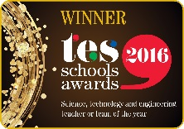

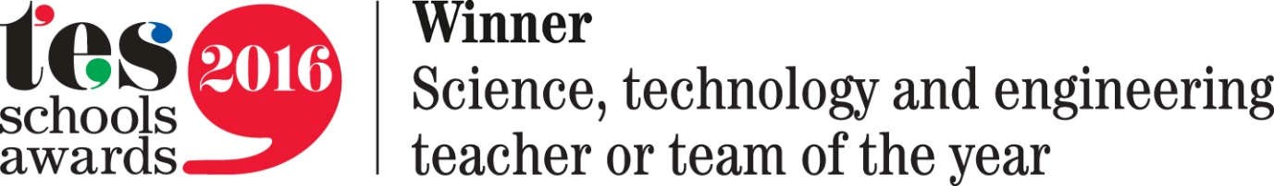

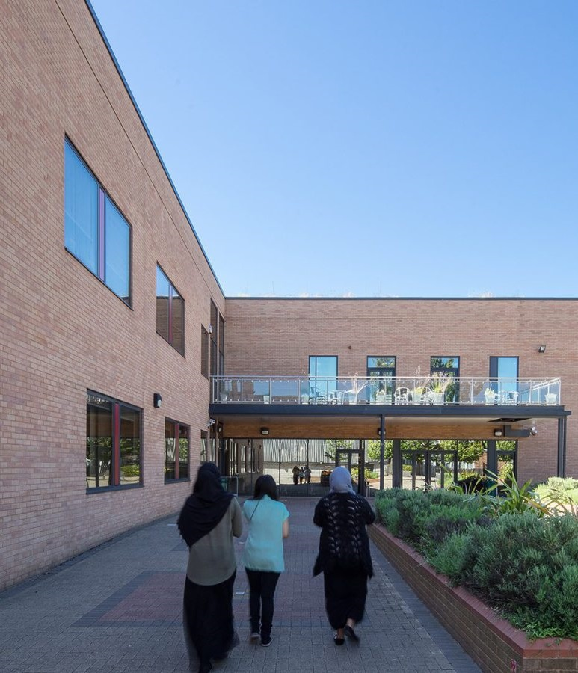

Job Description: Welfare and Guidance Manager
Contract:  Starting Salary:  Purpose: | Full Time, Permanent, term time only + 10 days, 36.5 hours per week  Grade 4 Point 23 – 25 £27,741 - £29,577 (pro rata)  To maximise the successful entry of our students into the world’s top Universities, FE Colleges and Apprenticeships schemes by ensuring all our students are provided with information, advice and guidance to access further education, training and the workplace in order for them to achieve their personal goals and career aspirations.
Starting Date:  Accountable to: | January 2021  Head of Sixth Form
Responsible for: | - Providing careers advice in preparation for curriculum choices at 14+, 16+ and beyond in line with the national statutory Gatsby Benchmarks  - Advising on: option for KS4; post 16 studies; Y12 to Y13 transition; and applications for post 16 and post 18 choices  - Growing and develop an engaged network of parents, alumni, business partners and other friends of the school and community such as MOSAIC, to provide mentorship, work experience and to co-ordinate networking events  - Developing robust relationships with Universities, FE Colleges, vocational institutions and the business community, including the Chamber of Commerce, the CBI and local employment agencies to identify opportunities in the job market, work experience, apprenticeships and internships  - Ensuring a comprehensive programme of pre-employment advice and training is available for our students so they are job ready upon leaving Y11 and the Sixth Form  - Developing wide-ranging and engaging enrichment interventions for our Sixth Form students
Key Factors of the Role: | - Increasing our success rate in applications to world class Universities and progression into apprenticeships and employment.  - Developing an explicit programme of activities to stretch and challenge our most able students and to market these widely to existing and prospective students  - Ensuring our students are appropriately challenged, supported and engaged in the achievement of their ambitions  - Being an external ambassador as a speaker at conferences and networking events in marketing our Sixth Form provision within the local and National marketplace  - Maintaining our position as a centre of excellence in Higher Education and Careers Guidance

Main Duties |  |  | - To support Head of KS5 with all matters in relation to student welfare, including academic and attendance monitoring.  - To help improve communication, advice and guidance between school, home, external agencies and the local community.  - To manage the work experience week for Y12.  - To talk with students who may be experiencing difficulties with other students and mediate.  - To be the named person for vulnerable students, including “newly-arrived” at KS5, to attend relevant meetings and to mentor these students.  - To counsel students who exhibit disruptive or withdrawn behaviour in lessons or around the school.  - To work with targetted groups of students to promote self-esteem.  - To keep a record of student intervention strategies and to monitor and record effectiveness.  - To make links with parents and students to assist school staff at meetings with individuals and groups of parents (in particular with translation services).  - To assist school staff in their day-to-day contacts with parents (relaying messages, attending case conferences, assisting at Parents’ Evenings etc).  - To support arrangements for alternative educational placements, as required.  - To accompany students on educational visits as required.  - To undertake pastoral and administrative support in relation to work-placements.  - To assist school staff in understanding customs, traditions, linguistic, religious and cultural backgrounds of ethnic minority parents and students.  - To organise/assist with parents’ events/workshops to promote involvement in their daughter’s learning.  - To assist, when required, with the supervision of sick students and to ensure they are transported home safely.  - To undertake surveys as required and to report on results.  - To liaise with external agencies as required by the school.  - To undertake home visits with the Head of Sixth Form.  - To assist and support with Key Stage assemblies/award evenings.  - Any other duties as may be commensurate with the grade and nature of the post as directed by the Headteacher/Head of Sixth Form. Please note that in a busy school it will be necessary to provide support across all Key Stages.
 | Whilst every effort has been made to explain the main duties and responsibilities of the post, each individual task undertaken may not be identified.

General Requirements
All School staff are expected to:

- Maintain confidentiality according to the organisation and legal requirements
- Uphold School policies, routines and codes of conduct as set out on Firefly (VLE)
- Undertake other such reasonable duties as may be required from time to time
- Work towards the School’s vision and objectives
- Be aware of and adhere to the Child Protection and Safeguarding Policies
- Support and contribute to the School’s responsibility for safeguarding students
- Work to promote equal opportunities for all students and staff, both current and prospective
- Maintain high professional standards of attendance, punctuality, appearance, conduct and positive courteous relationships with students, parents and colleagues
- Engage actively in the performance management review process
- Show a willingness to undertake training and professional development either in-house or externally

Safeguarding Statement

BGGS and Sixth Form is committed to safeguarding and promoting the welfare of children and young people and expects all staff and volunteers to share this commitment. An enhanced DBS check must be completed for all successful applicant.

Signature: …………………………………… (Postholder) Date: …………………………………………….

Signature: …………………………………… (Postholder) Date: …………………………………………….
The school operates a safer recruitment process. Appointment to the post will be subject to suitable references and an enhanced DBS check. The school is committed to safeguarding and promoting the welfare of children and expects all staff and volunteers to share this commitment.

Person Specification Welfare and Guidance Manager

Essential Requirements
- An up to date knowledge of career options and alternative career paths for KS5 students
- A CEIAG qualification or equivalent
- Experience of the UCAS application process
- Excellent communication skills: particularly the ability to listen, empathise and support students
- Experience or knowledge of working in a School and Sixth Form with an understanding of the School curriculum
- Ability to network effectively within the community and the wider marketplace
- Ability to develop robust and engaged relationships
- Ability to work efficiently, effectively and to meet deadlines, including when under pressure
- Able to communicate concisely and knowledgeably orally and in writing to a variety of audiences
- Be able to deal with challenging students and deliver improved outcomes for them
- The ability to develop effective and appropriate community links and partnerships
- To have experience of working with vulnerable people to ensure their welfare is maintained with positive outcomes
- To have a good understanding of current social, community and educational issues
- To engage in effective interaction with young people/parents who have diverse religious and cultural beliefs and values
- To help the school and school staff in understanding these beliefs and values
- To have evidence of making sound judgements and achieving raised standards for students
- To have experience of working with vulnerable people to ensure their welfare is maintained with positive outcomes
- Excellent presentation skills
- Excellent interpersonal skills
- Ability to work as part of team
- Attention to detail
- Excellent organisational skills
- Excellent in the use of ICT
- Ability to manage and deal with confidential data/issues appropriately.
- Personal warmth to gain confidence of students, staff, parents
- High work standards evidenced by consistently thorough, detailed, organised approach to work
- Collaborative, flexible and supportive when working in a team environment
- Impressive personal presence and presentation
- Commitment to ongoing improvement and desire for excellence
- High levels of discretion and confidentiality
- Proven track record of delivering advice and guidance in a 1:1 and group setting
- Educated to GCSE level or equivalent
- Subject passes in Maths and English minimum
- Competent user of Microsoft Applications including Word and Excel
- Post holder must hold a current UK Driving Licence and will be required to undertake an enhanced DBS check
- This post is covered by Part 7 of the Immigration Act (2016) and therefore the ability to speak fluent spoken English is an essential requirement for the role.
Desirable Requirements
- Knowledge of work experience and or volunteering programmes/opportunities
- Experience of training in interview techniques
- First Aid Qualification or willingness to undertake training
- DSL trained or willingness to undertake DSL training

The school operates a safer recruitment process. Appointment to the post will be subject to suitable references and an enhanced DBS check. The school is committed to safeguarding and promoting the welfare of children and expects all staff and volunteers to share this commitment.

