Hodgson Academy

Imagine...Believe...Achieve

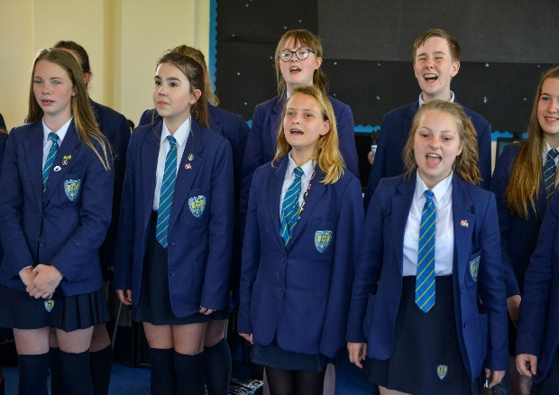
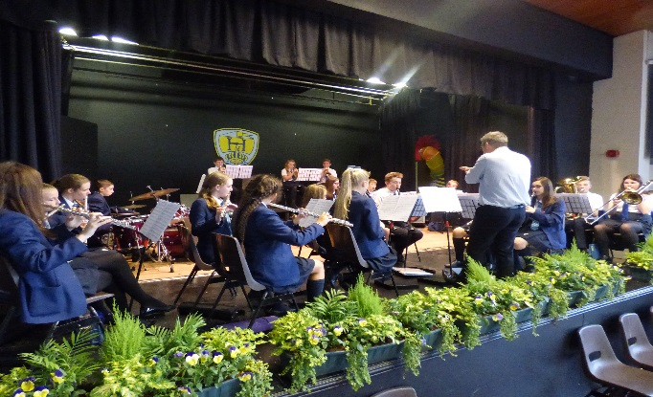
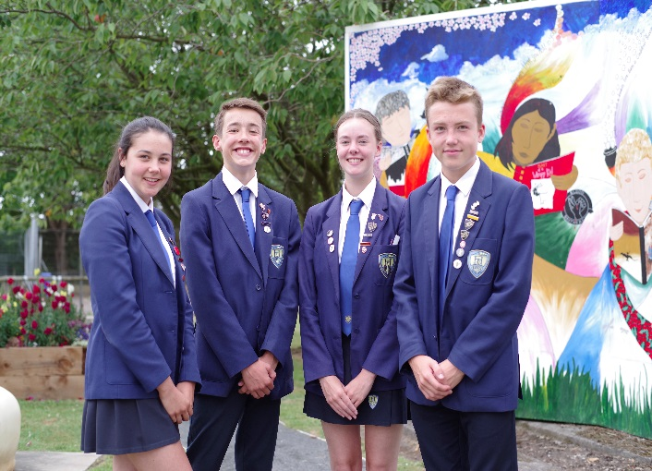
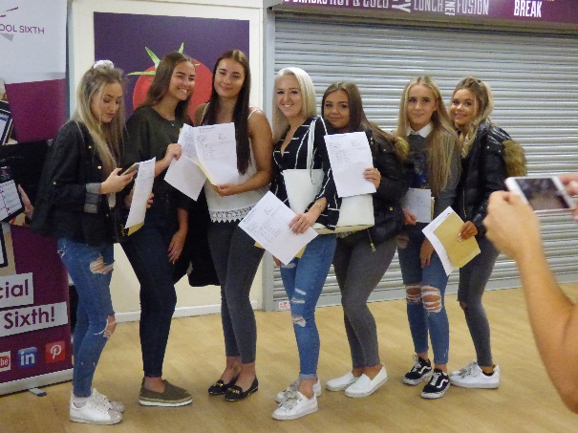

Appointment of Teacher of Science
November 2019

Moorland Road, Poulton-le-Fylde, FY6 7EU

Following the appointment of a new Headteacher from August 2019, we are seeking to appoint an exceptional Science Teacher to join a successful team of specialists.
Teacher of Science
M1 - UPS3

Are you passionate about teaching science?

Do you have the highest expectations of every member of the school community?

Are you a values-driven teacher who models integrity and a commitment to inclusion?

Can you inspire and influence young people’s lives and to promote the value of education?

If you can answer yes to these questions, we would love to hear from you.

Further details and an application pack are available on the academy website:
https://www.hodgson.lancs.sch.uk/about-us/staff-vacancies/
In addition to the academy application form or TES ‘quick apply’, candidates are invited to submit a letter outlining their experience and suitability for this particular post (1500 words maximum).
Applications can be emailed to Julie Jackson, HR Manager j.jackson@hodgson.lancs.sch.uk
Closing date for applications: 11th November 2020 (9am)
Interviews likely to be held w/c 11th November
Post start date September 2020.

The school is strongly committed to safeguarding and promoting the welfare of children and young people and expects all staff and volunteers to share this commitment. You shall be required to undertake an enhanced DBS disclosure and a range of other recruitment checks.

Contents
4 Letter from the Headteacher

5 Person Specification

6 Job Description

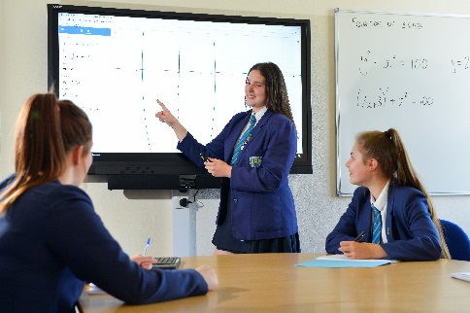

Letter from the Headteacher
Dear Colleague,

I would like to thank you for taking an interest in this post and offer you a very warm welcome to Hodgson Academy. As the newly appointed Headteacher this year, I am excited about the opportunities and challenges that lie ahead for the academy as we continue to endeavour to give our students the very best education available. I joined Hodgson in 2010, initially as Head of Mathematics before becoming a member of the Senior Leadership Team in 2012. In my time, we have enjoyed many successes – attainment is high, behaviour is good and leadership is strong. We also continue to face challenges – aspects of student progress require close attention and we must continue to strive to improve boys’ achievement as well as that of our disadvantaged students.

Against that background, Hodgson continues to have a very outward-facing philosophy that I aim to continue and enhance under my leadership. We are a cohort one National Teaching School (in partnership with Blackpool Sixth Form College) which acts as sponsor to the Fylde Coast Academy Trust (FCAT), a trust of ten academies – primary, secondary and all-through – predominantly in the Blackpool area. We are committed to the success of FCAT and have a responsibility to support these academies wherever possible.

This is an exciting time for Hodgson Academy and the appointment of new staff in key positions such as this one is very important to us. Our expectations, of all our stakeholders, are high as I am determined to give our students the very best education possible and require the very best teachers and leaders available in our team to help me to deliver this vision. If you feel excited about this challenge and able to deliver in this role then I would very much like to read an application from you.

Yours faithfully,

Iain Siddall
Headteacher

Person Specification
Job Description
POST: Teacher of Science

RESPONSIBLE TO: Headteacher
Deputy Headteacher
Senior Assistant Headteacher: Achievement and Standards
Director of Science
Head of Science

RESPONSIBLE FOR: Core responsibilities as outlined in Section A
Specific responsibilities as outlined in Section B

SALARY: M1- UPS3

The academy is strongly committed to safeguarding and promoting the welfare of children and young people and expects all staff and volunteers to share this commitment.

You shall be required to undertake an enhanced DBS disclosure and a range of other recruitment checks.

Please note we are also a non-smoking site.

A. Core Responsibilities
- Professional Standards: To meet the Professional Standards for Teachers, Core and Threshold, as applicable to the postholder and as revised in the School Teachers Pay & Conditions Document 2012.
- Act as a House Progress Tutor, carrying out the duties described in the General Job Description: House Progress Tutor
- To take part in marketing and liaison activities such as Open Evenings, Parents Evenings and other Academy events
- To support the implementation of whole school literacy, numeracy and reading strategy

B. Specific Responsibilities
Impact on Teaching and Progress of students
- To establish a safe and stimulating environment for pupils, rooted in mutual respect
- To share and support the Academy’s responsibility to provide and monitor opportunities for personal and academic growth
- To demonstrate consistently the positive attitudes, values and behaviour which are expected of pupils.
- To have clear rules and routines for behaviour in classrooms, and take responsibility for promoting good and courteous behaviour both in classrooms and around the school, in accordance with the Academy Behaviour Policy
- To have high expectations of behaviour and establish a framework for discipline with a range of strategies, using praise, sanctions and rewards consistently and fairly in line with the Academy expectations
- To manage classes effectively, using approaches which are appropriate to pupils’ needs in order to involve and motivate them
- To maintain good relationships with pupils, exercise appropriate authority, and act decisively when necessary
- To assist the Head and Director of Science in the implementation of a challenging curriculum
- To consistently plan and deliver high quality lessons which stretch and challenge students of all backgrounds, abilities and dispositions
- To facilitate and encourage a learning experience which provides students with the opportunity to achieve their individual potential, thus contributing to raising standards of student attainment
- To maintain appropriate records and to provide relevant accurate and up-to-date information for management information systems
- To communicate effectively with the parents of students as appropriate
- To contribute to the process of monitoring and evaluating the curriculum area during the Collaborative Planning Sessions
- To co-operate with other staff to ensure a sharing and effective usage of resources to the benefit of the Academy, department and the students

Accountability
- Accountable for the standards of achievement within the classes allocated
- Accountable for managing behaviour within the classes allocated
- Accountable for meeting assessment and reporting deadlines

The above represents a broad outline of the specific duties and responsibilities currently attached to the role of Teacher of Science. Depending on the needs of the academy, these may be altered from time to time in consultation with the Headteacher.

Job Description prepared by: Iain Siddall Date: November 2019

Teacher of Science – Person Specification

Qualifications A good record of academic achievement, including a relevant honours degree
Qualified teacher status
Excellent written and oral communication skills

**********

Personal qualities High level of professional and personal integrity
A good attendance record in any previous employment
High levels of personal commitment and willingness to work hard
Personal warmth, good rapport with students, colleagues and parents
Excellent organisation skills
Willingness to learn and apply new strategies for improving and sustaining the highest quality of teaching, learning and achievement
Confident use of ICT

Effective planning, assessment & record keeping

**********

Teaching and learning Excellent subject knowledge of science curriculum, including a thorough understanding of assessment and monitoring
Excellent classroom practitioner
Knowledge of the current national developments relating to science
Ability to teach Chemistry or Physics to KS4 to a high standard
Ability to teach at least 2 science subjects to KS4
Effective classroom management

**********

Philosophy and Ethos Commitment to create a safe, supportive & stimulating learning environment for all students
High expectations for students’ attainment, personal development and conduct

