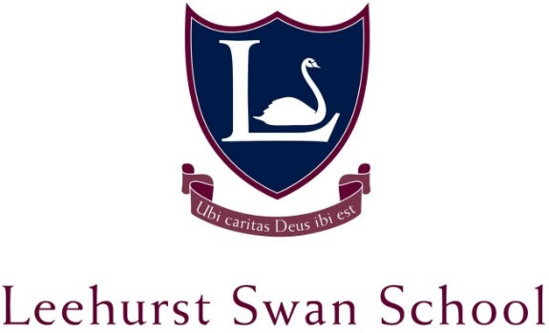

TEACHER OF SPANISH – KEY STAGE 3 & 4
CANDIDATE PACK

THE SCHOOL
Leehurst Swan is a leading independent day school based in the city of Salisbury, Wiltshire. With currently over 200 pupils on roll aged 4 to 16, and an Outstanding ISA inspection rating in 2018; the School will be under the leadership of Mr Terence Ayres from September 2019.
At Leehurst Swan, our pupils are at the heart of everything we do. We recognise the uniqueness of each child and it is our privilege to guide them on the road to discovering their talents and achieving their true potential. We offer a family-friendly, nurturing environment based on Christian values, and a broad and varied education which both stimulates and challenges. We seek to encourage a true enthusiasm for learning, and to help pupils grow in knowledge, wisdom and understanding, whilst preparing them for their future beyond school.
We have been educating children on this site for over 100 years and our academic record is very strong. However, we also firmly believe learning should be imaginative and fun, and we place learning and laughter at the heart of all that we do. We are a small school, which allows us to provide individual attention, exciting opportunities and creative activities for all our children while preparing our pupils for their future beyond school
THE ROLE
This is a permanent position for the new academic year and we will consider a full time or part time position. We offer a competitive salary re-numeration, current TPS membership and free on-site parking.

APPLICATION PROCESS AND IMPORTANT DATES
Applicants should download an application form and provide the following documents:
- A covering letter highlighting any strengths and reasons for applying for the post;
- A current CV.
Applications should be sent to the HR Manager in hard copy and be emailed to patohm@leehurstswan.org.uk
Applicants must be willing to undertake a full enhanced DBS check, complete a health declaration form and be willing to undertake any screening for child protection reasons.
If you would like further details about the school, or you would like to have a look around the school, please contact the School Office in the first instance.
Closing Date for Applications: Monday 17th June 2019, midday
Interview Date: Wednesday 19th June 2019
Start Date: Monday 2nd September 2019

Candidates will be expected to teach a 30 minute observed lesson. Due to the short timescale for recruitment, please ensure that you are available on the interview date prior to applying.

JOB DESCRIPTION
The post of teacher of Spanish will involve the following tasks which may be adjusted in consultation with the Head of Modern Foreign Languages or the Head.

- Teaching MFL
- Responsibility for the planning and teaching of a broad, balanced and stimulating Spanish language course across the school and ability range.

- Ensure that the curriculum is appropriate to the needs and abilities of each group, and of individuals within the group, and that expectations are realistically high to see that gifted pupils are stretched, and weaker pupils encouraged.

- Use the school data from MidYIS scores and School Base management systems to help inform teaching, curriculum and assessment.

- Assessment and recording, reporting on students’ progress including end of term reports, internal examinations and tests and GCSE examination requirements (Cambridge IGCSE in Spanish and French).

- Ensure that the subject and its demands are understood as fully as possible by parents, using methods agreed as a whole school policy, such as brochures.

- To be responsible for equipment in Modern Foreign Languages and understand and contribute to the Health and Safety requirements within the department

- Take an active part in curriculum development and innovation within the MFL department.

- Take responsibility for the routine administration for the delivery of Spanish.

- Promote the subject and help to keep the profile of the MFL department high.

- Take responsibility for an area of display in the department and other areas of the school as appropriate

- Wider contributions to the school
- Liaise with the Pastoral Stage Co-ordinators where appropriate.
- Attend Staff Meetings, Parents’ Meetings etc as required by the Head.
- Possibility of taking on Form Tutor role

PERSON SPECIFICATION

Degree or equivalent
Teaching Qualification
QTS status achieved
Further qualifications
Curriculum knowledge
Relevant experience
Range of teaching strategies
Inspiring teacher
Team player
Empathetic
High pastoral care
Supports school ethos
Respect for Colleagues
Sense of Humour
Flexibility
Effective communicator
Role model
Emotionally intelligent
Resilient
Good time-management skills
Good listener
Accept criticism
Inspire confidence in pupils
Communicates well with Parents

