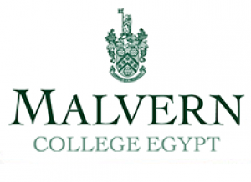
Position Vacancy Information

Job title: | Head of Primary School
Academic requirements | Master’s degree (Education)  NPQSL or NPQH  PGDE or PGCE  Bachelor’s degree
Start date: | Contract date 1st of August 2021  MCE start date 10th of August 2021
Closing date for applications: | 11th of Feb
Proposed dates for initial Teams or Zoom interviews: | From the 4th of Feb, ether Teams or Zoom
Details of Department: | Head of Primary School  Member of the College Leadership Team  Chair of Primary School Leadership Team
Any additional areas of responsibility beyond general teaching remit: | Non- teaching role
Any other requirements: | International Primary School leadership experience is advantageous.  Significant Head Primary School leadership experience

