THE GRANGE SCHOOL

Specialising in Business & Enterprise



TEACHER OF ENGLISH





THE GRANGE SCHOOL

The Grange School is a well established, friendly school, specialising in Enterprise.
Enterprise is a driving factor throughout learning as evidenced by our Grange Enterprise and Learning Skills (GELS) which are embedded across the curriculum.

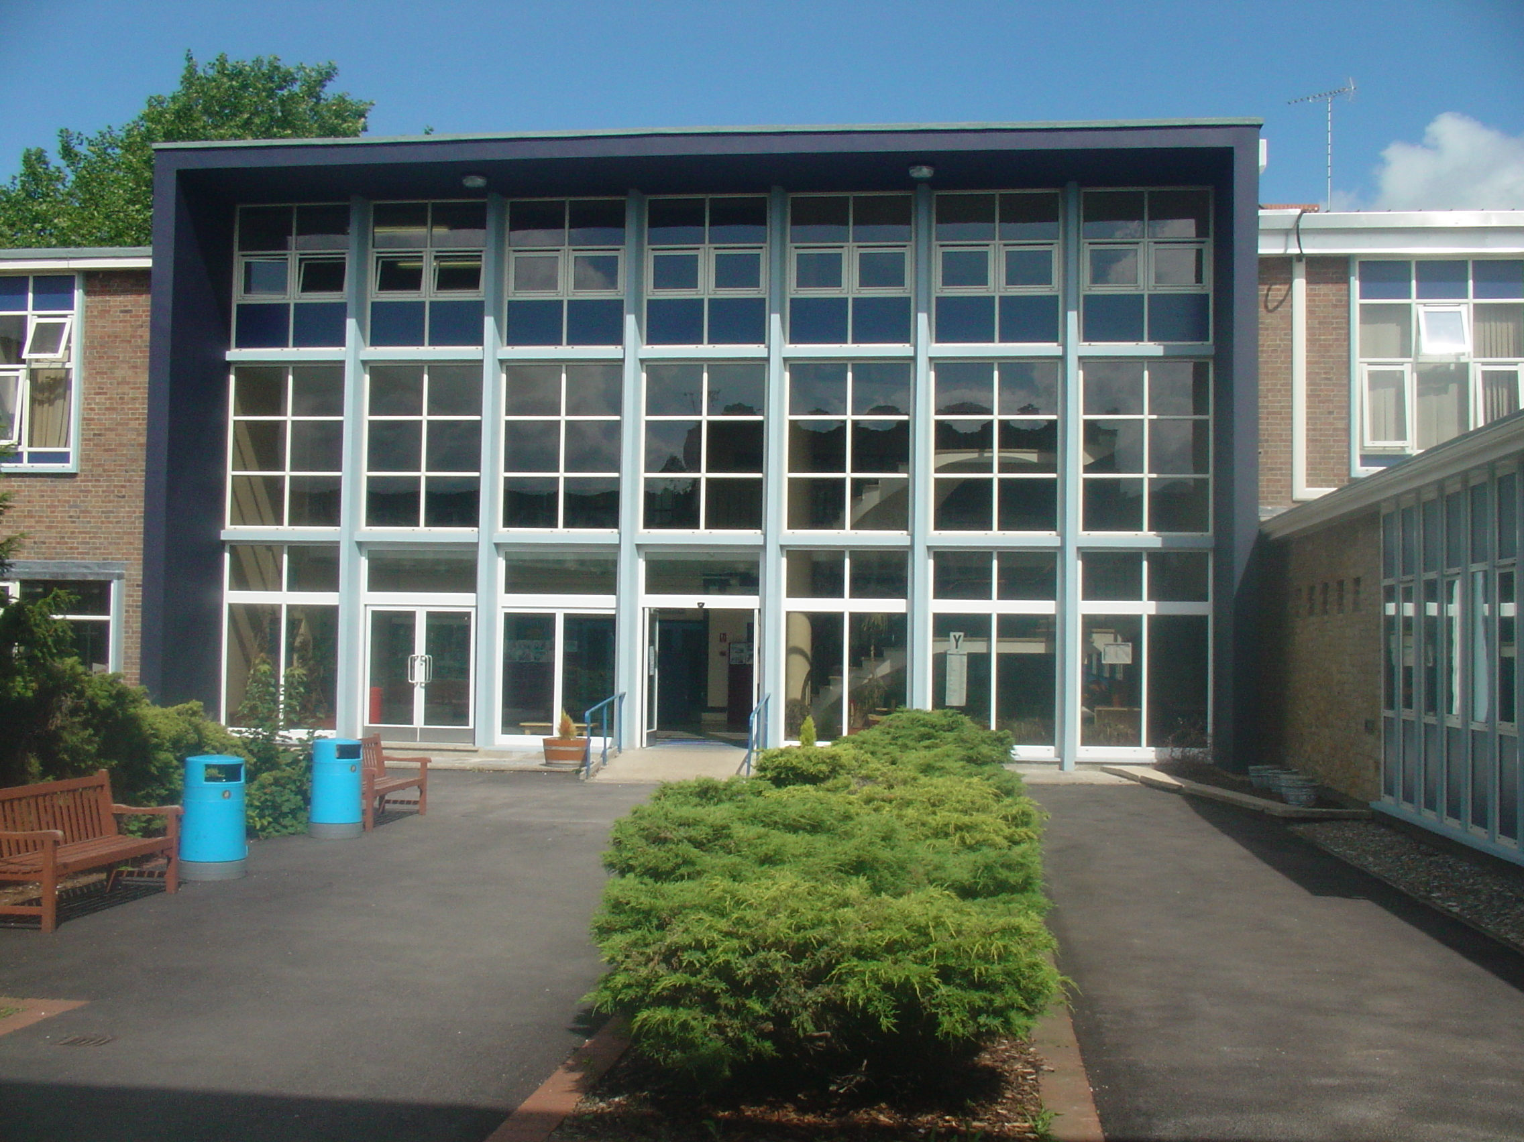

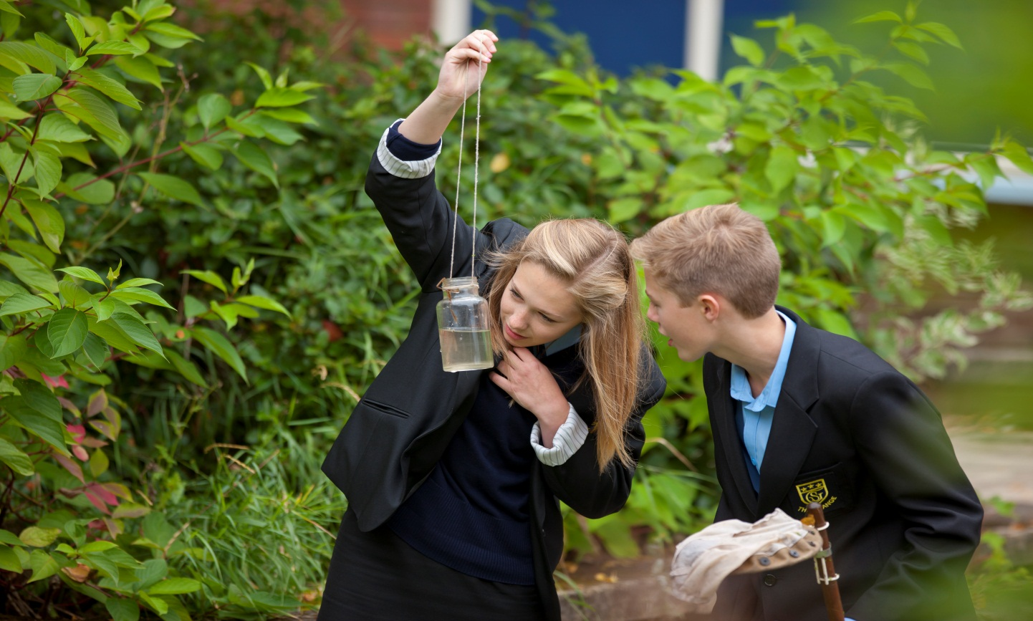

We aim to equip all students with the adaptability and flexibility to meet the demands of a rapidly changing world and to promote a sense of responsibility towards others, the school and the wider community. The support and guidance of students is based on a Year system and aims to develop co-operation, involvement and respect in all students.

A broad and balanced curriculum is provided for Years 7 to 9. In Years 10 and 11 all students will study English, Mathematics, Science, PE, RE, ICT and PSHCE (Personal, Social & Health and Citizenship Education). Students can then choose from a range of additional GCSE, BTEC and vocational courses. We offer a range of traditional and vocational courses at Key Stage 5. The curriculum in all Key Stages is further enhanced through wide ranging extra curricular experiences.

We aim to attract energetic and conscientious staff who have a commitment to the education of our students. The professional development of all staff is an important focus for the school. We strive to create a learning environment which serves the needs of all the members of our diverse and vibrant community.

THE GRANGE SCHOOL

TEACHER OF ENGLISH

JOB DESCRIPTION

JOB PURPOSE

To be part of a team which will have an impact on students’ levels of literacy and numeracy, empowering them both within the curriculum and in their lives beyond school.

DUTIES

- To teach English to students of all abilities.

- To raise the level of achievement of all students.

- To contribute to the team’s development of an exciting and challenging curriculum, which will meet the needs of all students.

- To promote and support extra-curricular activities as part of the academic and cultural life of the school.

- To foster good relationships with students and with home, including attendance at parent-teacher consultations.

- To support students’ learning by the use of the school’s policies of marking, assessment, record-keeping, reporting and target-setting.

- To attend all relevant meetings.

The Department of English focuses on the basic skills of oracy, reading and writing that are the heart of the curriculum. The teaching groups are structured to respond to the range of competencies of students in order to address their differing needs. There is a close liaison with the Support for Learning team, support staff and other agencies in order to ensure an equality of access to the curriculum. Learning will increasingly involve extensive use of ICT.

THE GRANGE SCHOOL

THE ENGLISH DEPARTMENT

STAFF AND STRUCTURE

The department consists of nine experienced teachers. We are a committed team bringing expertise from all areas of the English Curriculum. One of the strengths of the team is our willingness to share good ideas and reflect on our teaching to get the best from our students. We have recently developed comprehensive schemes of learning in place across all Key Stages.

Students enjoy English across the Key Stages; where the department teaches a curriculum which includes literature, language and media skills, developing cross-curricular links and independent learning skills. Students’ progress is regularly monitored and teachers work with the intervention co-ordinator and other departmental leads to help maximise progress.

All students study both Language and Literature at Key Stage 4, with Year 10 and 11 following the Edexcel specification for 2017 and 2018. The schemes of learning have been developed from resources published by the examination board.

At Key Stage 5, we offer A-level Literature (Edexcel) and A-level Media Studies (AQA; with a move to WJEC Film Studies for examination in 2019): courses which are successful and increasing in popularity.

THE ENGLISH DEPARTMENT FACILITIES

The English corridor is in the same part of the school as the Library and we make good use of library facilities. All English classrooms benefit from interactive whiteboards.

EXTRA CURRICULAR

The English Department is actively involved in extra-curricular activities. Examination preparation classes are held after school as appropriate, alongside additional support for younger students. We also run a well-supported Film Club. In addition, we organise a range of enrichment visits and activities throughout the year.

We are looking for an ambitious and committed English teacher who is passionate about young people’s learning to join our department. You would need to be someone who has the drive and enthusiasm to develop a love of literature and communication skills, both within the curriculum and beyond. This post would be ideal for either an NQT looking to develop their practice or a more experienced teacher looking for new challenges. With the leadership of an experienced Head of English and a wealth of knowledge from the team, we are an innovative and supportive team who work closely together and are committed to constantly improving our practice.

Candidates are invited to visit the school prior to interview.
Please contact Jenny Bell, PA to the Headteacher, to make an appointment.

The Grange School, Wendover Way, Aylesbury, Bucks, HP21 7NH
Tel: 01296 390900
Fax: 01296 390991
E-mail: office@grange.bucks.sch.uk
www.grange.bucks.sch.uk

