“A place for everyone…to work and succeed!”

Welcome from the Principal Team
We live in exciting times – our great city of Liverpool is currently undergoing an amazing renaissance, with new jobs, investment and opportunities. We are proud to tell you that North Liverpool Academy is also undergoing its own renaissance. Our most recent Ofsted inspection has graded us as a ‘good’ school in all areas. Our exceptional academic results and reputation continue to confirm us as one or the fastest improving schools in Liverpool.
NLA lies at the heart of the local community. It is our task to prepare our young people for the exciting challenges and opportunities ahead. Our curriculum inspires a lifelong passion for learning and equips our students with the confidence and skills to take advantage of the tremendous opportunities on our doorstep and further afield.
Our ethos and core values are built around a culture of enjoyment and achievement. We believe that when joining our team as a student, parent, member of staff or a member of the local community, by embracing our values of high aspiration, transformational experience, community engagement and excellent achievement we will deliver outstanding educational outcomes for all.
We believe it is our job to ensure that our students take pride in all they do and graduate from North Liverpool Academy with the confidence to take on the competitive and ever-changing world around us. This is a truly exciting time for the North Liverpool Academy as we establish a world class academy with excellence for personal development, leadership, teaching and learning.
If you have any questions, would like a conversation or if you wish to come and see the outstanding work happening across our academy please feel free to contact us.
Emily Vernon Patrick Ottley-O’Connor
Interim Principal Executive Principal
History of NLA

North Liverpool Academy opened in 2006 as one of the first Academies in the country and has benefitted from the various advantages that brings. The Academy is well resourced both in terms of facilities and staff. It is housed in a superbly equipped building, erected in 2009 and enjoys an excellent reputation within the local community.

The Trust

Northern School Trust is a not-for-profit education charity. It is a well-developed MAT (Multi-Academy Trust) held in high regard by the DFE. There are currently four schools in the Trust including an innovative Studio School and a Life Sciences UTC in the centre of Liverpool and a UTC based in Wigan.

The Trust is proud of its collaborative way of working and is developing into a nationally recognised and trusted academy sponsor with an excellent reputation. The Trust has a wide range of expertise and specialised experience to call upon, having access to the FE, University, private and voluntary sectors as well as partner schools and consultant expertise drawn from across the UK.

The Trust has a central team that provides best value and an efficient service delivery in areas of HR, Finance, Enterprise & Marketing, Governance, Strategic ICT Development, Data and Facilities Management to all NST schools.

Latest Ofsted

North Liverpool Academy’s recent Ofsted inspection rated the school officially as a Good School, along with the improving trend in academic results confirms the school as one of the most improved in Liverpool.

Ofsted recognised the significant improvements and achievements made as well as the aspirational ambition of the academy. The inspectors praised the “highly effective leadership, clear vision, high standards” and “strong ambition” and emphasised that “the schools is well placed to continue improving”.

Rated Good across the board, inspectors said that: “Pupils enjoy their learning and have positive relationships with one another and their teachers.”

“Pupils behave well in lessons and take pride in their work”

The report also praised the Sixth Form saying: “It is effectively led and consequently has improved since the last inspection. Outcomes are good because students are taught well. When they leave, an increasing number of students move on to University courses, further education, employment and training” showing a sustained picture of improvement.

Latest results
Key Stage 4
2018 Exam Results – Invalidated
Attainment
- Our Attainment 8 score is 41.4
- 59.5% of pupils achieved a 4 or above in one of the English GCSEs
- 51.8% of pupils achieved a 4 or above in GCSE Maths and in one of the English GCSEs
- 30.4% of pupils achieved a 5 or above in GCSE Maths and GCSE English
- 58.9% of pupils gained a grade 4 or above in GCSE Maths
Progress
- Our Progress 8 score is -0.16
- Our Maths Progress 8 score is -0.04
- Our English Progress 8 score is -0.63
Destinations
96% of students from this cohort have continued to be in education or training, or move on to employment at the end of 11 to 16 study
Key Stage 5
Value added by qualification category.
*Figures taken from SISRA Analytics and currently in-validated

*This is currently only available for A level and Applied General qualifications; this will be updated January 2018 when national data is released.
- The Progress Measure for A level results is -0.20
- The Progress Measure for Applied General qualifications is -0.56
Average grade by qualification category
*Figures taken from SISRA Analytics and currently in-validated
- The average grade that students achieve in A level qualifications is D+
- The average grade that students achieve in Vocational qualifications is Distinction-
- The average grade that students achieve in Applied General qualifications is Distinction-
- The average grade that students achieve in Technical level qualifications is D-
Progress in English and Maths (from Key Stage 4)
*Figures taken from SISRA Analytics and currently in-validated
- The Progress measure for English Level 2 qualification is 1.06
- The Progress measure for Maths Level 2 qualification is 0.06
Retention
- 86% of students in Year 12 2016/17 have progressed to Year 13 in 2017/18

Key stage 5 destinations
- 75.6% of students in Year 13 in 2017/18 now attend university or college
- 12.8% of students in Year 13 in 2017/18 are now in full-time employment
- 5.1% of students in Year 13 in 2017/18 are now in an Apprenticeship
- 93.5% of students continue in education or training, or move on to employment at the end of 16 to 19 study

Key stage 4 destinations
*This data is in-validated at present, and will be updated on publication of the September Guarantee
For the academic year 2017/18, 92.1% of students continue in education or training, or move on to employment at the end of 11 to 16 study

Charter Mark & Achievements
- Flagship Inclusion Mark
- Leadership Academy Award
- Sainsbury’s School Sports Mark Gold
- Career Connect Quality Awards
- Healthy Schools Award
Our Amazing Facilities:
North Liverpool Academy moved into a purpose built state of the art building in September 2009 and has the following outstanding facilities to name a few:
- 7 Technology classrooms
- 13 state of the art Science classrooms which are fully supported by 2 full-time Science Technicians
- Outstanding Drama Theatre which includes movable walls and bleacher seating to accommodate 220
- High quality dance studio with 2 designated teaching spaces
- Music practice and performance rooms
- Designated sixth form provision with LRC, classrooms and space for study or research
- Library
- ICT facilities including banks of I-Pads, Chromebooks and laptops
- Multi-purpose media suite
- Teaching & learning hub
- Sports hall and fully equipped Gym and Fitness Centre
- Full size Astro pitch
- On site Scoot 66 Scooter supplies shop
- Secure car parking with spaces for up to 140 cars
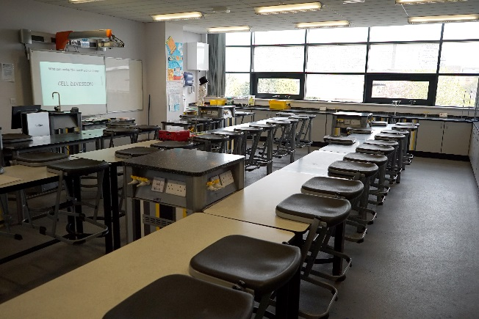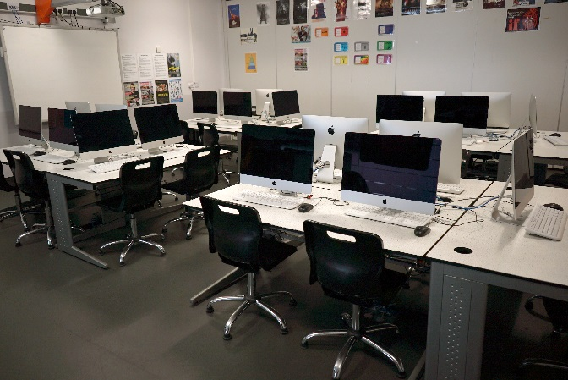
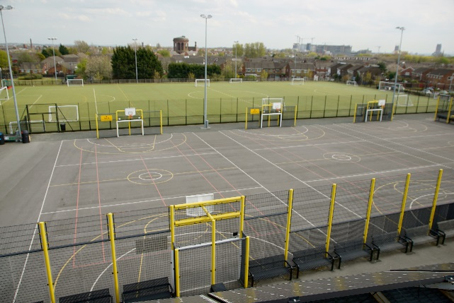

So why choose North Liverpool Academy?
All Staff
- Excellent opportunities for advancement & promotion
- Bespoke training as part of our talent management programme and online accredited CPD courses
- Well lead and managed teams
- Inclusive induction programme
- Designated reprographics support & ICT helpdesk
- Pay related benefits such as Childcare vouchers and Cycle to Work scheme
- Proactive approach to mental health and wellbeing including a supportive HR Department who can provide access to wellbeing services such as Counselling & Occupation Health
- Free on-site secure parking
- Free access to Fitness suite
- Complementary tea & coffee facilities
- Duke of Edinburgh
- Extended opening hours to promote a better quality of work/life balance
Teachers
- Fast track UPS/Leadership progression
- Main scale teachers have a minimum 15% timetabled PPA time
- Training and support for middle or emerging leaders and access to NPQML/SL programmes
- Comprehensive NQT/School Direct/Teach First programme
- Paid Development post opportunities
Support Staff
- 35 days paid annual leave
- Support for staff wishing to progress into teaching through School Direct
- Membership into the local Government pension scheme, where we as employers pay an additional 11% of contributions
- Time off in lieu when available
- Non contractual discretionary leave during school closure periods

The Computer Science Department
The Department consists of 5 teachers with a range of experience and is overseen by a College Leader who also has responsibility for Maths and Business.
The curriculum is over KS3 & 4 with KS3 having 1 lesson per week (1 hour 15 mins) and KS4 2 lessons per week. At KS3 pupils follow a computing curriculum ICT skills including software and languages, Scratch, Python, HTML, APP inventor, Small Basic, Microsoft Package, Flash, Image editing and home Learning is given once a fortnight.
At KS4 (Year 9, 10 and 11) the majority of pupils in years 9, 10 and 11 are enrolled on the GCSE OCR Computing qualification with a few classes taking OCR I Media L2 qualification which is 2 lessons a week split into skill development and practical time with other lessons focused on exam preparation. Average class size is 24.
The academy is well resourced with each room having 24 Windows PCs, Microsoft 2013 packages on all PCs and pupils use Google Mail, Google Chrome and Internet Explorer installed, Adobe Master Collection on all PCs
All members of the department are supportive of each other and have an excellent team ethos. We are constantly striving to improve and we are truly invested as a team in providing the best possible outcomes for our students. We have forged strong links with studio school within the trust and Liverpool University and offer as many enrichment opportunities.
We are seeking to appoint a Teacher of Computing who will lead the team and play an integral role in the creation and delivery of an exciting computing curriculum. A positive outlook and high standards are very important. Our students receive outstanding pastoral care, support and guidance and we would expect any successful candidate to be of a mind-set where they believe anything is possible.
Carl Joynson, College Leader for Maths, Business & ICT

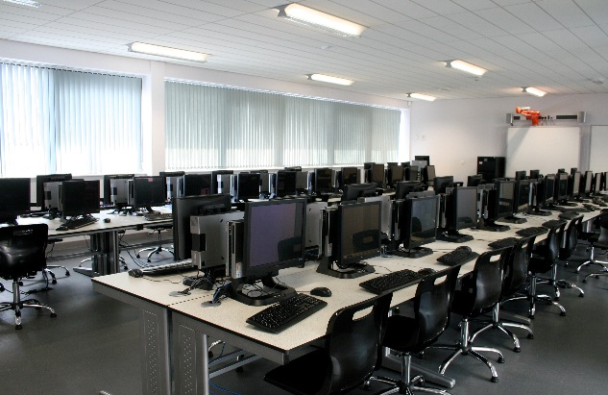

SUBJECT LEADER

RESPONSIBILITY FOR THE LEADERSHIP & MANAGEMENT
OF TEACHING & LEARNING IN ICT & COMPUTER SCIENCE
SALARY SCALE: L1-5

RESPONSIBLE TO: College Leader for Maths, Business & ICT

RESPONSIBLE FOR: All teachers, students and support staff (assigning duties only) within the ICT & Computer Science department.

Academies are leading practitioners in learning; these posts are key roles in the shaping of the future of the North Liverpool Academy, community of learners and should be read as such; not limited by the tasks but driven by commitment and vision.

PART ONE

You are required to carry out the duties of a School Teacher as defined in the Academy structure and to meet and exceed the Teacher Standards.

PART TWO

In particular you are required to undertake the following responsibilities:

To be a visionary leader of ICT & Computer Science. Be a leading edge deliverer. Develop a shared understanding of pedagogy within the Computer ICT & Computer Science department and across the academy.

ROLE As a middle leader to communicate and implement the aims and policies of the Academy and to manage, monitor and review the provision of high quality education within ICT & Computer ICT & Computer Science.
Have high expectations of students and staff.
Have an up-to-date knowledge of subject, national developments, pedagogy, classroom management, and research and inspection findings.
To meet statutory requirements and be committed to your own professional development.
To form the strategic direction and development of the ICT & Computer ICT & Computer Science team, including any whole-school dimension; in particular to advance the curriculum.in preparation for life after the academy

GENERAL DUTIES To perform in accordance with the Academy’s generic Job Description for a subject teacher.

Use all available facilities, resources and courses to enable students to achieve to their fullest potential and support staff in the development of that vision
KEY TASKS

1. Accountabilities

- Presentations at ELT & SLT about activities and outcomes.

- Regular written reports to SLT

- Whole-school Development Plan re ICT & Computer Science

- Client surveys, external agencies, students, parents re satisfaction.

- Ofsted Self Evaluation Form relevant aspects.

- On academy Intranet to have ICT & Computer ICT & Computer Science information files and ‘ICT’ policies and mapping of cross-curricular aspects.

- To have responsibility for the maximum utilisation of ICT resource to the benefit of all students within the subject.

- To ensure high quality regular inset for all staff in ICT & Computer ICT & Computer Science.

- To support the development and understanding of Literacy and Communications specifically within ICT & Computer ICT & Computer Science.

- To develop an Enterprise Culture within ICT & Computer ICT & Computer Science.

2. The quality of ‘Teaching
and Learning’ within the
Curriculum area

a. To develop, monitor and review the effectiveness and quality of ‘Teaching and Learning’ within the
ICT & Computer Science department by
(i) team teaching, paired lesson observation, research and experimentation.
- excellent personal practice that other staff can observe.
- the professional development of the team.
- looking at staff planning and record books regularly.
- analysing students’ work on a regular basis.
- developing the pedagogy and methodology by which the curriculum is delivered.
- ensuring marking and homework setting is done to curriculum area policy and standards.
- sharing and developing practice within the team

b. To keep senior staff informed of new developments within ICT & Computer Science and their implications for the curriculum area and the Academy.

c. Responsibility for the delivery of high quality achievement in examinations.

d. To co-ordinate the regular reviewing and amendment to Schemes of Work, i.e. appropriate ‘Teaching and Learning’ strategies.

e. To research and develop high quality ‘Teaching and Learning’ resources to support development and students learning.

f. To meet the needs of all students including management of behaviour and its impact on learning.

g. To provide educational enhancement as required, i.e. booster classes, trips.

h. To ensure that students and staff meet deadlines re coursework and grades for assessments.

i. To be responsible for the oversight and management of all aspects of the online curriculum in the relevant area of learning.

3. Assessment, recording a. To oversee the production, review and development of
and reporting curriculum area frameworks for learning which incorporate all the statutory requirements of the National Curriculum.

b. (i) to set up, monitor and review appropriate assessment and record keeping procedures.
(ii) to moderate standards across ICT & Computer Science and across the school.
- to work with students and staff to ensure the establishment of on line portfolios of assessed work for ICT & Computer Science
- to provide moderated assessment information termly to the central database for reporting to parents.
- To participate in cross school standardisation of practice and student work

c. To contribute and set students’ targets and analyse test and examination statistics by sets and against external data and other schools’, LA and national statistics.

d. To maintain, encourage and contribute to liaison with partner primary schools, Further Education and Higher Education, advisory staff, local industry, the community and careers services.

e. To ensure the quality of data published to parents is accurate and provides clear information to parents.

f. To complete accurately and promptly any requests for subject specific statistical/other information (including external examination pro forma) from senior staff.

4. Personnel a. To support, guide and motivate ICT & Computer Science team members and support staff and heighten the common purpose and shared vision – securing commitment.

b. To promote high quality ‘Teaching and Learning’ by working alongside staff and coaching them to enable them to develop these professionally.

c. To keep records of professional development meetings and interviews with staff.

d. To advise on staff pay issues, references, promotion, induction, ITT of staff in ICT & Computer Science, etc.

5. The professional a. (i) to act when asked as a ‘team leader’ under
development of the the Academy’s performance management system.
teachers
- to line manage and set challenging targets that will enable the professional development of all staff in the ICT & Computer Science team.
- to set individual class targets for each member of staff that enables the ICT & Computer Science team to meet the targets.
- to review targets and provide the Principal with an assessment of progress to enable performance management decisions to be made by Governing Body that reflect the totality of the teacher’s work and contribution.

b. To organise high quality in-service ICT & Computer Science training to meet individual needs and aspirations.

c. To keep ‘Teaching and Learning’ at the forefront of each agenda.

d. To provide clear leadership based on an awareness and understanding of current ICT & Computer Science developments and the requirements of the National Curriculum.

e. To assist the Principal, Assistant Principal and Governors in the selection of staff.

f. To delegate work as appropriate to staff and ensure that this is undertaken in an appropriate manner

g. To oversee the organisation and supervision of support staff.

h. To agree, review and annually update Job Descriptions of all staff within the ICT & Computer Science area.

i. To ensure that the spaces for learning given to your care are attractive and well kept. To devise strategies to ensure that the students work is well displayed and the area kept clear of litter.

j. In relations to the above to devise and where necessary lead staff training.

k. To ensure that all staff members have the ability to reach across the key stages and adequate opportunities for professional development.

6. The administration of a. To prepare and implement ICT & Computer Science
the English team Improvement Plans.

b. To prepare a termly report for the Principal against the Improvement Plan – with an annual review of work undertaken against the Improvement Plan.

c. To present ICT & Computer Science examination review annually to other Leaders and Governors.

d. To organise ICT & Computer Science meetings with clear agendas/agreed tasks.

e. To organise preparation assessments and planning time for all staff and keep clear records.

f. To represent/promote the ICT & Computer Science area at meetings/ parents’ evenings/other events.

g. To meet regularly with the Assistant Principal and other senior leaders to review the effectiveness of the ICT & Computer Science team.

To contribute to the writing of the academy self evaluation and its regular updating, supplying evidence for judgements.

7. Outcomes

To secure high quality examination results for all students and examination accreditation for all students within ICT & Computer Science in all Key stages.

8. Resources Accommodation:

- to create an ambience conducive to learning.
- to provide Risk Assessments to ensure the safety of staff and students where appropriate
- to ensure value for money and effective deployment of staffing and resources and in conjunction with College Leader,

FURTHER DUTIES

Any other duty that the Principal may reasonably request.

This Job Description will be reviewed annually.

Signed Date

Person Specification

TEACHER
QUALIFICATIONS
Essential
- Relevant professional qualifications - Degree level or equivalent
- Has up to date knowledge of relevant legislation and guidance in relation to working with, and the protection and safeguarding of children and young people
- Displays commitment to the protection and safeguarding of children and young people
- Teaching Certificate

SKILLS / KNOWLEDGE / QUALITIES

Teaching

To be a good very good or excellent teacher

Management of Learning
Essential
- Commitment to and ability to support the distinctive ethos of the Academy
- very good communication skills
- Planning and organisational skills
- Ability to relate well to staff, students and parents
- Values and respects the views and needs of children and young people
- Has good ICT skills which can be used in teaching for learning and good presentational skills
- Is resilient and demonstrates ability to work well under pressure. Manages time effectively
- Ability to be a fully integrated team member and be adaptable and flexible in approach to meet the needs and aspiration of the students.
- Is committed to personal and professional development. Is reflective and learns form past experiences.
- Is willing to work within the organisational procedures and processes to meet the required standards for the role
- Has problem solving analytical and negotiating skills

Curriculum
Essential
- Good understanding of the relevant curriculum area
- Willingness to keep up-to-date on issues concerning curriculum development
- Willingness to participate in the evaluation and monitoring of the relevant curriculum area(s) and quality assurance procedures
- Willingness to identify and implement action points for improvement
- Ability to maintain confidentiality where appropriate

Staff
Essential
- Willingness to participate in Personal Development Review and Staff Development procedures.
- Commitment to equality of opportunity and fair treatment for all staff and students.
- Appreciates the significance of safeguarding and interprets this accurately for all individual children and young people whatever their life circumstances
- Willingness to undertake training to complete individual training needs.
- Willingness to contribute to the design and delivery of staff development programmes.

The Academy is committed to the safeguarding of its students and the promotion of the welfare of children and young people and expects all staff and volunteers to share this commitment.

Liverpool and Mersey region
Whether you are a native to Merseyside or looking at relocating, it’s clear that Liverpool and Merseyside as a whole has a lot to offer. Being European Capital of Culture in 2008 it’s evident why.
Here in Liverpool, there is something for everyone to enjoy, whether it’s visiting one of the many museums for a spot of history and culture, to experiencing a taste of the orient – Liverpool has the biggest Chinese arch outside of mainland China!
Here are some other reasons to enjoy our City
- 2 amazing Cathedrals
- Amazing parks and gardens
- 2 top premier league football clubs – both of which are located within walking distance of the Academy
- House prices in the North West are far cheaper than anywhere else in the UK
- Excellent transport links
- Top tourist attractions
- Fantastic range of shopping, restaurants and nightlife

Why not visit www.visitliverpool.com to see why Liverpool is great!

