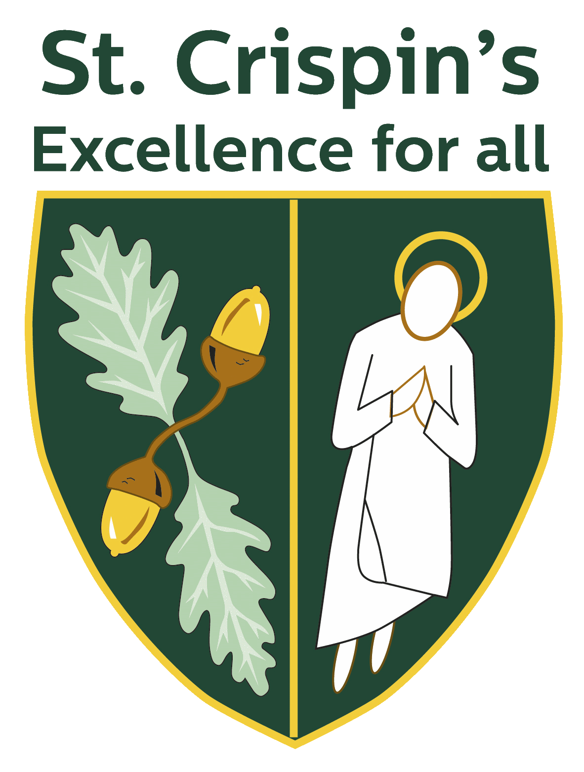
Department Details: History

1. Introduction and welcome by Head of Department including departmental vision
The History department is committed to bringing the past to life and making students life-long lovers of the subject. We are an experienced and forward-thinking team who are at the forefront to developing learning and teaching, both within the department and across the school. We are never afraid to take on challenges and are always looking to ensure our work serves the very best interests of those who study the subject.

2. Curriculum overview
At Key Stage 3, students have four lessons per fortnight and follow a broad chronology of British, European and World history from 1066 to the present day, interspersed with elements of project-based learning and in depth studies to acquire the core skills required for success. At GCSE, students follow the Edexcel Modern World Study syllabus with examined elements on Crime and Punishment c.1000-present day, the Cold War 1943-1991, Elizabethan England 1558-1588 and Germany 1918-1945. At A-Level, students follow the OCR A syllabus studying units on the Wars of the Roses, the unification of Italy, Russia 1855-1964 and an independent individual study.

3. Exam performance
Performance at GCSE has been improving and is in line with national performance measures. At A-level, performance was within the top 5% of all schools for value added and many students go on to read History or related subjects at university.

4. Resources and rooming
The department comprises four full time members of staff. History classrooms are located in the iconic Tower building, all of which have projectors and AV units. The team has worked hard to create a strong and welcoming atmosphere. The department is well resourced with an extensive range of textbooks and props to help deliver interactive and varied lessons.

5. Other information
The department is deeply committed to extending students’ learning and offers a variety of enrichment and extra-curricular opportunities, with visits to Warwick Castle, the Black Country and Bovington Tank Museum in lower school. At key stage 4, students have the chance to accompany the department on a 3-day residential trip to Berlin and a spooky evening walking tour of Whitechapel. We run lively investigation-based sessions for Gifted and Talented students in lower school and a film club at GCSE. In recent years, we have made strong links with Reading University, attending lectures and seminar sessions for A-level students.

